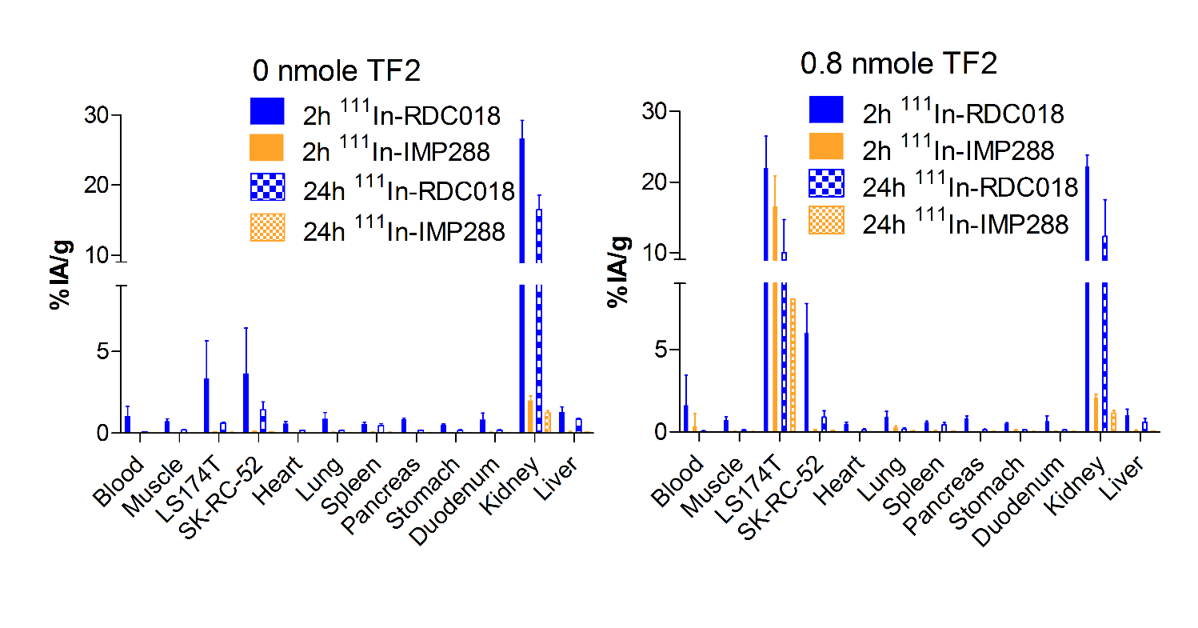
Figure S2. Biodistribution profiles of ¹¹¹In-RDC018 and ¹¹¹In-IMP-288 at 2 h and 24 h p.i. after pretargeting with 0 and 0.8 nmole TF2 in BALB/c nude mice with s.c. tumors.

