Additional file 1:
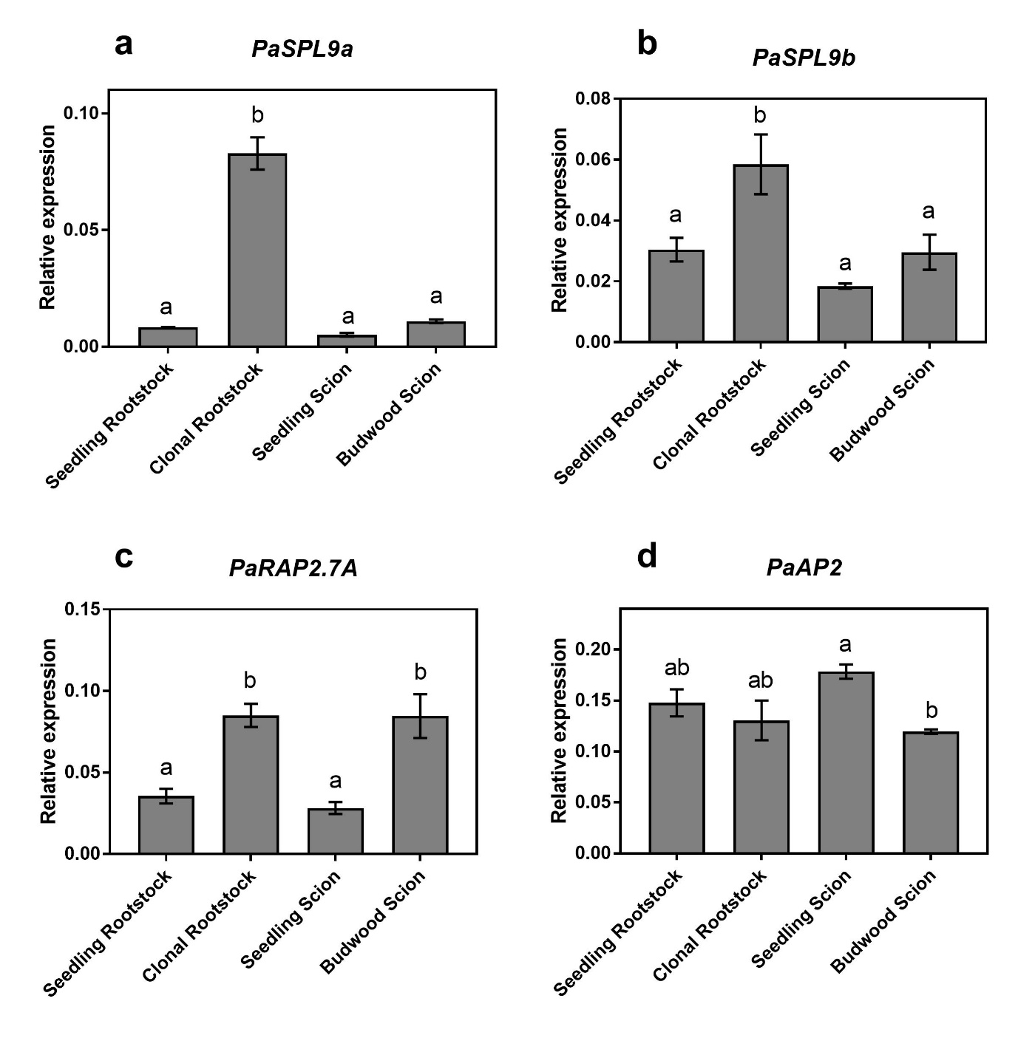
Additional file 1: Fig. S1: Expression analysis of a PaSPL9a, b PaSPL9b, c PaRAP2.7A and d PaAP2 in pre-graft avocado leaves sampled from the seedling rootstock, clonal rootstock, seedling scion and budwood scion. Error bars represent standard error of the mean (n=3), and significant differences are shown in different letters (p<0.05).

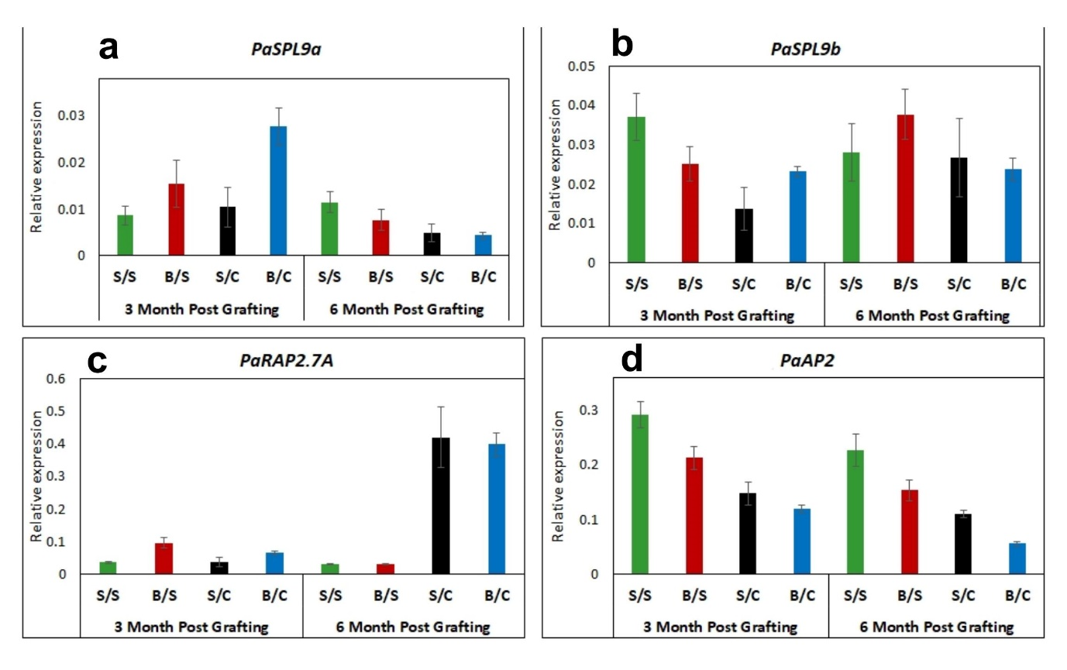
Additional file 1: Fig. S2: Expression analysis of a PaSPL9a, b PaSPL9b, c PaRAP2.7A and d PaAP2 in post grafting avocado leaves, cv. Hass as scion and cv. Velvick as rootstock. Where, S/S= seedling scion on seedling rootstock, B/S= budwood scion on seedling rootstock, S/C= seedling scion on clonal rootstock and B/C= budwood scion on clonal rootstock. Error bars represent standard error of the mean (n=3).

Additional file 1: Table S1: Graft success observed for avocado grafts.
1 | Graft combination | Total grafts | Success | Died | Graft success %
 | Budwood Hass/ Seedling Velvick | 22 | 20 | 2 | 90.90909091
 | Seedling Hass/ Seedling Velvick | 21 | 12 | 9 | 57.14285714
 | Budwood Hass/ Clonal Velvick | 12 | 10 | 2 | 83.33333333
 | Seedling Hass/ Clonal Velvick | 12 | 5 | 7 | 41.66666667
2 | Leaf removal vs intact leaves in rootstock part experiment | Total grafts | Success | Died | Graft success %
 | Budwood Hass/ Clonal Velvick with intact leaves | 12 | 10 | 2 | 83.33333333
 | Budwood Hass/ Clonal Velvick Without leaves | 12 | 3 | 9 | 25

Additional file 1: Table S2: Phenotypic observation for flowering and plant height in the avocado grafted plants. Where, Hb= Budwood Hass, Hs= Seedling Hass used as scion, Vs= Velvick seedling rootstock and Vc= Velvick Clonal rootstock.
Graft combination | sample no | Flowering- (July – 8-months post-grafting) | Height (cm) 6 months post-grafting
Hb/Vs | 1 | yes | 45
Hb/Vs | 2 | yes | 48
Hb/Vs | 3 | yes | 40
Hb/Vs | 4 | yes | 52
Hb/Vs | 5 | yes | 53
Hb/Vs | 6 | yes | 50
Hb/Vs | 7 | yes | 44
Hb/Vs | 8 | yes | 49
Hb/Vs | 9 | yes | 45
Hb/Vs | 10 | yes | 39
Hs/Vs | 1 | No | 44
Hs/Vs | 2 | No | 51
Hs/Vs | 3 | No | 28
Hs/Vs | 4 | No | 39
Hs/Vs | 5 | No | 42
Hs/Vs | 6 | No | 54
Hs/Vs | 7 | No | 37
Hs/Vs | 8 | No | 50
Hs/Vs | 9 | No | 41
Hs/Vs | 10 | No | 49
Hb/Vc | 1 | Yes | 95
Hb/Vc | 2 | Yes | 100
Hb/Vc | 3 | Yes | 93
Hb/Vc | 4 | Yes | 85
Hb/Vc | 5 | Yes | 93
Hb/Vc | 6 | Yes | 98
Hb/Vc | 7 | Yes | 90
Hb/Vc | 8 | Yes | 81
Hb/Vc | 9 | Yes | 101
Hs/Vs | 1 | No | 93
Hs/Vs | 2 | No | 100
Hs/Vs | 3 | No | 90
Hs/Vs | 4 | No | 86
Hs/Vs | 5 | No | 74

Additional file 1: Table S3: Primers used for miRNA and gene quantification.
No. | Gene | F Primer | R Primer
1 | miR156 | TGACAGAAGAGAGTGAGCAC | Universal Primer
2 | miR172 | AGAATCTTGATGATGCTGCAT | Universal Primer
3 | U6 SnoRNA | GGATGACACGCACAAATCGAG | Universal Primer
5 | 5.8S ribosomal RNA rRNA | GAATTGCAGAATCCCGTGAACC | Universal Primer
6 | PaRAP2.7A/TOE1A | GCAGTAGAGAGGGCTGAACTC | GTAACAGTAGGTAGGAAAATGGCC
7 | PaRAP2.7B | CAACTACGAGGCTCTACTGC | GCTTTCAGCTCTGGTAATAGTAGG
8 | PaAP2 | GGAGCAGTAGTAATTGGGCTGC | CATAATCAAGGGTCAGGTAGGTC
9 | PaSPL4 | CGTTGGTTCTCTACTATGCTCTC | GTACCTACTGGCACAGATAGC
10 | PaSPL9a | CTTTGGCAGGGTAGCATAGAG | GCTGTGATACCCGAAGCTCG
11 | PaSPL9b | GCAGGAATCTCCAACTCCAG | TGGCACTATGACTTGGTGGA
12 | PaTPS1 | CTTCAAGCGAGGGATATGCT | TGCTGCACCCTTTGTAACAC
13 | PaGAPDH | TGGGAAACTTACAGGAATGG | GTCACCCACAAAGTCAGTAGAA
14 | PaEF1a | ATCAAGCGTGGGTTTGTTGC | TACCCGTTGCCAATCTGACC

