Additional files
Functional exosome-mediated co-delivery of doxorubicin and hydrophobically modified microRNA 159 for triple-negative breast cancer therapy
Chunai Gong,^{#a, b} Jing Tian,^{# a} Zhuo Wang,^{#a} Yuan Gao^{c} Xin Wuª Xueying Ding^{d} Lei Qiangª Guorui Liª Zhimin Hanª Yongfang Yuan,^{*b} and Shen Gao,^{*a}
1.PMA-induced monocyte differentiation
Figure S1 THP-1 monocyte differentiation induced by PMA. (A) Quantitative analysis expression of CD11b and A15 in THP-1 monocytes and differentiated macrophages for different treated concentration of PMA. (B) a)Flow cytometry analysis of A15 expression in THP-1 cells treated with PMA (50 ng/mL) for different times; b) mean fluorescence intensity of A15 expression in THP-1 cells treated with PMA (50 ng/mL) for different times;

2.In vitro targeting of A15-Exo
Figure S2 Confocal laser-scanning microscopy (CLSM) images of MDA-MB-231 and MCF-7 incubated with PKH7 labled Exo or A15-Exo at 37℃ for 4 h.
3. Cell-Migration Study
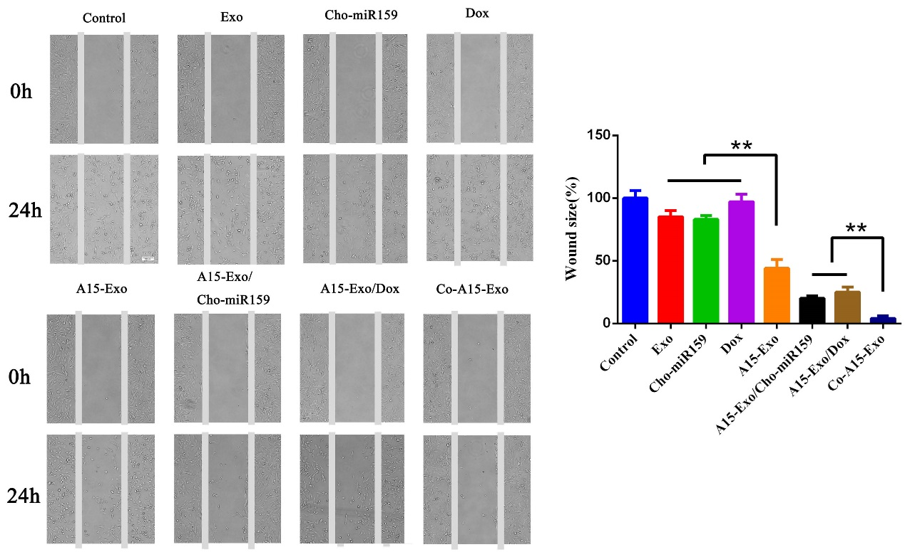
Figure S3 Wound healing assay of MDA-MB-231 cells incubated with Co-A15-Exo displayed arrested healing/closing of the scratch. (representative pictures from 3 repeated experiments) Scale bar: 100 μm.

4. Transwell migration assay
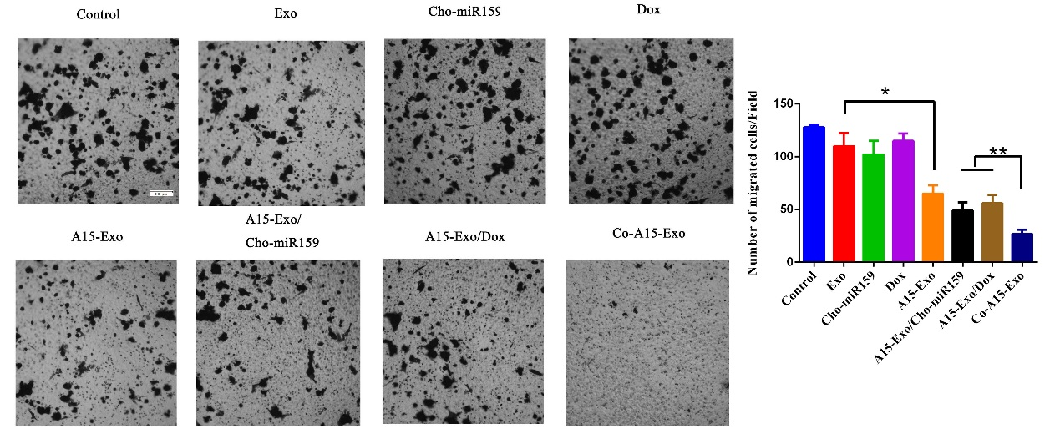
Figure S4 The migratory ability of MDA-MB-231 receiving different treatments was further confirmed by the transwell assay and quantitative analysis of the migrated cells. n = 3 per group. Scale bar, 100 μm.

