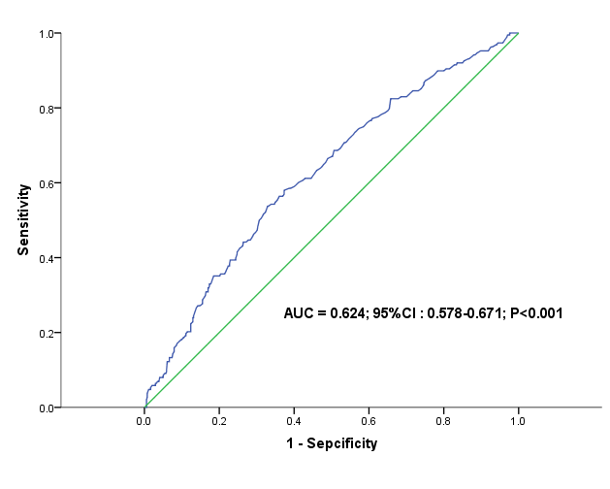
Fig S1. Preoperative serum albumin receiver operating characteristic curve for discriminating critically ill subjects with AKI (n = 188) from those without AKI (n = 541). The cutoff value of preoperative serum albumin for postoperative AKI was 37.5g/L determined by the Youden index with a sensitivity of 0.54, specificity of 0.67 and positive predictive value of 0.36. AUC, area under the curve; CI, confidence interval; AKI, acute kidney injury.

