**Facile synthesis of boronic acid-functionalized core-shell magnetic nanoparticles for efficient dopamine extraction**

Jeong Keun Kook, Do-Yeong Koh, Phung Viet Duc, Sang-Wha Lee*

*Department of Chemical and Biological Engineering, Gachon University, 1342 Seongnamdaero, Sujeong-gu, Seongnam-si, 461-701, Republic of Korea*

*E-mail: lswha@gachon.ac.kr, TEL: +82-31-750-5360

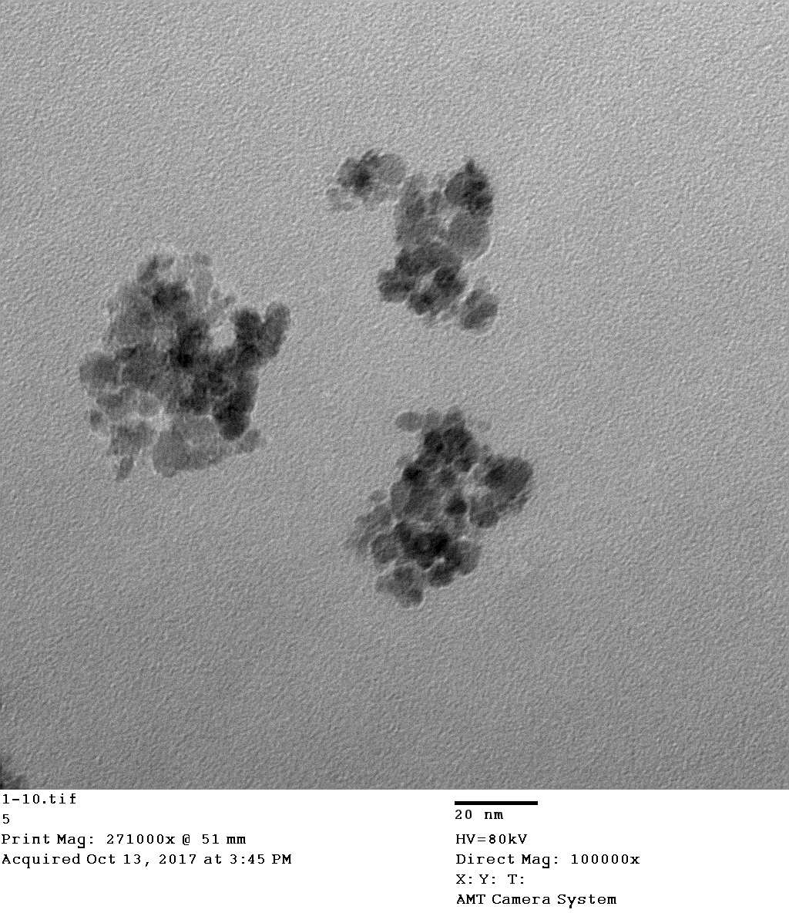

**50 nm**

**Fig. S1.** TEM image of A-Fe3O4.



**Fig. S2.** Particle size distribution of core-shell Fe3O4@SiO2 by DLS method.

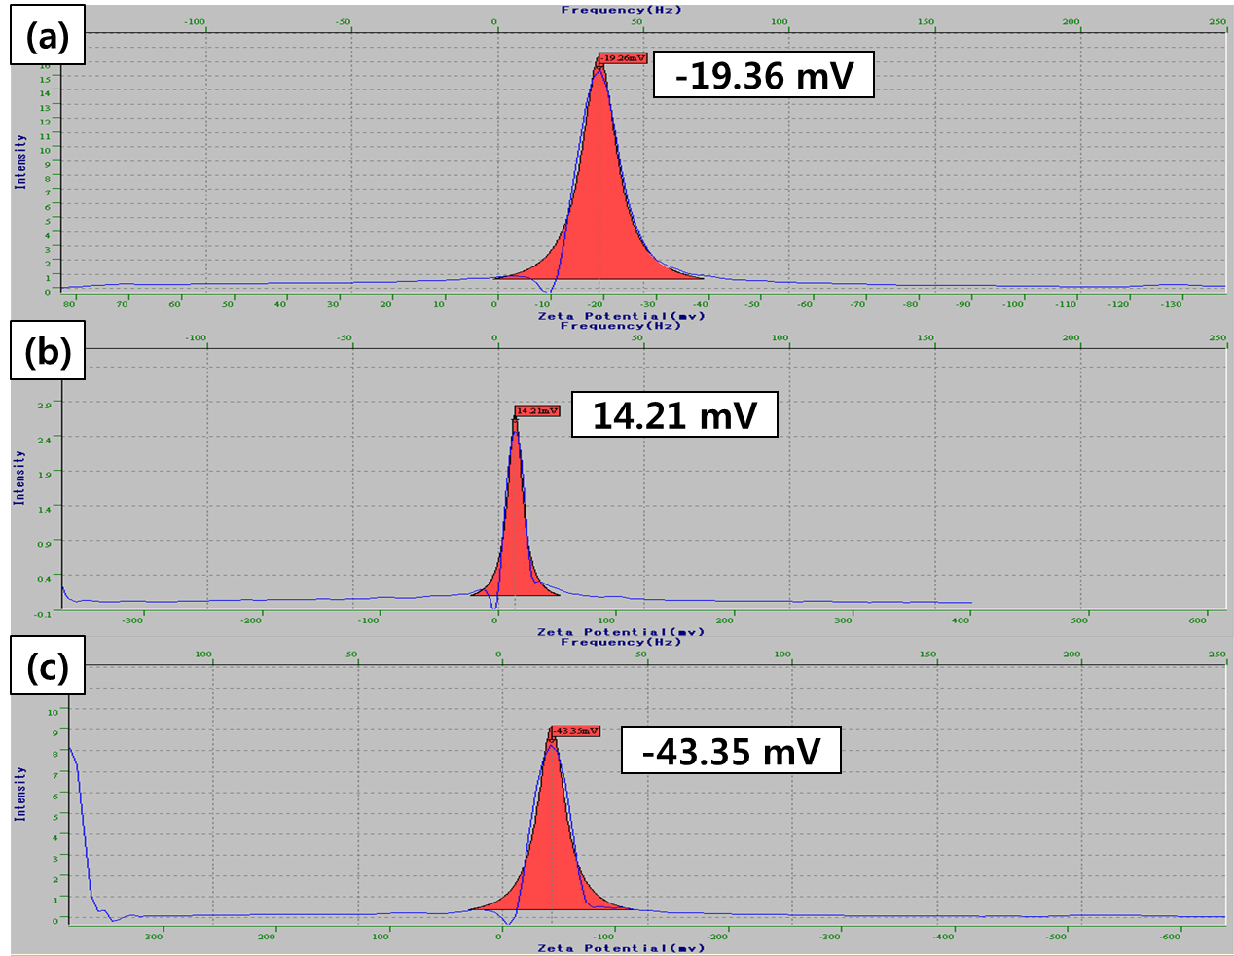

**Fig. S3.** Zeta-potentials of as-prepared samples: a) Fe3O4@SiO2, b) Fe3O4@SiO2–NH2 c) Fe3O4@SiO2-COOH.



**Fig. S4.** X-ray diffraction (XRD) patterns of A-Fe3O4 and Fe3O4@SiO2.



(a) (b) (c)

**Fig. S5.** Comparative dispersion/redispersion of Fe3O4@SiO2@APBA in various medias (**1.** Water, **2.** PBS (pH7.4), **3.** Tris-HCl buffer (pH8.0), **4.** Tris-HCl buffer (pH 9.0), **5.** Ethanol) at different times: a) 0 min, b) 3 hr, c) after re-dispersion .



**Fig. S6.** pH effect on the adsorption capacity of dopamine by Fe3O4@SiO2@APBA.

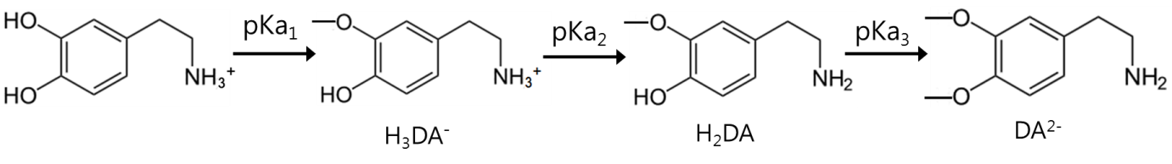

(a)

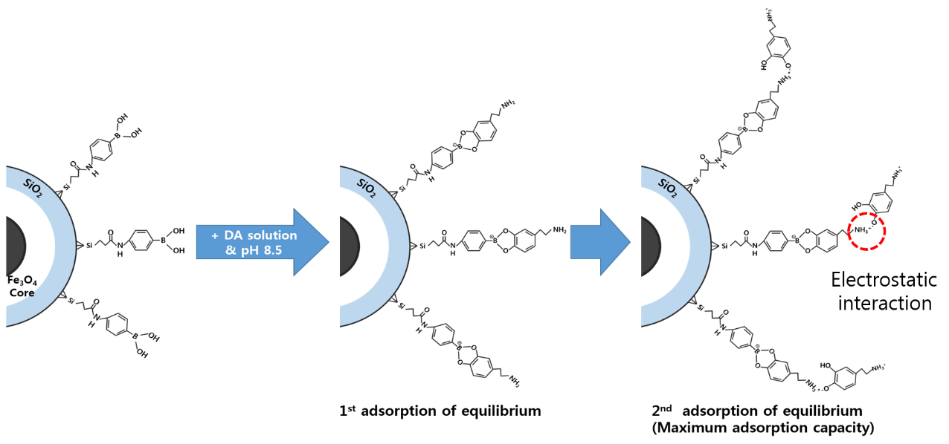

(b)

**Fig. S7.** Adsorption mechanism of dopamine by using boronic aicd-functionalized magnetic particles (Fe3O4@SiO2@APBA).