a. Forest plot. Effect of antiresorptive medications preventing secondary vertebral fracture. 3
b. Forest plot. GI complaints of bisphosphonates. 4
c. Forest plot. Discontinuation due to AEs – Zoledronate 5
d. Forest plot. Preventing non-vertebral fracture – Zoledronate 5
e. Forest plot. GI complaints - Alendronate 5
f. Forest plot. Discontinuation due to AEs – Alendronate 5
g. Forest plot. Non-vertebral fracture – Alendronate 6
h. Forest plot. GI complaints – Risedronate 7
i. Forest plot. Discontinuation due to AEs - Risedronate 7
j. Forest plot. Non-vertebral fracture – Risedronate 7
k. Forest plot. Sensitivity test. Excluding a study with a small sample size and big variance with other studies. 8
l. Forest plot. GI complaints – Etidronate 8
m. Forest plot. Discontinuation – Etidronate 8
n. Forest plot. Non-vertebral fracture – Etidronate 9
o. Forest plot. Discontinuation due to AEs – Ibandronate (sufficient dose) 9
p. Forest plot. Discontinuation due to AEs – Ibandronate (insufficient dose) 9
q. Forest plot. Non-vertebral fracture – Ibandronate (sufficient dose) 9
r. Forest plot. Non-vertebral fracture – Ibandronate (insufficient dose) 10
s. Forest plot. Non-vertebral fracture – Minodronate 10
t. Forest plot. Non-vertebral fracture – Pamidronate 10
u. Forest plot. Non-vertebral fracture – HRT 10
v. Forest plot. Discontinuation due to AEs – HRT 11
w. Forest plot. Discontinuation due to AEs – PTH 11
x. Forest plot. Non-vertebral fracture – PTH 12
y. Forest plot. Discontinuation due to AEs – Denosumab 12
z. Forest plot. Non-vertebral fracture – Denosumab 12
aa. Forest plot. Discontinuation – Risedronate vs. PTH 13
bb. Forest plot. Non-vertebral fracture – Teriparatide vs. Risedronate 13
cc. Forest plot. Non-vertebral fracture – Alendronate vs. Denosumab 13
cc. Forest plot. Non-vertebral fracture – Romosozumab vs. Alendronate 13

a. Forest plot. Effect of antiresorptive medications preventing secondary vertebral fracture.
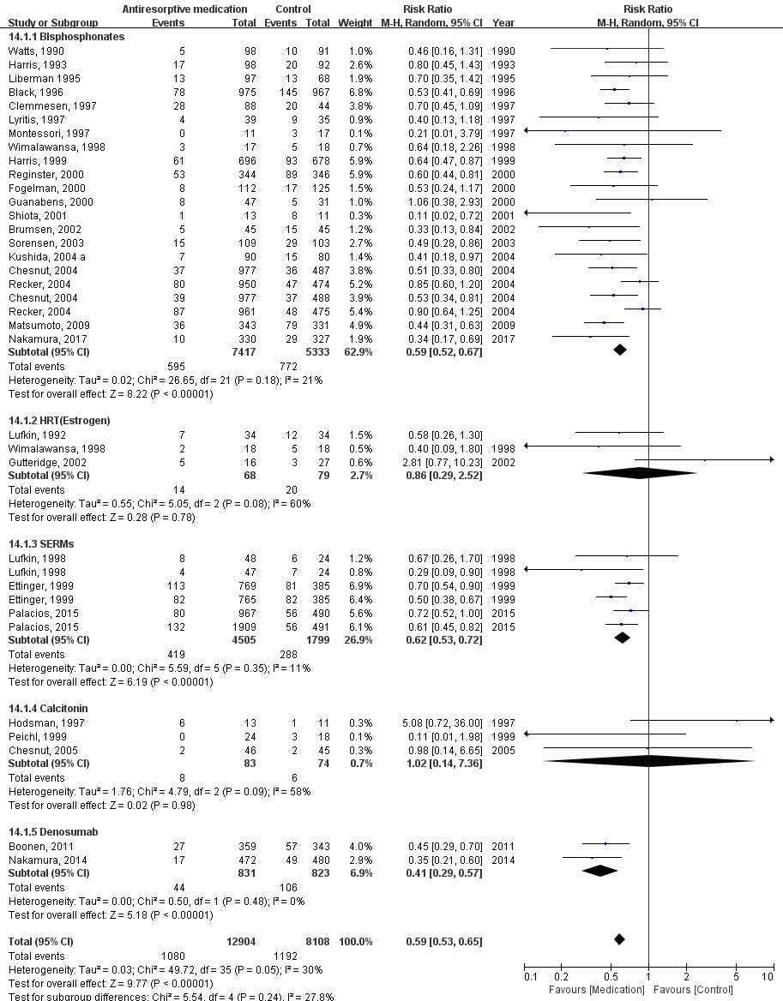

b. Forest plot. GI complaints of bisphosphonates.
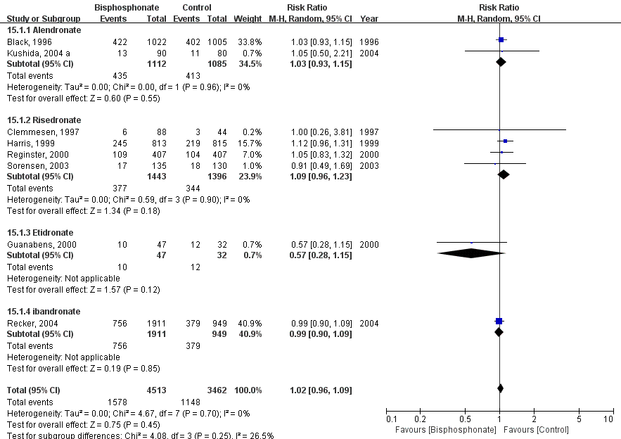

c. Forest plot. Discontinuation due to AEs – Zoledronate
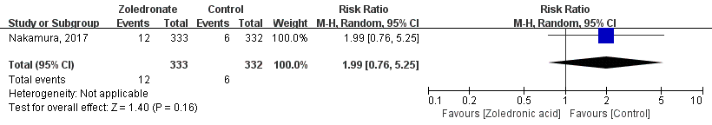

d. Forest plot. Preventing non-vertebral fracture – Zoledronate
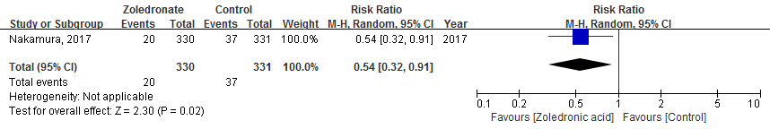

e. Forest plot. GI complaints - Alendronate
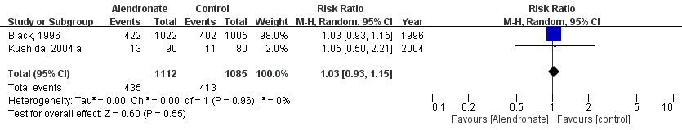

f. Forest plot. Discontinuation due to AEs – Alendronate
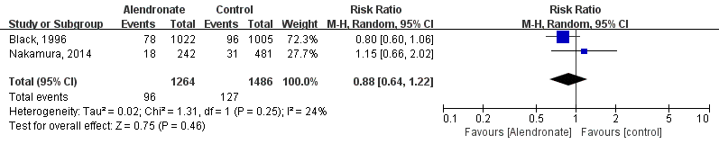

g. Forest plot. Non-vertebral fracture – Alendronate
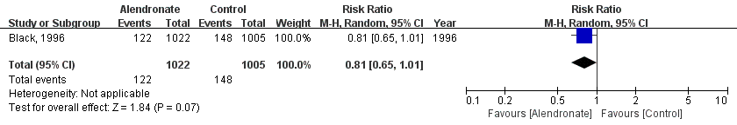

h. Forest plot. GI complaints – Risedronate
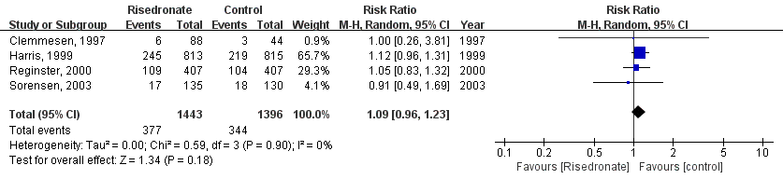

i. Forest plot. Discontinuation due to AEs - Risedronate
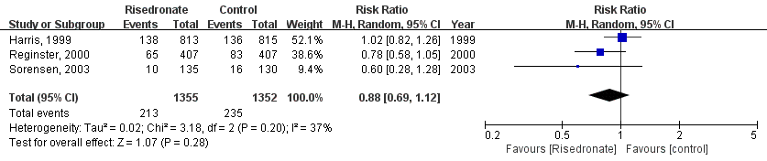

j. Forest plot. Non-vertebral fracture – Risedronate
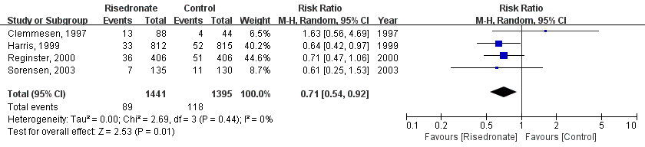

k. Forest plot. Sensitivity test. Excluding a study with a small sample size and big variance with other studies.
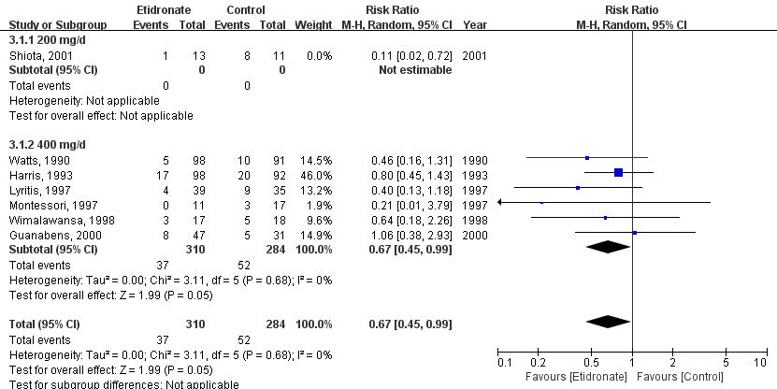

l. Forest plot. GI complaints – Etidronate
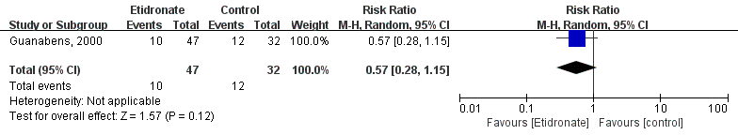

m. Forest plot. Discontinuation – Etidronate
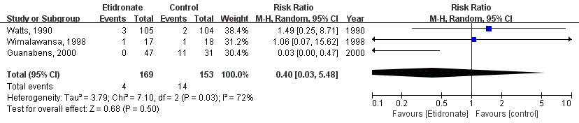

n. Forest plot. Non-vertebral fracture – Etidronate
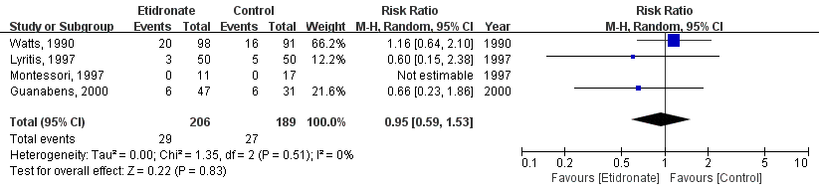

o. Forest plot. Discontinuation due to AEs – Ibandronate (sufficient dose)
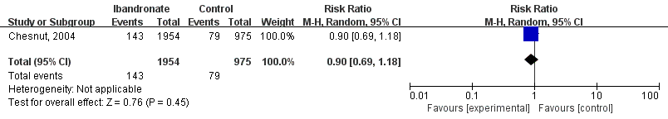

p. Forest plot. Discontinuation due to AEs – Ibandronate (insufficient dose)
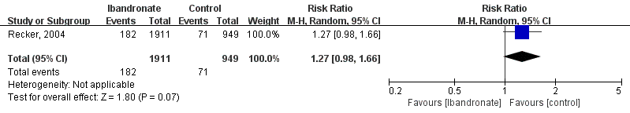

q. Forest plot. Non-vertebral fracture – Ibandronate (sufficient dose)
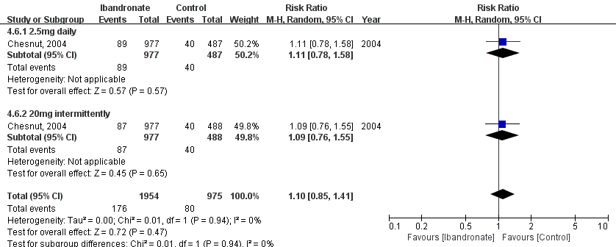

r. Forest plot. Non-vertebral fracture – Ibandronate (insufficient dose)
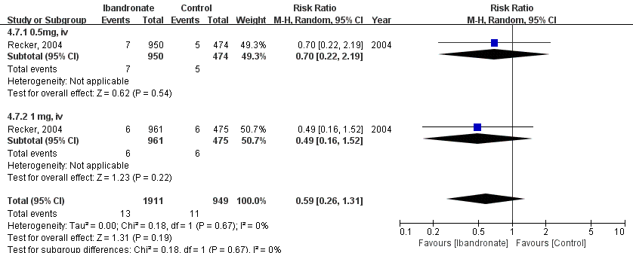

s. Forest plot. Non-vertebral fracture – Minodronate
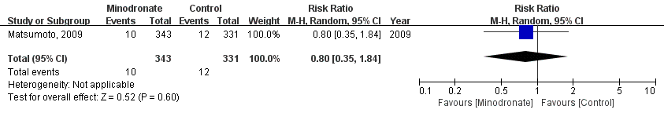

t. Forest plot. Non-vertebral fracture – Pamidronate
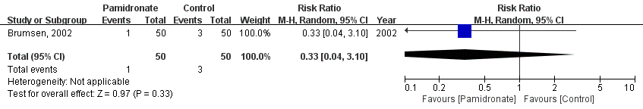

u. Forest plot. Non-vertebral fracture – HRT
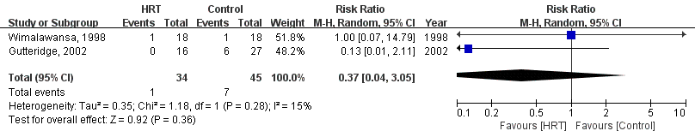

v. Forest plot. Discontinuation due to AEs – HRT
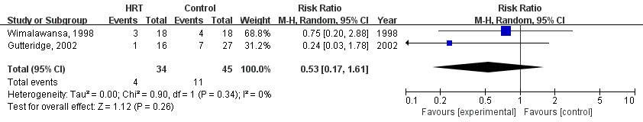

w. Forest plot. Discontinuation due to AEs – PTH
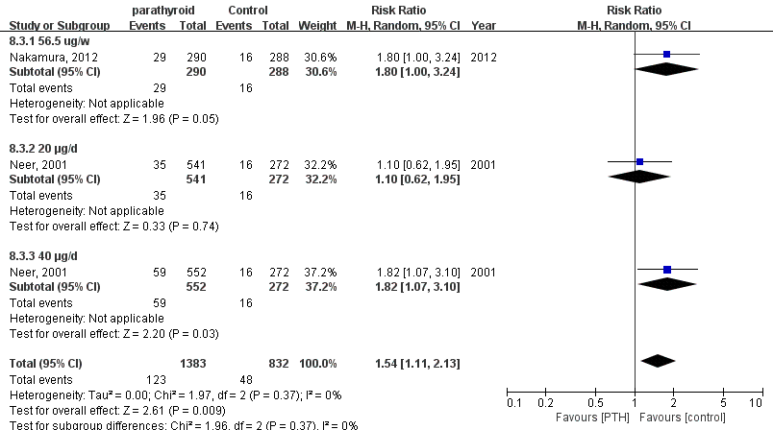

x. Forest plot. Non-vertebral fracture – PTH
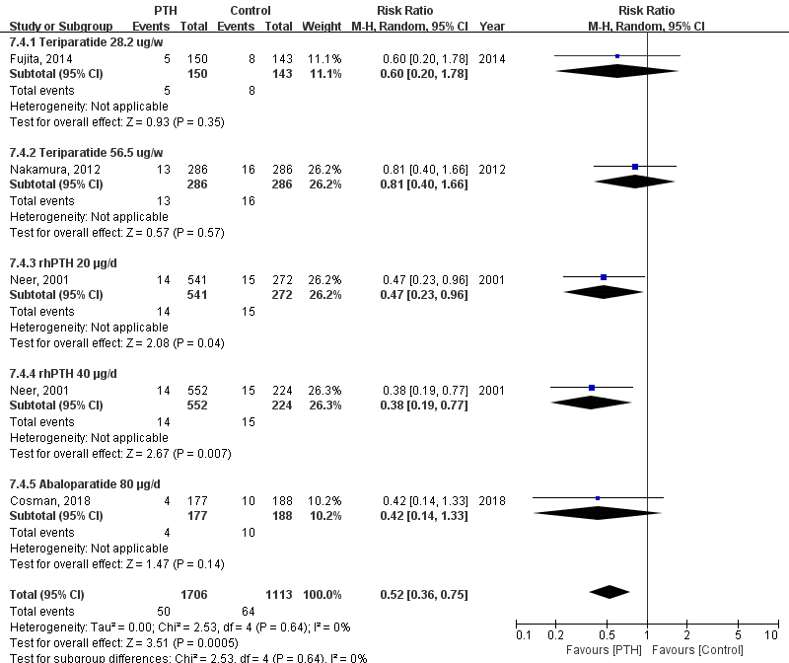

y. Forest plot. Discontinuation due to AEs – Denosumab
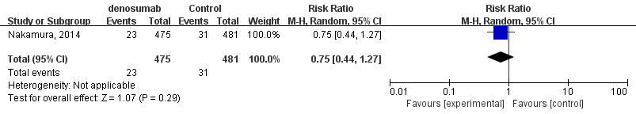

z. Forest plot. Non-vertebral fracture – Denosumab
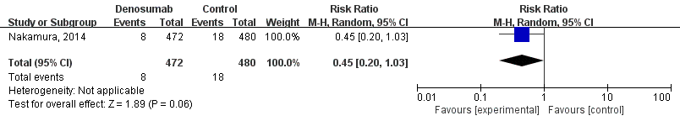

aa. Forest plot. Non-vertebral fracture – Ibandronate vs. Risedronate
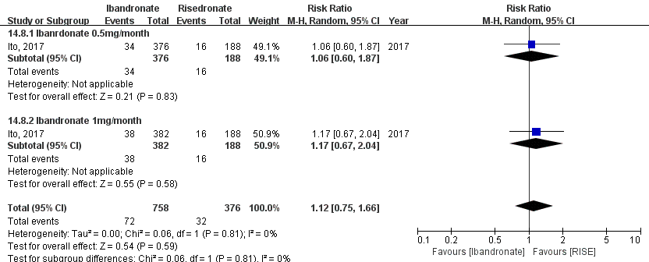

bb. Forest plot. Discontinuation – Risedronate vs. PTH
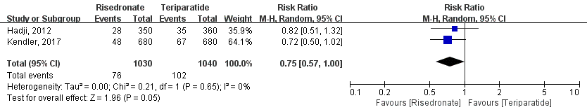

cc. Forest plot. Non-vertebral fracture – Teriparatide vs. Risedronate
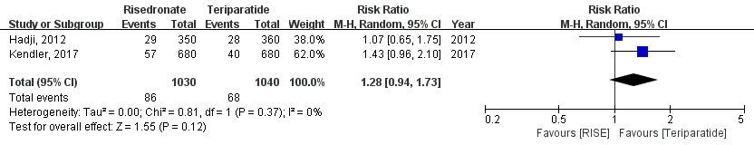

dd. Forest plot. Non-vertebral fracture – Alendronate vs. Denosumab
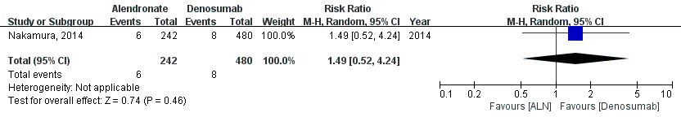

ee. Forest plot. Non-vertebral fracture – Romosozumab vs. Alendronate
