Additional file for
Fabrication of surface-functionalized PUA composites to achieve superhydrophobicity

¹Tian-Feng Hou, ¹Arunkumar Shanmugasundaram, ¹Bui Quoc Huy Nguyen,

^{1,2}Dong-Weon Lee*

¹MEMS and Nanotechnology Laboratory,

School of Mechanical Engineering, Chonnam National University,

Gwangju 61186, Republic of Korea

²Center for Next-generation Sensor Research and Development,
Chonnam National University,
Gwangju, 61186, Republic of Korea
Tel. no.: +82-62-530 1684. E-mail: mems@jnu.ac.kr.

*To whom all correspondence should be addressed
Fig. S1. The PDMS cross-linking polymerization reaction.

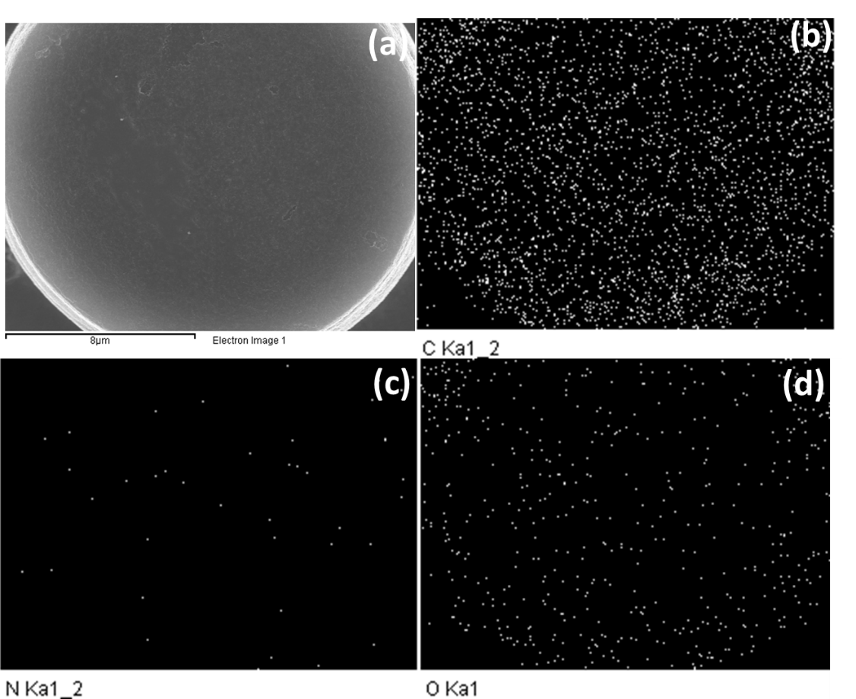
Fig. S2. Elemental analysis of the fabricated µ-patterned siloxane functionalized PUA (S-PUA). (a) Electron micrograph of µ-pillar top surface, elemental mapping of (b) carbon, (c) nitrogen and (d) oxygen.
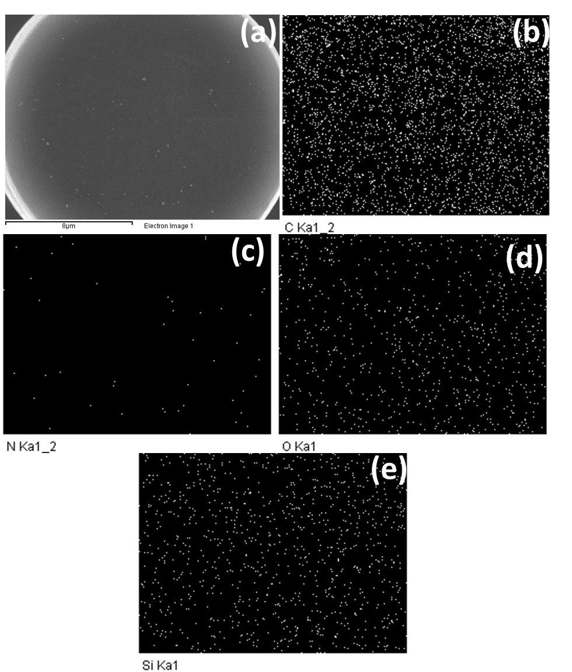
Fig. S3. Elemental analysis of the fabricated µ-patterned siloxane functionalized PG (S-PG). (a) electron micrograph of µ-pillar top surface, elemental mapping of (b) carbon, (c) nitrogen, (d) oxygen and (e) silicon.

Fig. S4. The water advancing contact angle (WACA), water receding contact angle (WRCA) and sliding angle (SA) of the siloxane functionalized GO incorporated PUA composite (S-PG) film as a function of µ-pillar distance, (n=5, mean ± standard deviation)

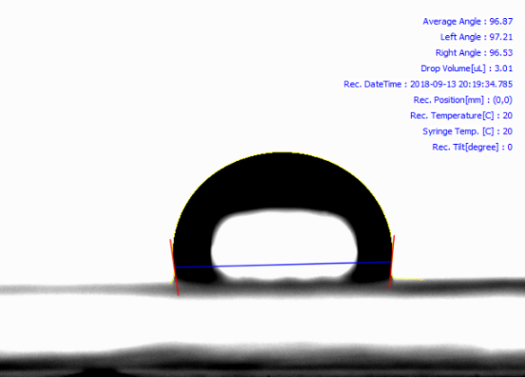
Fig. S5. Photograph of a water droplet on the surface of the siloxane functionalized flat PG (S-F-PG).

Fig. S6. The UV-DRS spectra of the fabricated siloxane functionalized-µ-patterned PG (S-PG) film.

