Presepsin | CRP | Procalcitonin
Egger’s test p-value = 0.0001 | Egger’s test p-value = 0.2812 | Egger’s test p-value = 0.0561
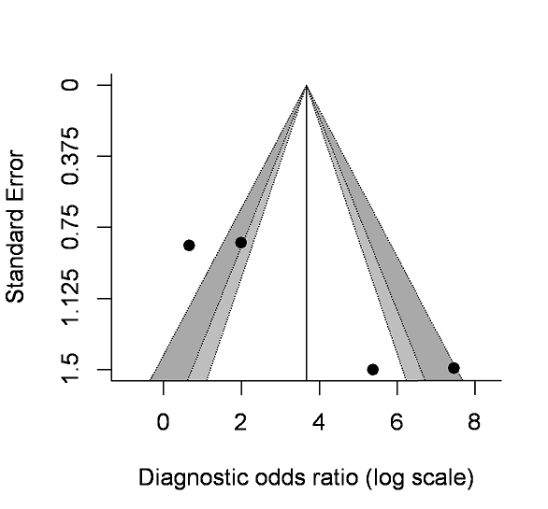 | 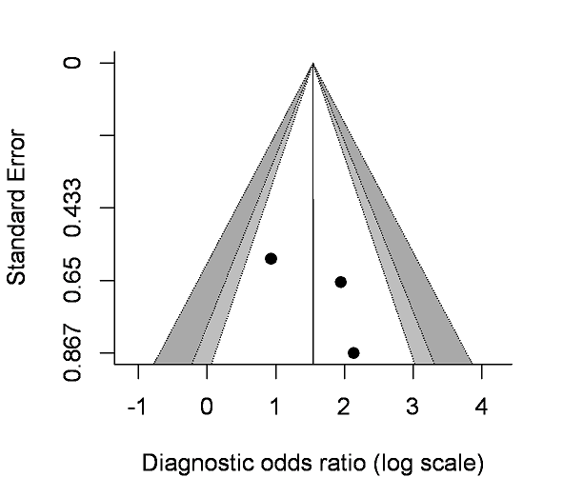 | 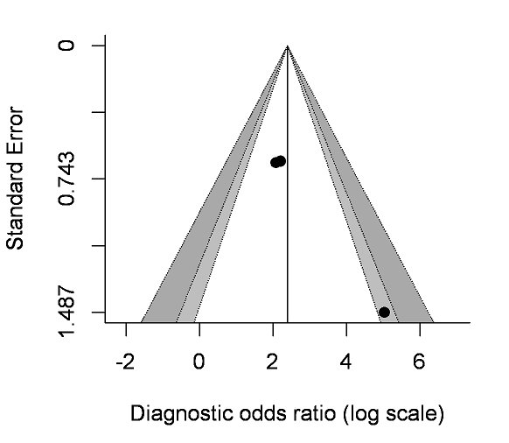

Additional File 3. Log (DOR) are 3.55 for presepsin (unadjusted), 1.54 for CRP (C-reactive protein), and 2.29 for PCT (procalcitonin). Egger’s test revealed a publication bias in the studies for presepsin (P < 0.05) but not in those for CRP or PCT.

