Supplemental Figure 3.

a.

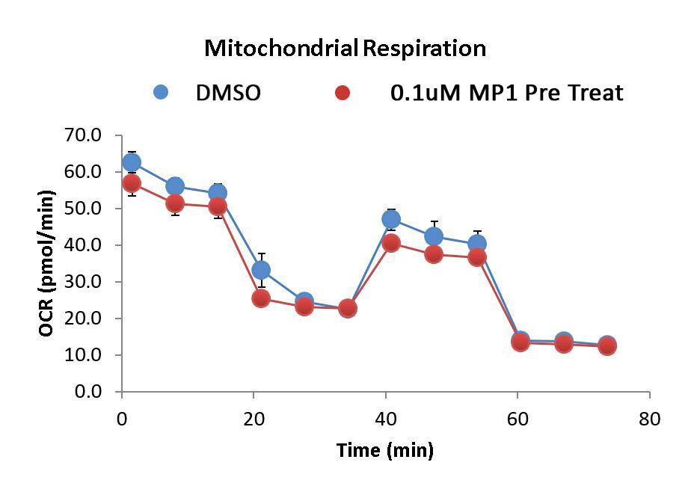

**p = 0.06**

b.

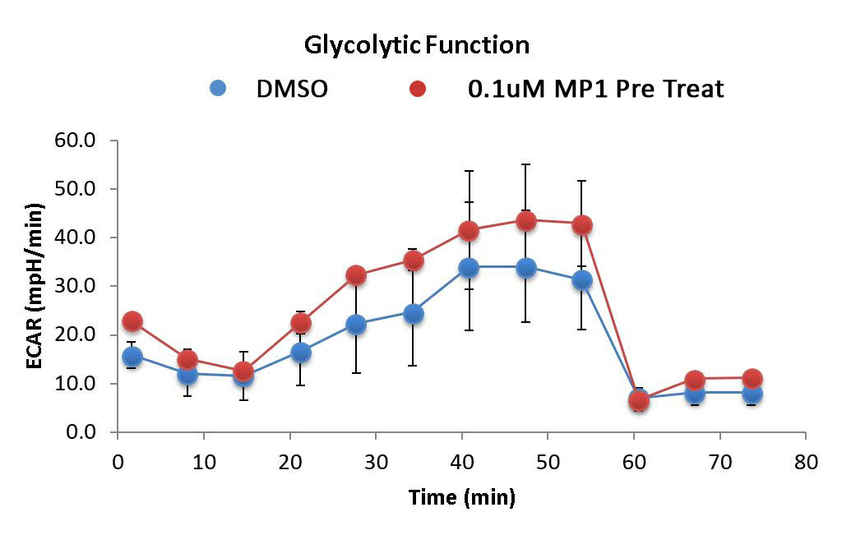

**p = 0.16**