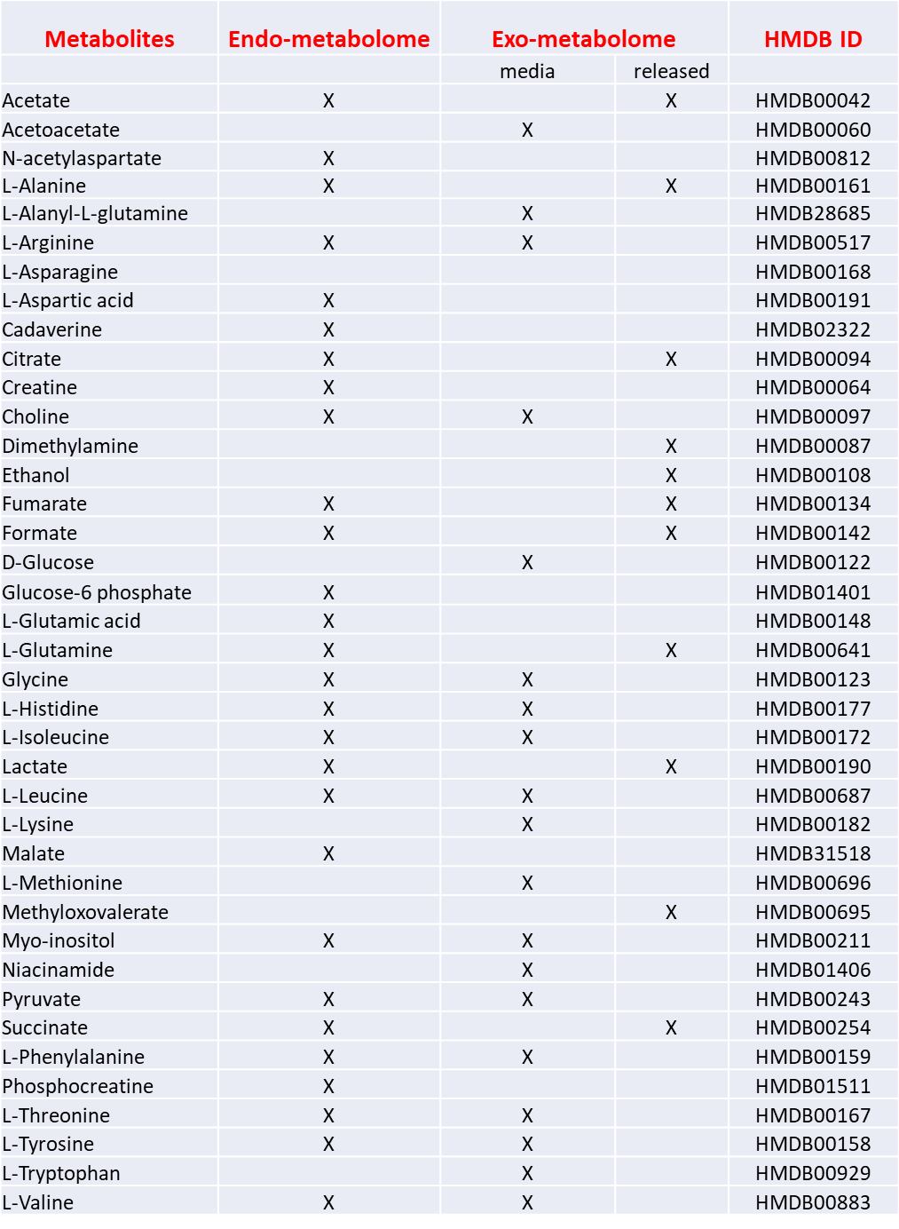

Table S1. List of the endo- and exo-metabolites assigned and analysed over time before and after GlaB treatment. Metabolites realised from GL261 cells after 48h of treatment are reported separately. The Human Metabolome Database (HMDB) compound ID of each metabolite is also reported.

TIME (min) | FLOW (ml/min) | % Solvent B
0 | 0.4 | 20
3 | 0.4 | 20
4 | 0.4 | 50
37 | 0.4 | 100
42 | 0.4 | 100
44 | 0.4 | 20
48 | 0.4 | 20

Table S2. The HPLC gradient for the brain extracts analysis. All chromatographic runs were performed at a flow-rate of 0.4 ml/min. Solvent A was Water/Acetonitrile 90:10 with the 0.1% v/v of formic acid, and solvent B was Acetonitrile/Methanol 50:50 with the 0.1% v/v of formic acid.

