The pain trajectory of juvenile idiopathic arthritis (JIA): translating from adolescent patient report to behavioural sensitivity in a juvenile animal model

Supplementary material
Annastazia E Learoyd¹, Debajit Sen², Maria Fitzgerald¹
¹Department of Neuroscience, Physiology & Pharmacology, University College London, UK and ²Arthritis Research UK Centre for Adolescent Rheumatology, University College London, UK

METHODS

Part 1: Patient cohort
 | All patients | Trajectory: |  |  | Statistical analysis
 |  | Low pain | Variable pain | High pain | F value/Chi-Square | P value
Total no. of patients | 97 | 45 (46.4%) | 30 (30.9%) | 22 (22.7%)
Included disease activity markers
PGA (cm) | 2.40 (2.52) | 1.40 (2.11) | 3.11 (2.73) | 3.47 (2.31) | 7.64 | 0.001
No. of:
Active joints | 0 (0-2) | 0 (0-1) | 1 (0-1) | 0 (0-2) | 2.06 | 0.13
Swollen joints | 0 (0-2) | 0 (0-0) | 1 (0-2.25) | 1 (0-3.25) | 4.33 | 0.016
Limited joints | 1 (0-2) | 0 (0-1) | 2 (0-3) | 2 (0-5) | 3.16 | 0.047
Blood disease markers:
ESR | 11.98 (18.10) | 8.27 (11.97) | 16.13 (17.02) | 16.67 (29.74) | 1.54 | 0.22
No. of patients | 61 | 33 | 16 | 12
CRP | 3.75 (6.99) | 2.66 (3.96) | 5.77 (10.72) | 4.24 (7.93) | 0.90 | 0.41
No. of patients | 50 | 28 | 13 | 9
Table 1 – JIA disease activity markers for each pain trajectory
Data is described as mean (standard deviation) for continuous data, number (% of patients with trajectory type) for categorical data or median (interquartile range) for discreet data (no. of active joints). Statistical comparison between trajectory groups were made using either one-way ANOVA or Chi-Square test. The number of patients with available information on blood disease markers is shown beneath each marker. PGA=Physician global assessment VAS.

 | Included patients | Excluded patients |  | Statistical analysis
 |  | ≤2 pain VAS scores | Incorrect time intervals | F value/Chi-Square | P value
No. of patients | 97 | 60 | 104
PainVAS at study onset | 3.29 (2.89) | 2.78 (3.30) | 3.40 (3.08) | 2.78 | 0.064
Age at JIA onset | 9.62 (4.86) | 9.13 (4.55) | 9.00 (4.93) | 0.48 | 0.62
Age at study onset | 16.40 (1.21) | 17.39 (1.57)* | 16.46 (1.34) | 10.51 | <0.001
Years since JIA onset | 6.78 (5.17) | 8.78 (4.83) | 8.15 (5.39) | 1.60 | 0.20
Sex: |  |  |  | 2.47 | 0.29
Female | 55 (56.7%) | 30 (50.0%) | 65 (62.5%)
Male | 42 (43.3%) | 30 (50.0%) | 39 (37.5%)
JIA subtype: |  |  |  | 8.14 | 0.23
Polyarticular course | 54 (55.7%) | 25 (41.7%) | 61 (58.7%)
Oligoarticular | 6 (6.2%) | 9 (15.0%) | 11 (10.6%)
Enthesitis Related | 32 (33.0%) | 20 (33.3%) | 25 (24.0%)
Systemic | 5 (5.2%) | 6 (10.0%) | 7 (6.7%)
JIA activity markers:
PGA | 2.40 (2.52) | 1.63 (2.55) | 2.25 (2.63) | 1.78 | 0.17
No. of active joints | 0 (0-2) | 0 (0-1) | 0 (0-2) | 1.15 | 0.32
Medications:
No. taking DMARDs | 67 (69.1%) | 35 (58.3%) | 56 (53.8%) | 5.03 | 0.081
No. taking Biologics | 40 (41.2%) | 19 (31.7%) | 41 (39.4%) | 1.53 | 0.47
No. taking Steroids | 16 (16.5%) | 6 (10.0%) | 13 (12.5%) | 1.47 | 0.48
Table 2 – Patient characteristics of included and excluded patients
Data is described as mean (standard deviation) for continuous data, number (% of patients with trajectory type) for categorical data or median (interquartile range) for discreet data (no. of active joints). Statistical comparison between trajectory groups were made using either one-way ANOVA or Chi-Square test. PGA=Physician global assessment VAS. * sig vs. included patients in post-hoc analysis.

RESULTS

Part 1: Pain in adolescent JIA patients
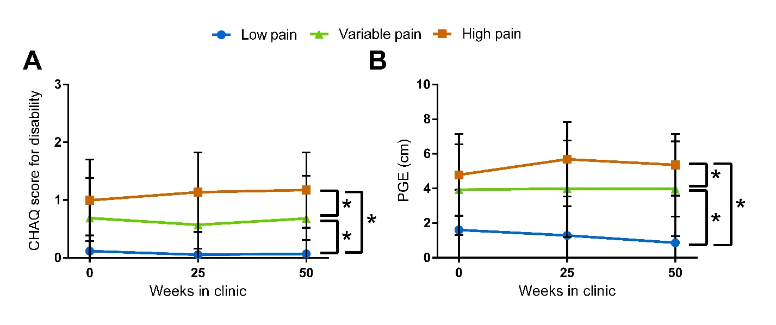
Figure 1 – Disability and quality of life as reported by patients with different levels of pain
Patients separated into low (n=45), variable (n=30) and high (n=22) pain trajectories via cluster analysis also experienced: A: differing levels of disability (as assessed by the Childhood Health Assessment Questionnaire [CHAQ]) (p<0.001) and B: varying levels of quality of life (as reported by the patient general evaluation VAS [PGE]) (p<0.001). * p<0.05 between indicated groups.

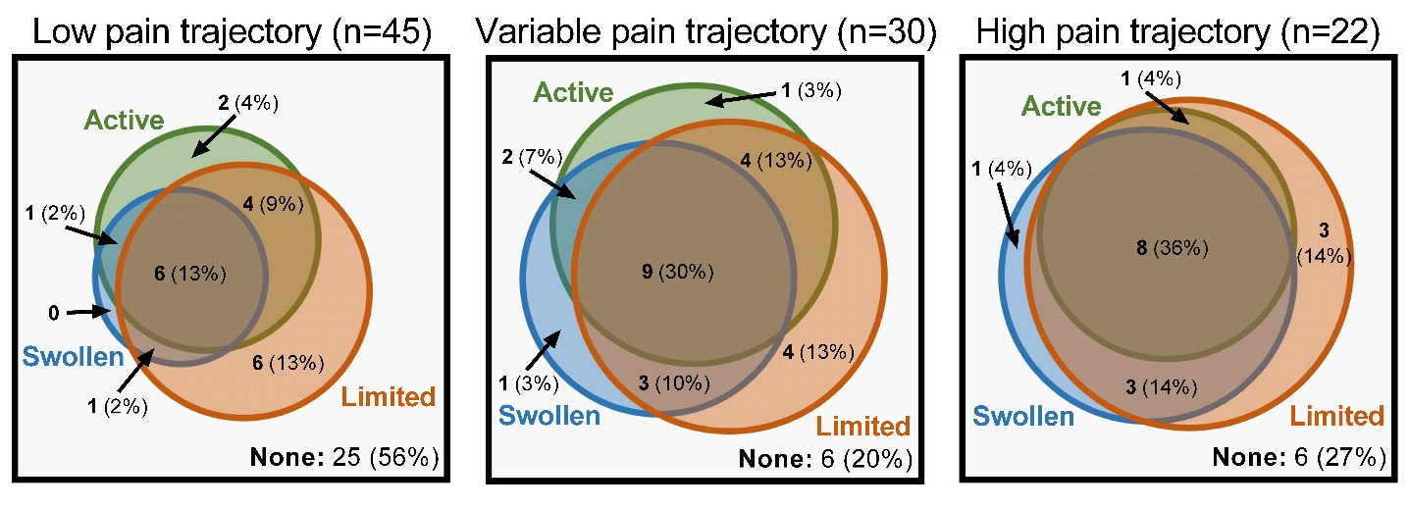
Figure 2 – Ven diagrams examining proportions of patients with each type of joint
Venn diagrams examining the proportion of patients with active (green), swollen (blue) or limited joints (orange), or a combination of the three, within each trajectory type revealed a reduced number of patients with only active joints and an increase in the number of patients with swollen and limited joints in the variable and high pain trajectory groups (p=0.029).

Part 2: Pain in a rodent model of joint inflammation
 | All animals | Sex |  | Statistical Analysis
 |  | Female | Male | Chi-Square | P value
No. of Animals | 25 | 10 | 15
Trajectory: |  |  |  | 58.40 | <0.001
Low Sensitivity | 7 (28.0%) | 1 (10.0%) | 6 (40.0%)
Medium Sensitivity | 9 (36.0%) | 6 (60.0%) | 3 (20.0%)
High Sensitivity | 9 (36.0%) | 3 (30.0%) | 6 (40.0%)
Table 3 – Animal numbers and the distribution of pain trajectories in female and male adolescent rats
Data is described as number (% of animals). Statistical comparison between trajectory groups were made using Chi-Square test.

 | All animals | Animal groups
 |  | Saline+Saline | Saline+CFA | CFA+CFA | CFA+CFA subgroups
 |  |  |  |  | Low Sensitivity | High Sensitivity
No. of animals | 67 | 24 | 22 | 21 | 12 | 9
Age of onset:
P8 | 35 (52.2%) | 12 (50.0%) | 11 (50.0%) | 12 (57.1%) | 8 (66.7%) | 4 (44.4%)
P21 | 32 (47.8%) | 12 (50.0%) | 11 (50.0%) | 9 (42.9%) | 4 (33.3%) | 5 (55.6%)
Sex:
Female | 34 (50.7%) | 12 (50.0%) | 11 (50.0%) | 11 (52.4%) | 7 (58.3%) | 4 (44.4%)
Male | 33 (49.3%) | 12 (50.0%) | 11 (50.0%) | 10 (47.6%) | 5 (41.7%) | 5 (55.6%)
Pain behaviour at baseline:
% Weight bearing on inflamed limb | 49.11 (2.28) | 49.91 (1.74) | 49.91 (1.38) | 47.35 (2.64) | 49.06 (1.61) | 45.07 (1.92)
50% log mechanical threshold | 1.12 (0.11) | 1.13 (0.10) | 1.10 (0.09) | 1.12 (0.13) | 1.13 (0.13) | 1.12 (0.15)
Table 4 – Animal numbers and characteristics of animal groups receiving one or two bouts of monoarthritis
Data is described as mean (standard deviation) for continuous data or number (% of animals within group). Age of onset refers to the age monoarthritis was first induced: either postnatal day 8 or 21 (P8 or P21).

