Additional file

Atom transfer radical polymer-modified paper for improvement in protein fixation in paper-based ELISA

Lu Qiª*, Aihong Zhang^{b}, Yu Wangª, Long Liuª and Xinghe Wangª

ªPhase I Clinical Trial Center, Beijing Shijitan Hospital, Capital Medical University, Beijing 100038, China
^{b}Institute of Chemical Defense, Beijing 102205, China

This Additional file includes additional information as described in the text of the main article:

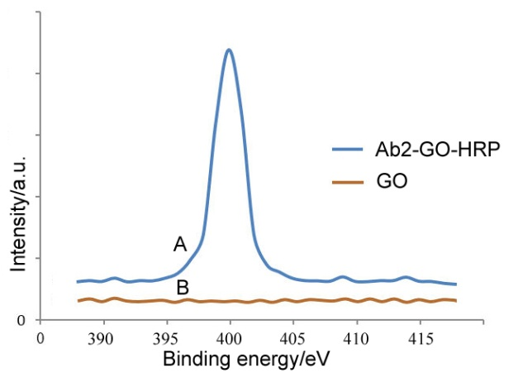
Fig. S1. XPS measurements of N1s for Ab2-GO-HRP (A) and GO (B).
The Ab2-GO-HRP spectrum exhibits a single sharp N 1s peak centred at 399.6 eV (curve A in Fig. S1), while the spectrum of GO does not (curve B in Fig. S1). This result indicates that the dark spots originate from Ab2-GO-HRP.
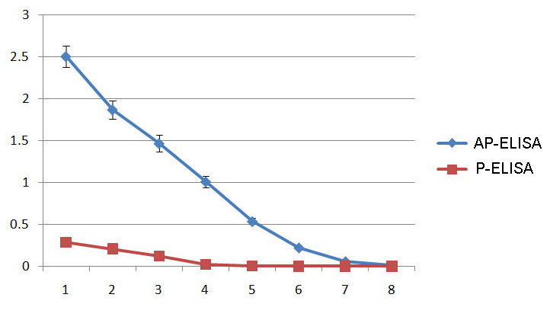
Fig. S2. The calibration curves of AP-ELISA and P-ELISA.
AFP was detected using the AP-ELISA and P-ELISA method. Each concentration in the figure was tested six times, and eight different concentrations were detected by two methods. Each concentration represents the average of six independent measurements (N = 6). The error bars represent one standard deviation from the average.

