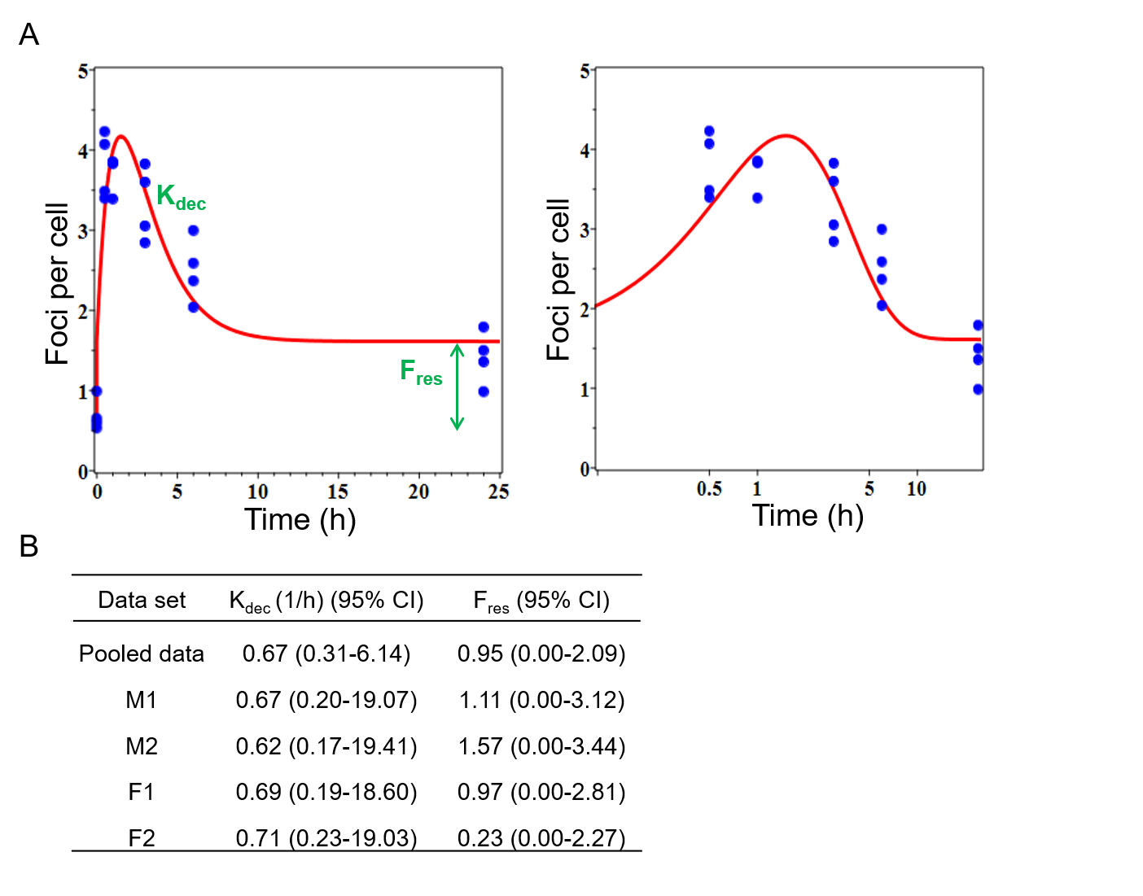
Additional File 1. Time-dependent γ-H2AX foci yields in human blood lymphocytes after 4 Gy irradiation. (A) Experimental data and model fit of γ-H2AX repair kinetics at 0.5, 1, 3, 6 and 24 h after ex vivo irradiation exposure are presented, based on foci number; the right panel is the zoomed picture for 0-12 h with a logarithmic time scale which helps to visualize early time points. (B) Each parameter of model fit of γ-H2AX repair kinetics was shown. K_{dec} is the constant for decay of γ-H2AX foci after irradiation. F_{res} is the residual value remaining at long times after irradiation.

