a
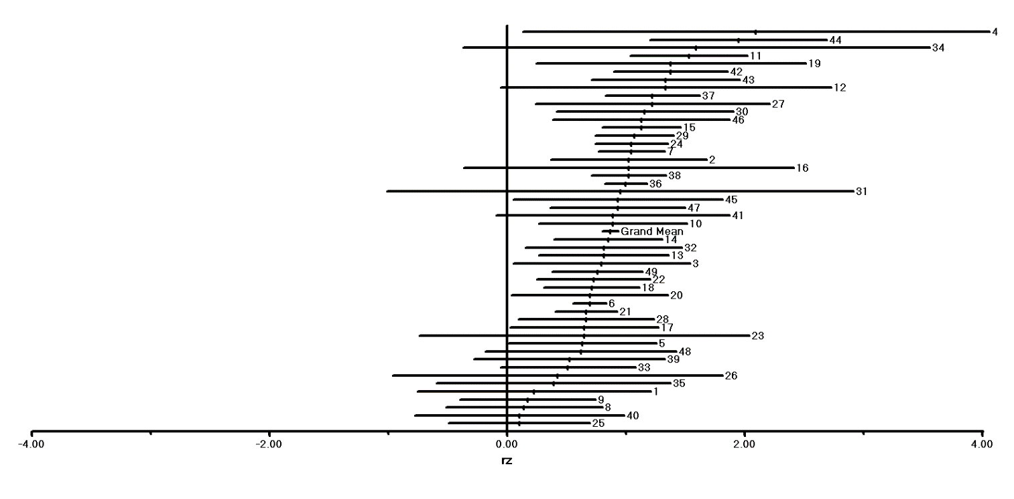

b
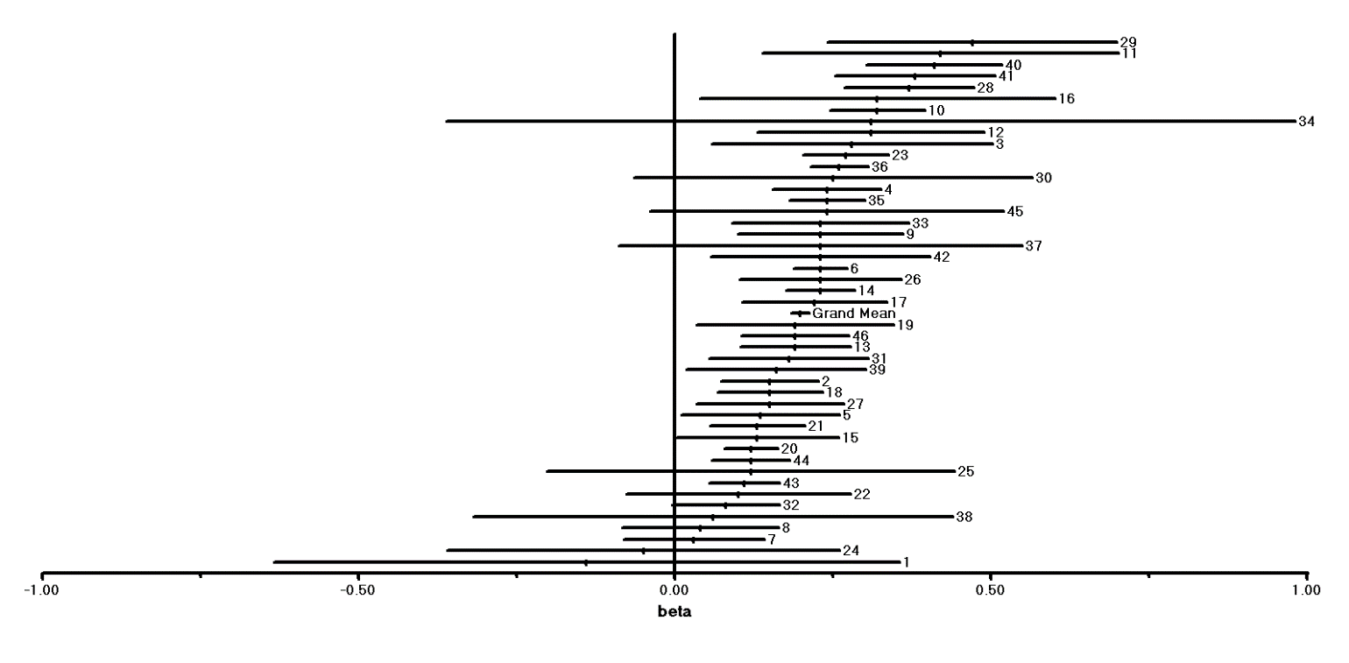
Fig. S1 Forest plot for the fit (a) and the slope value (b) of the SAR in urban green areas. Numbers indicate studies listed below. Effect sizes with confidence intervals (95%) are depicted.

