Supplementary Material
Table S1. Effect of E. faecium on alpha diversity of microbial community in colonic content of piglets challenged with ETEC K88
 | -ETEC |  |  | +ETEC |  |  | P-value
 | CON | PRO |  | CON | PRO |  | PRO | ETEC | PRO×ETEC
Observed-species | 505.17±24.98 | 502.50±21.53 |  | 482.83±25.60 | 493.83±24.93 |  | 0.87 | 0.53 | 0.78
Shannon | 5.97±0.16 | 5.73±0.24 |  | 5.90±0.21 | 5.59±0.18 |  | 0.19 | 0.62 | 0.86
Chao1 | 541.10±27.70 | 530.41±19.46 |  | 514.85±25.45 | 536.56±23.34 |  | 0.82 | 0.68 | 0.51
PD whole tree | 31.40±1.58 | 31.42±1.09 |  | 29.58±1.43 | 30.28±1.37 |  | 0.79 | 0.29 | 0.81
Data are presented as means ± SE (n = 6).
-ETEC, infusing the essential medium; +ETEC, infusing the Escherichia coli; CON, control group; PRO, Enterococcus faecium-supplemented group.
Table S2. Effect of E. faecium on the relative abundance for the top 30 most abundant genera in the colon of piglets challenged with ETEC K88
 | -ETEC |  |  |  | +ETEC |  |  | P-value
 | CON | PRO |  |  | CON | PRO |  | PRO | ETEC | PRO×ETEC
Fusobacterium | 10.91±4.57 | 8.81±5.36 |  |  | 14.68±5.04 | 8.96±6.95 |  | 0.11 | 0.97 | 0.64
Escherichia-Shigella | 9.99±3.86^{ab} | 8.38±2.03^{b} |  |  | 15.38±1.26ª | 14.45±3.10^{ab} |  | 0.69 | 0.02 | 0.84
Prevotella_2 | 7.38±2.13 | 7.74±2.92 |  |  | 14.06±3.46 | 4.88±1.07 |  | 0.32 | 0.29 | 0.42
Bacteroides | 8.14±1.97 | 7.61±3.12 |  |  | 5.19±1.19 | 5.14±2.01 |  | 0.40 | 0.34 | 0.80
Alloprevotella | 5.99±1.67 | 4.88±1.04 |  |  | 7.08±1.99 | 4.04±0.96 |  | 0.32 | 0.82 | 0.48
Butyricimonas | 1.66±0.44 | 1.81±0.52 |  |  | 4.44±1.32 | 1.68±0.41 |  | 0.18 | 0.14 | 0.10
Rikenellaceae_RC9_gut_group | 3.49±0.85 | 4.41±0.77 |  |  | 3.49±0.74 | 4.14±1.42 |  | 0.46 | 0.70 | 0.58
Lachnoclostridium | 4.86±1.23ª | 2.63±0.46^{ab} |  |  | 1.99±0.45^{b} | 2.23±0.68^{b} |  | 0.26 | 0.02 | 0.28
Prevotellaceae_UCG-003 | 1.24±1.11 | 1.49±1.25 |  |  | 0.57±0.24 | 0.80±0.42 |  | 0.87 | 0.56 | 0.89
Ruminococcaceae_UCG-002 | 1.90±0.95 | 1.55±0.66 |  |  | 1.44±0.52 | 1.44±0.65 |  | 0.95 | 0.83 | 0.92
Prevotellaceae_NK3B31_group | 1.30±0.88^{b} | 0.74±0.16^{ab} |  |  | 1.76±0.23ª | 1.70±0.79^{ab} |  | 0.95 | 0.05 | 0.32
Actinobacillus | 2.49±0.96 | 1.17±0.21 |  |  | 0.97±0.39 | 0.86±0.37 |  | 0.89 | 0.29 | 0.63
Tyzzerella | 0.14±0.07 | 0.22±0.10 |  |  | 1.50±0.90 | 0.15±0.08 |  | 0.57 | 0.57 | 0.31
Parabacteroides | 3.13±0.45 | 1.91±0.61 |  |  | 1.86±0.42 | 1.39±0.41 |  | 0.06 | 0.10 | 0.63
Alistipes | 1.47±0.62 | 1.23±0.49 |  |  | 1.60±0.51 | 0.76±0.21 |  | 0.17 | 0.68 | 0.32
Eubacterium_coprostanoligenes_group | 0.91±0.54 | 0.77±0.47 |  |  | 1.08±0.66 | 0.52±0.23 |  | 0.91 | 0.95 | 0.77
p-1088-a5_gut_group | 0.04±0.02 | 0.69±0.64 |  |  | 0.06±0.04 | 0.12±0.07 |  | 0.26 | 0.12 | 0.70
Ruminococcaceae_NK4A214_group | 1.75±0.53 | 1.35±0.13 |  |  | 1.04±0.35 | 1.05±0.36 |  | 0.89 | 0.07 | 0.97
Pasteurella | 0.73±0.49 | 0.59±0.46 |  |  | 0.18±0.07 | 0.20±0.10 |  | 0.99 | 0.35 | 0.85
Lactobacillus | 1.44±0.33 | 1.30±0.35 |  |  | 0.44±0.22 | 1.44±0.44 |  | 0.16 | 0.08 | 0.11
Anaerotruncus | 0.40±0.13 | 0.14±0.03 |  |  | 0.55±0.42 | 0.12±0.03 |  | 0.15 | 0.45 | 0.64
Oscillospira | 0.69±0.17 | 0.73±0.15 |  |  | 0.76±0.13 | 0.75±0.36 |  | 0.52 | 0.73 | 0.39
unidentified_Ruminococcaceae | 0.78±0.32 | 0.45±0.14 |  |  | 0.40±0.14 | 0.76±0.36 |  | 0.92 | 0.66 | 0.23
Bilophila | 0.87±0.33ª | 0.17±0.05^{b} |  |  | 0.27±0.09^{ab} | 0.24±0.08^{b} |  | 0.04 | 0.29 | 0.22
Desulfovibrio | 0.89±0.28 | 0.90±0.21 |  |  | 0.74±0.16 | 0.93±0.13 |  | 0.37 | 0.93 | 0.57
Eisenbergiella | 0.23±0.05 | 0.21±0.09 |  |  | 0.34±0.13 | 0.58±0.33 |  | 0.80 | 0.44 | 0.49
Odoribacter | 0.26±0.12 | 0.09±0.05 |  |  | 0.62±0.33 | 0.24±0.07 |  | 0.28 | 0.15 | 0.41
Ruminococcaceae_UCG-005 | 0.21±0.07 | 0.47±0.30 |  |  | 0.38±0.18 | 0.40±0.19 |  | 0.74 | 0.87 | 0.86
Victivallis | 0.44±0.30 | 0.20±0.09 |  |  | 0.03±0.01 | 0.22±0.13 |  | 0.19 | 0.11 | 0.25
Prevotella_7 | 0.04±0.03 | 0.37±0.28 |  |  | 0.00±0.00 | 0.03±0.03 |  | 0.18 | 0.08 | 0.35
Data are presented as means ± SE (n = 6).
-ETEC, infusing the essential medium; +ETEC, infusing the Escherichia coli; CON, control group; PRO, Enterococcus faecium-supplemented group.
^{a, b} Means within a row with different superscripts are significantly different (P < 0.05)
Table S3. Effect of E. faecium on short chain fatty acid concentrations of piglets challenged with ETEC K88
 | -ETEC |  |  | +ETEC |  |  | P-value
 | CON | PRO |  | CON | PRO |  | PRO | ETEC | PRO×ETEC
Acetate, mg/g | 0.61±0.07 | 0.59±0.05 |  | 0.73±0.09 | 0.61±0.12 |  | 0.39 | 0.39 | 0.58
Propionic acid, mg/g | 0.25±0.03 | 0.23±0.04 |  | 0.33±0.05 | 0.21±0.04 |  | 0.15 | 0.27 | 0.32
Butyric acid, mg/g | 0.11±0.02 | 0.09±0.02 |  | 0.14±0.02 | 0.09±0.03 |  | 0.20 | 0.27 | 0.71
Data are presented as means ± SE (n = 8).
-ETEC, infusing the essential medium; +ETEC, infusing the Escherichia coli; CON, control group; PRO, Enterococcus faecium-supplemented group.

Figure S1. The experimental design of the different treatments and procedures.

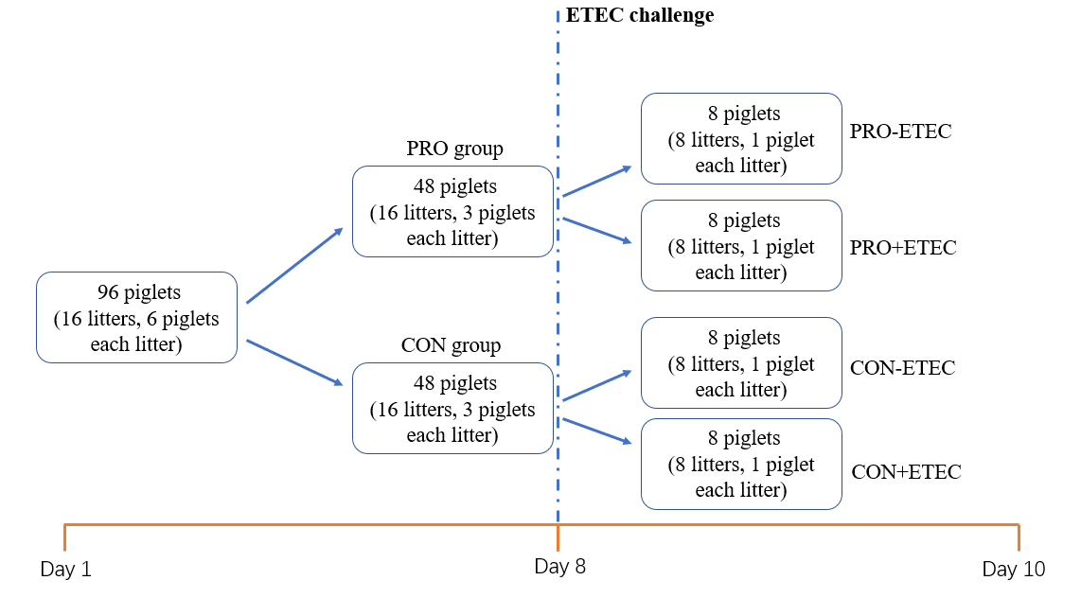
Day 1-7: treatment with E. faecium for one week
Day 8: ETEC challenge only at day 8
Day 10: tissue sample collection

Figure S2. Comparison of the gut microbiota composition among four groups. Principal coordinate analysis to visualize the unweighted UniFrac distances of colon digesta samples from individual piglet.
C.ETEC: CON+ETEC; C: CON-ETEC; P.ETEC: PRO+ETEC; P: PRO-ETEC.

