Additional file 2

Transcriptome Profile of Corynebacterium pseudotuberculosis in Response to Iron Limitation

Izabela Coimbra Ibraim¹, Mariana Teixeira Dornelles Parise¹, Doglas Parise¹, Michelle Zibetti Tadra Sfeir², Thiago Luiz de Paula Castro³, Alice Rebecca Wattan⁴, Preetam Ghosh⁵, Debmalya Barh¹, Emannuel Maltempi Souza², Aristóteles Góes-Neto⁶, Anne Cybelle Pinto Gomide^{a1}, Vasco Azevedo^{a1*}

Corresponding Author: Dr. Vasco Azevedo - vasco@icb.ufmg.br

Table of Contents:

Figure S2. Effect of iron depletion on the growth curve and growth rate of C. pseudotuberculosis wild-type T1 strain and Cp13 mutant

Figure S3. Effects of ethanol on bacterial growth

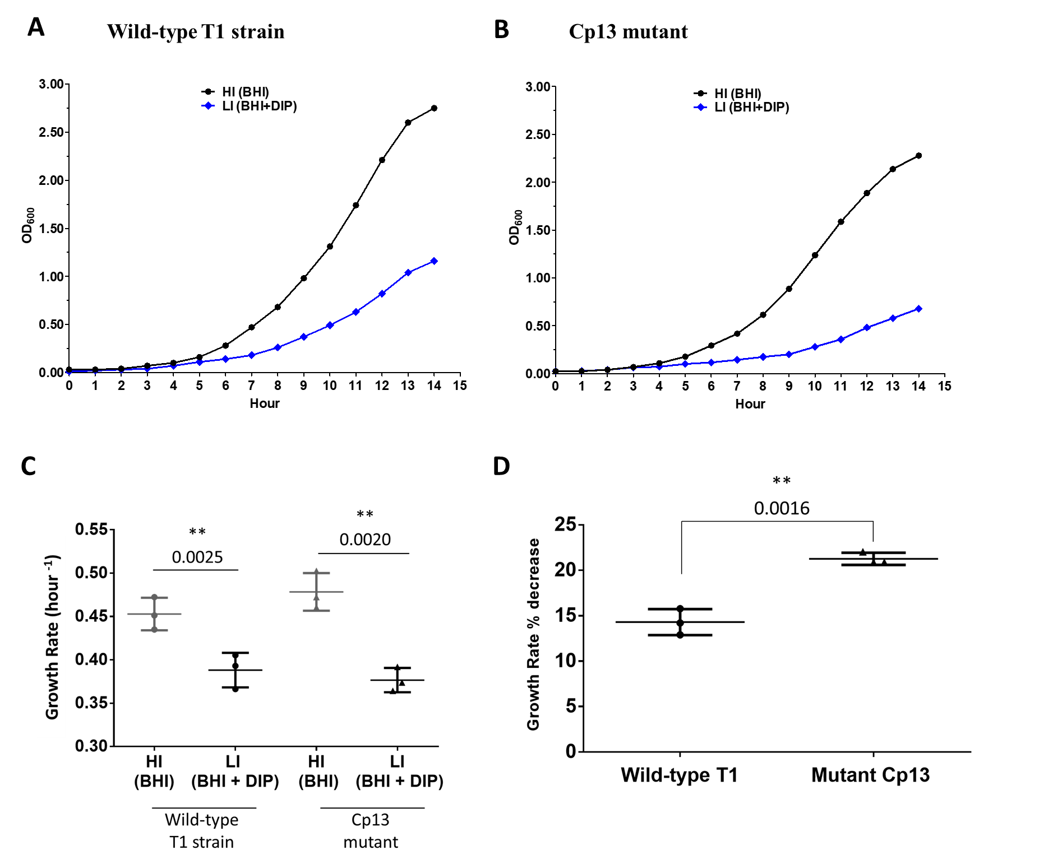
Figure S2. Effect of iron depletion on the growth curve and growth rate of C. pseudotuberculosis wild-type T1 strain and Cp13 mutant. Cultures of the (A) wild-type T1 strain and the (B) Cp13 mutant were cultivated at 37°C in BHI broth (HI – high iron) and BHI broth treated with 250 µM 2,2-dipyridyl (DIP) (LI -low iron). Growth proliferation was measured hourly by optical density for 14 hours at 600nm. For ease of interpretation, data is plotted on a linear scale. (C) Log rate plots of OD 600 for the wild-type T1 and Cp13 mutant were calculated using the growth rate equation: $Growth rate=(2.303*\left(\log_{10}{ODf}\right)- (\log_{10}{ODi}))/(T_{final}- T_{initial})$, where OD_{i} represents the optical density (OD₆₀₀) at the start of the incubation period (t=0) and OD_{f} is the OD₆₀₀ value at the final incubation time (t= 6h30) in BHI medium, with and without 250 µM 2,2-dipyridyl (DIP). Horizontal lines indicate the mean of 3 individual assays and vertical lines standard deviation (sd) from mean. Statistical analysis using a paired t-test confirmed that iron limitation induced a significant effect on the growth rate of the Cp13 (p value = 0.0020) and T1 strains (p value = 0.0025). No difference was observed when analyzing HI and LI samples between the strains (student t-test, p value > 0.05). (D) Limited iron availability induced an average decrease of 21.3% in the growth rate of the Cp13 mutant and 14.3% mean average decrease in the wild-type T1 strain.

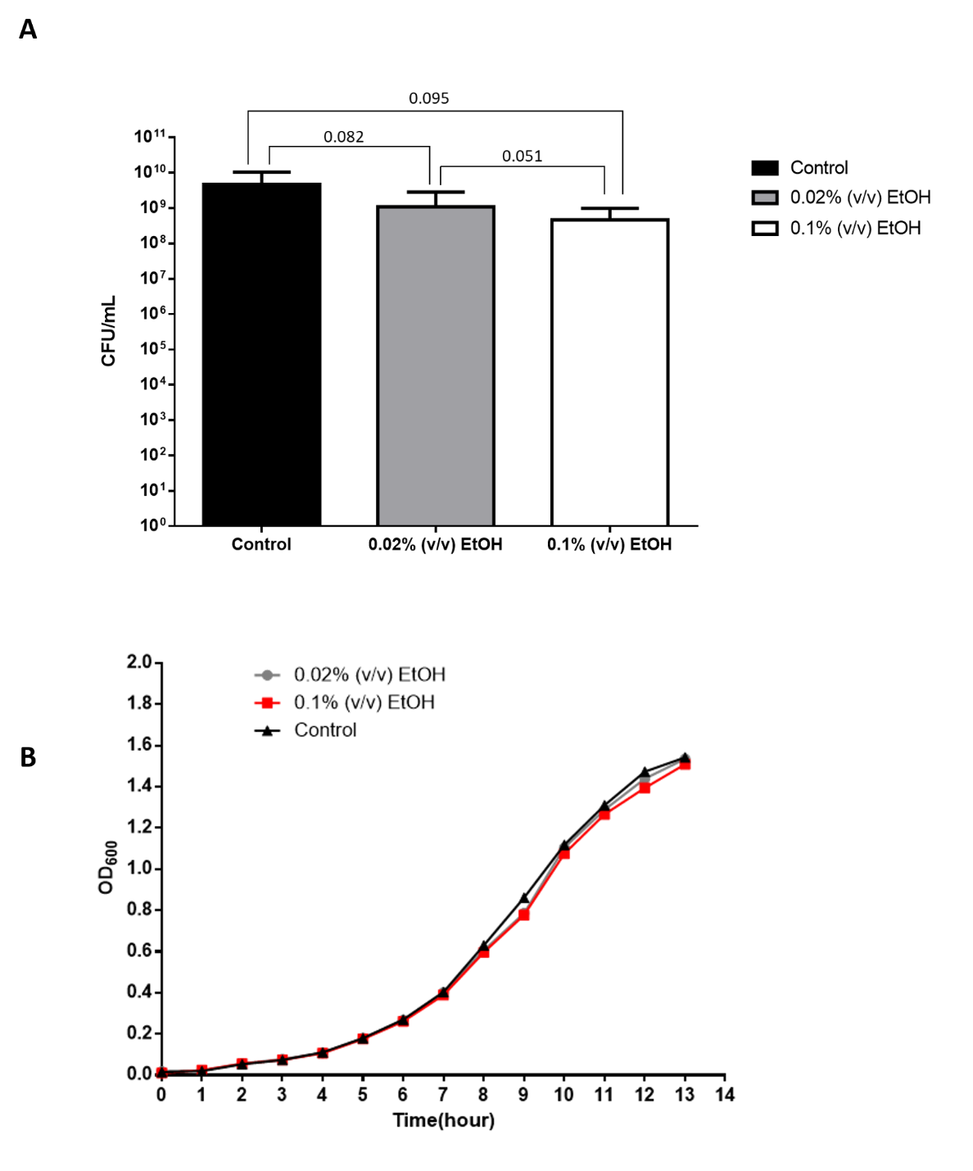

Figure S3. Effects of ethanol on bacterial growth. (A) The effects of ethanol on the growth of the C. pseudotuberculosis Cp13 strain was measured by determining the number of CFU/mL after 13 hours of incubation in BHI control medium and BHI media supplemented with 0,02% and 0,1% of ethanol (v/v). No significant difference was observed between the CFU counts of control and ethanol supplemented cultures (p > 0.05). (B) growth proliferation was measured hourly by optical density for 13 hours at 600nm in control, 0.02% and 0.01% of ethanol cultures.

