Supplement:

Figure S1: Nchelenge District sampled and enumerated households from April 2012 – July 2017. Taken with permission from Hast, M.A., et al. (2019). "The impact of three years of targeted IRS with pirimiphos-methyl on malaria parasite prevalence in a high-transmission area of northern Zambia." *The American Journal of Epidemiology.*

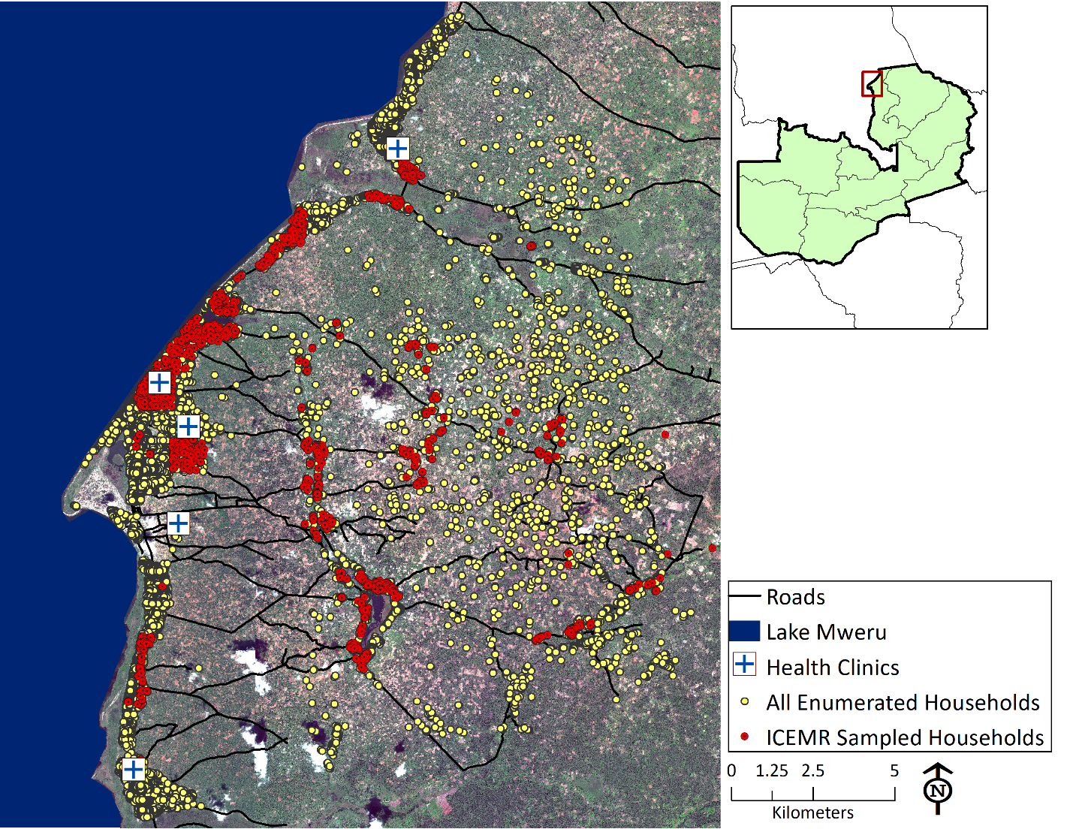

Figure S2: Histograms of total distance traveled in km and average daily distance traveled in km per participant, for overall time and peak biting time

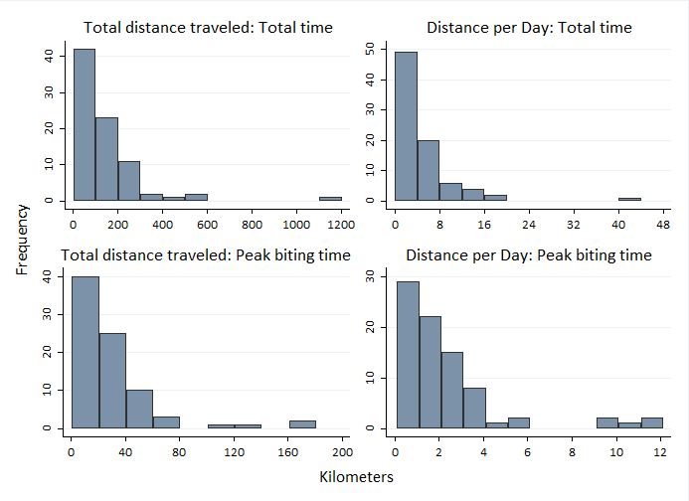

Figure S3: All GPS data logger points recorded from August 2014 to July 2015 in Nchelenge District overlaid on a malaria risk map of the study area

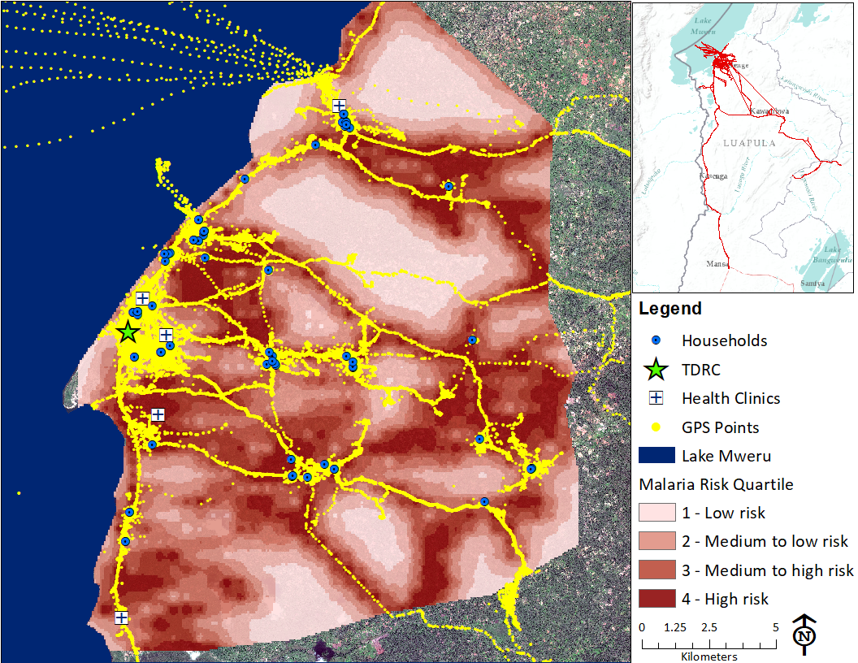

Figure S4: Boxplots of calculated average nightly malaria risk score by participant for A) peak biting times (*overall nightly risk*) and B) time spent away from home during peak biting times (*outdoor nightly risk*) by PCR status at visits 1 and 2



B

A