Additional Figures and Tables
Table S1. Summary of results for liquid growth (generation time), solid growth (final colony diameter), and biofilm formation. Generation time results are shown from fastest to slowest growing strain. All other results are shown from highest to lowest value.
Isolate | Liquid culture |  | Solid culture | Biofilm
 | Generation time  (fastest to slowest) |  | Colony diameter at 48 hpi
WSU002 | F | WSU002 | ATCC 33701 | UKVDL206
WSU003 | F | WSU003 | WSU004 | 103S-GFP
WSU005 | F | WSU005 | ATCC 33701 pc | 103+
WSU001 | MF | WSU001 | WSU002 | WSU002
WSU004 | MF | WSU004 | WSU005 | WSU004
WSU007 | MF | WSU007 | WSU007 | WSU001
103+ | MS | 103+ | WSU001 | ATCC 33701
UKVDL206 | MS | UKVDL206 | WSU003 | WSU003
ATCC 33701 | MS | ATCC 33701 | WSU006 | WSU007
ATCC 33701 pc | MS | ATCC 33701 pc | UKVDL206 | ATCC 33701 pc
WSU006 | S | WSU006 | 103+ | WSU005
103S-GFP | S | 103S-GFP | 103S-GFP | WSU006
F: fast-growing, MF: moderate-fast-growing, MS: moderate-slow-growing, S: slow-growing

Table S2. Significant differences observed between strains in liquid growth over time
 | 103+ | 103S-GFP | 33701 | 33701 pc | UKVDL206 | WSU001 | WSU002 | WSU003 | WSU004 | WSU005 | WSU006 | WSU007
103+ |  |  | 24, 40 | 16 |  | 16, 24 | 40 | 16 | 16
103S-GFP |  |  |  |  | 12, 40 |  |  | 12 | 12, 16 |  | 24, 40 | 24, 40
33701 |  |  |  | 16 | 24, 40 | 40 |  | 40 | 16, 40 | 40 | 24, 40 | 24, 40
33701 pc |  |  |  |  | 16 |  |  |  | 16 |  | 12 | 12, 16
UKVDL206 |  |  |  |  |  | 16, 24 | 8, 40 |  | 16 | 24 | 12 | 8, 12
WSU001 |  |  |  |  |  |  |  |  | 16 |  | 12, 24 | 12, 24
WSU002 |  |  |  |  |  |  |  | 12 | 16 |  | 40 | 40
WSU003 |  |  |  |  |  |  |  |  | 16 |  | 12, 40 | 12, 40
WSU004 |  |  |  |  |  |  |  |  |  | 16 | 12, 16, 24, 40 | 12, 16, 24
WSU005 |  |  |  |  |  |  |  |  |  |  | 12, 24 | 12, 24
WSU006
WSU007
Numbers signify time point at which a significant difference was observed, P<0.05
Underlined indicates the isolate in the top row possessed the larger value at the specified time point

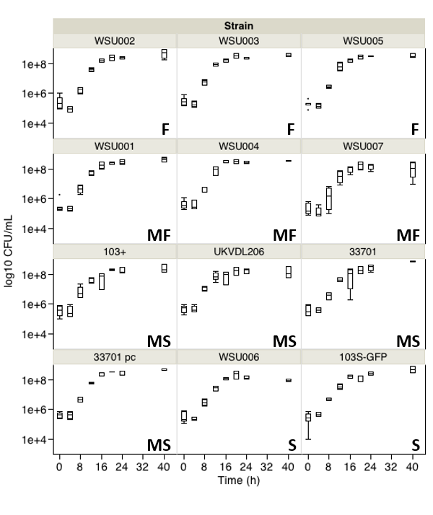
Figure S1. Growth profiles of R. equi strains over time grown in BHI broth at 37ºC with 100 rpm shaking. (F: Fast-growing; MF: Moderate-fast; MS: Moderate-slow; S: Slow. Error bars represent SEM.)
Figure S2. Discrete R. equi colony sizes (mm) for 12 strains over time grown on BHI agar plates incubated 37ºC for 48 h. (Error bars represent SEM.)

