Supplementary Figures

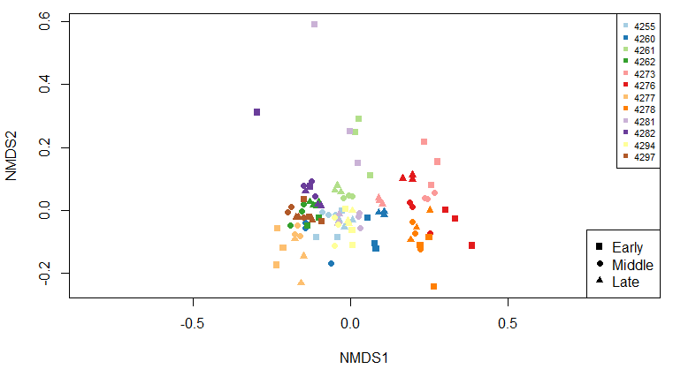Figure S1. Non-metric multidimensional scaling (NMDS) plot of the liquid fraction samples. Distances were calculated using the Bray-Curtis dissimilarity index in the vegan package in R. Points were plotted based on subject and period of lactation.

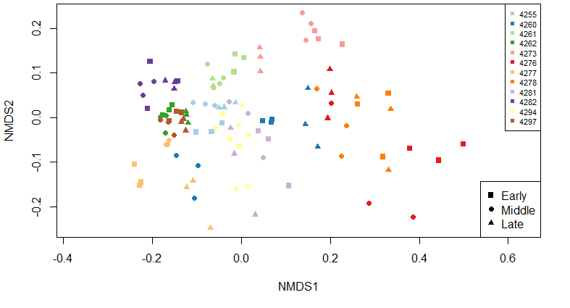
Figure S2. NMDS plot of the solid fraction samples. Distances were calculated using the Bray-Curtis dissimilarity index in the vegan package in R. Points were plotted based on subject and period of lactation.

