Additional Information: Experiments on textile swatches stained with copper oxohydroxide solution

Cellulosic (cotton, linen, hemp) and proteinaceous (silk, wool) textiles swatches measuring 10x10cm were immersed in a 100ml of 1M CuSO₄ solution (pH~6.5) for 10mins and subsequently immersed in a 100ml solution of 0.05M NaOH (pH~12.5) for 5mins, and finally rinsed with softened water for 5mins (Fig. 1). Three sets of swatches were used for each different fibre. The swatches were treated with sodium hydroxide after having been immersed in the metal solution for the metal ions to react to metal hydroxides. They were rinsed to remove loosely bound material (Fig. 2). The method was repeated twice to ensure the results were reproducible. Swatches were allowed to air dry and equilibrated for 24hrs under ambient conditions before further assessment and sampling.

Figure S1: The staining experiments in progress.
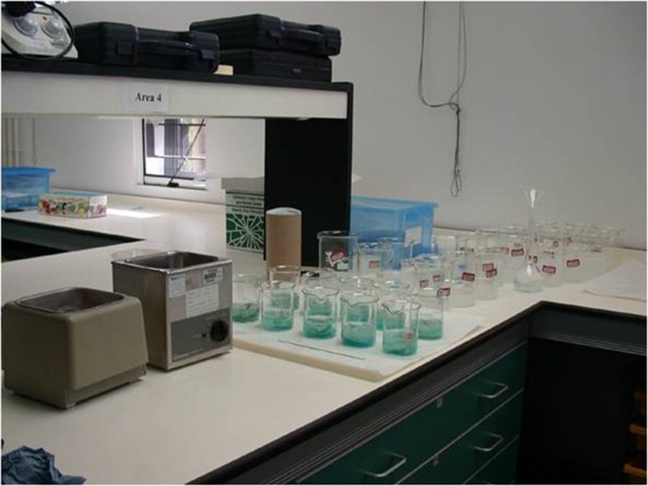
Figure S2: An example of a cotton swatch after staining.
