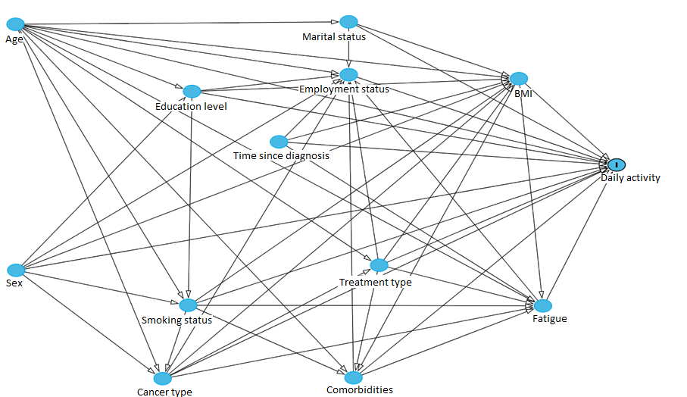
Additional file 1: Figure S1. Directed acyclic graph (DAG) visualizing potential confounders of the association between demographic and clinical characteristics and daily activity

