Supplemental Information

Exosomes released from neural progenitor cells and induced neural progenitor cells regulate neurogenesis through miR-21a

Yizhao Ma, Chunhong Li, Yunlong Huang, Xiaohuan Xia, Jialin C. Zheng

Supplemental Materials
Supplementa Figure 1
Supplemental Figure 2
Supplemental Figure 3
Supplemental Figure 4
Supplemental Figure 5
Supplemental Figure 6
Supplemental Table 1

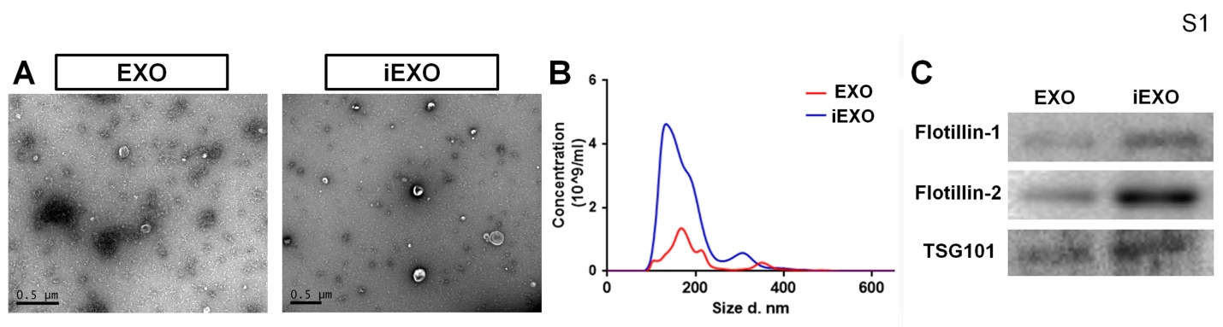
Figure S1. Characterization of exsomes released from NPCs and iNPCs.
(A) Exosomes were isolated from supernatants culture with NPCs and iNPCs for 12 h and observed under Transmission electron microscopy (TEM) using negative staining. (B) The size of exosomes derived from NPCs/iNPCs was assessed by NTA analysis. (C) Protein lysates were prepared from NPCs- and iNPCs-derived exomes. The levels of exosome markers Flotillin-1, Flotillin-2, and HSP70 were determined by Western blots. Scale bar, 500 nm (A). Experiments were carried out three times in triplicates.

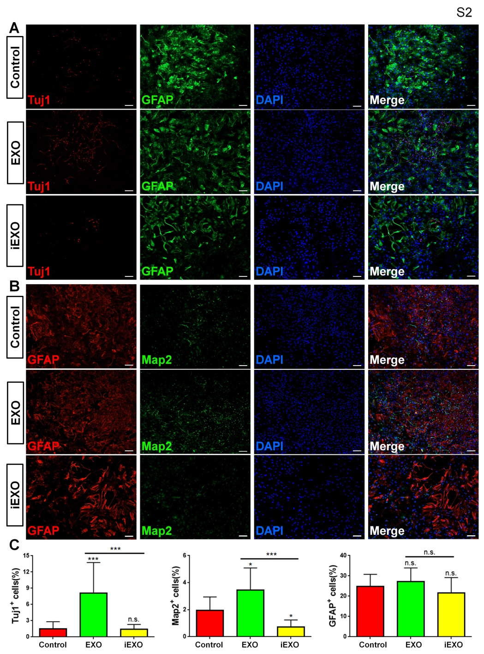
Figure S2. Effects of EXOs/iEXOs on long-term differentiation of NPCs.
(A) Representative immunofluorescent images showing expression of Tuj1 (in red), GFAP (in green) and DAPI (in blue) in NPCs cultured in differentiation conditions for 14 days. (B) Representative immunofluorescent images showing expression of GFAP (in red), Map2 (in green) and DAPI (in blue) in NPCs cultured in differentiation conditions for 14 days. (C) Quantification of Tuj1⁺/Map2⁺/GFAP⁠⁺ cells (as a percentage of total cells) in the culture. Scale bar, 100 μm (A, B). Data are mean ± SD. ∗∗∗p < 0.001 and ∗p < 0.05. n.s. denotes no significance. Experiments were carried out three times in triplicates.
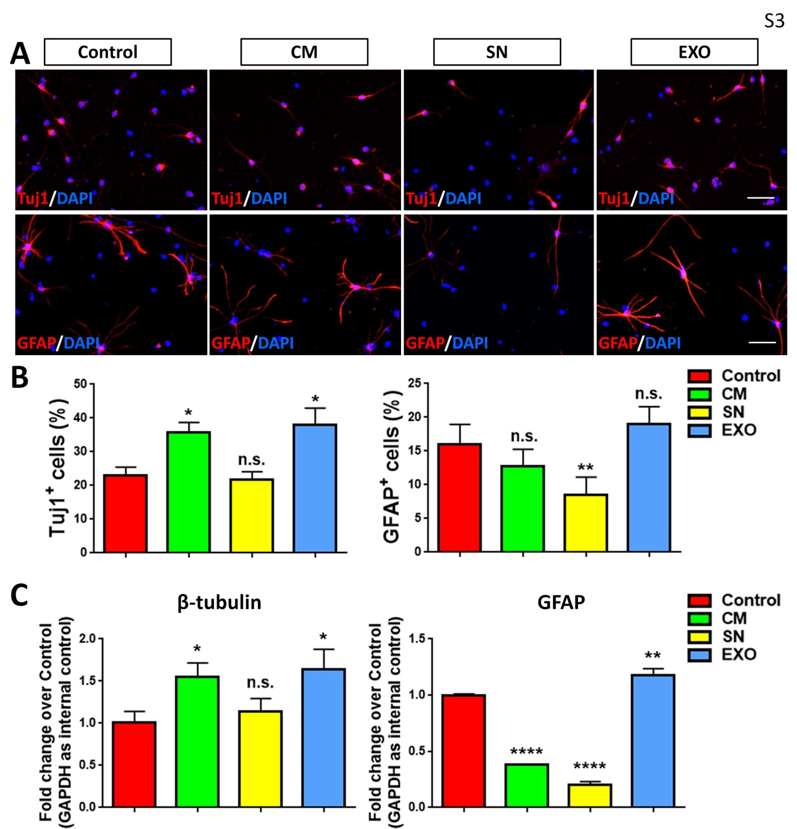
Figure S3. Exosomes are the key components of conditioned medium on neuronal differentiation regulation.
(A) Representative immunofluorescent images showing expression of Tuj1 and GFAP in NPCs cultured in defined conditions for differentiation. (B) Quantification of Tuj1⁺ and GFAP⁠⁺ cells (as a percentage of total cells) in the culture. (C) The transcript expression of β-tubulin and GFAP was determined by qPCR analysis. Scale bar, 50 μm (A). Data are mean ± SD. ∗∗∗∗p < 0.0001, ∗∗p < 0.01 and ∗p < 0.05. n.s. denotes no significance. Experiments were carried out three times in triplicates. CM, conditioned medium; SN, exosome-free supernatant; EXO, exosomes.
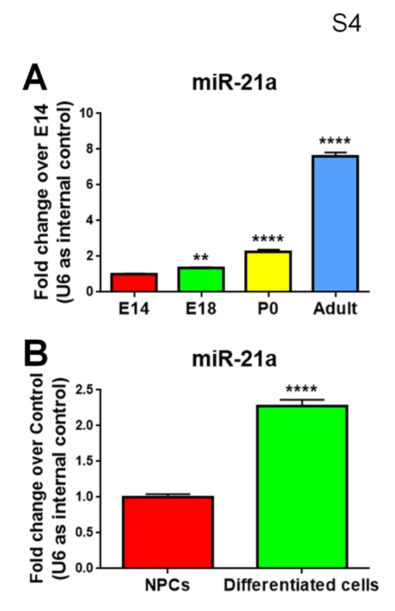
Figure S4. Temporal expression patterns of miR-21a in vivo and in vitro.
(A) qPCR analysis of miR-21a expression patterns during brain development. (B) qPCR analysis of miR-21a expression levels in NPCs and differentiated cells. Data are mean ± SD. ∗∗∗∗p < 0.0001, ∗∗p < 0.01. Experiments were carried out three times in triplicates.

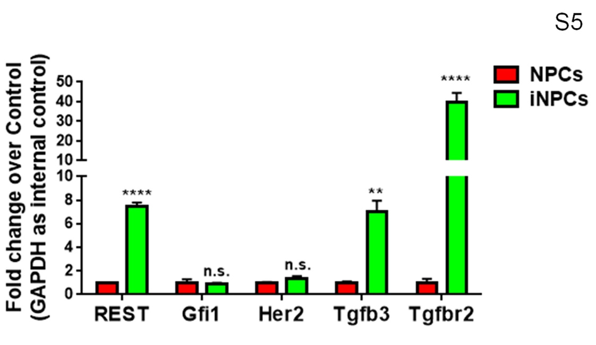
Figure S5. Expression of miR-21 up-stream regulators.
qPCR analysis of candidate miR-21a up-stream regulators in NPCs and iNPCs. Data are mean ± SD. ∗∗∗∗p < 0.0001, ∗∗p < 0.01. n.s. denotes no significance. Experiments were carried out three times in triplicates.

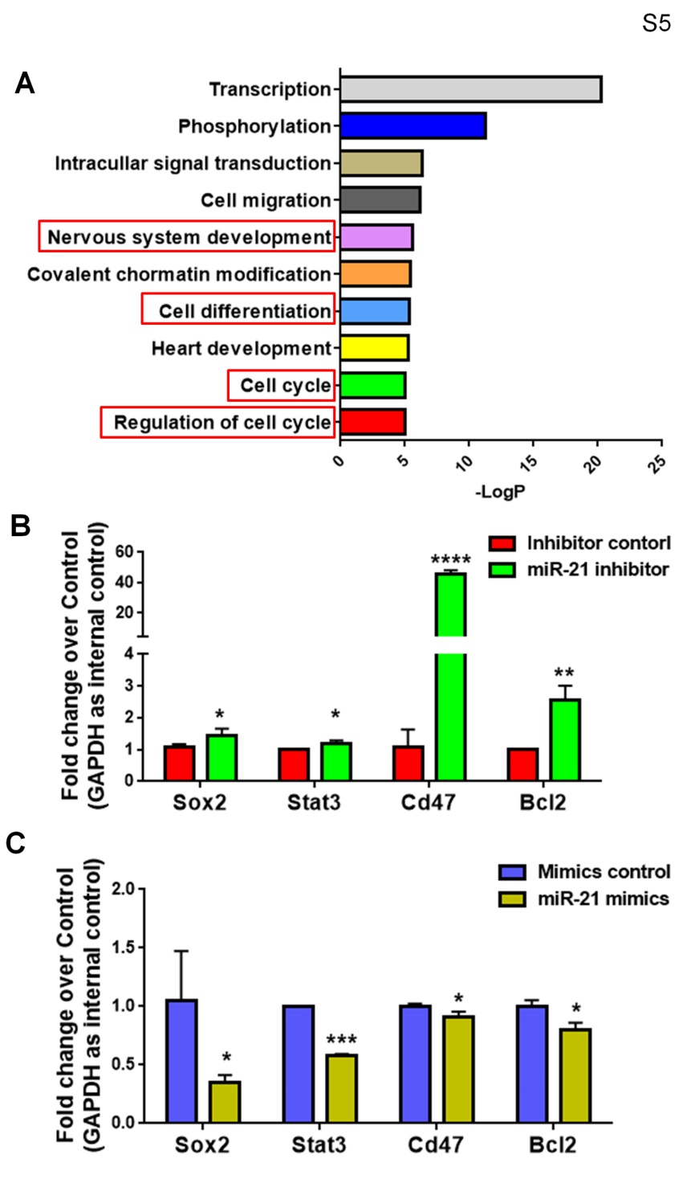
Figure S6. miR-21a targets prediction.
(A) The GO analysis of top 10 enriched biological processes in the predicted miR-21a target genes. (B, C) qPCR analysis of candidate miR-21a target genes in the miR-21a LOF (B) and GOF (C) groups, compared to their respective controls. Data are mean ± SD. ∗∗∗∗p < 0.0001, ∗∗∗p < 0.001, ∗∗p < 0.01, and ∗p < 0.05. Experiments were carried out three times in triplicates for in vitro perturbation.

Gene | Sequence | Size(bp) | Tº | Accession N.
β-tubulin  (Tuj1) | 5’-CTTTATCTTCGGTCAGAGTGGTGC-3’  5’-TTCTTTCCGCACGACATCTAGG-3’ | 103 | 57 | NM_023279.2
Bcl2 | 5’-CTGGCATCTTCTCCTTCCAGC-3’  5’-ACCTACCCAGCCTCCGTTATC-3’ | 446 | 56 | NM_177410.3
Cd47 | 5’-AGGGGCAAACGTTTCAGGGG-3’  5’-GCAAAGCTGCTGGCAACCTG-3’ | 192 | 57 | NM_010581.3
Her2 | 5’-CTTCGGGTCATTCGGGGACG-3’  5’-CCACGGGCACACAGTGAGTT-3’ | 272 | 57 | NM_001003817.1
GAPDH | 5’-CATGTTCCAGTATGACTCCACTC-3’  5’-GGCCTCACCCCATTTGATGT-3’ | 136 | 60 | NM_001289726.1
GFAP | 5’-TTGCTGGAGGGCGAAGAAAA-3’  5’-CATCCCGCATCTCCACAGTC-3’ | 148 | 57 | NM_010277.3
Gfi1 | 5’-CATCCACTCGGACACTCGGC-3’  5’-CCCTTGGTGCACAGCTCACA-3’ | 216 | 57 | NM_008114.3
REST | 5’-GTGCGAACTCACACAGGAGA-3’  5’-AAGAGGTTTAGGCCCGTTGT-3’ | 201 | 52 | NM_011263.2
Sox2 | 5’-AGTCTCCAAGCGACGAAAAA-3’  5’-GCAAGAAGCCTCTCCTTGAA-3’ | 141 | 57 | NM_003106
Stat3 | 5’-CCCCGTACCTGAAGACCAAG-3’  5’-TCCTCACATGGGGGAGGTAG-3’ | 159 | 57 | NM_011486.5
Tgfb3 | 5’-AGAGGGCCCTGGACACCAAT-3’  5’-CTGCGGAGGTATGGGCAAGG-3’ | 163 | 57 | NM_009368.3
Tgfbr2 | 5’-TGCCGCTTCTCCCAAGTGTG-3’  5’-TCGGGACTGCTGGTGGTGTA-3’ | 132 | 57 | NM_009371.3
miRNA
Universal primer | 5’-GAATCGAGCACCAGTTACGC-3’
U6 | 5’-TGGCCCCTGCGCAAGGATG-3’ |  | 55
let-7b | 5’-TGAGGTAGTAGGTTGTGTGGTT-3’ |  | 55 | MIMAT0000522
let-7c | 5’-TGAGGTAGTAGGTTGTATGGTT-3’ |  | 55 | MIMAT0000776
let-7i | 5’-TGAGGTAGTAGTTTGTGCTGTT-3’ |  | 55 | MIMAT0000415
miR-10b | 5’-TACCCTGTAGAACCGAATTTGTG-3’ |  | 55 | MIMAT0000208
miR-10b* | 5’-CAGATTCGATTCTAGGGGAATA-3’ |  | 55 | MIMAT0004538
miR-127 | 5’- TCGGATCCGTCTGAGCTTGGCT-3’ |  | 55 | MIMAT0000139
miR-143 | 5’-TGAGATGAAGCACTGTAGCTC-3’ |  | 55 | MIMAT0000247
miR-145a | 5’-GTCCAGTTTTCCCAGGAATCCCT-3’ |  | 55 | MIMAT0000157
miR-146a | 5’-TGAGAACTGAATTCCATGGGTT-3’ |  | 55 | MIMAT0000158
miR-182 | 5’-TTTGGCAATGGTAGAACTCACACCG-3’ |  | 55 | MIMAT0000211
miR-183 | 5’-TATGGCACTGGTAGAATTCACT-3’ |  | 55 | MIMAT0000212
miR-195a | 5’-TAGCAGCACAGAAATATTGGC-3’ |  | 55 | MIMAT0000225
miR-21a | 5’-TAGCTTATCAGACTGATGTTGA-3’ |  | 55 | MIMAT0000530
miR-214* | 5’-TGCCTGTCTACACTTGCTGTGC-3’ |  | 55 | MIMAT0004664
miR-219a-2 | 5’-AGAATTGTGGCTGGACATCTGT-3’ |  | 55 | MIMAT0022841
miR-23b | 5’-ATCACATTGCCAGGGATTACC-3’ |  | 55 | MIMAT0000125
miR-30a | 5’-TGTAAACATCCTCGACTGGAAG-3’ |  | 55 | MIMAT0000128
miR-335 | 5’-TCAAGAGCAATAACGAAAAATGT-3’ |  | 55 | MIMAT0000766
miR-34a | 5’-TGGCAGTGTCTTAGCTGGTTGT-3’ |  | 55 | MIMAT0000542
miR-34c | 5’-AGGCAGTGTAGTTAGCTGATTGC-3’ |  | 55 | MIMAT0000381
miR-340 | 5’-TTATAAAGCAATGAGACTGATT-3’ |  | 55 | MIMAT0004651
miR-3473b | 5’-GGGCTGGAGAGATGGCTCAG-3’ |  | 55 | MIMAT0020367
miR-3473e | 5’- GGGCTGGAGAGATGGCTCGTA-3’ |  | 55 | MIMAT0025587
miR-370 | 5’-GCCTGCTGGGGTGGAACCTGGT-3’ |  | 55 | MIMAT0001095
miR-375 | 5’-TTTGTTCGTTCGGCTCGCGTGA-3’ |  | 55 | MIMAT0000739
miR-409 | 5’-GAATGTTGCTCGGTGAACCCCT-3’ |  | 55 | MIMAT0001090
miR-466i-5p | 5’-TGTGTGTGTGTGTGTGTGTG-3’ |  | 55 | MIMAT0017325
miR-6540-5p | 5’-CTAAGGCAGGCAGACTTCAGTG-3’ |  | 55 | MIMAT0025585
miR-672 | 5’-TGAGGTTGGTGTACTGTGTGTGA-3’ |  | 55 | MIMAT0003735
miR-7a | 5’-TGGAAGACTAGTGATTTTGTTGT-3’ |  | 55 | MIMAT0000677
miR-9 | 5’-TCTTTGGTTATCTAGCTGTATGA-3’ |  | 55 | MIMAT0000142
miR-9* | 5’-ATAAAGCTAGATAACCGAAAGT-3’ |  | 55 | MIMAT0000143
miR-92a | 5’-TATTGCACTTGTCCCGGCCTG-3’ |  | 55 | MIMAT0000539
miR-96 | 5’-TTTGGCACTAGCACATTTTTGCT-3’ |  | 55 | MIMAT0000541
Supplemental table 1. List of specific primers.

