Supplementary information
Materials and methods
Receiver operating characteristic (ROC) analysis was performed on SUVpeak and MATV. The discriminant power of each index was evaluated using the areas under the ROC curves (AUC). The Pearson correlations test was performed to evaluate the correlation relationship between MATV and texture features. All statistical analyses were performed using SPSS 17.0 software. P < 0.05 was considered to indicate statistical significance.
Results
The ROC analysis (Table S1, Figure S1) showed that Early SUVpeak and Delayed SUVpeak worked similar with Early SUVmax and Delayed SUVmax, and the Early MATV and Delayed MATV were not a good predictor.
The correlation coefficients of volume and texture features were calculated (Table S2 and Table S3). The Pearson correlation test showed the SUVmax and texture features are correlated with MATV on both early (standard) and delayed time point PET images (P<0.05)，but the correlations coefficients is low.
TABLES
Table S1. Area Under the ROC Curve
Variable(s) | Area
Early SUVpeak | 0.75
Early SUVmax | 0.75
Delayed SUVpeak | 0.74
Delayed SUVmax | 0.74
Early MTAV | 0.58
Delayed MTAV | 0.59

Table S2. The Pearson Correlations Coefficient of MATV and indexes on early PET images
 | Early SUVmax | Early Coarseness | Early Contrast | Early Busyness
Early MTAV | 0.396 | 0.401 | -0.514 | 0.353

Table S3. The Pearson Correlations Coefficient of MATV and indexes on delayed PET images
 | Delayed SUVmax | Delayed Coarseness | Delayed Contrast | Delayed Busyness
Delayed MTAV | 0.380 | 0.313 | -0.440 | 0.305

FIGURE
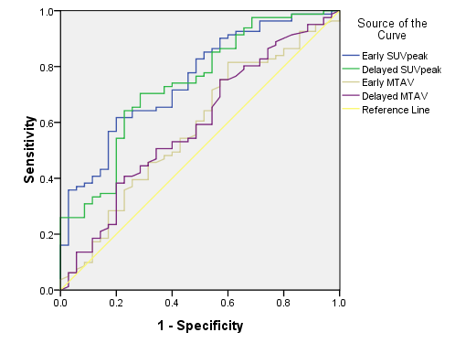
Figure S1. ROC curve of early SUVpeak, Delayed SUVpeak, Early MTAV and Delayed MTAV. The ROC analysis showed Early SUVpeak and Delayed SUVpeak worked similar with Early SUVmax and Delayed SUVmax, and the Early MATV and Delayed MATV were not a good predictor.

