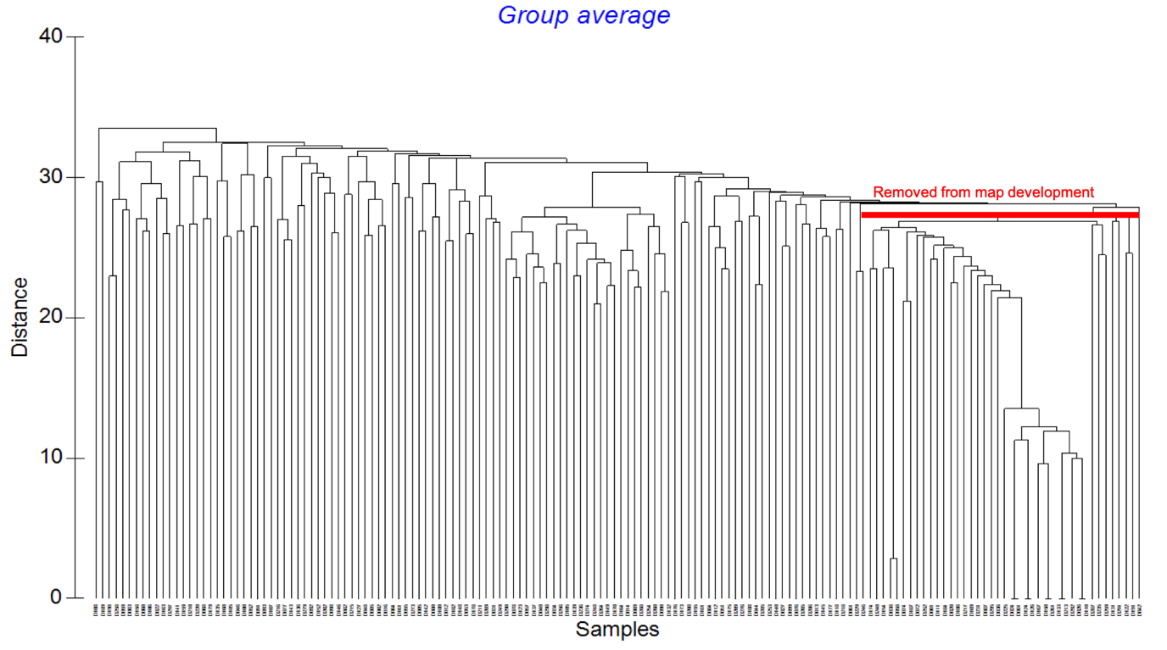

Supplementary Figure 1: The diagram presenting the clustering of RILs based on their genetic distances compared to population parents. The RILs are clustering on x-axis while y-axis shows the distance measured in NTSYS software

