**Additional file**

Investigating how faculty social networks and peer influence relate to knowledge and use of evidence-based teaching practices

**Table of Contents**

Lexicon/Abbreviations……………………………………………………………………1

Figures…………………………………………………………………………………..2-8

Figure S1….2

Figure S2….3

Figure S3….4-8

Tables…………………………………………………………………………………..9-12

Table S1…..9

Table S2…..10

Table S3…..11

Table S4…..12

Survey Questions……………………………………………………………………..12-15

**Lexion/Abbreviations for Supplemental File**

Assoc: associate

Asst: assistant

tt: tenure track

d: department

u: university

ns: not significant

sd: standard deviation

EBIP: evidence-based instructional practice

EBIP1: EBIP item 1 from survey (knowledge of EBIPs)

EBIP2: EBIP item 2 from survey (use of EBIPs)

e1ave: EBIP item 1 partner mean, unweighted

e1ave.wt: EBIP item 1 partner mean, weighted

e2ave: EBIP item 2 partner mean, unweighted

e2ave.wt: EBIP item 2 partner mean, weighted

**Figures**

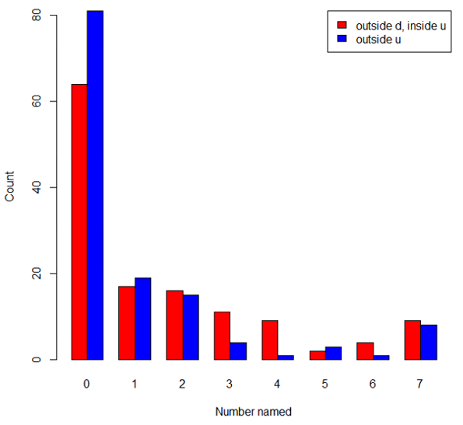

**Figure S1: Distributions of number of outside teaching contacts named**. X-axis is the number of discussion partners named by each respondent. Y-axis is the number of respondents. Red indicates partners named outside of the department, yet inside the university. Blue indicates partners named outside of the university. Restricting survey responses to seven people did appear to limit their ability to name discussion partners.

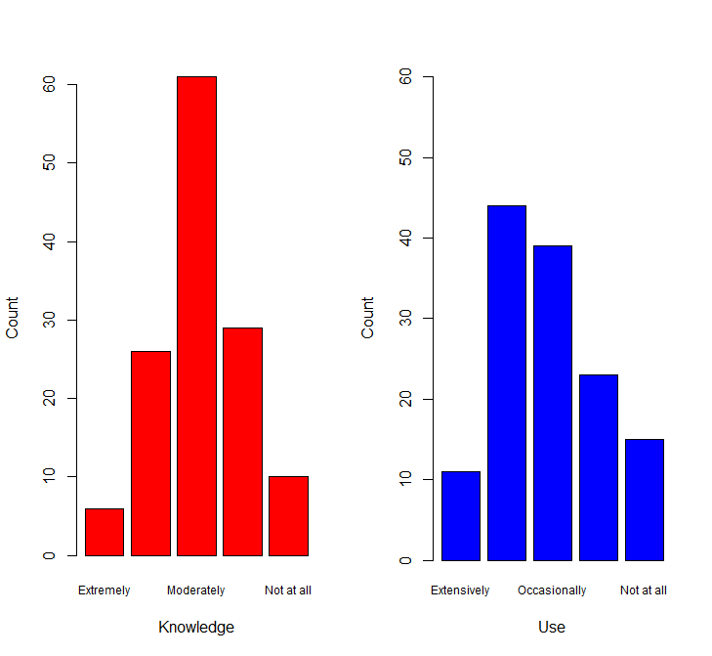

**Figure S2: Distribution of EBIP knowledge and use**. (Left, red) responses to EBIP item 1 about knowledge. (Right, blue) responses to EBIP item 2 about use. X-axis indicates response and y-axis indicates number of respondents with a given response. Data demonstrate variation in responses to knowledge and use questions

|  |  |  |
| --- | --- | --- |
|  | Unweighted | Weighted |
| Bio1  Knowledge |  |  |
| Bio1  Use |  |  |
| Bio2  Knowledge |  |  |
| Bio2  Use |  |  |
| Bio3  Knowledge |  |  |
| Bio3  Use |  |  |
| Bio4  Knowledge |  |  |
| Bio4  Use |  |  |
| Chem1  Knowledge |  |  |
| Chen1  Use |  |  |
| Chem2  Knowledge |  |  |
| Chem2  Use |  |  |
| Chem3  Knowledge |  |  |
| Chem3  Use |  |  |

**Figure S3**: **Department Sociograms Comparing Weighted and Unweighted.**  Vertices are sized by indegree centrality and shaded by level of knowledge and level of use, darker shades signifying more knowledge and more use, respectively, and lighter shades, less knowledge and less use, respectively. In the networks in the weighted column, arcs are shaded and of different widths such that dark, wide arcs indicate stronger teaching discussion ties (as defined by the multiplexity criterion) and light narrow arcs indicate weaker teaching discussion ties.

|  |  |  |  |  |  |
| --- | --- | --- | --- | --- | --- |
| Table S1  **Tables**  **Rank Homophily Overall and by Field***\** | | | | | |
| All | Tie Counts To | | | |  |
| Tie Counts From | Asst | Assoc | Full | Other | Total |
| Asst | 49 | 48 | 49 | 29 | 175 |
| Assoc | 54 | 49 | 43 | 29 | 175 |
| Full | 50 | 51 | 66 | 54 | 221 |
| Other | 32 | 27 | 44 | 67 | 170 |
| Total | 185 | 175 | 202 | 179 | 741 |
| $τ$ = 0.082, p<.001 | | | | | |
| Bio | Tie Counts To | | | |  |
| Tie Counts From | Asst | Assoc | Full | Other | Total |
| Asst | 43 | 39 | 29 | 17 | 128 |
| Assoc | 44 | 32 | 18 | 10 | 104 |
| Full | 24 | 23 | 10 | 14 | 71 |
| Other | 18 | 13 | 18 | 14 | 63 |
| Total | 129 | 107 | 75 | 55 | 366 |
| $τ$ = 0.006, ns | | | | | |
| Chem | Tie Counts To | | | |  |
| Tie Counts From | Asst | Assoc | Full | Other | Total |
| Asst | 6 | 9 | 20 | 12 | 47 |
| Assoc | 10 | 17 | 25 | 19 | 71 |
| Full | 26 | 28 | 56 | 40 | 150 |
| Other | 14 | 14 | 26 | 53 | 107 |
| Total | 56 | 68 | 127 | 124 | 375 |
| $τ$ = 0.083, p<.01 | | | | | |
| $τ$* is the inbreeding coefficient defined in the text. | | | | | |

|  |  |  |  |  |
| --- | --- | --- | --- | --- |
| Table S2  **Tenure Status Homophily Overall and by Field***\** | | | | |
| All | Tie Counts To | | |  |
| Tie Counts From | Not-tt | Untenured | Tenured | Total |
| Not-tt | 67 | 32 | 71 | 170 |
| Untenured | 29 | 49 | 97 | 175 |
| Tenured | 83 | 104 | 209 | 396 |
| Total | 179 | 185 | 377 | 741 |
| $τ$ = 0.096, p<.001 | | | | |
| Bio | Tie Counts To | | |  |
| Tie Counts From | Not-tt | Untenured | Tenured | Total |
| Not-tt | 14 | 18 | 31 | 63 |
| Untenured | 17 | 43 | 68 | 128 |
| Tenured | 24 | 68 | 83 | 175 |
| Total | 55 | 129 | 182 | 366 |
| $τ$ = 0.019, ns | | | | |
| Chem | Tie Counts To | | |  |
| Tie Counts From | Not-tt | Untenured | Tenured | Total |
| Not-tt | 53 | 14 | 40 | 107 |
| Untenured | 12 | 6 | 29 | 47 |
| Tenured | 59 | 36 | 126 | 221 |
| Total | 124 | 56 | 95 | 375 |
| $τ$ = 0.114, p<.01 | | | | |
| $τ$* is the inbreeding coefficient defined in the text. | | | | |

|  |  |  |  |
| --- | --- | --- | --- |
| Table S3  **Gender Homophily Overall and by Field***\** | | | |
| All | Tie Counts To | |  |
| Tie Counts From | F | M | Total |
| F | 86 | 151 | 237 |
| M | 149 | 355 | 504 |
| Total | 235 | 506 | 741 |
| $τ$ = 0.067 | | | |
| Bio | Tie Counts To | |  |
| Tie Counts From | F | M | Total |
| F | 49 | 95 | 144 |
| M | 77 | 145 | 222 |
| Total | 126 | 240 | 366 |
| $τ$ = 0.000 | | | |
| Chem | Tie Counts To | |  |
| Tie Counts From | F | M | Total |
| F | 37 | 56 | 93 |
| M | 72 | 210 | 282 |
| Total | 109 | 266 | 375 |
| $τ$ = 0.143 | | | |
| $τ$* is the inbreeding coefficient defined in the text. | | | |

|  |  |  |  |  |  |  |
| --- | --- | --- | --- | --- | --- | --- |
| Table S4  **Knowledge and Use – Correlations Between Respondent Score and Mean or Weighted Mean of Partner Scores***\** | | | | | | |
|  | EBIP1 | EBIP2 | e1ave | e1ave.wt | e2ave | e2ave.wt |
| EBIP1 EBIP2  e1ave  e1ave.wt  e2ave  e2ave.wt | 1.000 | 0.763  1.000 | 0.238  0.243  1.000 | 0.237  0.240  0.976  1.000 | 0.212  0.225  0.813  0.802  1.000 | 0.208  0.226  0.803  0.826  0.979  1.000 |
| *All values significant at p<.05. | | | | | | |

**Survey Questions**

**Section 1: Discussion Partners**

Q1: My current academic rank is:

* Assistant professor
* Associate professor
* Professor
* Research assistant Professor
* Research Associate Professor
* Research Professor
* Lecturer
* Lab Teacher
* Professor Emeritus/Adjunct Faculty

Q2 During the most recent academic year, I discussed instructional activities (e.g. teaching strategies, student learning, grading, student achievement) with the following colleagues within the [Department]: (Check as many as apply; Please do not select your name)

[List of faculty provided]

Q3 During the most recent academic year, I discussed instructional activities (e.g. teaching strategies, student learning, grading, student achievement) with the following colleagues who are **outside the [Department]** **but at [University]** and/or **outside [University]:** **Identify up to 7 individuals in each category; columns indicate whether the individual is at [University] or not.**

|  |  |  |
| --- | --- | --- |
|  | Names of people outside the [Department] but at [University] | Names of people outside [University] |
| Individual 1 |  |  |
| Individual 2 |  |  |
| Individual 3 |  |  |
| Individual 4 |  |  |
| Individual 5 |  |  |
| Individual 6 |  |  |
| Individual 7 |  |  |

Q4 During the most recent academic year, I discussed research activities (e.g. your research topics, their research topics, mutual collaborations, funding opportunities) with the following colleagues within the [Department]: (Check as many as apply; Please do not check your name)

[List of faculty provided]

Q5 During the most recent academic year, I discussed research activities (e.g. your research topics, their research topics, mutual collaborations, funding opportunities) with the following colleagues who are outside the [Department] but at [University] and/or outside [University]: Identify up to 7 individuals in each category; columns indicate whether the individual is at [University] or not.

|  |  |  |
| --- | --- | --- |
|  | Names of people outside the [Department] but at [University] | Names of people outside [University] |
| Individual 1 |  |  |
| Individual 2 |  |  |
| Individual 3 |  |  |
| Individual 4 |  |  |
| Individual 5 |  |  |
| Individual 6 |  |  |
| Individual 7 |  |  |

Q6 During the most recent academic year, I discussed general department and university affairs (e.g. course scheduling, administrative policies and procedures, faculty governance) with the

following colleagues within the [Department]: (Check as many as apply; Please do not check your name)

[List of faculty provided]

Q7 During the most recent academic year, I discussed general department and university affairs (e.g. course scheduling, administrative policies and procedures, faculty governance) with the

following colleagues who are outside the [Department] but at [University] and/or outside [University]: Identify up to 7 individuals in each category; columns indicate whether the individual is at [University] or not.

|  |  |  |
| --- | --- | --- |
|  | Names of people outside the [Department] but at [University] | Names of people outside [University] |
| Individual 1 |  |  |
| Individual 2 |  |  |
| Individual 3 |  |  |
| Individual 4 |  |  |
| Individual 5 |  |  |
| Individual 6 |  |  |
| Individual 7 |  |  |

**Section 2: EBIPs**

**Evidence-based instructional practices (EBIPS) include active learning techniques, such as just-in-time teaching, peer instruction, think-pair-share, cooperative learning, team-based learning, and many others.**

Q8 I would describe my knowledge of EBIPs as:

* Extremely knowledgeable
* Very knowledgeable
* Moderately knowledgeable
* Slightly knowledgeable
* Not knowledgeable at all

Q9 I would describe my use of EBIPs in courses I teach as:

* Used extensively
* Used often
* Used occasionally
* Used a little
* Not used at all
* No courses I teach are appropriate courses for EBIP application

Q10 Having others in my department adopt EBIPs makes it more likely that I will choose to use EBIPS.

* Strongly agree
* Somewhat agree
* Neither agree nor disagree
* Somewhat disagree
* Strongly disagree

Q11 Having others in my department adopt EBIPs means that it is easier for me to use my current teaching methods.

* Strongly agree
* Somewhat agree
* Neither agree nor disagree
* Somewhat disagree
* Strongly disagree