Additional information for:
Genotyping by low-coverage whole-genome sequencing in intercross pedigrees from outbred founders: a cost efficient approach
Yanjun Zan, Thibaut Payen, Mette Lillie, Christa F. Honaker, Paul B. Siegel and Örjan Carlborg

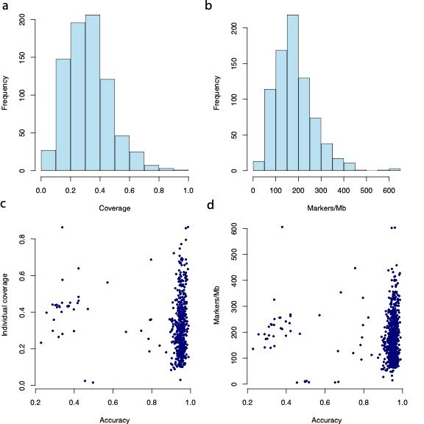
Figure S4. Ilustration of relationship between sequencing coverage, marker density and imputation accuracy. A/B) Histograms of the sequencing coverage/marker densities for the 803 genotyped F₂ individuals; C/D) Scatter plots of individual coverage/marker density vs imputation accuracy measured as proportion of sites that has same genotype with the averaged genotype probabilities estimated by (Wahlberg et al., 2009) using genotypes of 434 SNP and microsatellite markers with the Haley and Knott algorithm (Haley et al., 1994).

