Additional information for:
Genotyping by low-coverage whole-genome sequencing in intercross pedigrees from outbred founders: a cost efficient approach
Yanjun Zan, Thibaut Payen, Mette Lillie, Christa F. Honaker, Paul B. Siegel and Örjan Carlborg
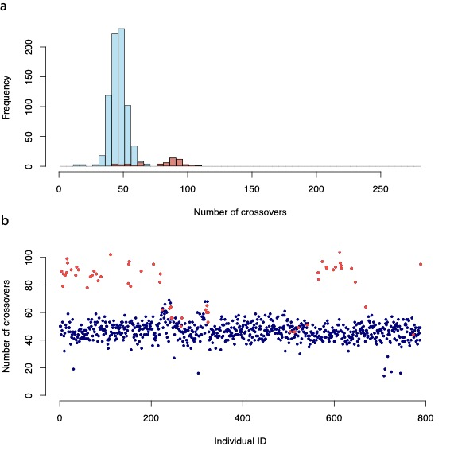

Figure S1. Visualization of the number of crossover in all F₂ individuals. A) Histogram of number of imputed crossover events for the 803 genotyped F₂ individuals; B) Number of imputed crossover events in each individual, sorted by the 73 full-sib families. Individuals with low call rate (call Rate <0.9) are coloured into red.

