Plasma protein fractions in free-living white-tailed eagle (Haliaeetus albicilla) nestlings in Norway

Jørgen Floª, Mari Engvig Løsethª, Christian Sonne^{b}, Veerle L. B. Jaspersª and Hege Brun-Hansen^{c}

Affiliation:
ª Department of Biology, Norwegian University of Science and Technology (NTNU), Høgskoleringen 5, 7491 Trondheim, Norway
^{b} Department of Bioscience, Faculty of Science and Technology, Arctic Research Center (ARC), Aarhus University, Frederiksborgvej 399, PO Box 358, DK-4000 Roskilde, Denmark
^{c} Department of Basic Sciences and Aquatic Medicine, Norwegian University of Life Sciences (NMBU), 0454 Oslo, Norway

Number of pages: 5
Number of tables: 2
Number of figures: 6

Contents:
Table S1: Body mass and age of white-tailed eagle nestlings
Table S2: Plasma protein concentrations in white-tailed eagle nestlings
Figure S1: Map of Norway displaying the two sampling locations
Figure S2: Scatterplot between age and plasma protein levels
Figure S3: Histograms of plasma protein levels and 95% RI (90% CI) for nestlings from
Smøla
Figure S4: Histograms of plasma protein levels and 95% RI (90% CI) for nestlings from
Steigen
Figure S5: Percentages of total protein content for each plasma protein fraction
Figure S6: Scatterplot between time of day at sampling and plasma protein levels

Table S1: Body mass and age of white-tailed eagle nestlings from Smøla and Steigen, 2015 and 2016.
SMØLA | 2015 |  |  |  |  |  |  |  | 2016
 | n | AM | ± | SE | Median | Range |  |  | n | AM | ± | SE | Median | Range
Female mass (kg) | 7 | 6107 | ± | 213 | 6000 | 4994 | - | 6650 | 10 | 5660 | ± | 129 | 5600 | 5000 | - | 6200
Male mass (kg) | 6 | 4825 | ± | 159 | 4975 | 4200 | - | 5200 | 12 | 4496 | ± | 119 | 4550 | 3650 | - | 5300
Age (days) | 13 | 79 | ± | 2 | 81 | 65 | - | 87 | 22 | 66 | ± | 2 | 67 | 52 | - | 82
STEIGEN | 2015 |  |  |  |  |  |  |  | 2016
 | n | AM | ± | SE | Median | Range |  |  | n | AM | ± | SE | Median | Range
Female mass (kg) | 8 | 4994 | ± | 180 | 5025 | 4150 | - | 5950 | 10 | 5505 | ± | 97 | 5475 | 5000 | - | 6000
Male mass (kg) | 6 | 4330 | ± | 227 | 4350 | 3650 | - | 4950 | 11 | 4468 | ± | 86 | 4500 | 3850 | - | 5000
Age (days) | 14 | 63 | ± | 5 | 65 | 44 | - | 85 | 21 | 68 | ± | 2 | 71 | 50 | - | 82

Table S2: Plasma protein concentrations in Norwegian white-tailed eagle nestlings from Steigen and Smøla, 2015 and 2016.
 |  | SMØLA |  |  |  | STEIGEN
 | 2015 |  | 2016 |  | 2015 |  | 2016
 | n = 13 |  | n = 22 |  | n = 14 |  | n = 21
Analyte | Mean ± SE | Min – Max | Mean ± SE | Min – Max | Mean ± SE | Min – Max | Mean ± SE | Min – Max
Prealbumin | 5.24 ± 0.41 | 2.72 – 7.89 | 4.46 ± 0.22 | 2.83 – 6.62 | 4.05 ± 0.15 | 2.89 – 4.88 | 3.84 ± 0.29 | 1.85 – 6.63
 | 16.4% |  | 14.3% |  | 13.3% |  | 11.6%
Albumin | 14.55 ± 0.49 | 11.87 – 17.23 | 14.72 ± 0.38 | 11.52 – 19.07 | 13.70 ± 0.35 | 10.64 – 15.18 | 15.82 ± 0.52 | 9.71 – 19.35
 | 45.7% |  | 47.3% |  | 45.2% |  | 47.6%
α₁-globulin | 0.65 ± 0.05 | 0.43 – 1.01 | 0.74 ± 0.05 | 0.36 – 1.45 | 0.86 ± 0.07 | 0.45 – 1.38 | 0.73 ± 0.05 | 0.42 – 1.34
 | 2.0% |  | 2.4% |  | 2.8% |  | 2.2%
α₂-globulin | 3.47 ± 0.11 | 2.77 – 4.03 | 3.61 ± 0.09 | 2.88 – 4.41 | 3.59 ± 0.10 | 2.96 – 4.21 | 4.08 ± 0.14 | 2.80 – 5.25
 | 10.9% |  | 11.6% |  | 11.8% |  | 12.3%
β-globulin | 5.16 ± 0.25 | 4.12 – 7.68 | 4.88 ± 0.12 | 4.03 – 6.06 | 4.83 ± 0.12 | 4.07 – 5.68 | 5.34 ± 0.16 | 3.51 – 6.35
 | 16.2% |  | 15.7% |  | 15.9% |  | 16.1%
γ-globulin | 2.79 ± 0.12 | 2.22 – 3.50 | 2.71 ± 0.14 | 2.00 – 4.45 | 3.31 ± 0.21 | 2.21 – 5.23 | 3.40 ± 0.16 | 2.01 – 4.52
 | 8.8% |  | 8.7% |  | 10.9% |  | 10.2%
Total protein | 31.87 ± 0.54 | 28.10 – 34.80 | 31.12 ± 0.67 | 26.00 – 35.90 | 30.34 ± 0.65 | 25.10 – 33.80 | 33.21 ± 0.98 | 20.30 – 39.60
A:Gª ratio | 1.65 ± 0.05 | 1.39 – 2.09 | 1.62 ± 0.04 | 1.28 – 2.05 | 1.42 ± 0.03 | 1.16 – 1.68 | 1.46 ± 0.04 | 1.20 – 1.76
A:G^{b} ratio | 0.86 ± 0.05 | 0.54 – 1.20 | 0.90 ± 0.02 | 0.76 – 1.13 | 0.83 ± 0.02 | 0.73 – 0.93 | 0.92 ± 0.02 | 0.76 – 1.12
ªAlbumin to globulin ratio: (albumin + prealbumin)/(α₁ + α₂+ β + γ globulins)
^{b}Albumin to globulin ratio: (albumin)/(prealbumin + α₁-+ α₂-+ β-+ γ-globulins, Roman et al., 2013)
Mean (± SE) and range of plasma protein concentrations (g/L) and A:G ratios for white-tailed eagle nestlings sampled at Smøla and Steigen in 2015 and 2016, separately. The percentage of the total protein content is also provided for each plasma protein fraction (%).

Figure S1: Map of Norway displaying the two sampling locations in the present study, Smøla and Steigen.

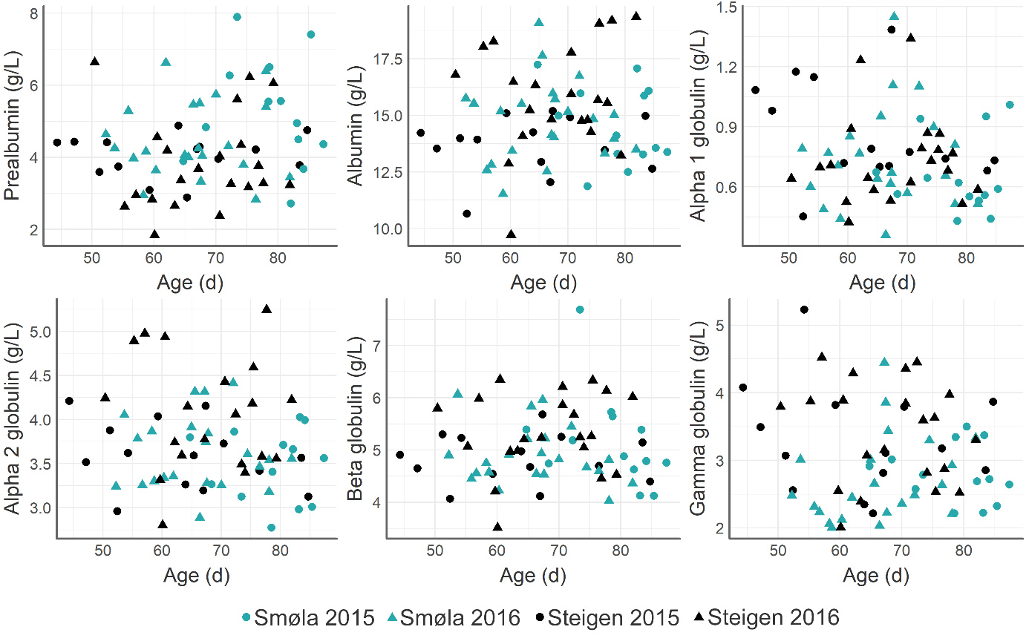
Figure S2: Scatterplot between age (days) and protein fractions (g/L) in plasma from white-tailed eagles (n = 70) sampled at Smøla and Steigen Norway, in 2015 and 2016.

SMØLA
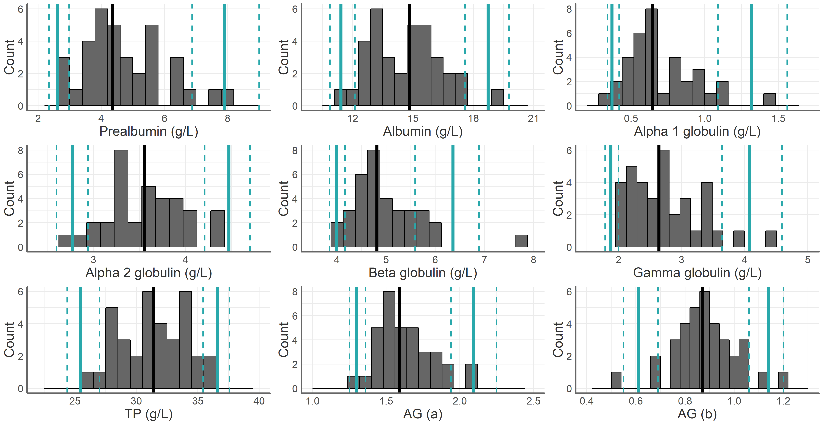
Figure S3: Histogram of protein fractions (g/L), total protein (g/L) and A:G ratio, 95% RI limits (solid blue lines), 90% CI around RI limits (dashed blue lines) and median (black lines) in plasma from white-tailed eagle nestlings (n=35) sampled at Smøla, 2015 and 2016.

STEIGEN
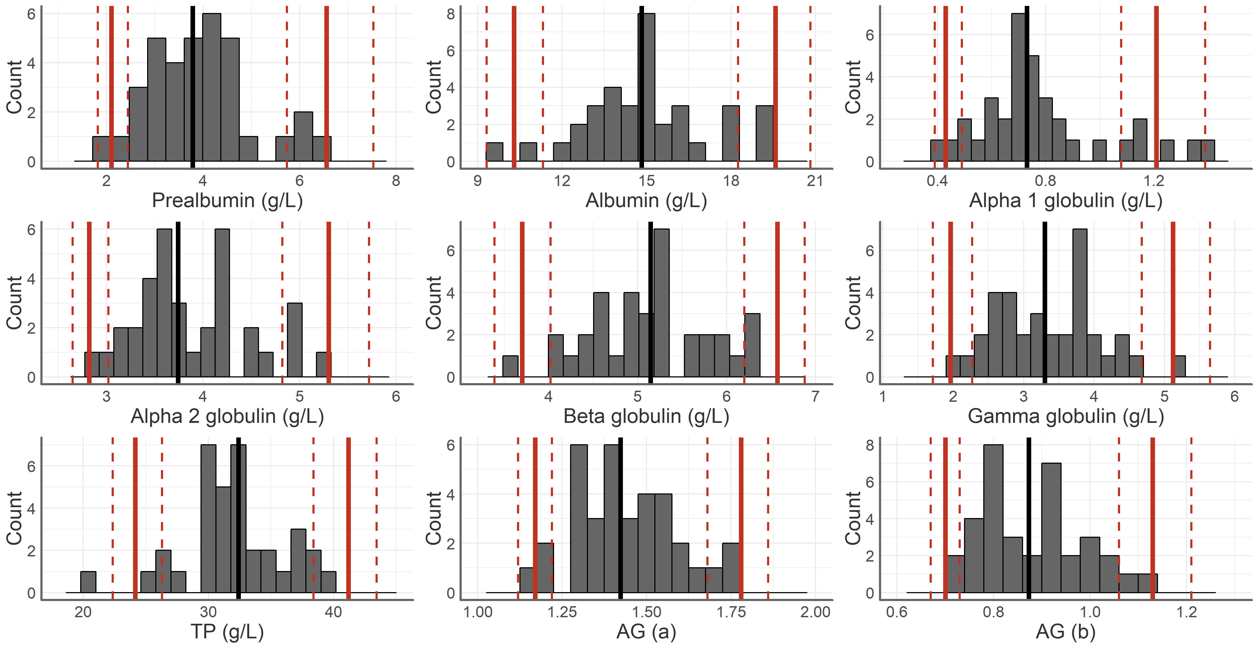
Figure S4: Histogram of protein fractions (g/L), total protein (g/L) and A:G ratio, 95% RI limits (solid blue lines), 90% CI around RI limits (dashed blue lines) and median (black lines) in plasma from white-tailed eagle nestlings (n=35) sampled at Steigen, 2015 and 2016.

Figure S5: Percentages of total protein for each plasma protein content in plasma of white-tailed eagle nestlings (n = 70) from Smøla and Steigen, 2015 and 2016.

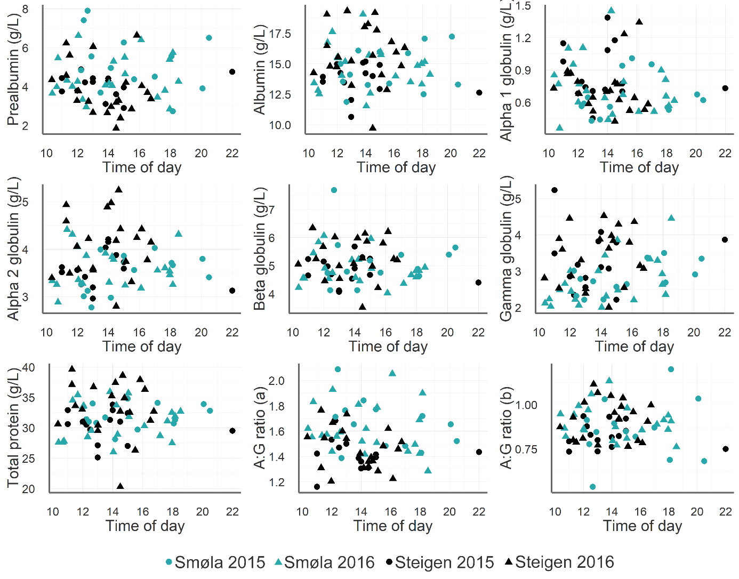
Figure S6: Plasma protein levels of white-tailed eagle nestlings in relation to sampling time of day at Smøla and Steigen in 2015 and 2016.

