Surgical procedure

Anatomical hepatectomy(S5, S8)
Surgeon: Xiangde Liu
Date: 2014-11-16
Address: Institute of Hepatobiliary Surgery, First affiliated hospital of Third Military Medical University (Army Medical University).

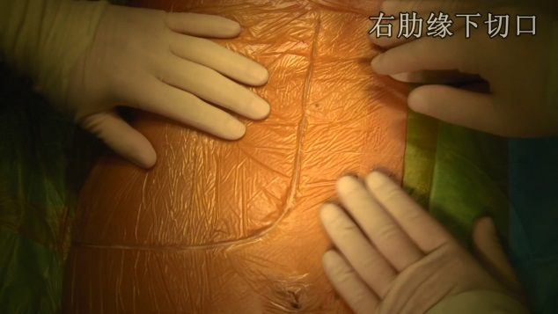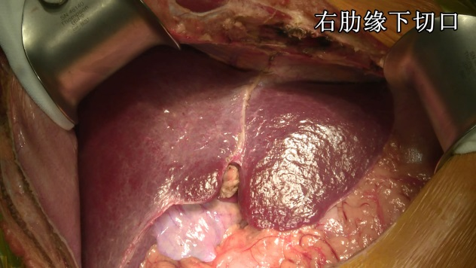
Right subcostal incision

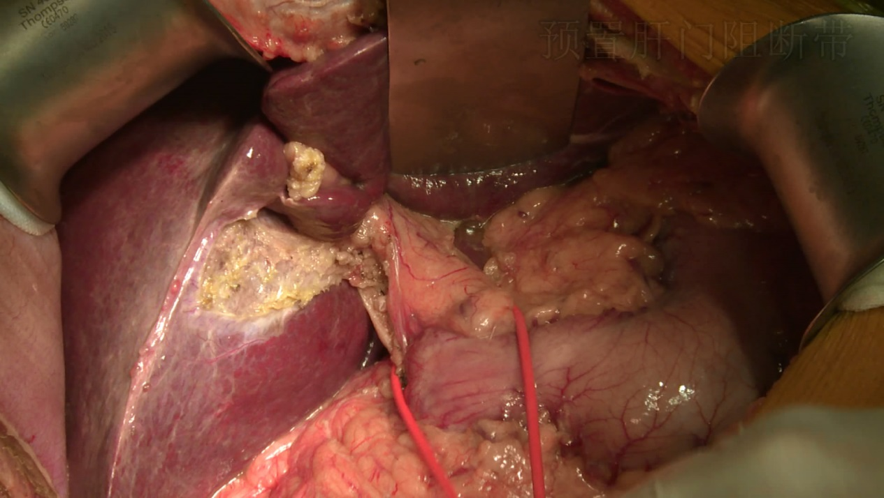
Preset hepatic portal occlusion

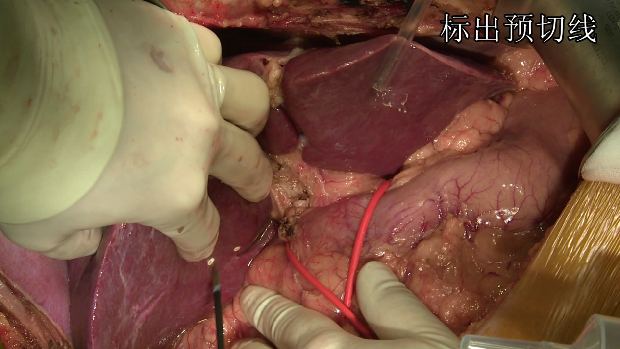
Mark line of resection

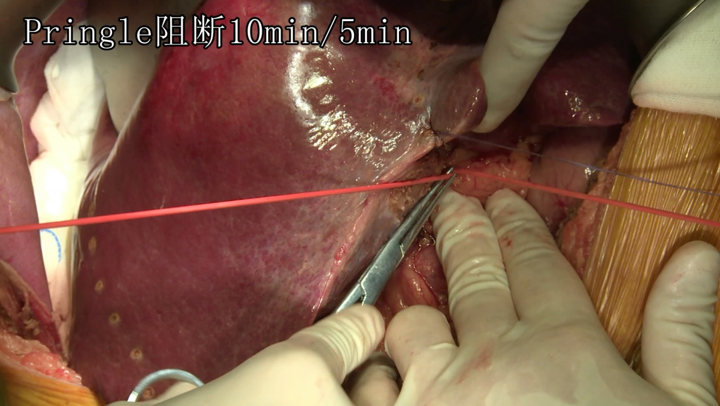
Pringle occlusion: 10 minutes of inflow occlusion followed by 5 minutes of reperfusion

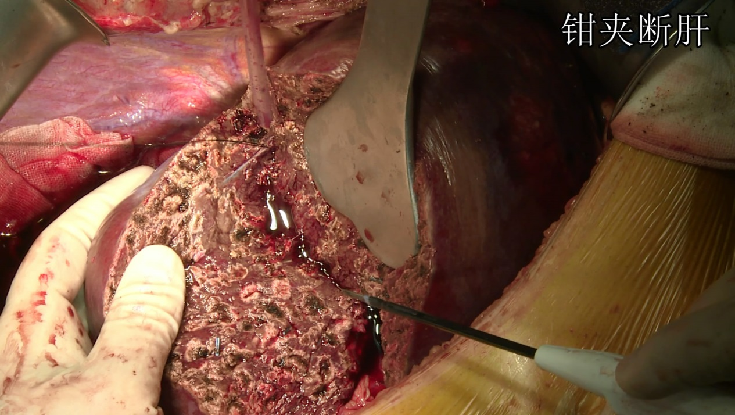
Clump Crushing Technique

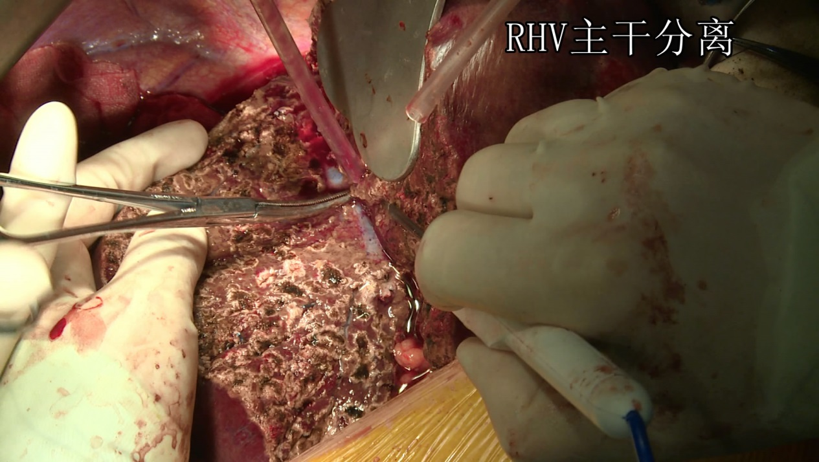
Isolation of Right Hepatic Vein (RHV) trunk

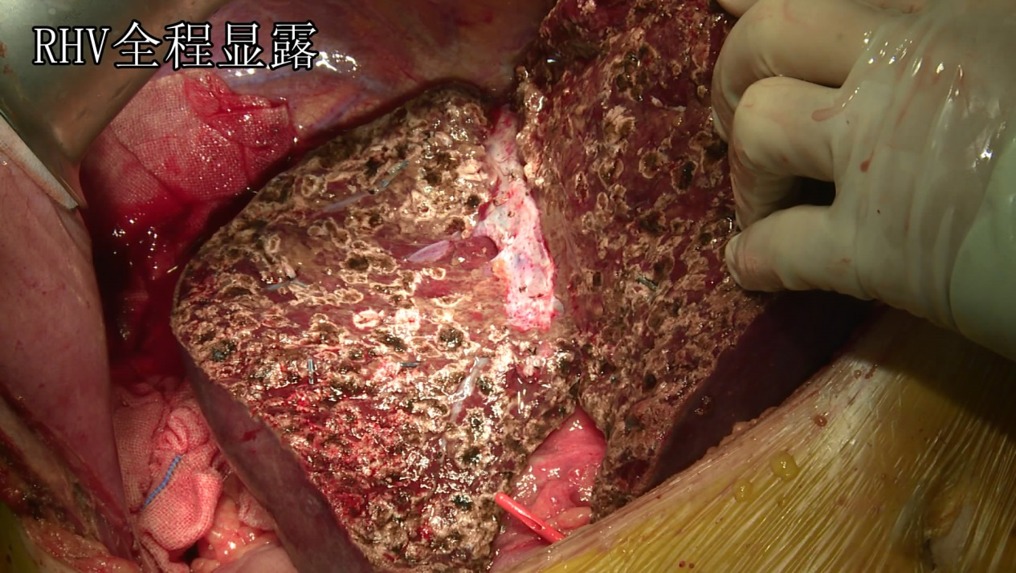
RHV exposure

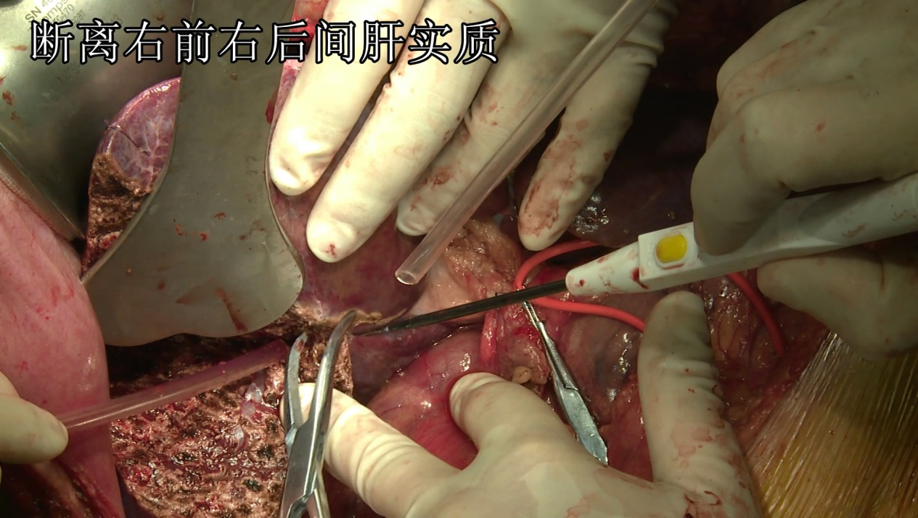
Separation of right anterior and right posterior hepatic parenchyma

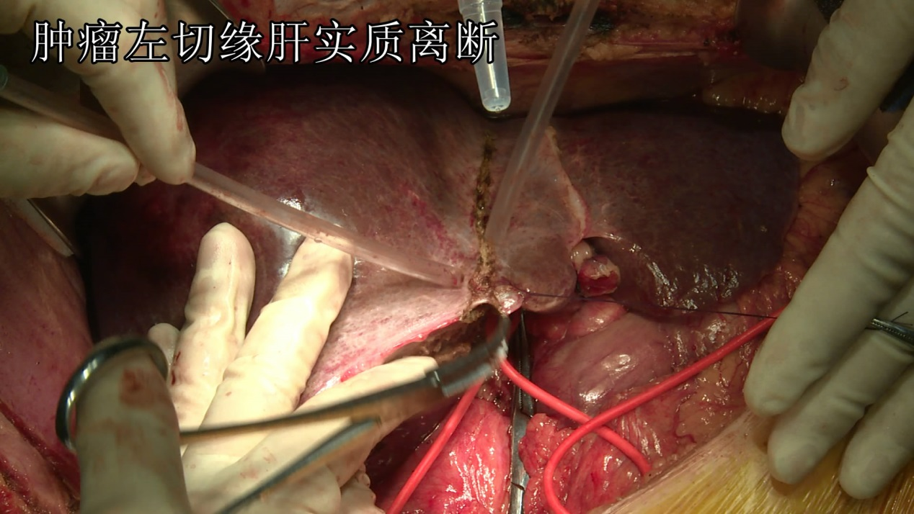
Separation of tumor left resection margin

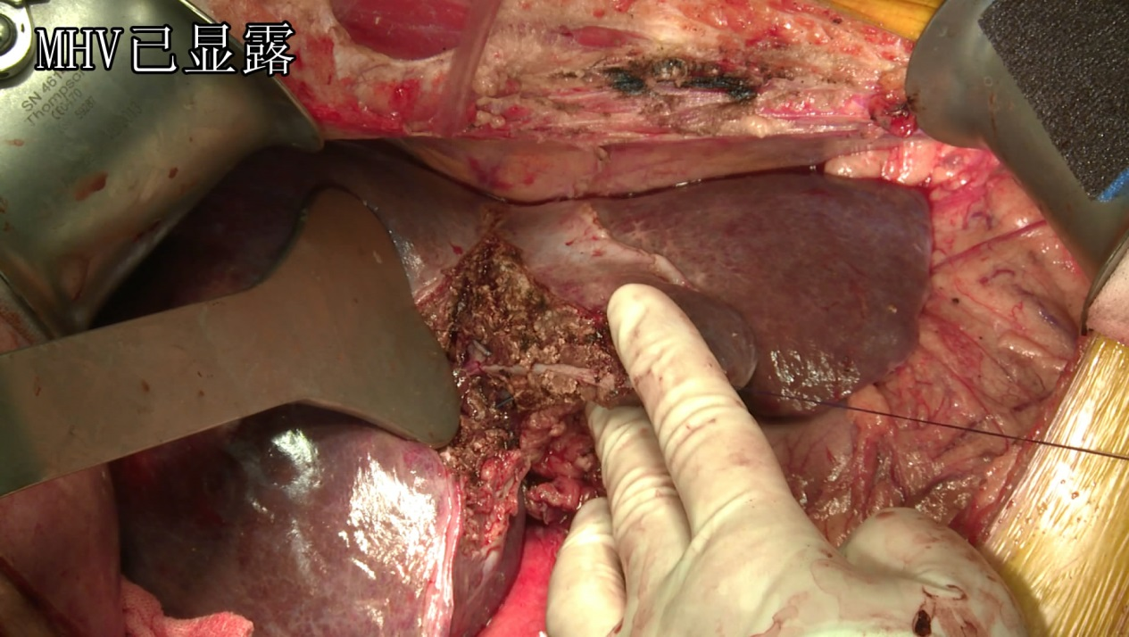
Middle hepatic vein (MHV) exposure

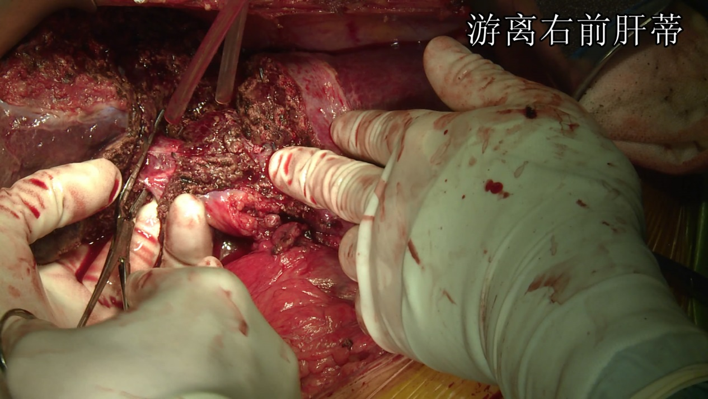
Isolation of right anterior hepatic pedicle

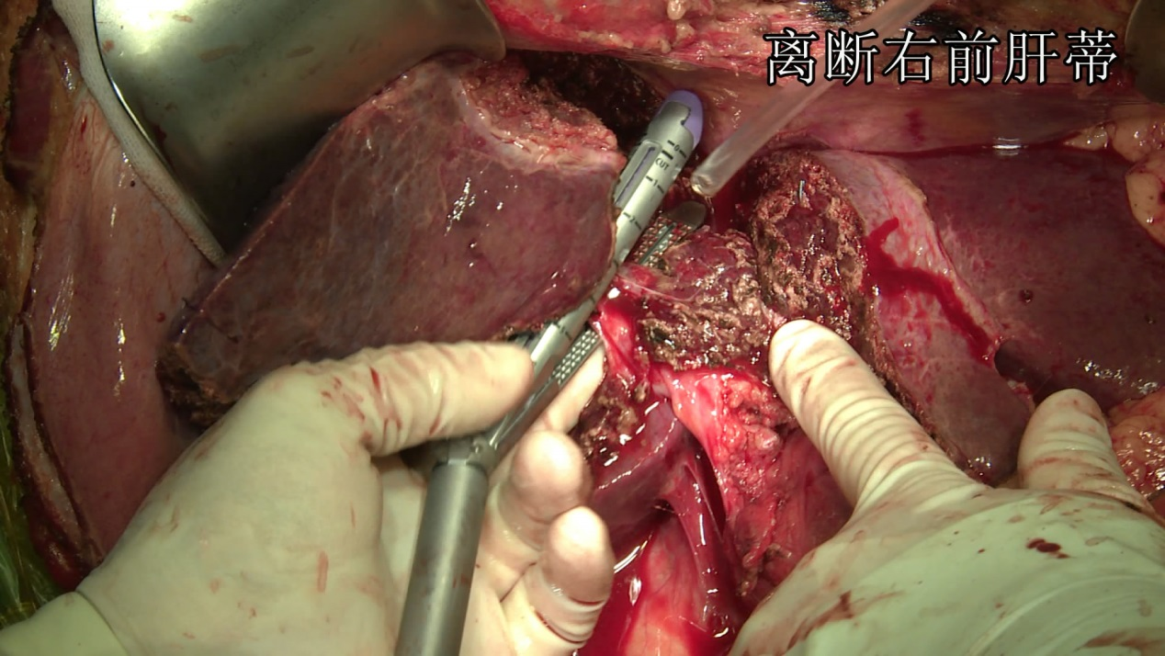
Cut off right anterior hepatic pedicle

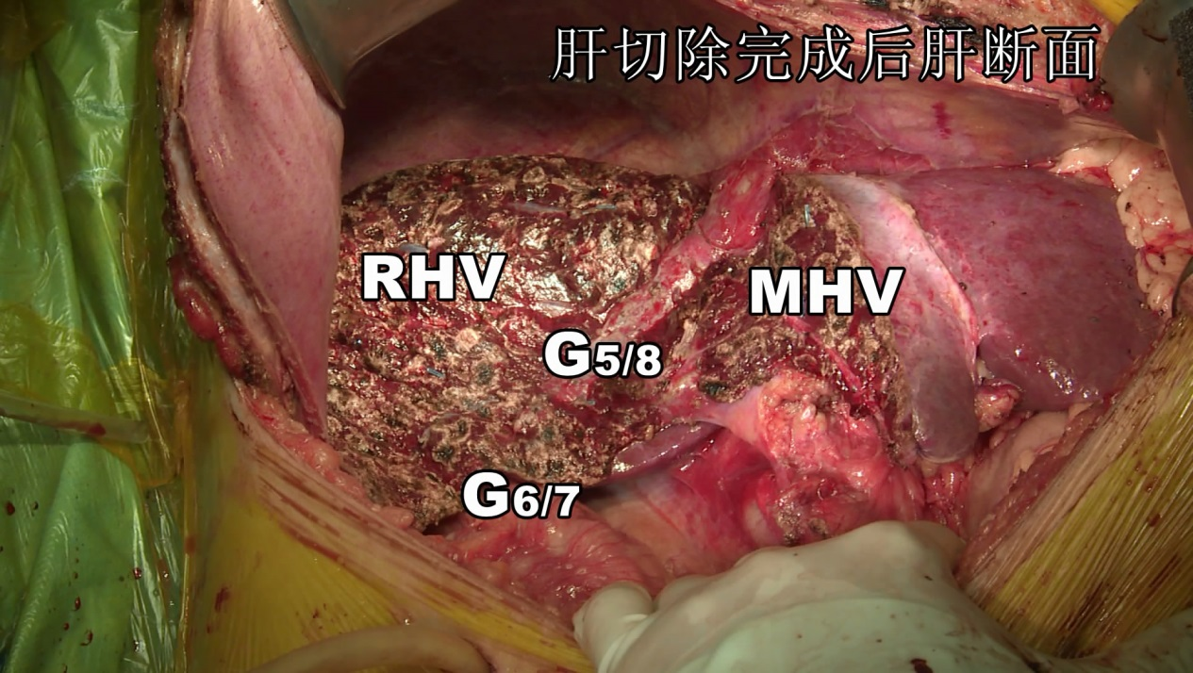
Section after hepatectomy

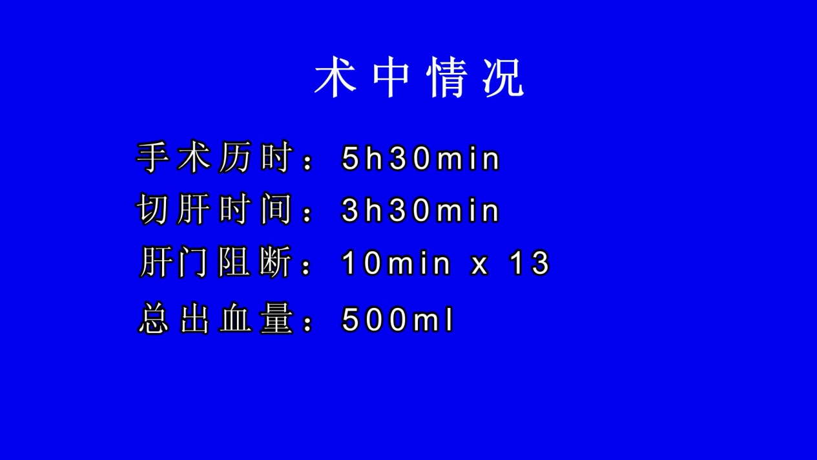
Intraoperative conditions
Duration of operation: 5 hours and 30 minutes
Duration of liver resection: 3 hours and 30 minutes
Duration of hepatic vascular occlusion: 10 minutes × 13
Amount of bleeding: 500ml

