**Additional file for article:**

**Assessment of directional accuracy of GNSS-Acoustic measurement using a slackly moored buoy**

Misae Imano1, Motoyuki Kido2, Yusaku Ohta3, Chie Honsho3, Narumi Takahashi4,5, Tatsuya Fukuda6, Hiroshi Ochi6, Ryota Hino3

1 Graduate school of Science, Tohoku University, 6-3 Aza-aoba, Aramaki, Aoba-ku, Sendai, Miyagi 980-8578, Japan

2 International Research Institute for Disaster Science, Tohoku University, 468-1 Aza-aoba, Aramaki, Aoba-ku, Sendai, Miyagi 980-0845, Japan

3 Research Center for Prediction of Earthquakes and Volcanic Eruptions, Tohoku University, 6-6 Aza-aoba, Aramaki, Aoba-ku, Sendai, Miyagi 980-0845, Japan

4 National Research Institute for Earth Science and Disaster Resilience, Tonnodai, Tukuba, Ibaraki 305-0006, Japan

5 Yokohama Institute for Earth Sciences, Japan Agency for Marine-Earth Science and Technology, 3173-25 Showa-machi, Kanazawa-ku, Yokohama, Kanagawa 236-0001, Japan

6 Yokosuka Headquarters, Japan Agency for Marine-Earth Science and Technology, 2-15 Natsushima-cho, Yokosuka, Kanagawa 237-0061, Japan



Figure S1. Chart table of three observation campaigns for individual PXP positioning.

Each set of observations consists of moving and/or point survey data.

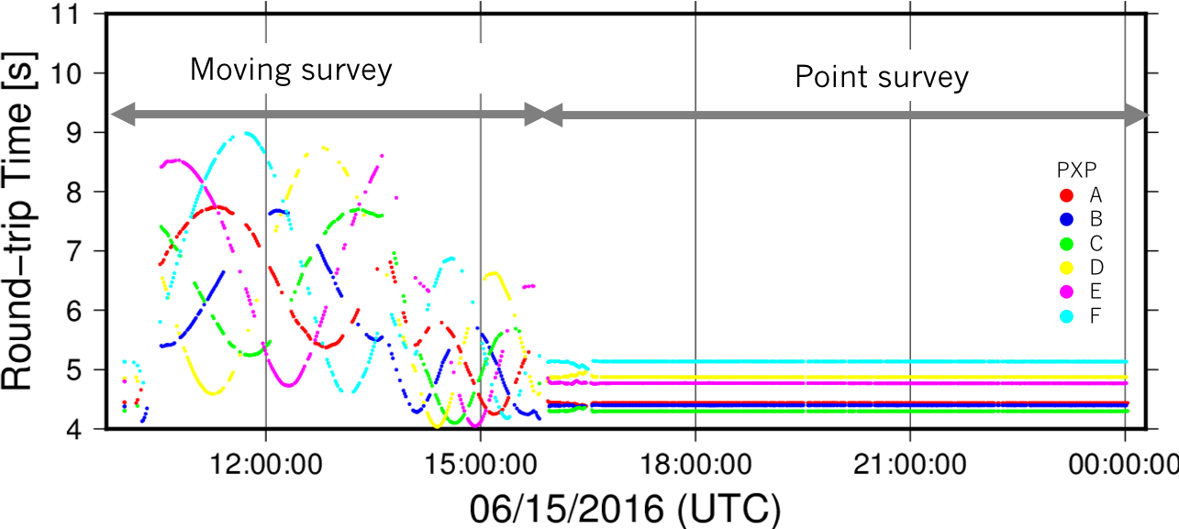

Figure S2. Time series of round-trip traveltimes obtained during moving and point surveys in Campaign 2. The traveltimes between the transducer and the PXPs are indicated by colored dots.

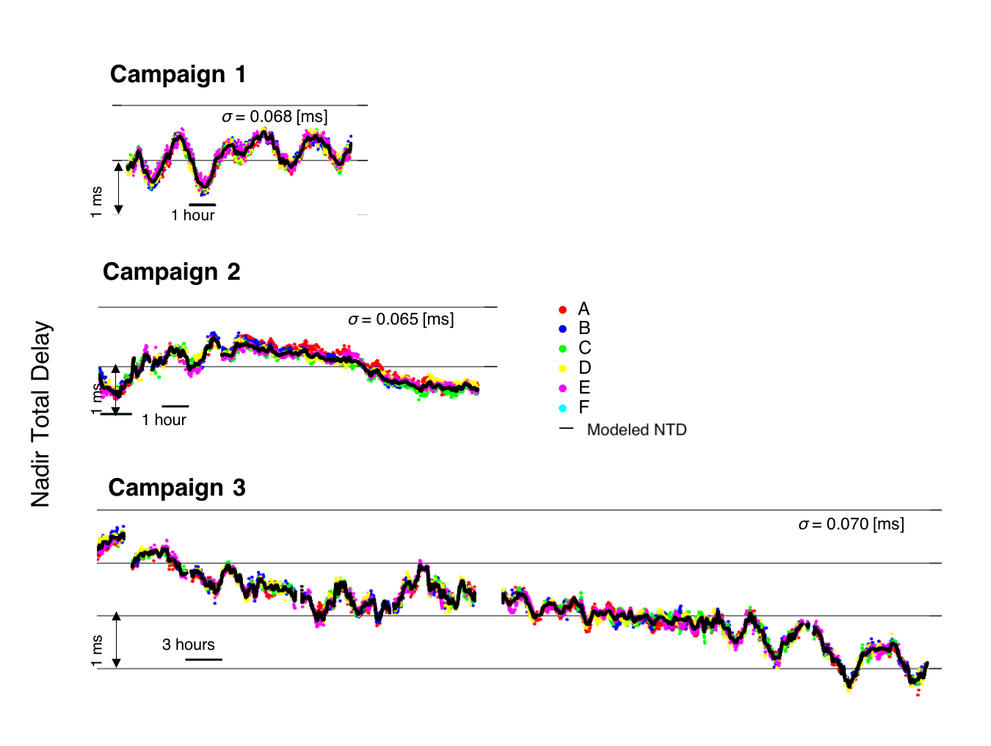

Figure S3. Individual PXP positioning results.

The colored dots and black lines indicate the observed and modeled NTD, respectively.

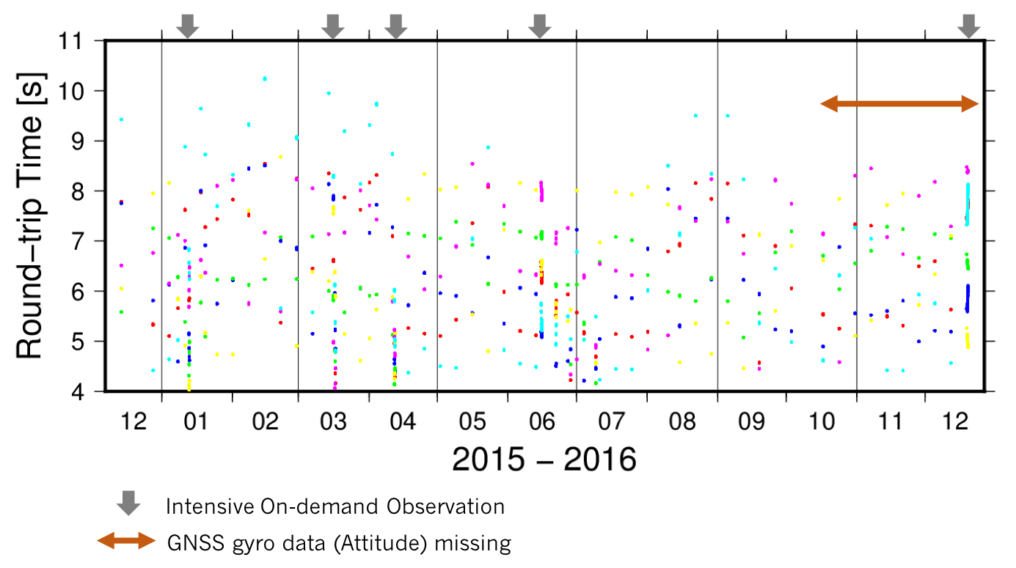

Figure S4. Time series of round-trip traveltimes obtained during continuous observation using a moored buoy. The dots, representing the traveltimes, are color coded in the same way as in Fig. S2

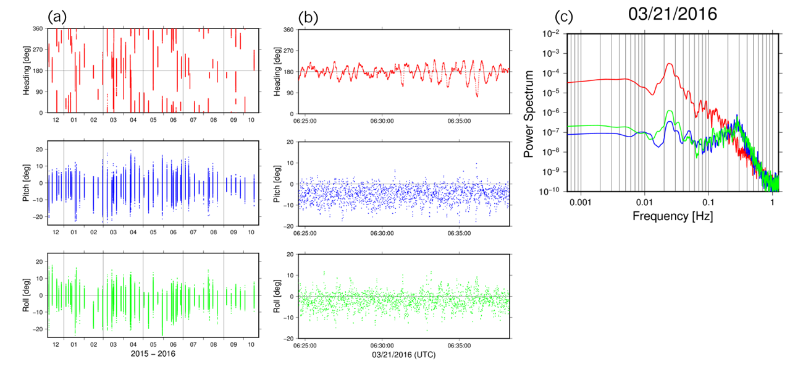

Figure S5. Attitude angle of the buoy from GNSS gyro during continuous observation. The plots on the left and in the center show the heading, pitch, and roll of the buoy from top to bottom during (a) the entire period until the occurrence of missing data (after mid-October 2016) and (b) a 20-minute period of a GNSS-A observation sequence on 21 March 2016. (c) Power spectrum of the attitude angle on 21 March 2016. The colored lines correspond to the same spectra of heading, pitch, and roll as in (b). The characteristic periods were 3–4 sec in pitch and roll and 30–50 sec in pitch, roll and heading.

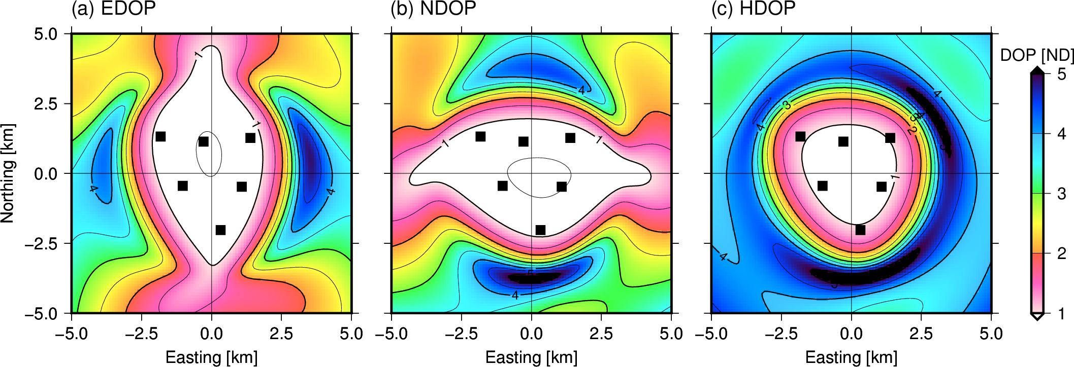

Figure S6. Map view of DOPs using our array geometry.

(a) EDOP, (b) NDOP, and (c) HDOP. The large DOP region (colored in shades of blue) indicates that the poisoning accuracy suffers. The contour lines are DOP intervals of 0.5.

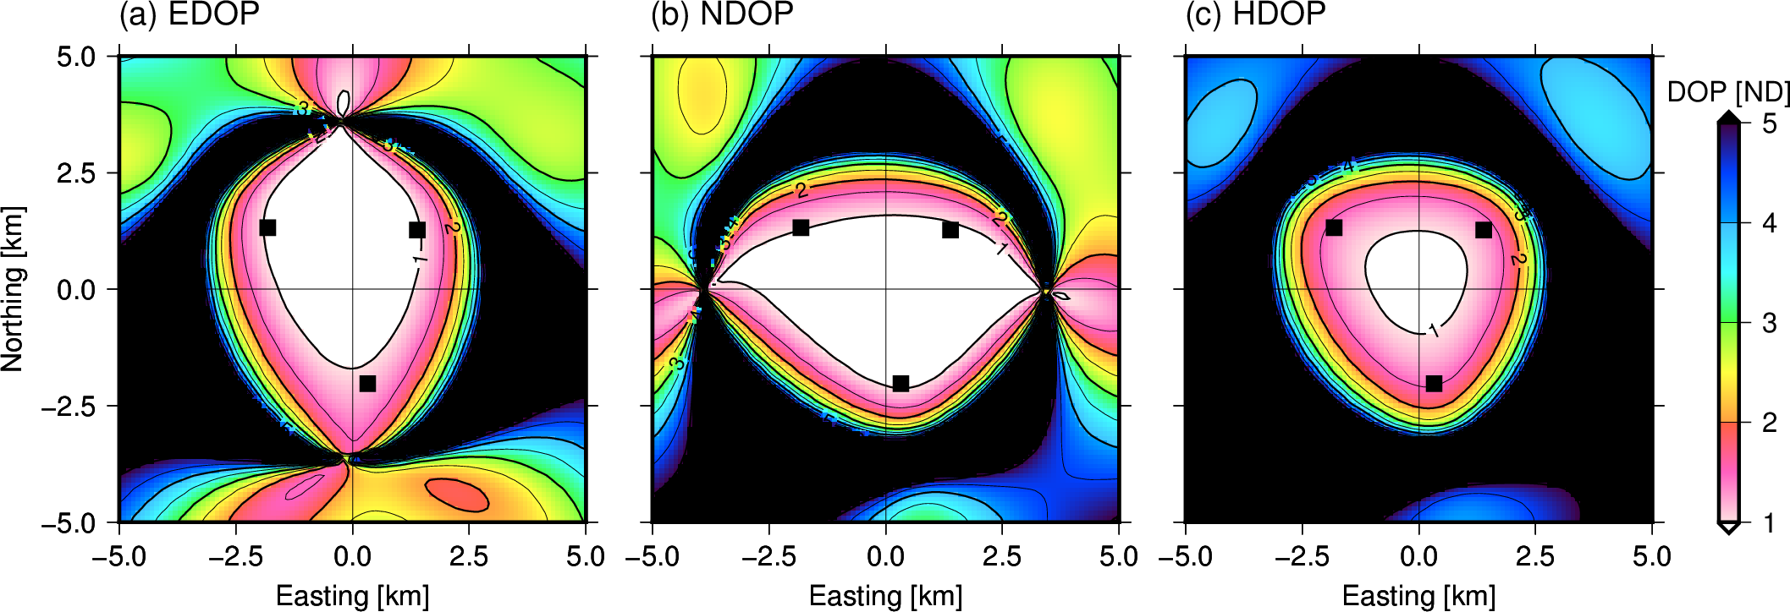

Figure S7. Map view of DOPs using outer three PXPs.   
(a) EDOP, (b) NDOP, and (c) HDOP. The color scale is the same as in Fig. S6. Black indicates a DOP value greater than 5.

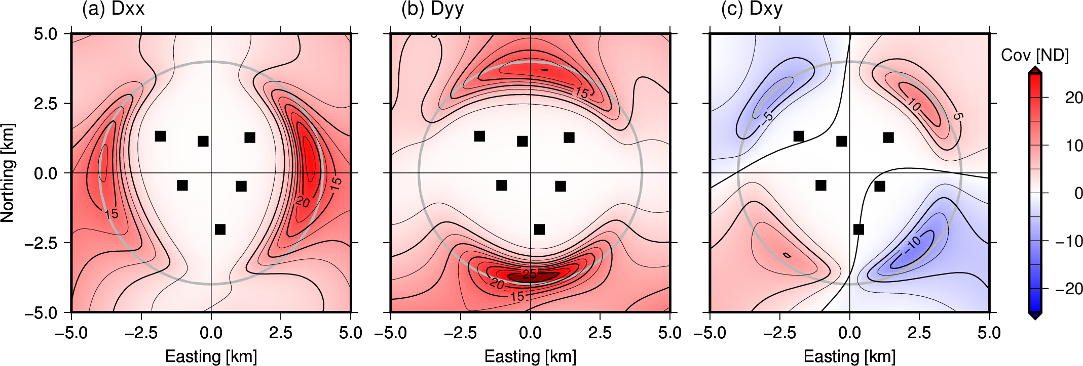

Figure S8. Map views of components of Equation (8).

(a) $D_{xx}$, (b) $D_{yy}$, and (c) $D_{xy}$. The gray circle indicates a radius of 4 km from the array center.