Supporting information
Facile bottom-up preparation of WS₂-based water-soluble quantum dots as luminescent probes for hydrogen peroxide and glucose

Da-Ren Hang^{a,b*}, De-You Sunª, Chun-Hu Chen^{c}, Hui-Fen Wu^{c}, Mitch M. C. Chou^{a,b}, Sk Emdadul Islamª, and Krishna Hari Sharmaª
ªDepartment of Materials and Optoelectronic Science, National Sun Yat-sen University, Kaohsiung 80424, Taiwan
^{b}Center of Crystal Research, National Sun Yat-sen University, Kaohsiung 80424, Taiwan
^{b}Department of Chemistry, National Sun Yat-sen University, Kaohsiung 80424, Taiwan

* Electronic mail: drhang@faculty.nsysu.edu.tw

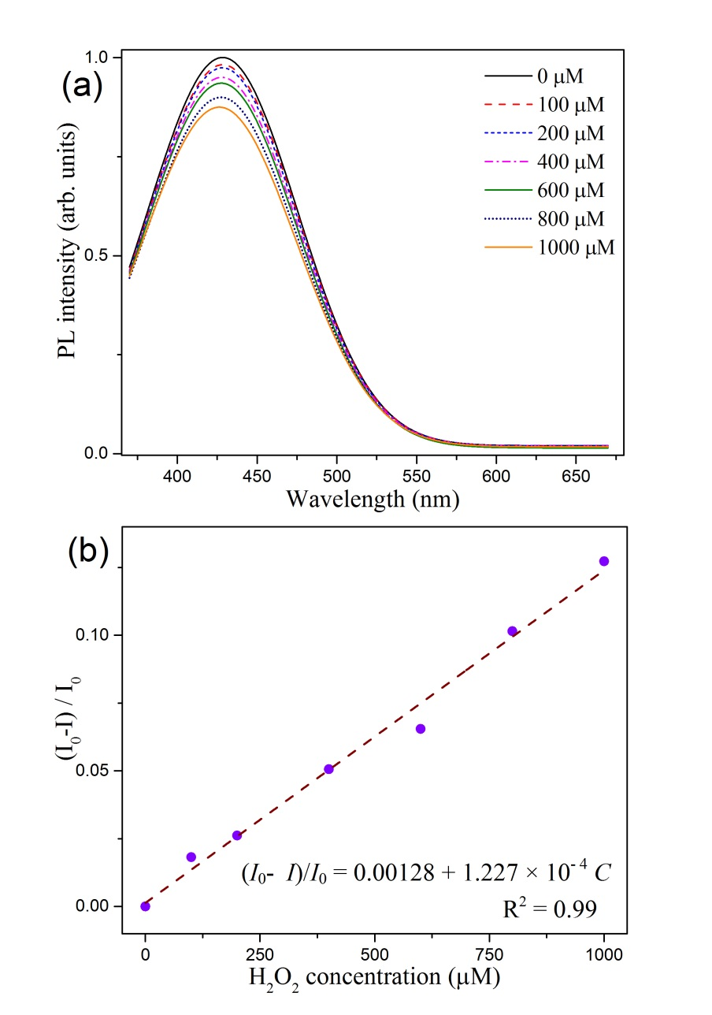
Figure S1. (a) PL spectra of WS₂ QDs under 360 nm irradiation with different concentrations of H₂O₂. (b) The linear calibration plot for H₂O₂ concentration.

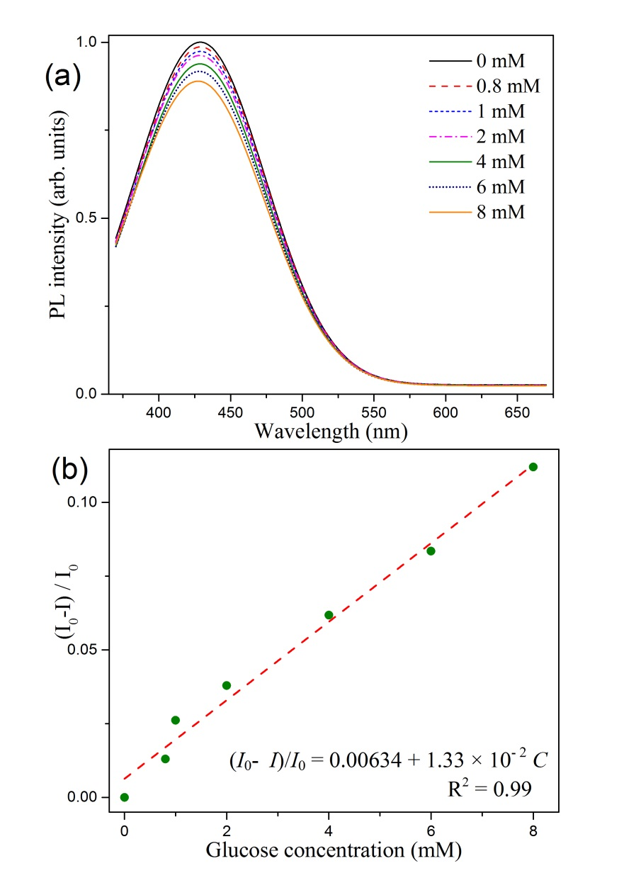
Figure S2. (a) The PL spectra of WS₂ QDs under 360 nm irradiation with different amounts of glucose. (b) The correlation between PL quenching ratios and the concentration of glucose.

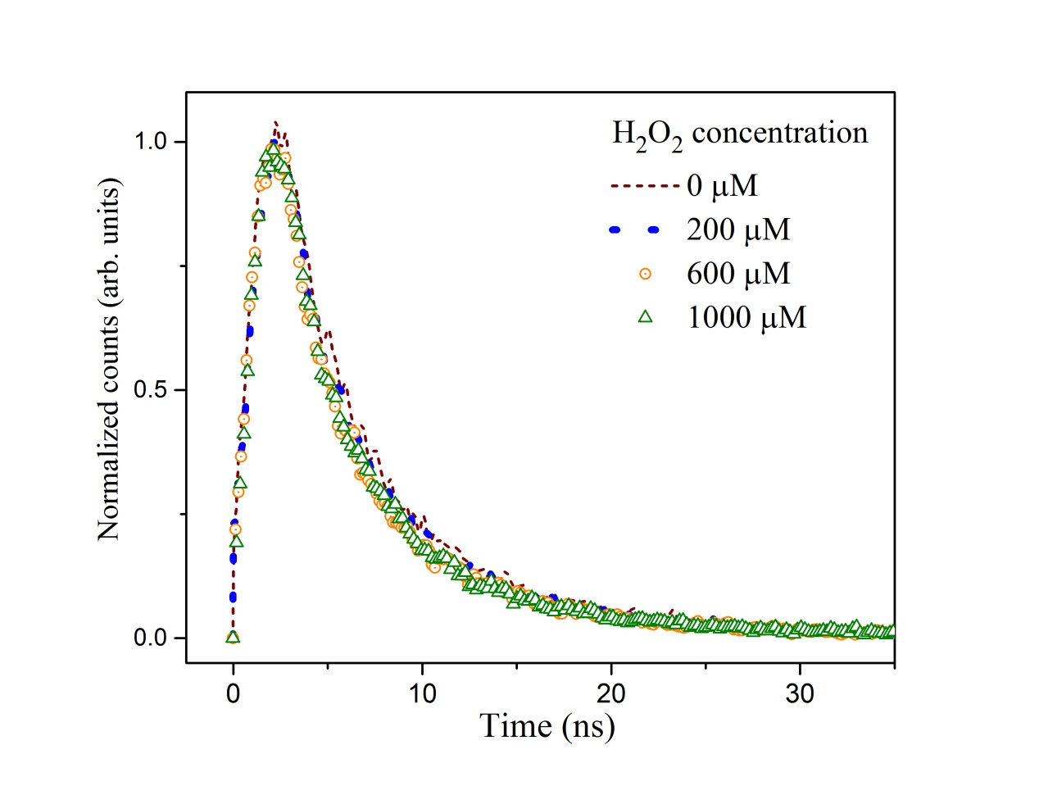
Figure S3. Time-resolved PL spectra of WS₂ QDs treated with an increasing concentration of hydrogen peroxide.

H₂O₂ concentration (μM) | 0 | 200 | 600 | 1000
Lifetime | 3.51 | 3.62 | 3.71 | 3.52

Table S1. Calculated lifetime of TRPL spectra of CD/WS₂ QDs treated with varied concentration of hydrogen peroxide.

