Supplementary Materials
A single- nuclei RNA sequencing study of Mendelian and sporadic AD in the human brain
Jorge L. Del-Aguila^{a,b,d}, Zeran Li^{a,b,d}, Umber Dube^{a,b,d}, Kathie A. Mihindukulasuriya^{a,d}, John P Budde^{a,b,d}, Maria Victoria Fernandez^{a,b,d}, Laura Ibanez^{a,b,d}, Joseph Bradley^{a,b,d}, Fengxian Wang^{a,b,d}, Kristy Bergmann^{a,b}, Richard Davenport^{a,b}, John C Morris^{b,c,e}, David Michael Holtzman^{b,c,e}, Richard J. Perrin^{b, c,,f}, Bruno A. Benitez^{a,d}, Joseph Dougherty^{g}, Carlos Cruchaga^{a,b,c,d*} , Oscar Harari^{a,b,c,d*}

Affiliations:
ªDepartment of Psychiatry, Washington University School of Medicine, St. Louis, MO, USA
^{b}Hope Center for Neurological Disorders, Washington University School of Medicine, St. Louis, MO, USA
^{c}Knight Alzheimer’s Disease Research Center, Washington University School of Medicine, St. Louis, MO, USA;
^{d}NeuroGenomics and Informatics, Department of Psychiatry Washington University in St. Louis
^{e}Department of Neurology, Washington University School of Medicine, St. Louis, MO, USA
^{f}Department of Pathology and Immunology, Washington University School of Medicine, St. Louis, MO, USA
^{g}Department of Genetics, Washington University School of Medicine, St. Louis, MO, USA

* To whom correspondence should be addressed:

Carlos Cruchaga, PhD
Professor Dep. of Psychiatry, Genetics and Neurology
Washington University School of Medicine
Campus Box 8134 | 425 S. Euclid Ave |BJC Institute of Health |Office: 9607 | St. Louis, MO 63110
Tel: (314) 286-0546 | Fax: (314) 362-2244
Email: cruchagac@wustl.edu

Oscar Harari, PhD
Assistant Professor
Department of Psychiatry
Washington University School of Medicine
Campus Box 8134 | 425 S. Euclid Ave |BJC Institute of Health |Office: 9615 | St. Louis, MO 63110
Tel: 314-273-1862 | Fax: 314-362-2244
Email: harario@wustl.edu

Jorge L Del-Aguila: del-aguila@wustl.edu
Zeran Li: zeranli@wustl.edu
Umber Dube: udube@wustl.edu
Kathie A. Mihindukulasuriya: mihindu@wustl.edu
John P Budde: budde@wustl.edu
Maria Victoria Fernandez: fernandezv@wustl.edu
Laura Ibanez: ibanezl@wustl.edu
Joseph Bradley: josephbradley@wustl.edu
Fengxian Wang: wang.fengxian@wustl.edu
Kristy Bergmann: k.bergmann@wustl.edu
Richard Davenport: r.davenport@wustl.edu
‎John C. Morris: jcmorris@wustl.edu
David M. Holtzman: ‎holtzman@wustl.edu
Bruno A. Benitez: babenitez@wustl.edu
Richard J. Perrin: rperrin@wustl.edu
Joseph Dougherty: jdougherty@wustl.edu
Carlos Cruchaga: cruchagac@wustl.edu
Oscar Harari: harario@wustl.edu

Table S1: 118 Cell type markers for Hicat Gene Marker
Cell-Type | Marker
Astrocytes | RYR3
 | LRRC16A
 | GPR98
 | F3
 | ETNPPL
 | CLU
 | SLC1A2
 | GJA1
 | DIO2
 | SLC4A4
 | EDNRB
 | AQP4
 | GPR37L1
 | ALDOC
 | CPE
 | ATP1B2
 | SLCO1C1
Endotheial cells | DCN
 | RGS5
 | ABCG2
 | TM4SF1
 | APOLD1
 | SDPR
 | FN1
 | NET1
Microglia | B3GNT5
 | CLEC7A
 | CCL4L1
 | C3AR1
 | CX3CR1
 | CD74
 | HLA-DRA
 | PLEK
 | LHFPL2
 | HAVCR2
 | LCP1
 | CD53
 | GPR183
 | OLR1
 | CH25H
 | IL1B
 | CD83
 | MSR1
 | CCL4
 | C3
Neurons | SYNPR
 | DLX6-AS1
 | SCN2A
 | SYT1
 | SNAP25
 | RTN1
 | RELN
 | STMN2
 | VSNL1
 | GAD1
 | GABRB2
 | UCHL1
 | SCG2
 | GABRA1
 | CNR1
 | PCLO
Oligodendrocytes | SEPT4
 | PLP1
 | TF
 | ENPP2
 | SLC24A2
 | TTLL7
 | UGT8
 | CLDND1
 | ERMN
 | MBP
 | CNDP1
 | SCD
 | MOBP
 | OPALIN
 | ANLN
 | SLAIN1
 | CNP
 | SLC44A1
 | SOX2-OT
 | TMEM144
 | PIP4K2A
 | TULP4
 | QDPR
OPC | PDGFRA
 | CNTN1
 | TNR
Layer 2 | GLRA3
Layer 2.3 | ACVR1C
 | LAMP5
 | CARTPT
Layer 2.4 | CUX2
 | THSD7A
Layer 2.6 | RASGRF2
 | PVRL3
Layer 3.4 | PRSS12
Layer 4 | PRR16
Layer 4.5 | RORB
Layer 4.6 | GRIK4
Layer 5 | KCNK2
 | SULF2
 | PCP4
 | HTR2C
 | FEZF2
Layer 5.6 | TOX
 | ETV1
 | RPRM
 | RXFP1
 | FOXP2
Layer 6 | SYT6
 | OPRK1
 | NR4A2
 | TLE4
 | NTNG2
 | ADRA2A
 | NXPH3
 | NXPH4

Table S2: Cell-type markers
Cell Type | Markers | Log Fold Change | Adjusted  p-value
Astrocytes | F3 | 0.40 | <2.23×10⁻³⁰⁸
 | ETNPPL | 0.64 | <2.23×10⁻³⁰⁸
 | SLC1A2 | 2.46 | <2.23×10⁻³⁰⁸
 | GJA1 | 0.67 | <2.23×10⁻³⁰⁸
 | EDNRB | 0.26 | 3.06×10⁻¹²²
Microglia | CLEC7A | 0.13 | <2.23×10⁻³⁰⁸
 | C3AR1 | 0.09 | <2.23×10⁻³⁰⁸
 | CX3CR1 | 0.57 | <2.23×10⁻³⁰⁸
 | CD74 | 0.50 | <2.23×10⁻³⁰⁸
 | LHFPL2 | 0.73 | 5.12×10⁻¹⁷⁸
 | LCP1 | 0.21 | <2.23×10⁻³⁰⁸
Endothelial cells | ABCG2 | 2.11 | <2.23×10⁻³⁰⁸
 | TM4SF1 | 1.11 | <2.23×10⁻³⁰⁸
 | SDPR | 1.25 | <2.23×10⁻³⁰⁸
 | FN1 | 1.38 | 1.44×10⁻²⁰⁴
 | NET1 | 1.81 | 2.13×10⁻¹³²
Neurons | DLX6-AS1 | 0.10 | 5.48×10⁻⁰⁹
 | SCN2A | 0.53 | <2.23×10⁻³⁰⁸
 | SYT1 | 0.79 | <2.23×10⁻³⁰⁸
 | SNAP25 | 0.58 | <2.23×10⁻³⁰⁸
 | RTN1 | 0.40 | <2.23×10⁻³⁰⁸
 | STMN2 | 0.42 | 2.94×10⁻²⁴⁰
 | VSNL1 | 0.48 | <2.23×10⁻³⁰⁸
 | GAD1 | 0.16 | 1.60×10⁻²⁷
 | GABRB2 | 0.65 | <2.23×10⁻³⁰⁸
 | UCHL1 | 0.24 | 2.21×10⁻⁷⁵
 | GABRA1 | 0.46 | <2.23×10⁻³⁰⁸
 | CNR1 | 0.18 | 3.32×10⁻⁰⁵
Oligodendrocytes | PLP1 | 2.65 | <2.23×10⁻³⁰⁸
 | TF | 1.95 | <2.23×10⁻³⁰⁸
 | ENPP2 | 1.52 | <2.23×10⁻³⁰⁸
 | UGT8 | 1.66 | <2.23×10⁻³⁰⁸
 | ERMN | 1.19 | <2.23×10⁻³⁰⁸
 | MBP | 2.19 | <2.23×10⁻³⁰⁸
 | CNDP1 | 1.40 | <2.23×10⁻³⁰⁸
 | SCD | 1.29 | <2.23×10⁻³⁰⁸
 | MOBP | 1.76 | <2.23×10⁻³⁰⁸
OPC | PDGFRA | 0.70 | <2.23×10⁻³⁰⁸
 | TNR | 1.84 | 3.19×10⁻¹⁶⁷

Table S3: Cerebral cortex layer-specific markers
Layer type | Markers
L2 | GLRA3
L2-3 | ACVR1C
 | LAMP5
 | CARTPT
L2-4 | CUX2
 | THSD7A
L2-6 | RASGRF2
 | PVRL3
L3-4 | PRSS12
L4 | PRR16
L4-5 | RORB
L4-6 | GRIK4
L5 | KCNK2
 | SULF2
 | PCP4
 | HTR2C
 | FEZF2
L5-6 | TOX
 | ETV1
 | RPRM
 | RXFP1
 | FOXP2
L6 | SYT6
 | OPRK1
 | NR4A2
 | TLE4
 | NTNG2
 | ADRA2A
 | NXPH3
 | NXPH4

Table S4: Distribution of nuclei per subject using CGS
Subject | Sample1 | Sample2 | Sample3 | Entropy*
Number of total cells | 5,663 | 7,147 | 13,521
Cluster 0 | 18.33% | 34.14% | 0.77% | 1.03
Cluster 1 | 8.79% | 8.87% | 8.68% | 1.58
Cluster 2 | 10.21% | 0.34% | 10.09% | 1.10
Cluster 3 | 0.37% | 0.01% | 13.31% | 0.19
Cluster 4 | 7.33% | 7.16% | 6.58% | 1.58
Cluster 5 | 6.11% | 6.90% | 7.09% | 1.58
Cluster 6 | 3.00% | 4.60% | 6.07% | 1.53
Cluster 7 | 0.81% | 0.77% | 8.88% | 0.76
Cluster 8 | 4.10% | 4.28% | 5.35% | 1.57
Cluster 9 | 7.82% | 3.47% | 3.85% | 1.48
Cluster 10 | 0.09% | 0.00% | 8.17% | 0.11
Cluster 11 | 7.28% | 3.43% | 1.90% | 1.38
Cluster 12 | 3.67% | 4.14% | 1.92% | 1.52
Cluster 13 | 6.04% | 5.11% | 0.24% | 1.12
Cluster 14 | 2.74% | 2.85% | 1.82% | 1.56
Cluster 15 | 3.21% | 1.65% | 2.12% | 1.53
Cluster 16 | 1.24% | 1.30% | 2.86% | 1.47
Cluster 17 | 2.38% | 2.21% | 1.37% | 1.55
Cluster 18 | 0.85% | 0.52% | 2.73% | 1.24
Cluster 19 | 1.13% | 2.63% | 1.24% | 1.47
Cluster 20 | 0.78% | 1.85% | 1.25% | 1.50
Cluster 21 | 1.59% | 0.31% | 1.62% | 1.34
Cluster 22 | 0.67% | 1.48% | 0.53% | 1.44
Cluster 23 | 0.72% | 1.01% | 0.72% | 1.57
Cluster 24 | 0.62% | 0.62% | 0.67% | 1.58
Cluster 25 | 0.12% | 0.35% | 0.18% | 1.45
*Entropy values <1.2 indicates uneven sample representation in the cluster

Table S5: Distribution of nuclei per subject using Hicat Marker Gene
Subject | Sample1 | Sample2 | Sample3 | Entropy*
Number of total cells | 5,663 | 7,147 | 13,521
Cluster 0 | 24.28% | 22.16% | 21.93% | 1.58
Cluster 1 | 16.07% | 11.49% | 23.06% | 1.53
Cluster 2 | 5.60% | 8.74% | 4.53% | 1.53
Cluster 3 | 3.36% | 2.00% | 4.36% | 1.52
Cluster 4 | 3.62% | 6.28% | 1.90% | 1.43
Cluster 5 | 4.29% | 4.14% | 2.57% | 1.55
Cluster 6 | 2.15% | 5.97% | 2.06% | 1.39
Cluster 7 | 2.45% | 2.15% | 3.14% | 1.57
Cluster 8 | 2.38% | 2.46% | 2.98% | 1.58
Cluster 9 | 3.30% | 1.94% | 2.89% | 1.55
Cluster 10 | 3.67% | 2.74% | 2.25% | 1.56
Cluster 11 | 2.91% | 1.37% | 3.22% | 1.50
Cluster 12 | 2.15% | 3.20% | 2.54% | 1.57
Cluster 13 | 2.40% | 5.67% | 1.11% | 1.30
Cluster 14 | 2.97% | 1.55% | 2.96% | 1.53
Cluster 15 | 1.73% | 2.90% | 2.70% | 1.55
Cluster 16 | 2.91% | 2.63% | 2.27% | 1.58
Cluster 17 | 1.40% | 2.29% | 2.89% | 1.53
Cluster 18 | 2.03% | 4.03% | 1.24% | 1.42
Cluster 19 | 1.77% | 1.37% | 2.71% | 1.53
Cluster 20 | 3.67% | 2.14% | 1.27% | 1.46
Cluster 21 | 1.38% | 0.55% | 2.80% | 1.33
Cluster 22 | 1.96% | 1.43% | 1.32% | 1.56
Cluster 23 | 1.54% | 0.77% | 1.30% | 1.53
*Entropy values <1.2 indicates uneven sample representation in the cluster

Table S6: Distribution of nuclei per subject using Consensus Gene Set
Subjects | Sample1 | Sample2 | Sample3 | Entropy*
Number of Total cells | 5,663 | 7,147 | 13,521
Cluster 0 | 16.95% | 27.05% | 18.96% | 1.55
Cluster 1 | 18.67% | 16.97% | 9.74% | 1.53
Cluster 2 | 9.25% | 11.82% | 10.61% | 1.58
Cluster 3 | 9.01% | 3.85% | 14.41% | 1.41
Cluster 4 | 9.43% | 7.61% | 8.82% | 1.58
Cluster 5 | 10.01% | 7.33% | 6.74% | 1.56
Cluster 6 | 6.55% | 7.18% | 7.70% | 1.58
Cluster 7 | 4.82% | 5.61% | 5.09% | 1.58
Cluster 8 | 6.20% | 6.87% | 3.76% | 1.54
Cluster 9 | 1.09% | 0.71% | 7.54% | 0.90
Cluster 10 | 2.93% | 2.49% | 1.60% | 1.54
Cluster 11 | 2.98% | 1.51% | 1.97% | 1.53
Cluster 12 | 0.67% | 0.50% | 1.50% | 1.42
Cluster 13 | 1.32% | 0.14% | 1.38% | 1.23
Cluster 14 | 0.11% | 0.35% | 0.18% | 1.42
*Entropy values <1.2 indicates uneven sample representation in the cluster.

Table S7: Number of cells for Sample1 and Sample2 in each cluster using imputed Consensus Gene Set data
Subject |  | Sample1 | Sample2 | Entropy*
Number of total cells |  | 5,663 | 7,147
Cluster 6 | In_1 | 7.77% | 8.17% | 1.00
Cluster 7 | In_6 | 6.29% | 6.95% | 1.00
Cluster 0 | Ex_1 | 17.36% | 27.16% | 0.96
Cluster 1 | Ex_2 | 18.68% | 17.01% | 1.00
Cluster 3 | Ex_4 | 8.83% | 3.86% | 0.89
Cluster 2 | Ex_5 | 9.27% | 11.70% | 0.99
Cluster 8 | Ex_6 | 6.20% | 6.91% | 1.00
Cluster 4 | Ex_7 | 9.34% | 7.51% | 0.99
Cluster 10 | Ex_8 | 2.95% | 1.53% | 0.93
Cluster 9 | Astrocytes | 1.08% | 0.74% | 0.98
Cluster 5 | Oligodendrocytes | 10.10% | 7.43% | 0.98
Cluster 12 | OPC | 1.32% | 0.14% | 0.45
Cluster 11 | Microglia | 0.71% | 0.53% | 0.99
Cluster 13 | Endothelial | 0.11% | 0.35% | 0.78
Only cluster 12, which includes 85 Oligodendrocytes Precursor Cells, has an uneven distribution of sporadic AD. This suggest that APOE e4 allele does not play a role in the overall clustering of nuclei. *Entropy values for two donors ranges from 0 (uneven) to 1 (even) sample representation in the cluster. In inhibitory neuron, Ex excitatory neuron, OPC Oligodendrocytes Precursor Cells.

Table S8 DAM markers significantly associated with pseudo-time
DAM | pval | qval | pval_Sample1 | qval_Sample1 | pval_Sample2 | qval_Sample2 | pval_Sample3 | qval_Sample3
KIAA1217 | 0 | 0 | 1.7E-104 | 1.9E-102 | 6.5E-09 | 2.6E-07 | 6.4E-87 | 6.4E-85
GLUL | 1.9E-39 | 6.5E-38 | 1.8E-05 | 0.00028 | 4.07E-17 | 2.8E-15 | 1.0E-09 | 1.9E-08
SAMD4A | 4.7E-34 | 1.4E-32 | 3.9E-07 | 8.3E-06 | 0.045 | 0.182 | 1.1E-28 | 4.4E-27
CD74 | 1.5E-31 | 4.1E-30 | 0.000 | 0.0001 | 1.4E-13 | 8.1E-12 | 0.194 | 0.255
SCD | 8.1E-29 | 2.1E-27 | 7.7E-08 | 1.7E-06 | 0.005 | 0.0456 | 0.188 | 0.249
EEF1A1 | 3.6E-25 | 8.5E-24 | 0.000 | 0.003 | 8.5E-07 | 2.6E-05 | 0.010 | 0.033
RFTN1 | 5.7E-24 | 1.3E-22 | 6.4E-16 | 2.9E-14 | 0.025 | 0.130 | 1.7E-20 | 6.2E-19
COX4I1 | 2.3E-22 | 4.7E-21 | 0.025 | 0.095 | 5.7E-05 | 0.001 | 8.6E-08 | 1.3E-06
MYO1E | 1.9E-20 | 3.9E-19 | 1.7E-08 | 4.1E-07 | 0.009 | 0.071 | 3.4E-09 | 6.1E-08
SPP1 | 3.0E-20 | 5.9E-19 | 0.0004 | 0.005 | 0.003 | 0.029 | 4.1E-43 | 2.0E-41
PGAM1 | 4.7E-19 | 8.3E-18 | 0.042 | 0.134 | 2.4E-06 | 6.7E-05 | 0.019 | 0.052
B2M | 6.2E-18 | 1.1E-16 | 0.063 | 0.171 | 0.0002 | 0.004 | 0.021 | 0.057
RHOB | 1.5E-17 | 2.4E-16 | 0.027 | 0.100 | 3.3E-07 | 1.1E-05 | 0.00013 | 0.001
LDLRAD3 | 5.5E-17 | 8.6E-16 | 2.3E-07 | 4.9E-06 | 0.001 | 0.013 | 3.9E-12 | 9.0E-11
PEA15 | 1.0E-16 | 1.5E-15 | 0.031 | 0.111 | 2.6E-06 | 7.3E-05 | 1.4E-12 | 3.4E-11
MAMDC2 | 5.6E-13 | 5.9E-12 | 2.3E-10 | 6.9E-09 | 0.148 | 0.339 | 5.8E-13 | 1.4E-11
CREG1 | 1.0E-12 | 1.0E-11 | 0.211 | 0.339 | 0.004 | 0.038 | 0.021 | 0.055
TPI1 | 1.9E-12 | 1.9E-11 | 0.042 | 0.134 | 0.009 | 0.070 | 0.008 | 0.027
RPL5 | 9.6E-11 | 7.8E-10 | 0.151 | 0.280 | 0.001 | 0.013 | 0.049 | 0.100
RPS14 | 1.1E-10 | 8.9E-10 | 0.030 | 0.107 | 0.014 | 0.091 | 0.030 | 0.073
GHR | 1.4E-10 | 1.1E-09 | 0.000 | 0.000 | 0.014 | 0.091 | 0.000 | 0.000
RPL3 | 8.3E-10 | 5.7E-09 | 0.003 | 0.022 | 0.139 | 0.329 | 0.031 | 0.073
TTYH2 | 5.7E-09 | 3.5E-08 | 0.006 | 0.035 | 0.005 | 0.043 | 0.250 | 0.307
GPR34 | 8.4E-09 | 5.1E-08 | 0.042 | 0.134 | 0.013 | 0.088 | 0.122 | 0.186
RPL11 | 1.2E-08 | 7.4E-08 | 0.028 | 0.102 | 0.107 | 0.290 | 0.178 | 0.240
TMEM163 | 2.1E-08 | 1.2E-07 | 0.000 | 0.001 | 0.574 | 0.697 | 0.000 | 0.000
RPS4X | 2.4E-08 | 1.3E-07 | 0.177 | 0.307 | 0.020 | 0.115 | 0.572 | 0.598
SCPEP1 | 3.7E-08 | 2.0E-07 | 0.002 | 0.017 | 0.039 | 0.169 | 0.246 | 0.304
RPS25 | 7.9E-08 | 4.1E-07 | 0.004 | 0.025 | 0.076 | 0.240 | 0.052 | 0.104
RPS8 | 2.4E-07 | 1.1E-06 | 0.003 | 0.020 | 0.262 | 0.470 | 0.197 | 0.258
PPT1 | 5.3E-07 | 2.3E-06 | 0.110 | 0.234 | 0.686 | 0.776 | 0.138 | 0.202
SERPINE2 | 6.4E-07 | 2.2E-06 | 0.100 | 0.222 | 0.003 | 0.028 | 0.040 | 0.088
DPP7 | 1.1E-06 | 4.4E-06 | 0.031 | 0.111 | 0.110 | 0.294 | 0.045 | 0.096
ATP6V0E1 | 1.5E-06 | 5.8E-06 | 0.060 | 0.167 | 0.003 | 0.029 | 0.091 | 0.152
CXCL14 | 1.8E-06 | 6.7E-06 | 0.228 | 0.355 | 0.648 | 0.750 | 0.551 | 0.579
RNASET2 | 5.4E-06 | 1.9E-05 | 0.228 | 0.355 | 0.002 | 0.021 | 0.355 | 0.402
FAU | 7.2E-06 | 2.4E-05 | 0.136 | 0.264 | 0.235 | 0.442 | 0.092 | 0.152
LDHA | 9.3E-06 | 3.0E-05 | 0.115 | 0.238 | 0.039 | 0.169 | 0.073 | 0.131
CD164 | 1.2E-05 | 3.8E-05 | 0.084 | 0.201 | 0.028 | 0.139 | 0.100 | 0.163
RPLP1 | 1.3E-05 | 4.1E-05 | 0.077 | 0.191 | 0.393 | 0.570 | 0.158 | 0.221
APOE | 1.5E-05 | 4.5E-05 | 0.003 | 0.024 | 0.202 | 0.405 | 0.033 | 0.077
PRDX1 | 1.6E-05 | 4.8E-05 | 0.201 | 0.329 | 0.071 | 0.231 | 0.153 | 0.216
CD83 | 1.9E-05 | 5.6E-05 | 0.002 | 0.018 | 0.522 | 0.660 | 0.404 | 0.445
RPL37 | 3.3E-05 | 9.3E-05 | 0.132 | 0.259 | 0.057 | 0.206 | 0.019 | 0.052
SDF4 | 4.1E-05 | 0.0001 | 0.054 | 0.157 | 0.207 | 0.411 | 0.157 | 0.220
NRP1 | 6.4E-05 | 0.0002 | 0.456 | 0.549 | 0.090 | 0.265 | 1.6E-06 | 1.8E-05
HINT1 | 7.4E-05 | 0.0002 | 0.265 | 0.389 | 0.073 | 0.235 | 0.185 | 0.247
HLA-A | 0.0001 | 0.0003 | 0.383 | 0.488 | 0.654 | 0.753 | 0.396 | 0.439
EGLN3 | 0.0002 | 0.0004 | 0.046 | 0.142 | 0.339 | 0.528 | 0.002 | 0.011
BHLHE40 | 0.0002 | 0.0005 | 0.198 | 0.326 | 0.030 | 0.146 | 0.270 | 0.325
RPLP0 | 0.0003 | 0.0006 | 0.408 | 0.509 | 0.406 | 0.580 | 0.339 | 0.388
LGMN | 0.0003 | 0.0007 | 0.051 | 0.152 | 0.752 | 0.822 | 0.157 | 0.220
EEF1B2 | 0.0004 | 0.0009 | 0.506 | 0.586 | 0.014 | 0.091 | 0.660 | 0.677
BRI3BP | 0.0005 | 0.0011 | 0.225 | 0.352 | 0.164 | 0.362 | 0.009 | 0.030
CTSA | 0.0006 | 0.0013 | 0.069 | 0.179 | 0.048 | 0.190 | 0.128 | 0.191
PLBD2 | 0.0010 | 0.0020 | 0.183 | 0.314 | 0.137 | 0.327 | 0.030 | 0.073
TOX2 | 0.0014 | 0.0025 | 0.287 | 0.408 | 0.723 | 0.800 | 0.190 | 0.252
RAMP1 | 0.0014 | 0.0026 | 0.416 | 0.514 | 0.308 | 0.508 | 0.001 | 0.007
RPL18 | 0.0016 | 0.0028 | 0.258 | 0.383 | 0.173 | 0.374 | 0.770 | 0.777
RPS3 | 0.0027 | 0.0045 | 0.053 | 0.156 | 0.612 | 0.725 | 0.031 | 0.074
RPL14 | 0.0032 | 0.0052 | 0.202 | 0.330 | 0.447 | 0.607 | 0.226 | 0.286
RPS19 | 0.0035 | 0.0056 | 0.062 | 0.170 | 0.215 | 0.420 | 0.421 | 0.461
P2RY13 | 0.0038 | 0.0060 | 0.800 | 0.828 | 0.303 | 0.504 | 0.643 | 0.662
ITGAX | 0.0040 | 0.0063 | 0.298 | 0.419 | 0.116 | 0.302 | 0.100 | 0.163
ANXA5 | 0.0092 | 0.0130 | 0.069 | 0.179 | 0.537 | 0.670 | 0.145 | 0.208
RPL22 | 0.0106 | 0.0147 | 0.400 | 0.503 | 0.119 | 0.306 | 0.148 | 0.211
RPL7 | 0.0125 | 0.0170 | 0.526 | 0.601 | 0.058 | 0.208 | 0.280 | 0.335
SHISA5 | 0.0135 | 0.0183 | 0.887 | 0.904 | 0.286 | 0.492 | 0.088 | 0.148
RPL37A | 0.0140 | 0.0188 | 0.040 | 0.130 | 0.680 | 0.772 | 0.004 | 0.016
CSF2RA | 0.0141 | 0.0190 | 0.512 | 0.590 | 0.957 | 0.969 | 0.621 | 0.642
SH3PXD2B | 0.0142 | 0.0190 | 0.071 | 0.181 | 0.399 | 0.574 | 0.052 | 0.104
RPLP2 | 0.0176 | 0.0230 | 0.243 | 0.369 | 0.099 | 0.278 | 0.385 | 0.429
RPL4 | 0.0226 | 0.0286 | 0.166 | 0.295 | 0.816 | 0.865 | 0.073 | 0.130
IGF1 | 0.0252 | 0.0315 | 0.317 | 0.432 | 0.213 | 0.418 | 0.423 | 0.463
RPS28 | 0.0265 | 0.0330 | 0.494 | 0.578 | 0.476 | 0.628 | 0.230 | 0.290
MAF | 0.0297 | 0.0364 | 0.282 | 0.403 | 0.502 | 0.647 | 0.734 | 0.744
DPYS | 0.0340 | 0.0411 | 0.068 | 0.178 | 0.581 | 0.703 | 0.446 | 0.484
SULF2 | 0.0371 | 0.0444 | 0.113 | 0.237 | 0.757 | 0.825 | 0.115 | 0.179
PTCHD1 | 0.0422 | 0.0495 | 0.370 | 0.476 | 0.523 | 0.661 | 0.019 | 0.052
IFI44 | 0.0570 | 0.0647 | 0.629 | 0.684 | 0.727 | 0.803 | 0.465 | 0.500
RPL10A | 0.0608 | 0.0686 | 0.284 | 0.405 | 0.556 | 0.685 | 0.284 | 0.338
PLEKHH2 | 0.0623 | 0.0701 | 0.016 | 0.070 | 0.651 | 0.752 | 0.608 | 0.630
CREB3L2 | 0.0627 | 0.0705 | 0.158 | 0.286 | 0.462 | 0.618 | 0.164 | 0.227
CD84 | 0.0635 | 0.0713 | 0.293 | 0.414 | 0.388 | 0.567 | 0.802 | 0.807
NPM1 | 0.0945 | 0.1031 | 0.259 | 0.383 | 0.668 | 0.763 | 0.523 | 0.554
CTSS | 0.1104 | 0.1189 | 0.320 | 0.436 | 0.706 | 0.788 | 0.538 | 0.568
DHRS3 | 0.1124 | 0.1210 | 0.854 | 0.875 | 0.620 | 0.730 | 0.205 | 0.265
TXNIP | 0.1282 | 0.1370 | 0.075 | 0.189 | 0.477 | 0.628 | 0.573 | 0.598
DKK2 | 0.3387 | 0.3465 | 0.474 | 0.561 | 0.705 | 0.788 | 0.383 | 0.428
GAS2L3 | 0.4079 | 0.4146 | 0.085 | 0.202 | 0.856 | 0.895 | 0.585 | 0.608
FAM20C | 0.4477 | 0.4537 | 0.507 | 0.586 | 0.606 | 0.719 | 0.380 | 0.425
FLT1 | 0.8162 | 0.8187 | 0.855 | 0.875 | 0.753 | 0.823 | 0.277 | 0.332

Figures

Figure S1: Single Nuclei after extraction from sample1.
Figure S2: DotPlot depicting expression of marker genes selected from the literature (see methods-Online Resource Table S2 and Table S3) on Classic Gene Set data.
Figure S3: Hicat Gene Markers Dimensional Reduction approach. . Panel A) TSNE plots depicting 26,331 nuclei in 23 clusters and Panel B) DotPlot depicting expression of markers genes selected by literature (see methods-Online Resource Table S2 and Table S3).
Figure S4: DotPlot depicting expression of marker genes. Marker genes were selected by literature (see methods-Online Resource Table S2 and Table S3) on Consensus Gene Set data prior gene expression imputation
Figure S5: Coincidence Analysis between Consensus Gene Set and its gene expression imputed counterpart. This plot summarizes how the nuclei are (dis)similarly clustered by the two approaches. All of the clusters learned by the Consensus Gene Set approach are represented along the X axis, and along the Y axis the clusters from the imputed gene expression. The Jaccard index for each pair is represented by the size of the circle (the bigger the higher value), and the color represents the pointwise mutual information (blue: low values; red: high values). All of the clusters in the non-imputed data were also identified when we re-analyzed the imputed data, with the exception of two neuronal clusters (7 and 10) that were merged into a single cluster (cluster 6).
Figure S6: Coincidence Analysis between Classic Gene Set and its Consensus Gene Set. This plot summarizes how the nuclei are (dis)similarly clustered by the two approaches. All of the clusters learned by the Consensus Gene Set approach are represented along the X-axis and along the Y-axis the clusters from the imputed gene expression. The Jaccard index for each pair is represented by the size of the circle (the bigger the higher value), and the color represents the pointwise mutual information (blue: low values; red: high values). Both approaches identified clusters similarly for Endothelial cells, OPC, Microglia and Astrocytes. Neural cells from CGS approach were reorganized into clusters also annotated as neuronal by the Consensus Gene Set approach (shown in boxes).
Figure S7: Entropy Data. Graphical representation of Entropy values for the three cell clusters methodologies used. On the y-axis are nuclei counts, on x-axis are Entropy values from 0 to 1.58. Sample 3 is overrepresented in cluster 9 for the ConGen as well as in cluster 7 for the CGS in both cases these clusters were annotated as Astrocytes.
Figure S8: Multimodal distributions of unique molecular identified (UMI) per nuclei.

Figure S1

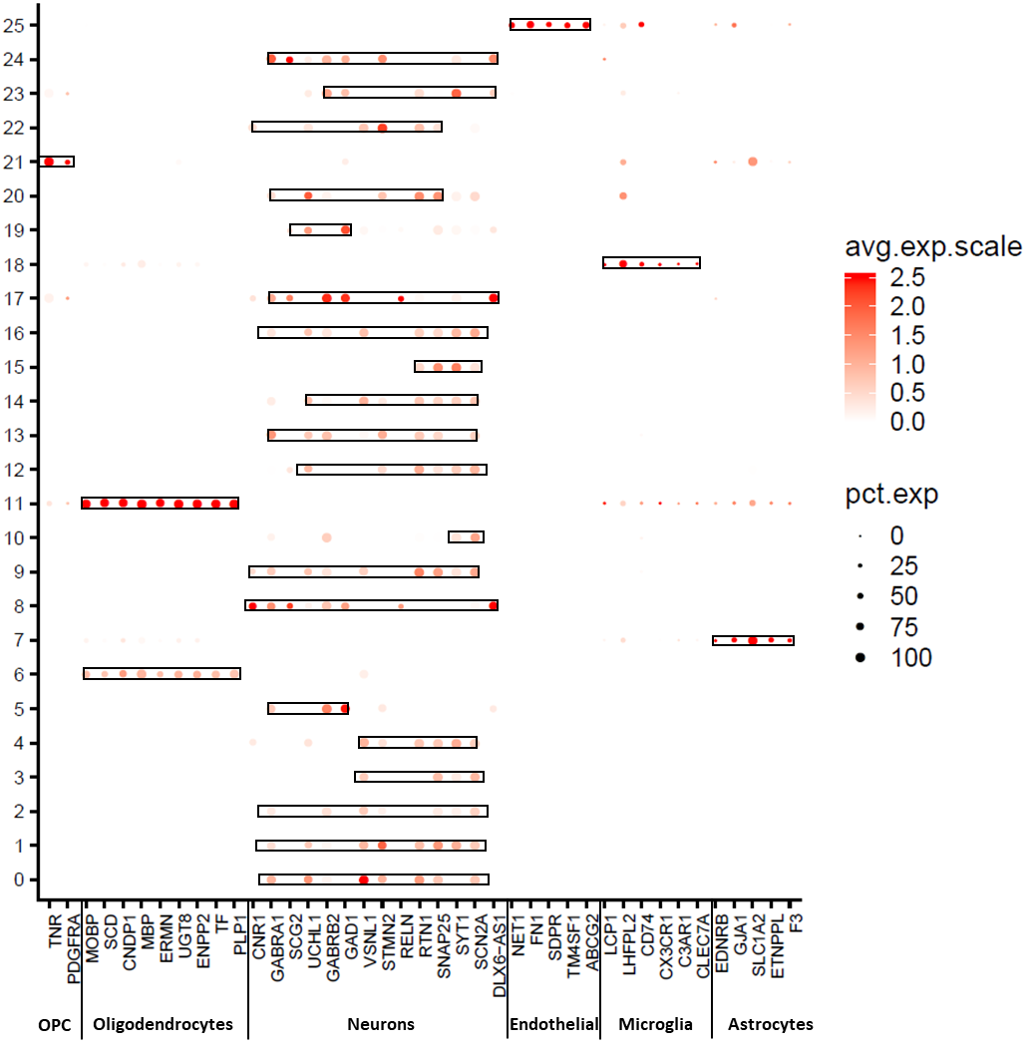
Figure S2

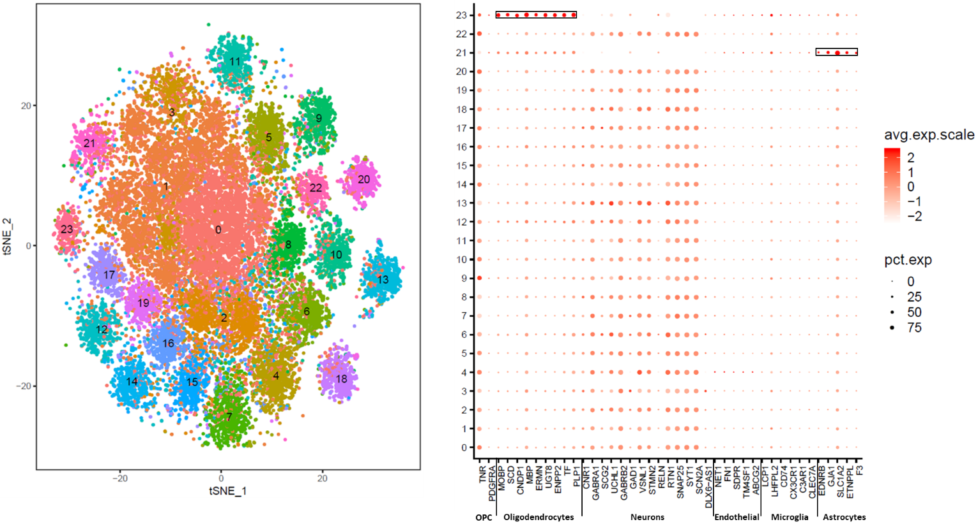
Figure S3

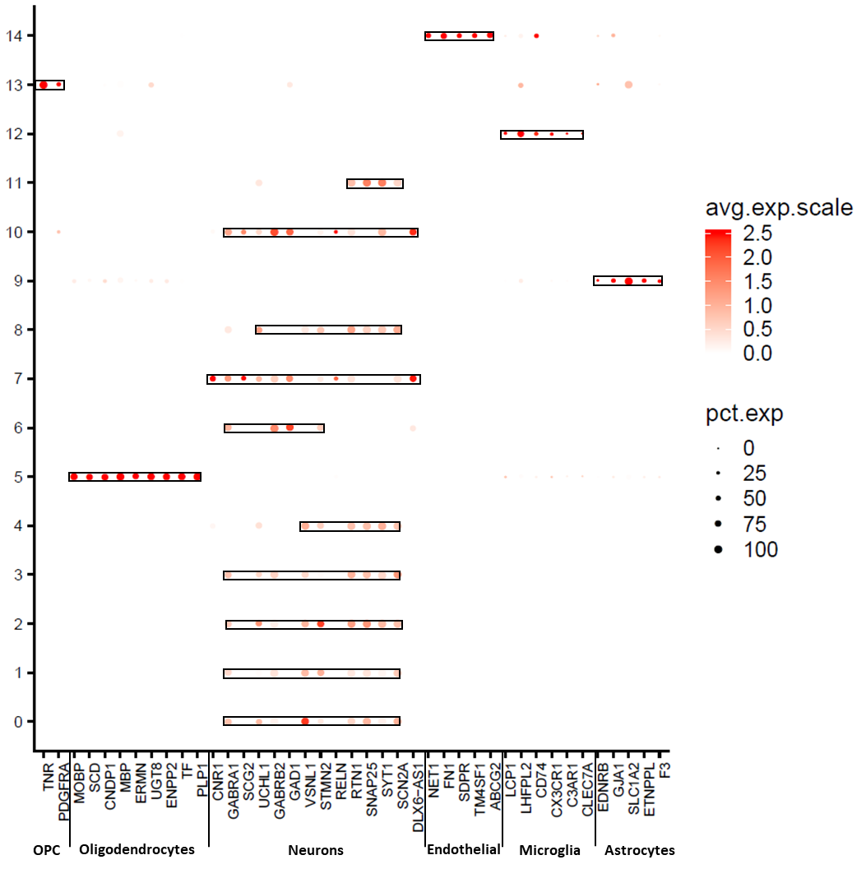
Figure S4

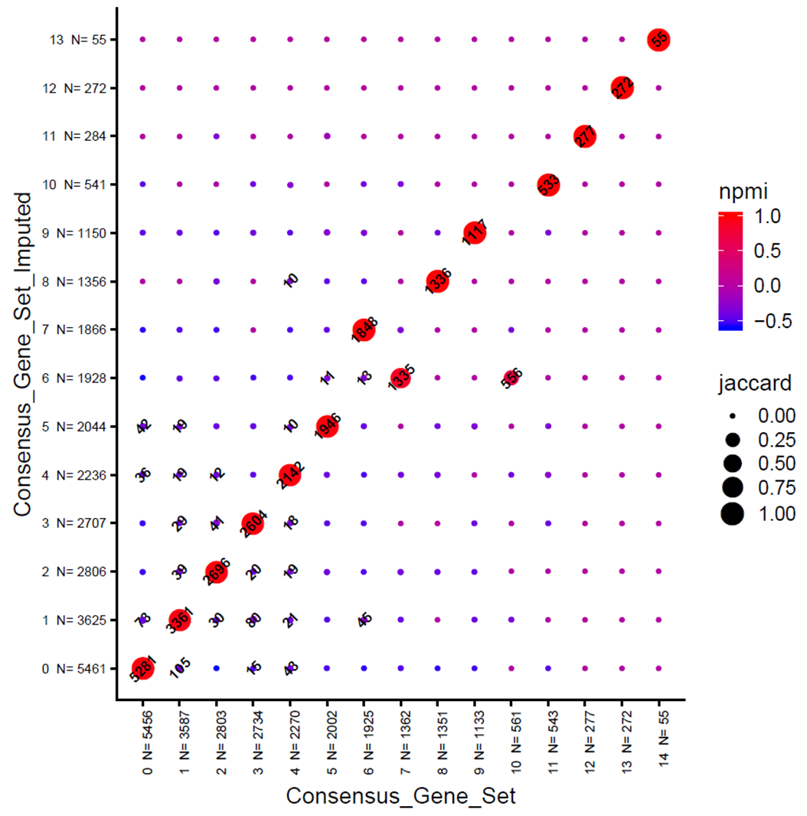
Figure S5

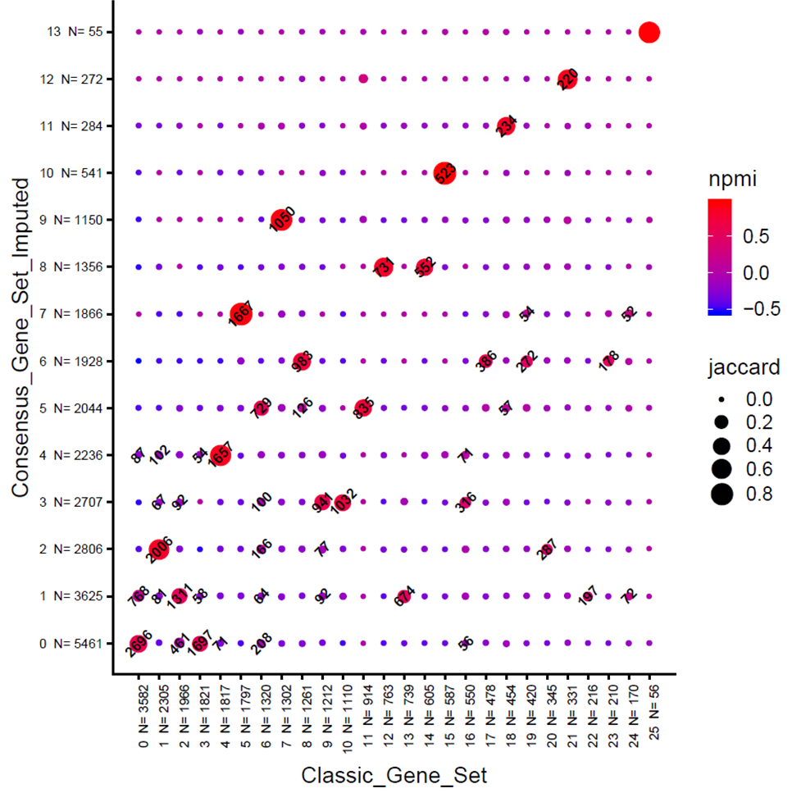
Figure S6

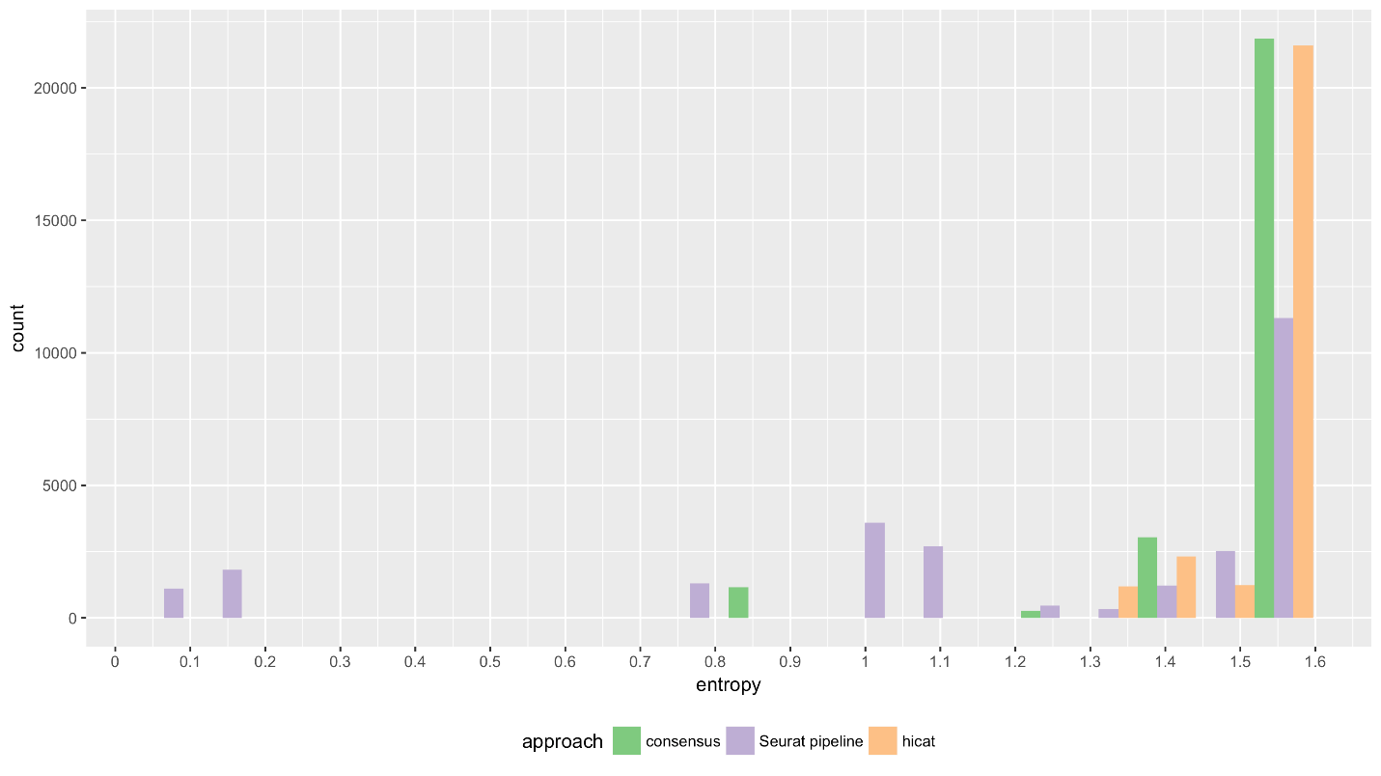
Astrocytes
Cluster 9
Cluster 7
Hicat
CGS
ConGen
Figure S7

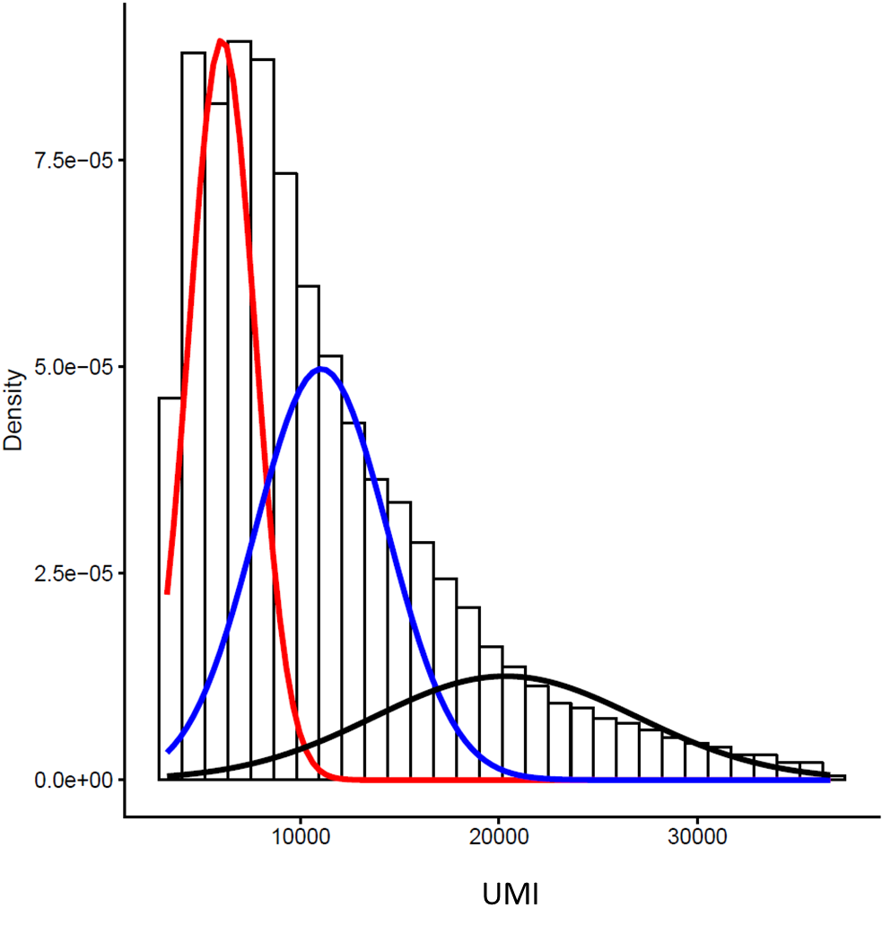
Figure S8

