Additional File 3: Additional meta-analysis results in Forest Plots

Figure S1 All interventions compared to control – mortality outcomes

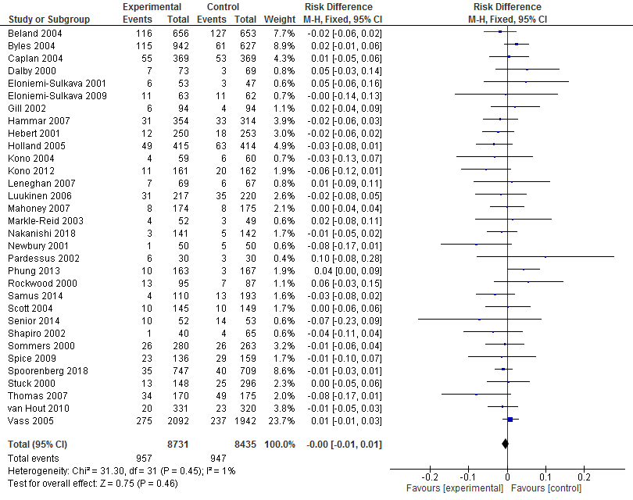

Figure S2 All interventions compared to control – quality of life

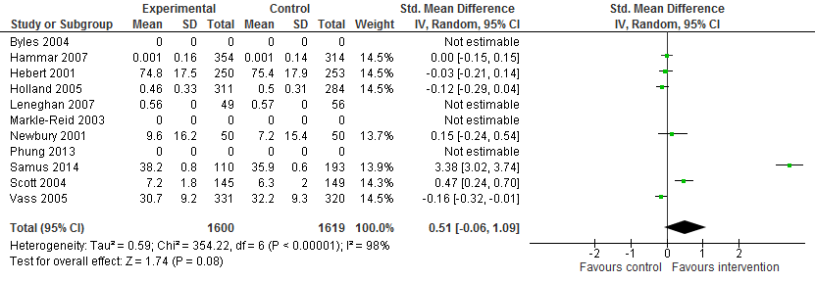

Figure S4 Dementia specific interventions compared to control – mortality
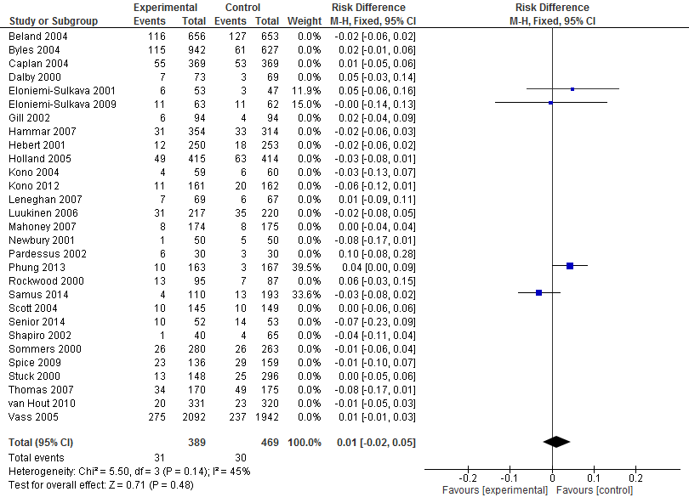
Note studies with 0% are not dementia specific interventions.

Figure S5 Dementia specific interventions compared to control – quality of life

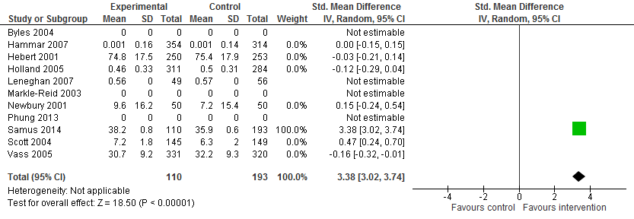
Note studies with 0% are not dementia specific interventions.

Figure S6 Restorative interventions compared to control – RAC admissions
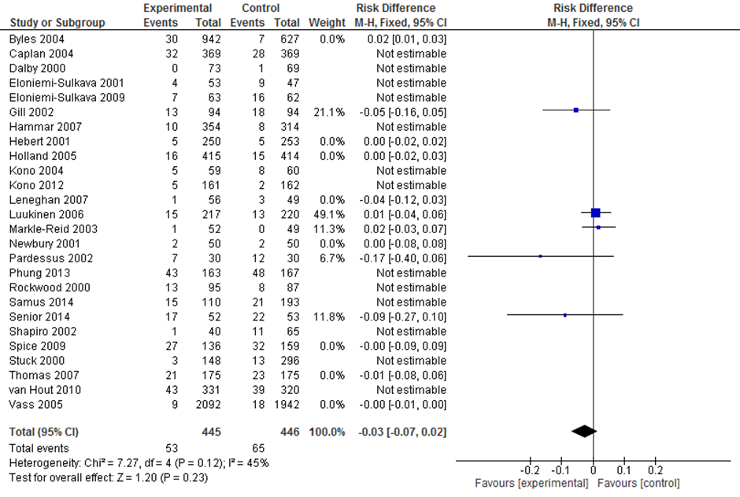
Note studies with 0% are not restorative interventions.

