Additional Information
Databases
PubChem HTS assays. List of assays used for HTSFP generation attached: Pubchem_assay_list.txt
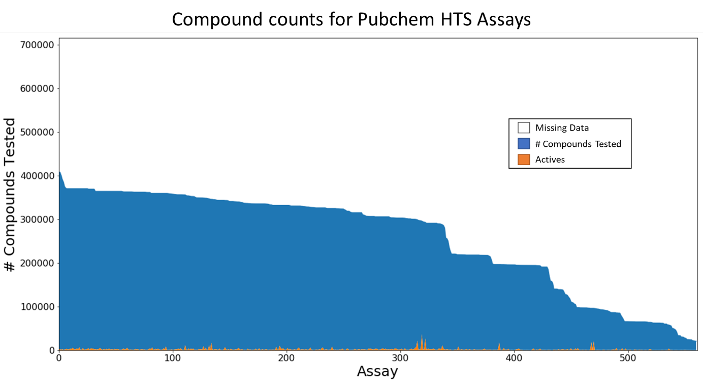Figure S1. Overview of PubChem HTS data. 582 unique assays were used, and 715,326 unique compounds were identified. White space refers to the number of compounds not tested for a given assay (missing data), blue space refers to the count of compounds marked as ‘not active’, and orange space refers to the count of compounds marked as ‘active’.

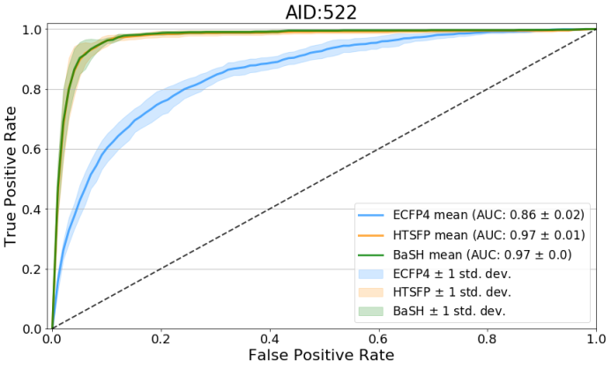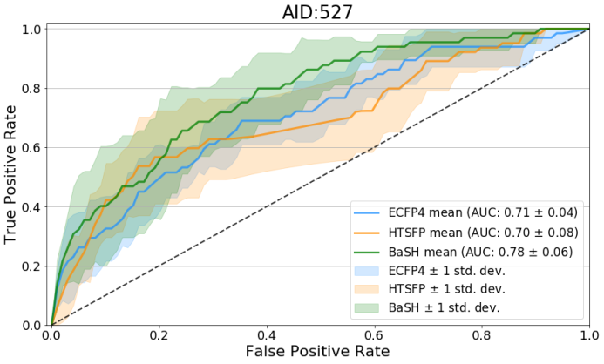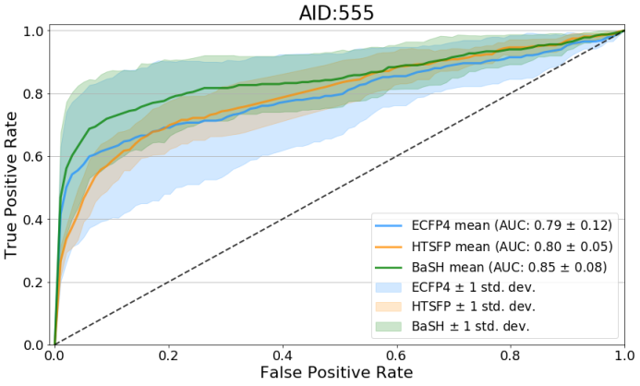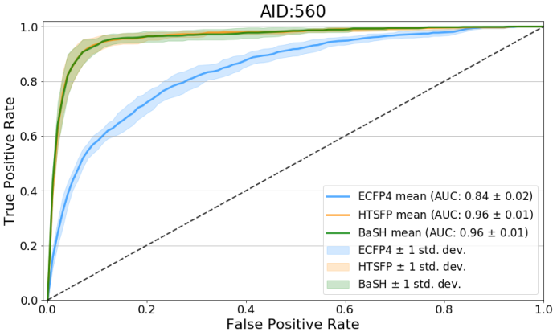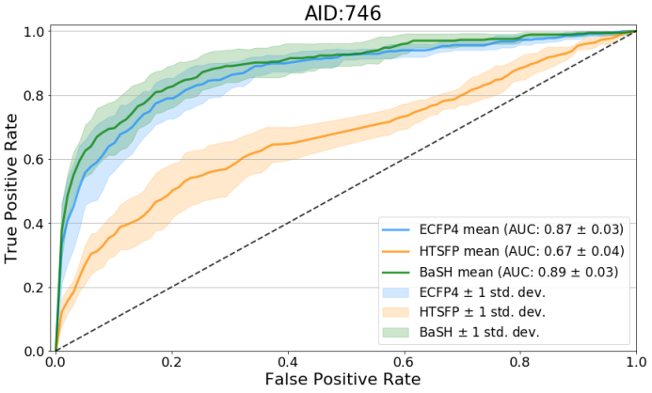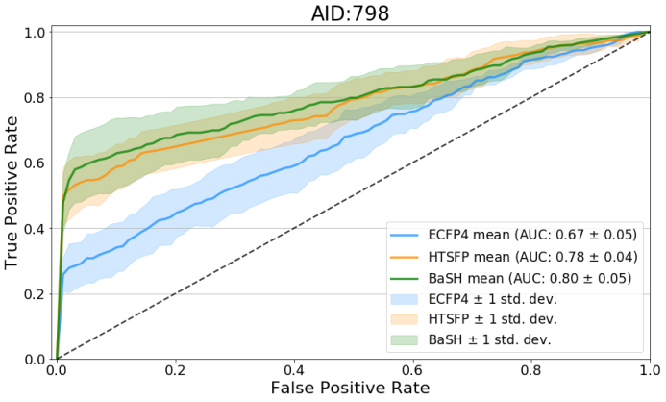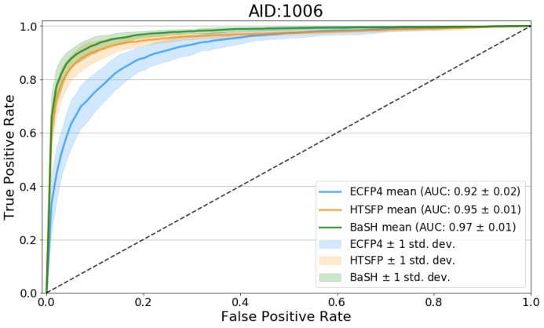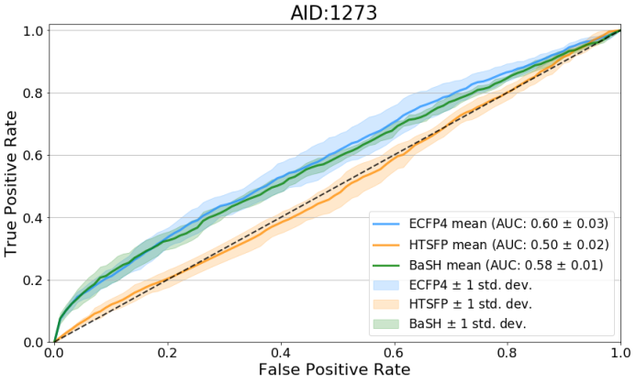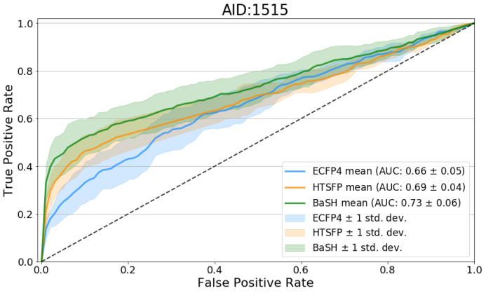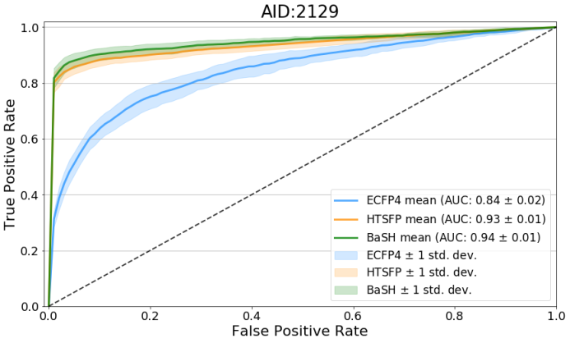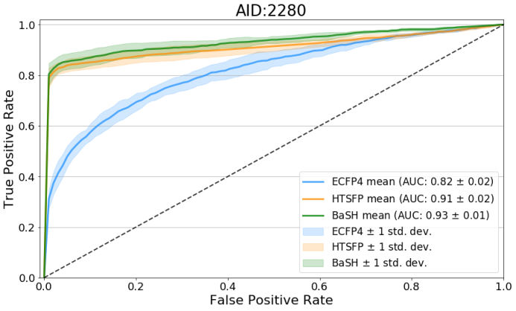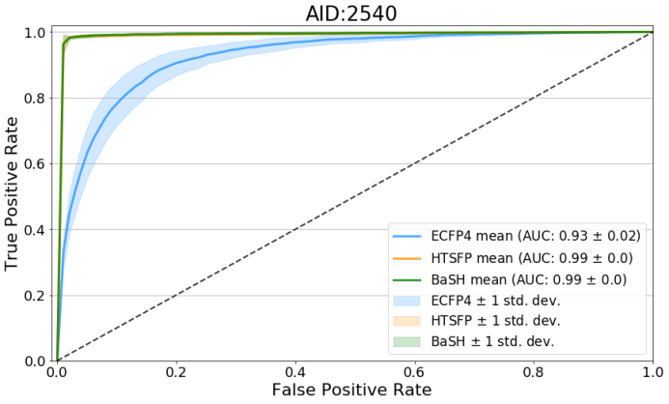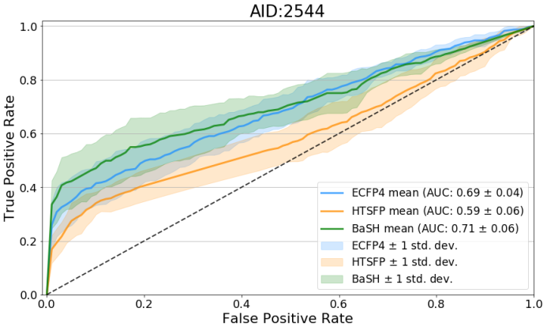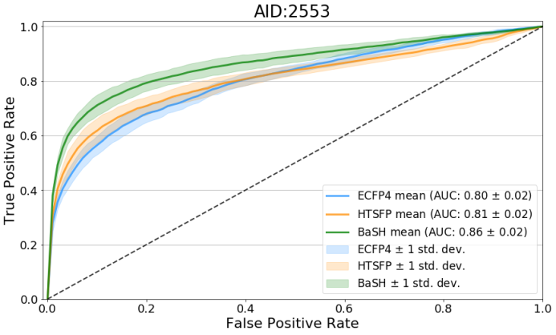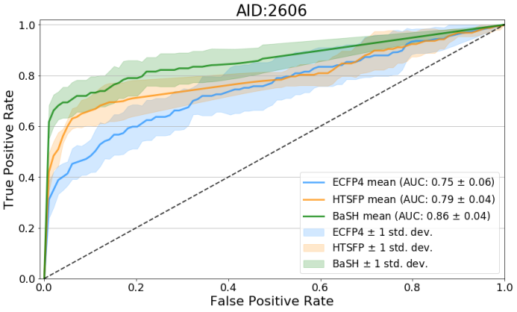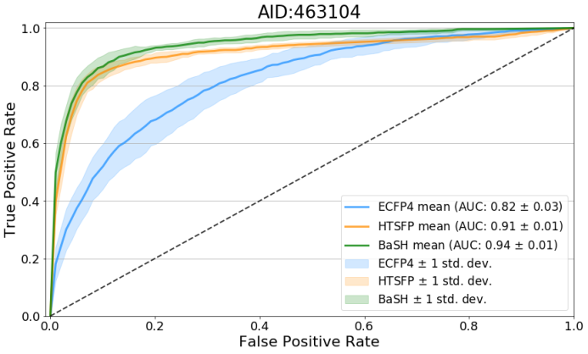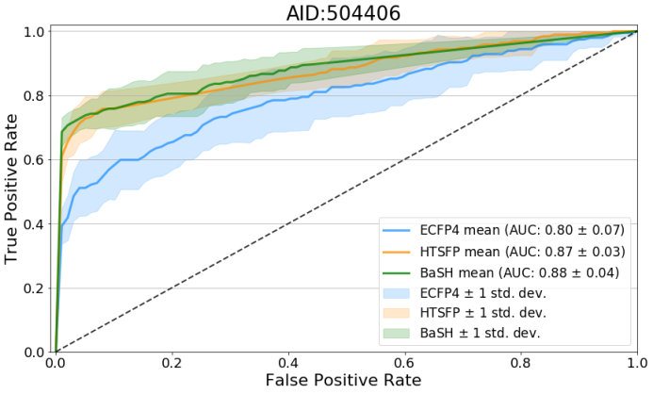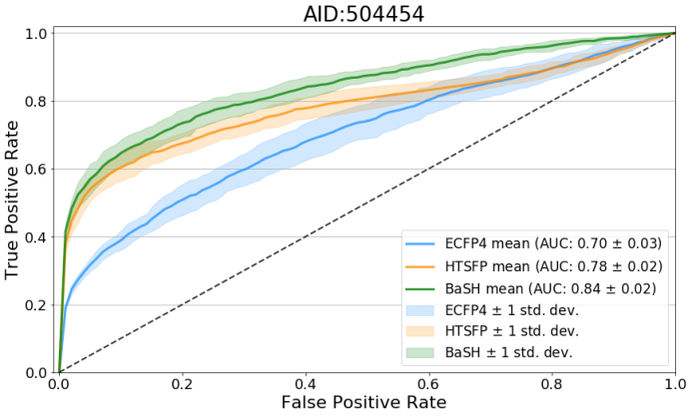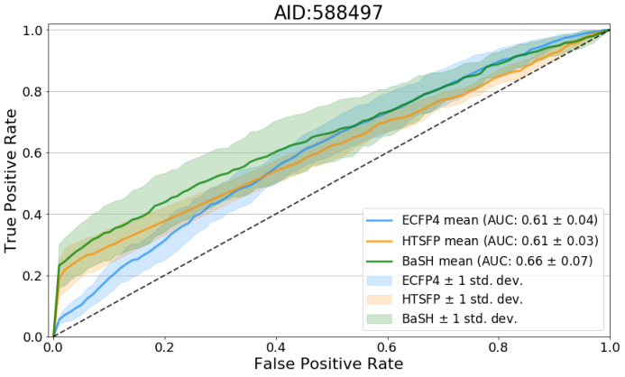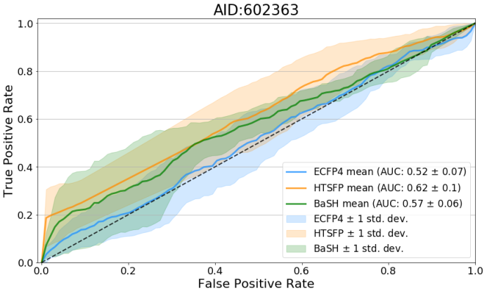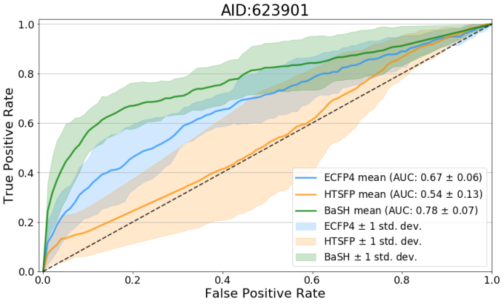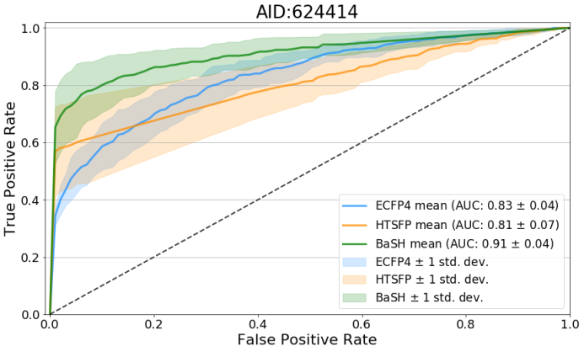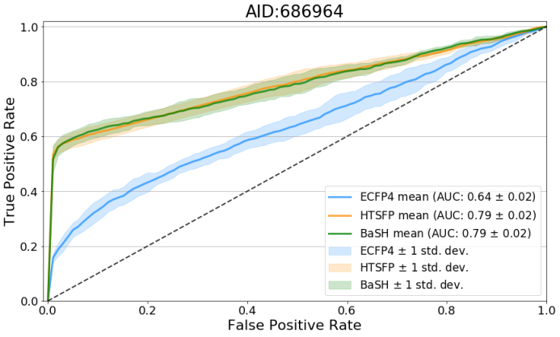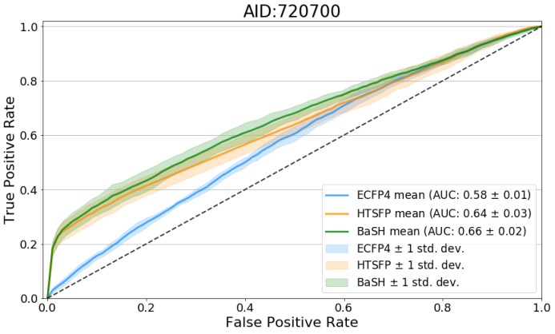
Figure S2. ROC curves of the 25 assays in the validation set, shown are the results of the random forest predictions for the three different descriptor types, ECFP, HTSFP, and BaSH (blue, orange, and green respectively). The solid line and the shaded area represents the

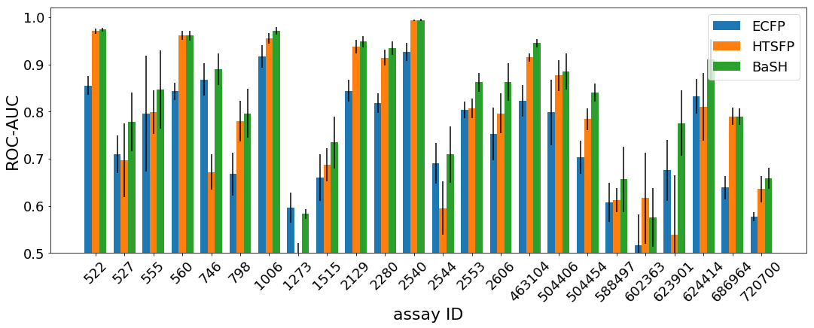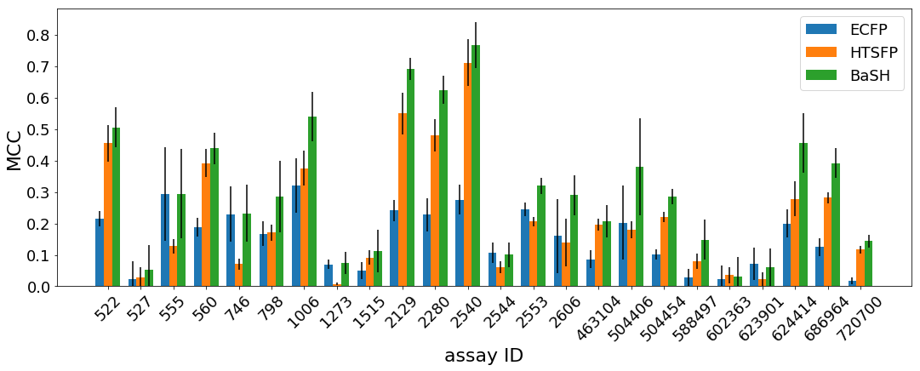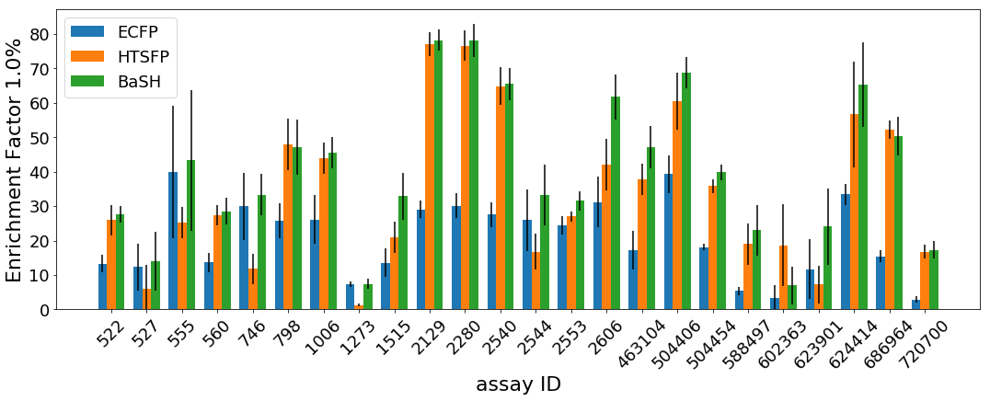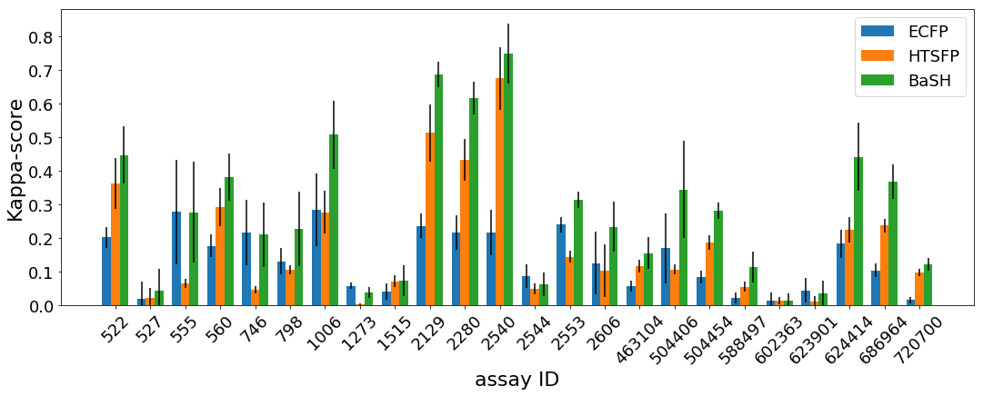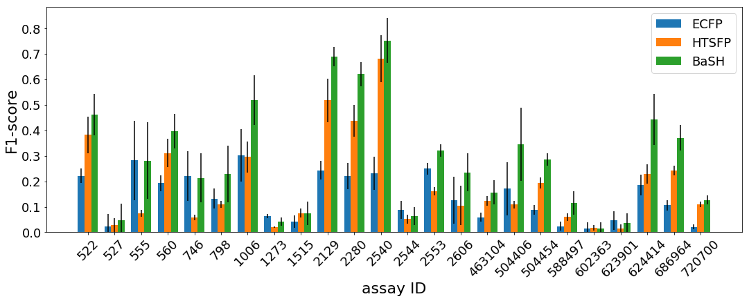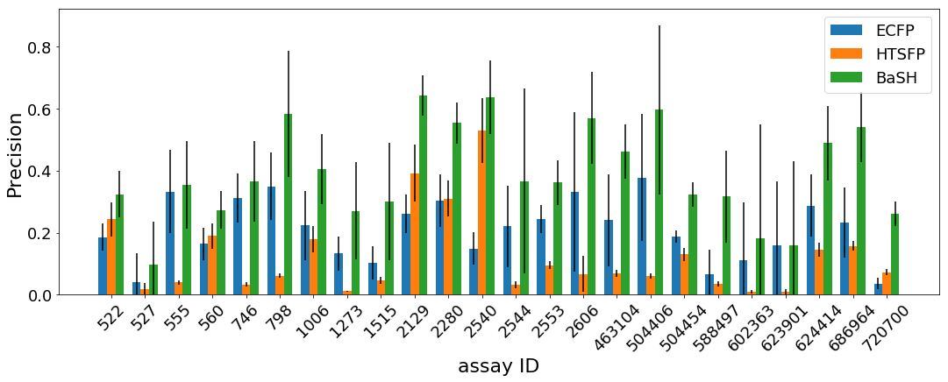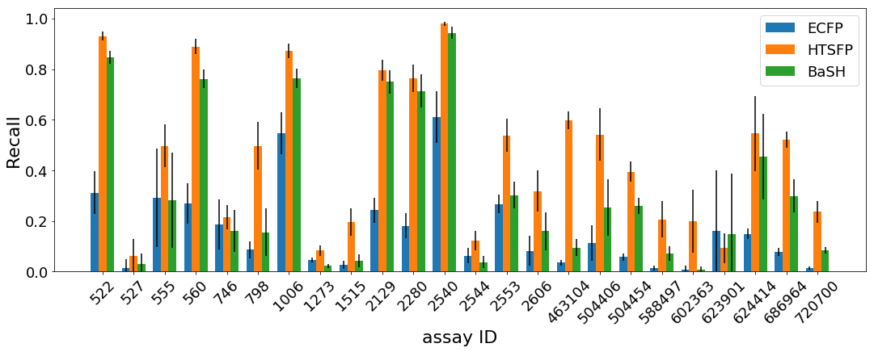Figure S3. Bar plots of performance metrics for each of the 25 validation set assays. ROC AUC, Matthews’s correlation coefficient, Kappa score, F1-score, Precision, Recall, and enrichment factors.
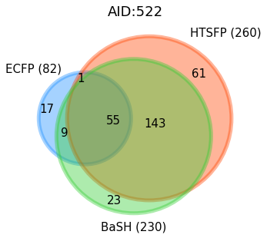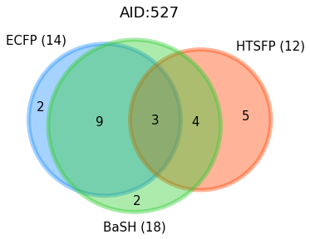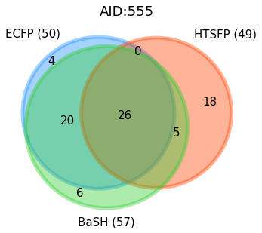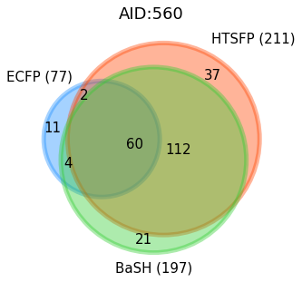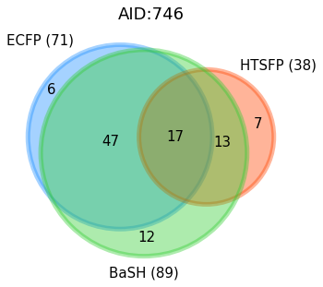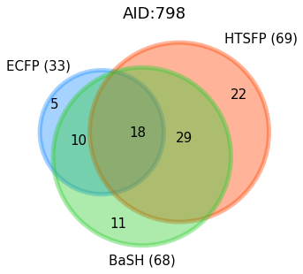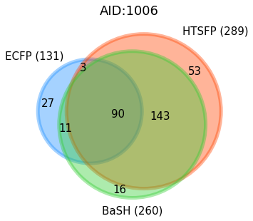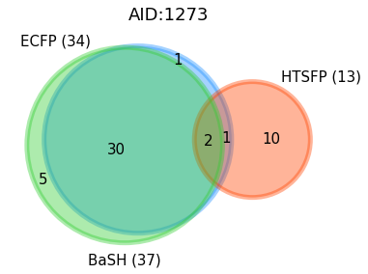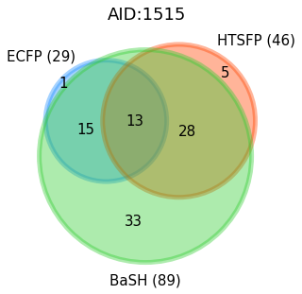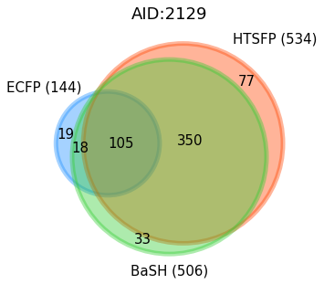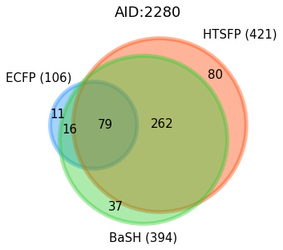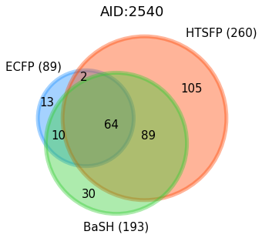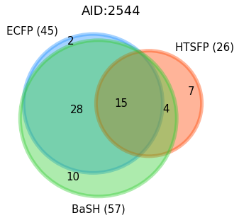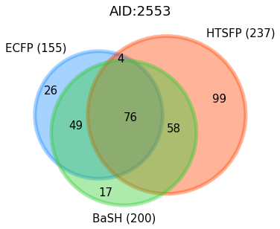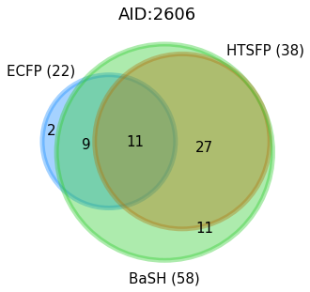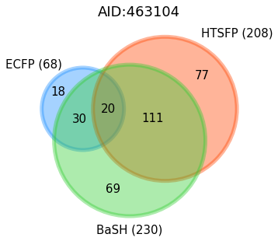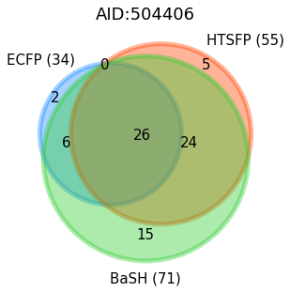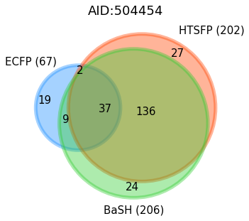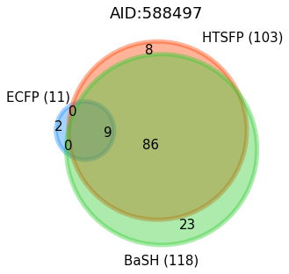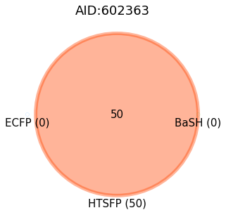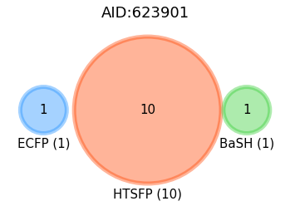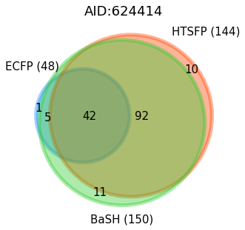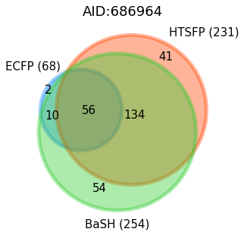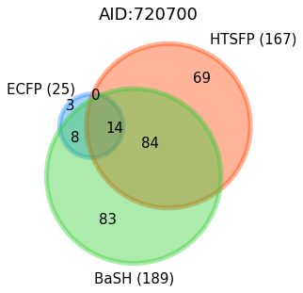 Figure S4. Venn diagrams showing the number of unique topological scaffolds in the top scoring 1% of predictions. Each circle represents one of the three predictive models: BaSH, HTSFP, and ECFP4 (green, orange, blue respectively).

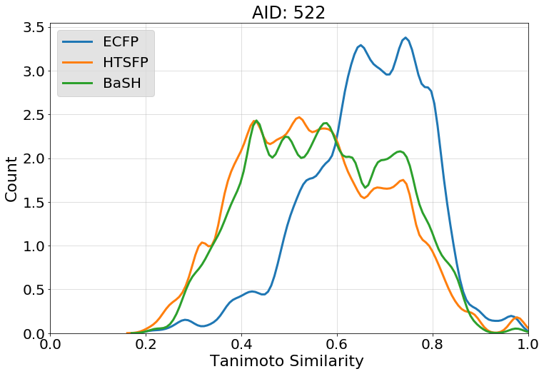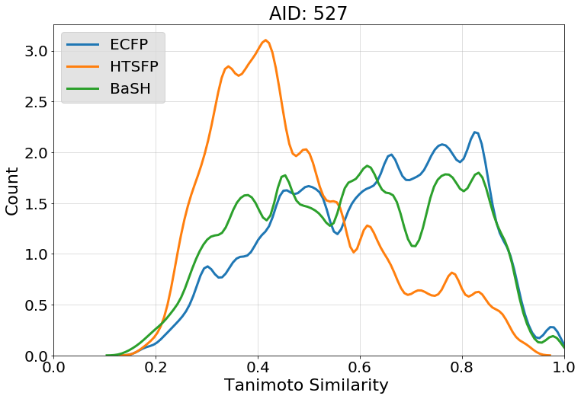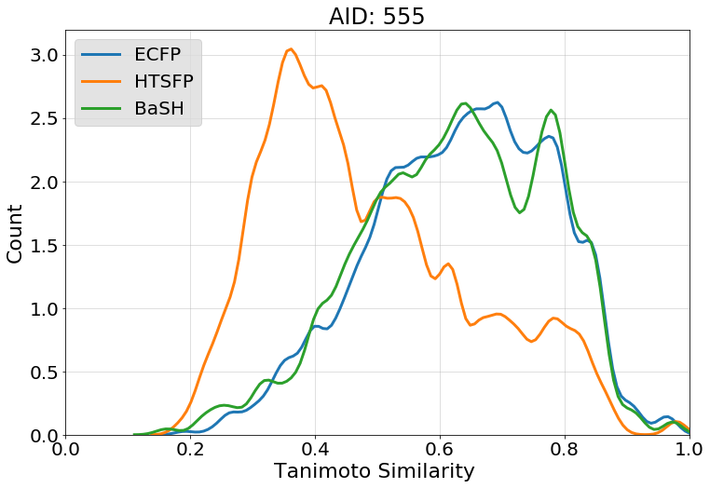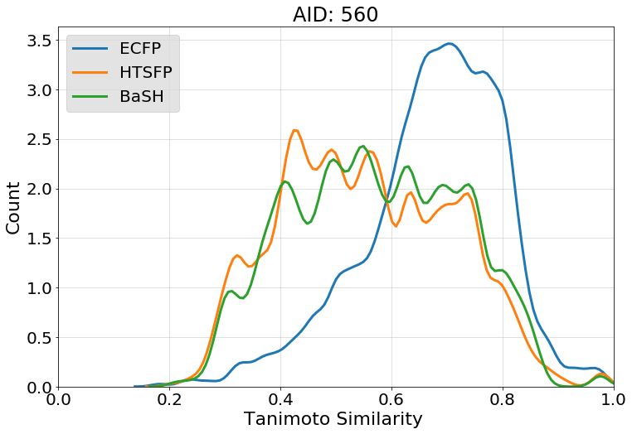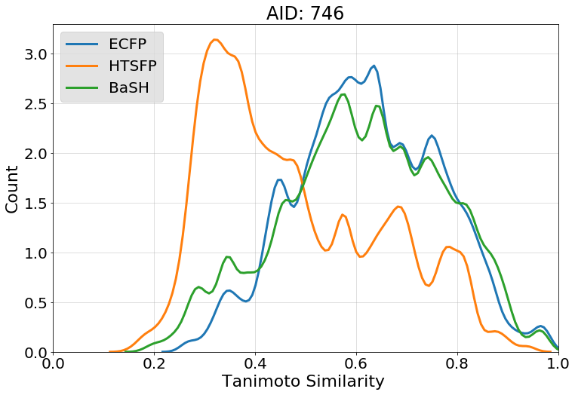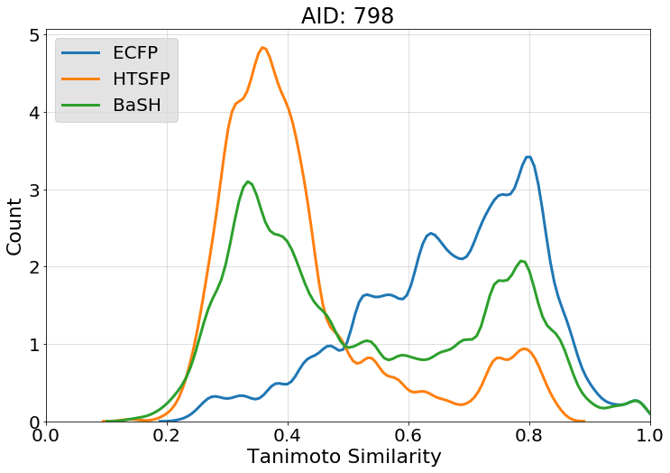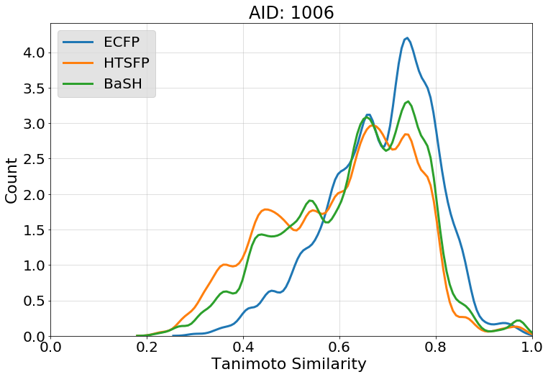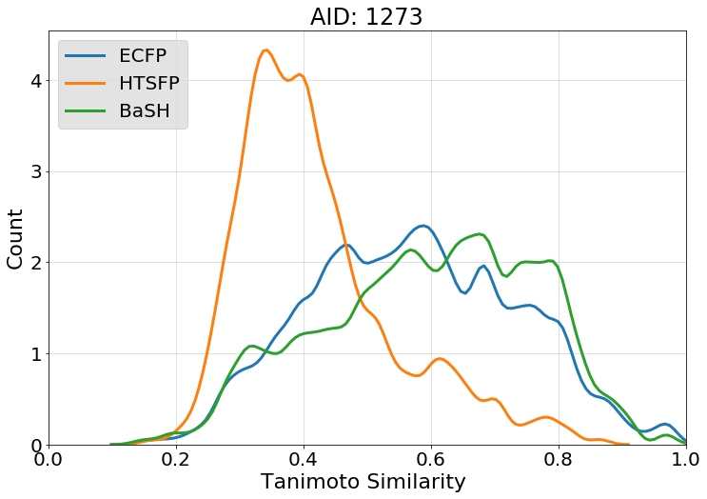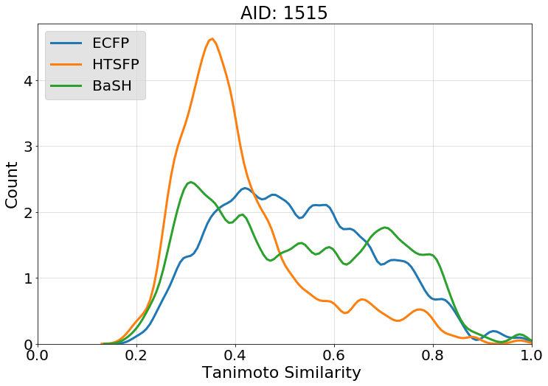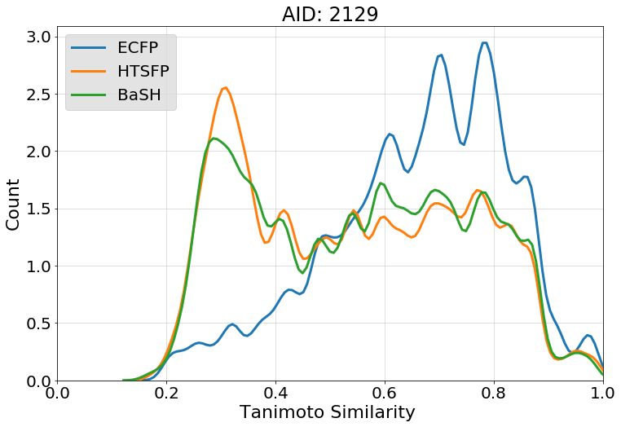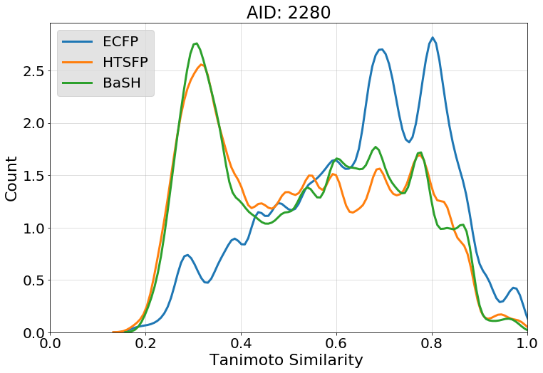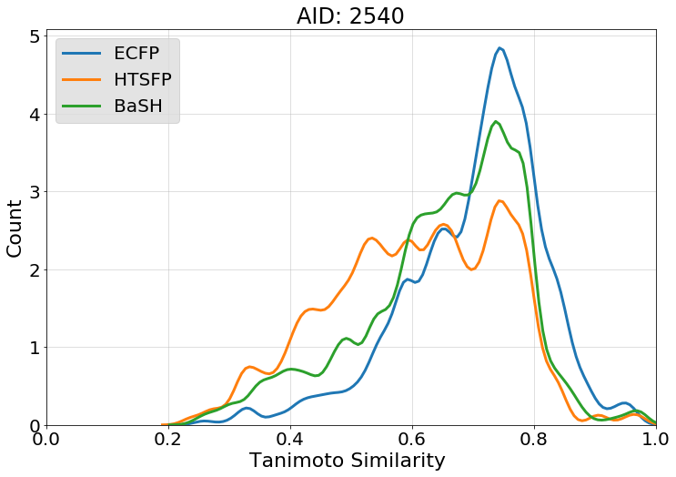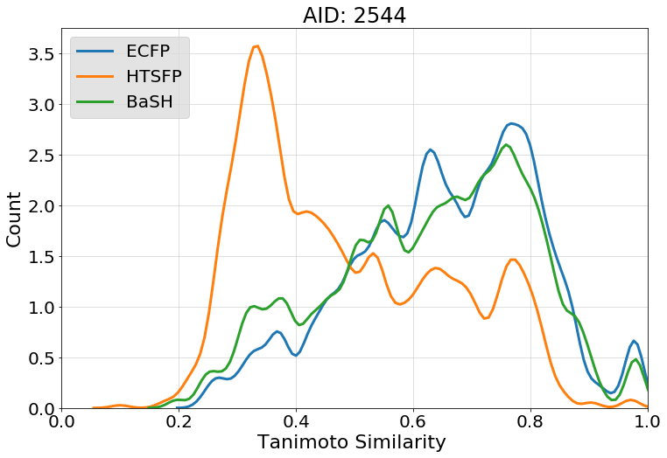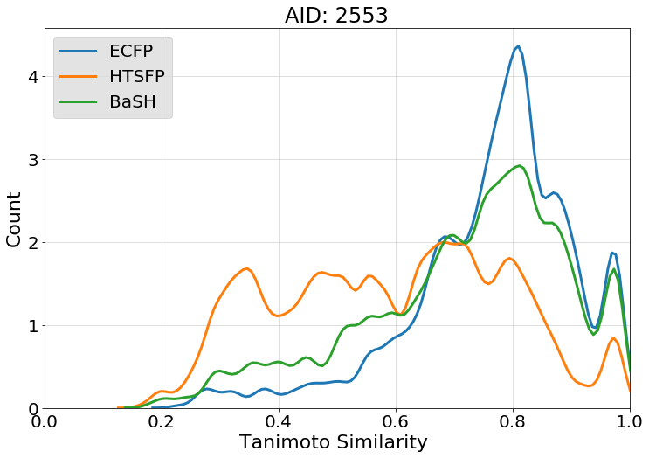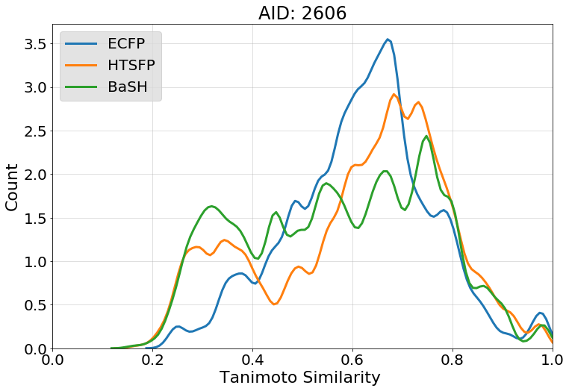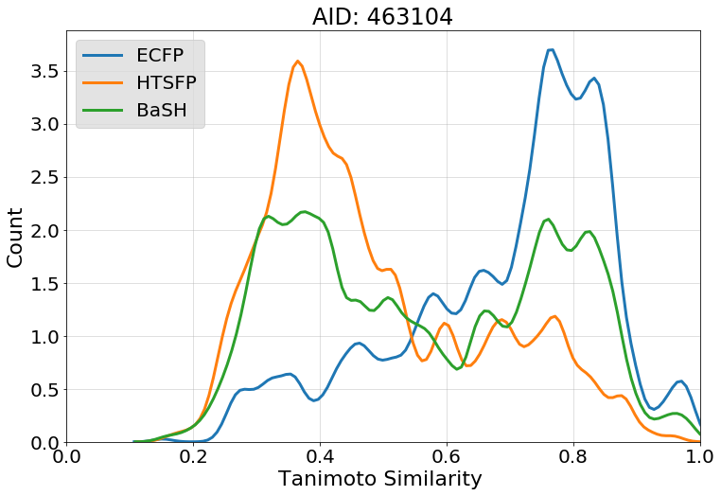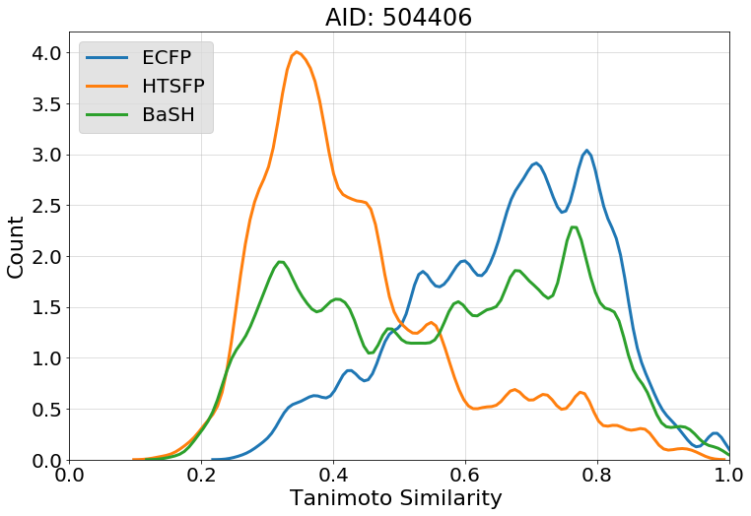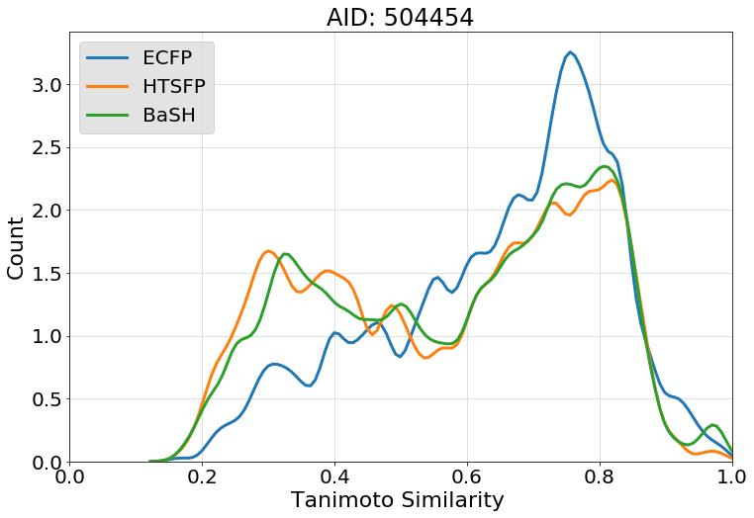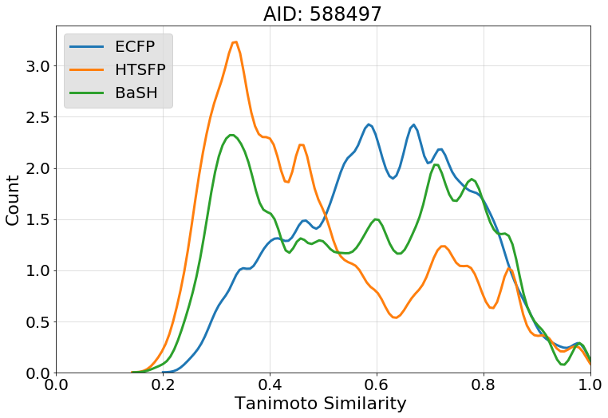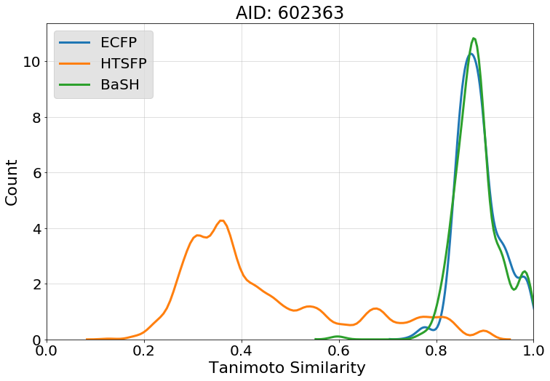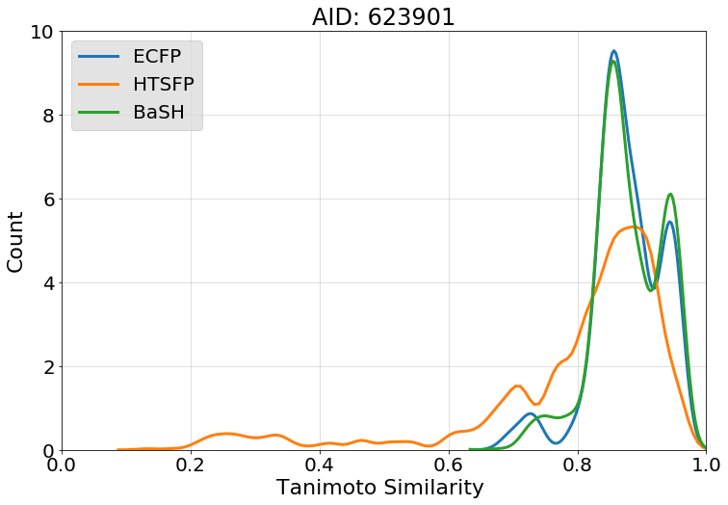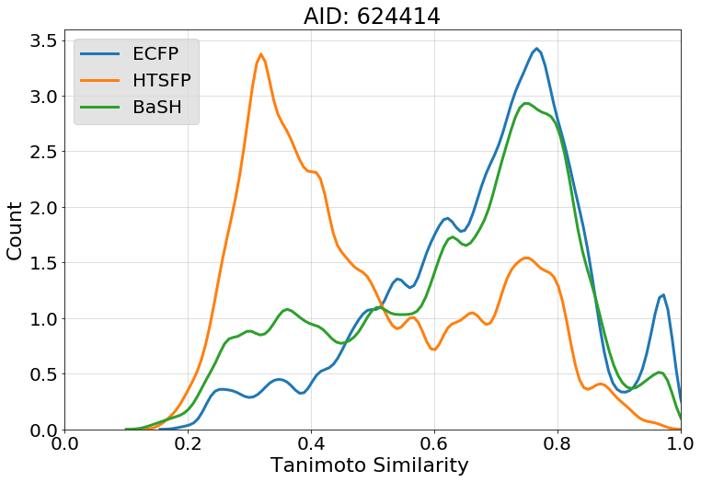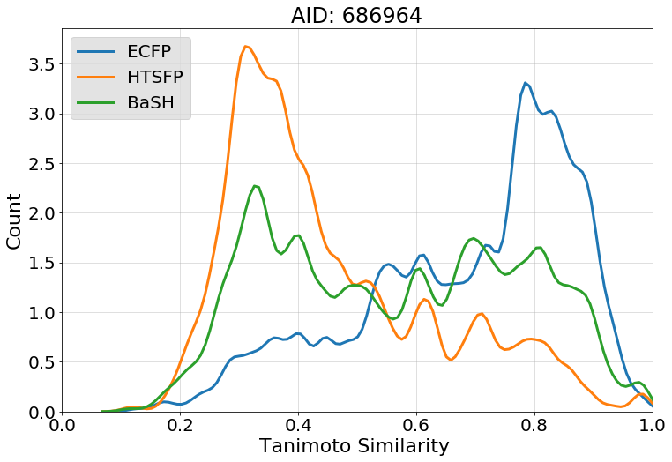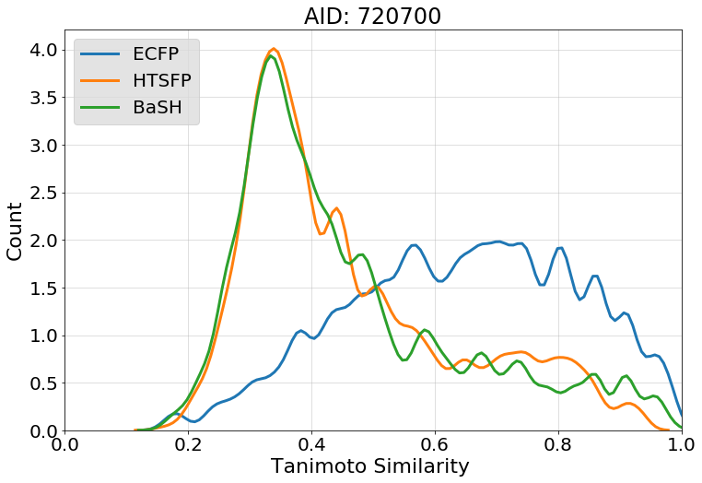
Figure S5. Compound diversity of top scoring 1000 compounds for each test assay. The nearest neighbor Tanimoto similarity was calculated for each of the 1000 compounds and plotted as a fitted histogram. The nearest neighbor similarity was calculated for each of the 3 predictive models BaSH: green, HTSFP: orange, and ECFP4: blue.

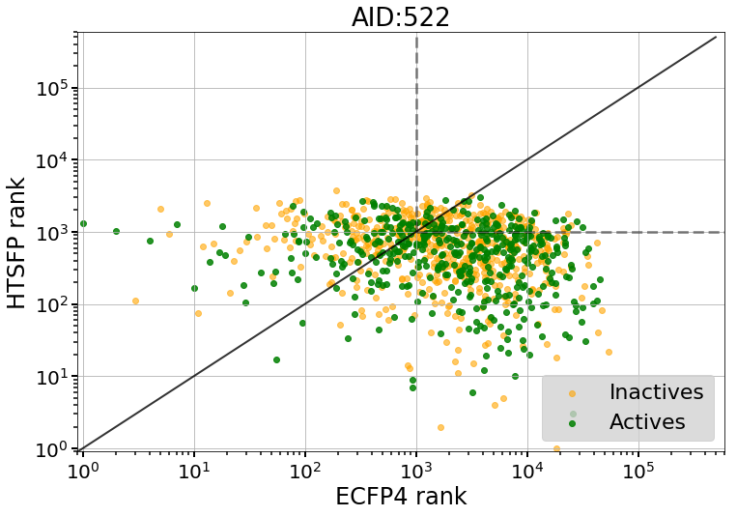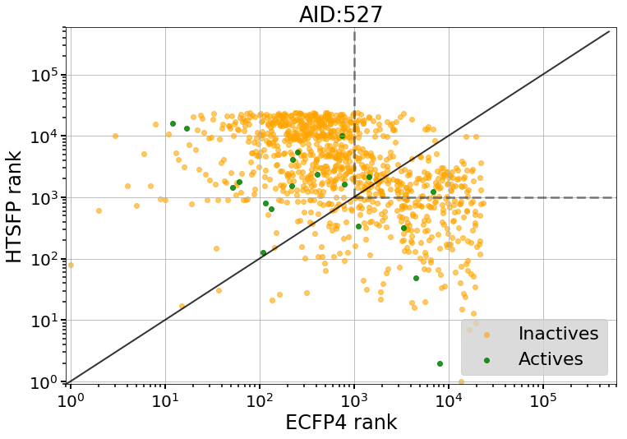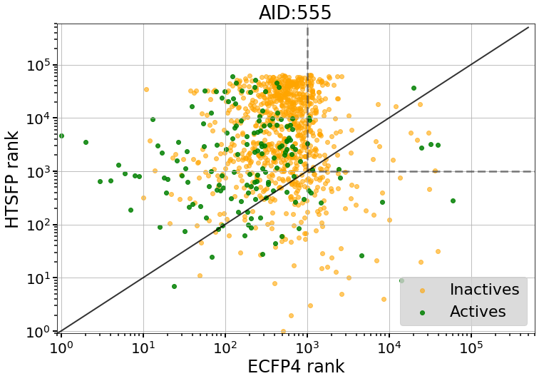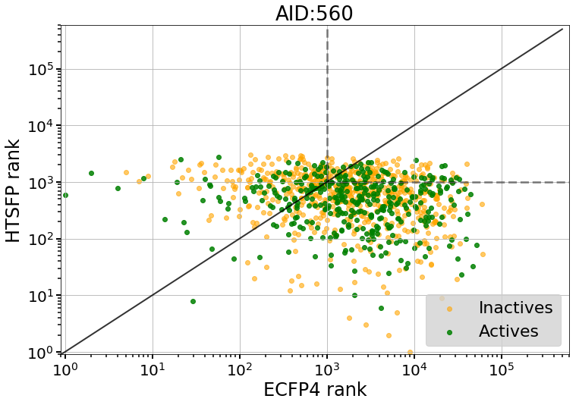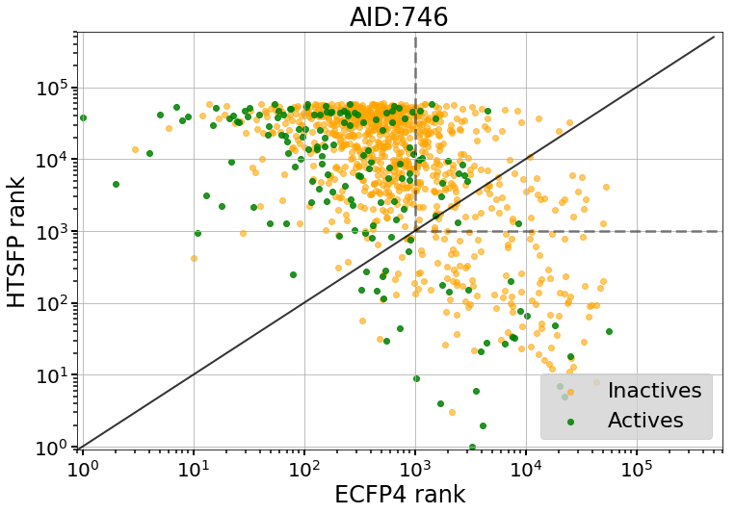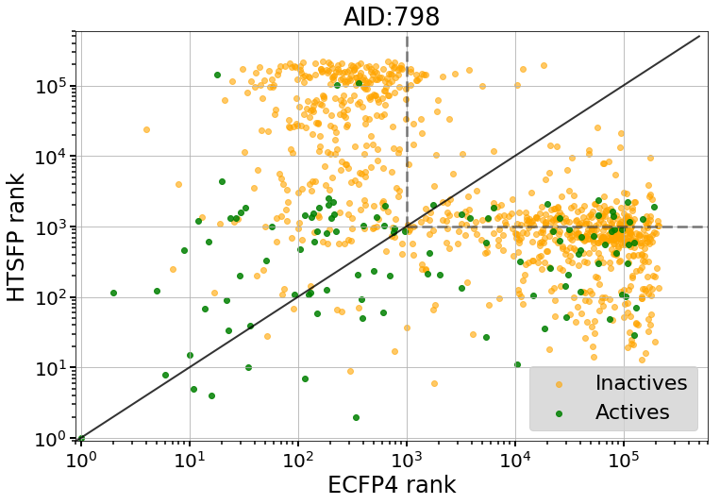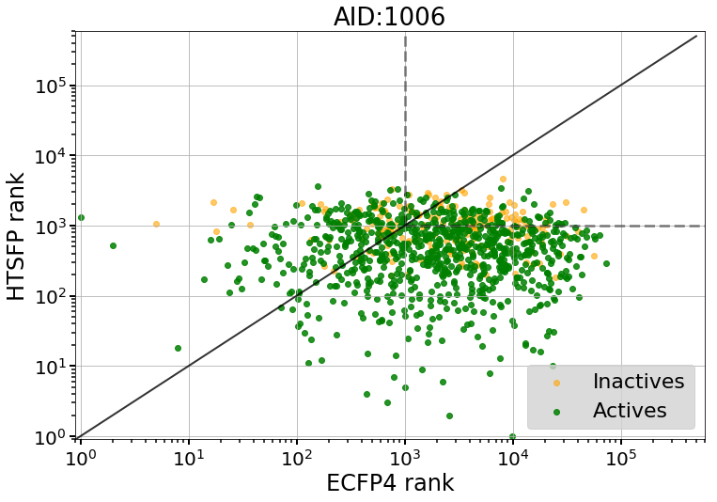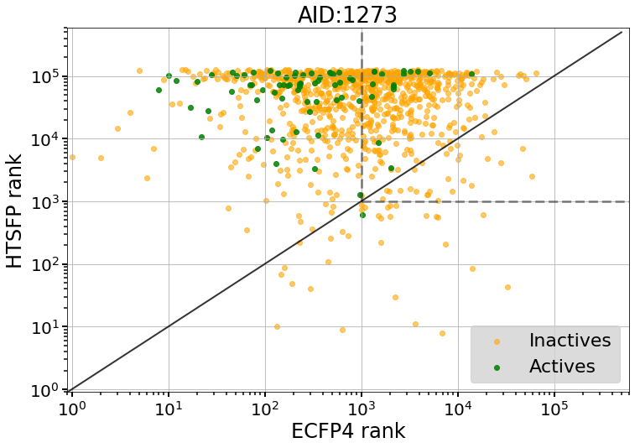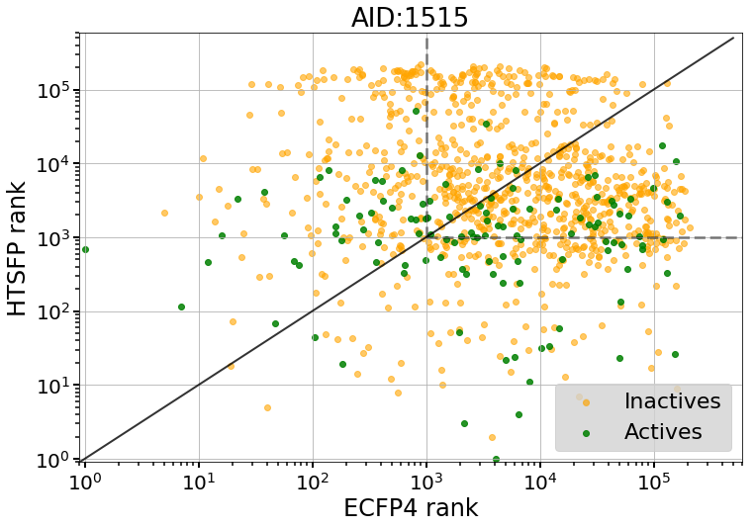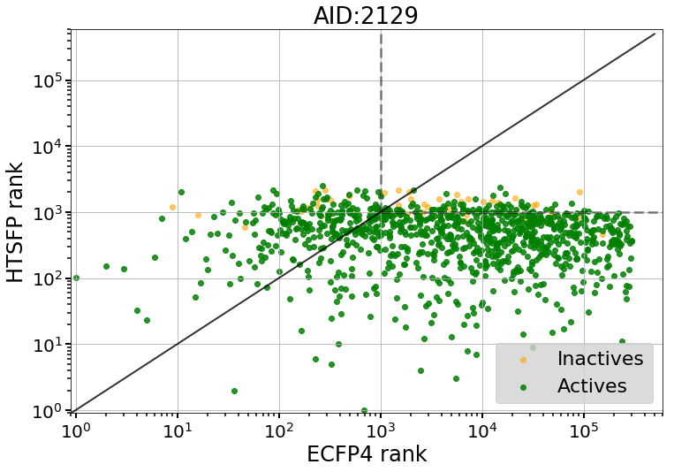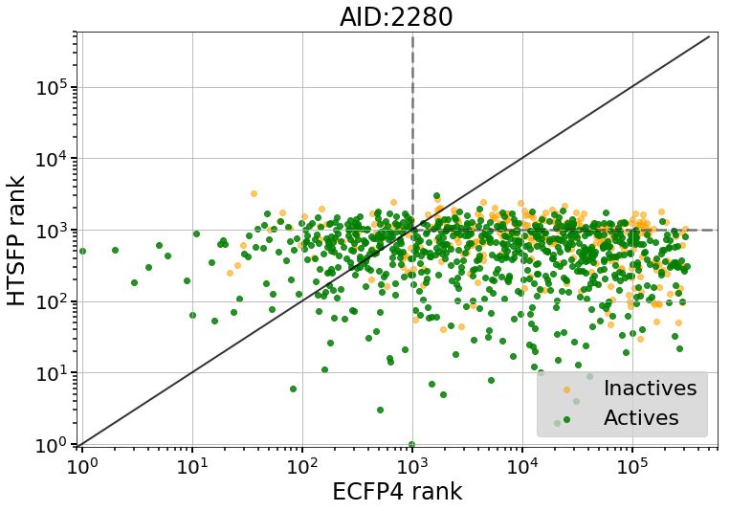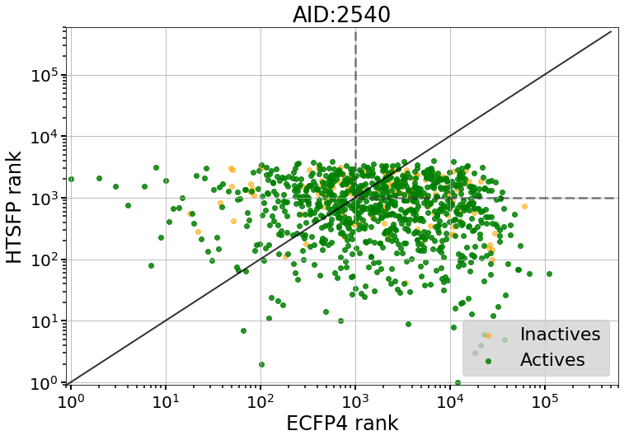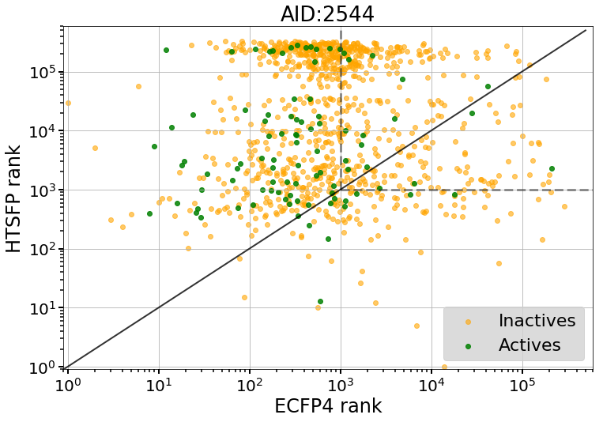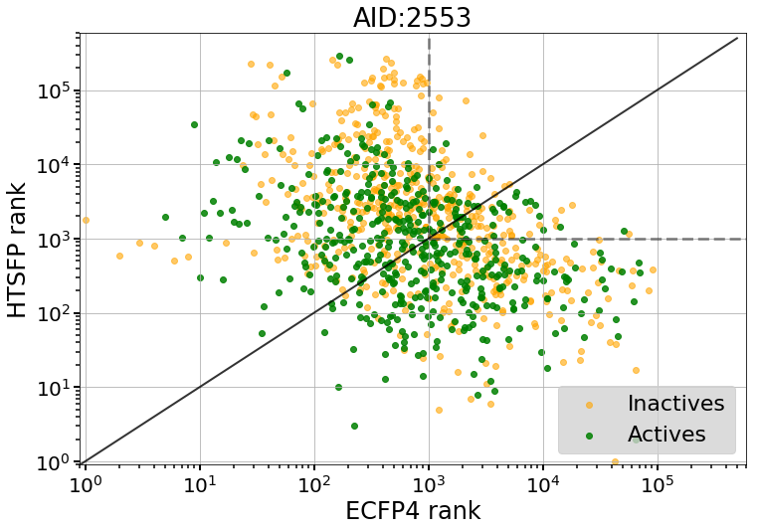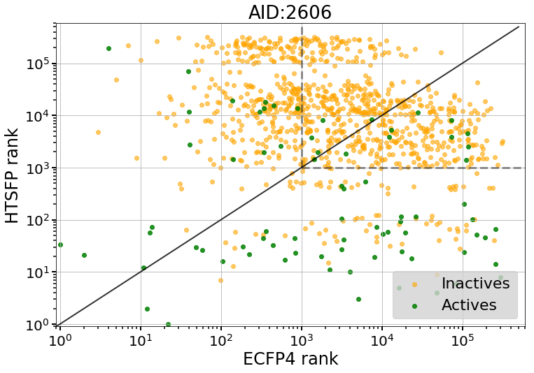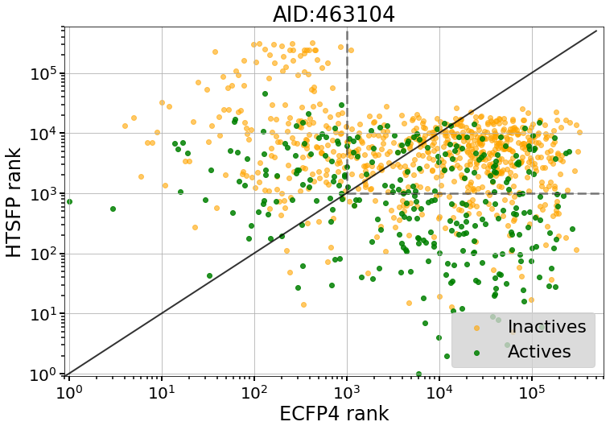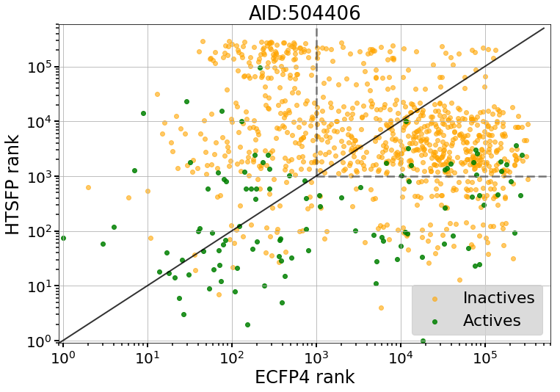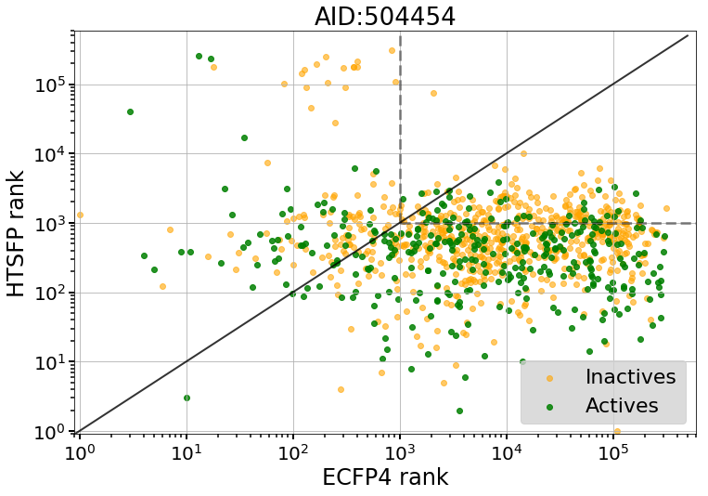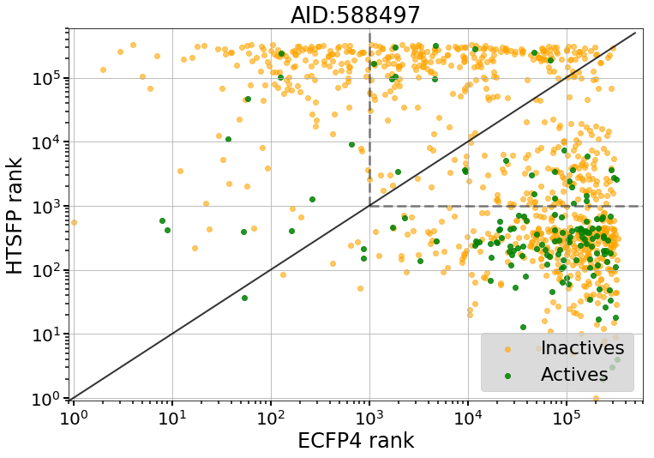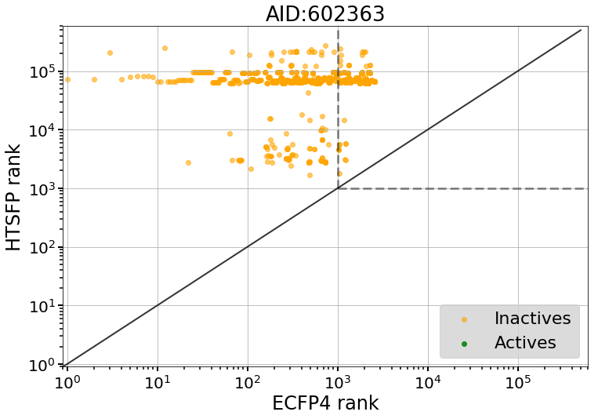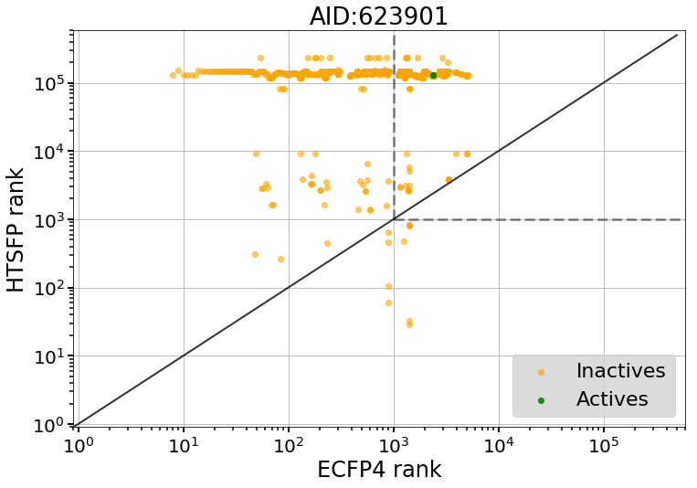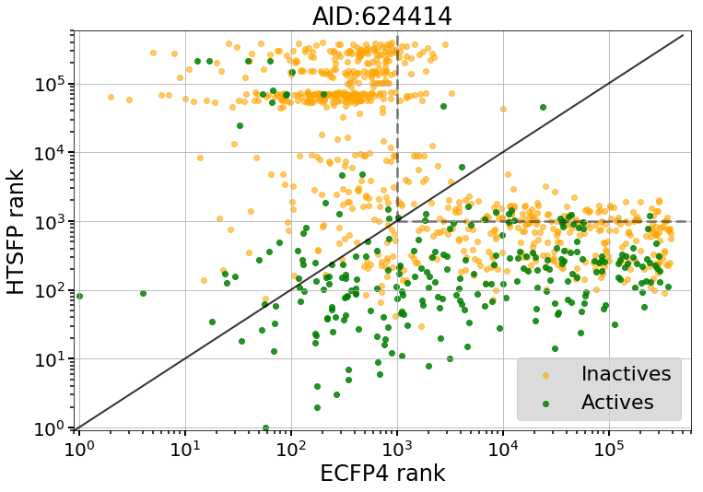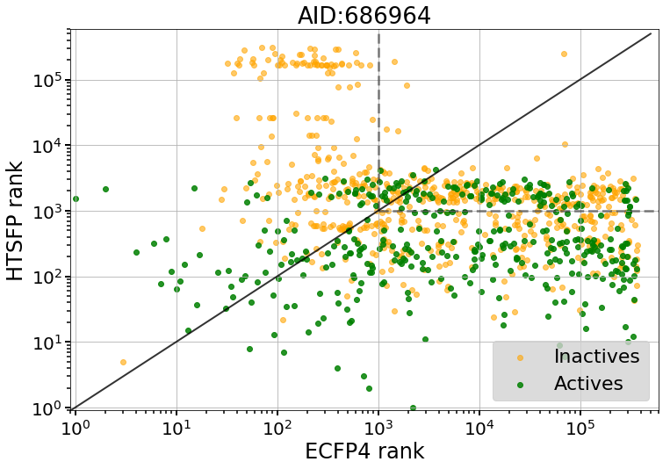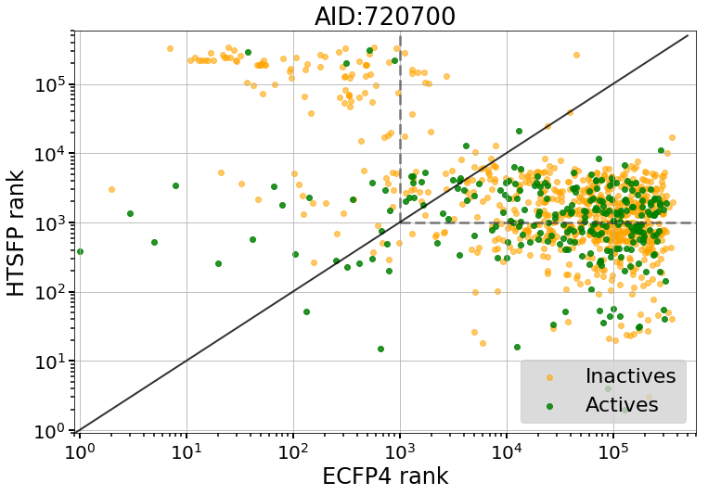
Figure S6. Comparison of compound rankings for the three prediction models. The top scoring 1000 compounds predicted using the BaSH are shown. The rankings of the same compounds in the HTSFP model (Y-axis) and the ECFP4 model (X-axis) are compared. The green and orange dots represent active and inactive compounds, respectively. The dashed line refers to rankings outside the top 1000 for both HTSFP and EFCP4. Plots A to H refer to each of the eight test assays.

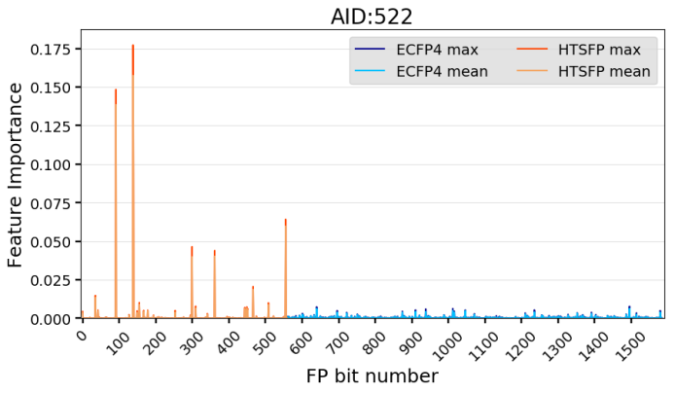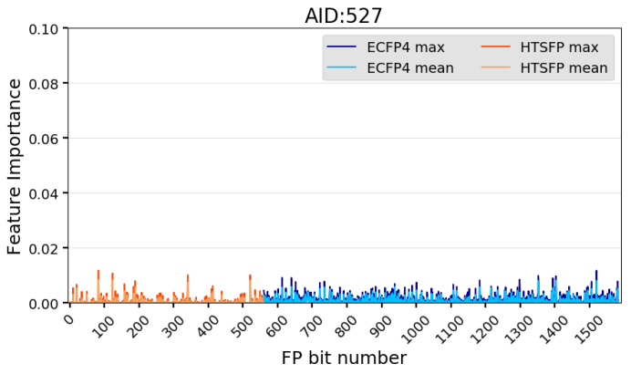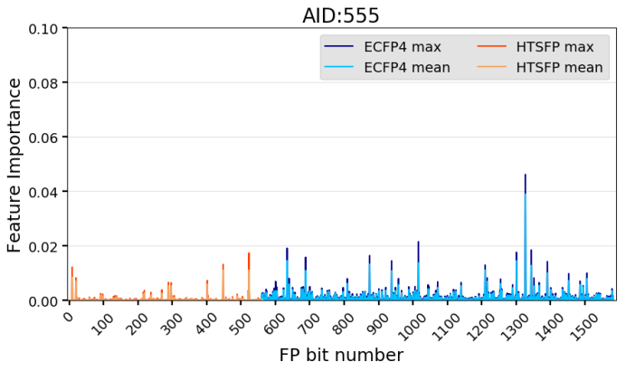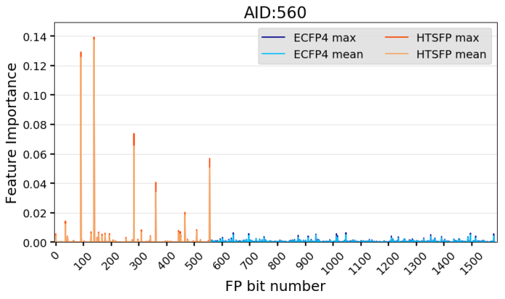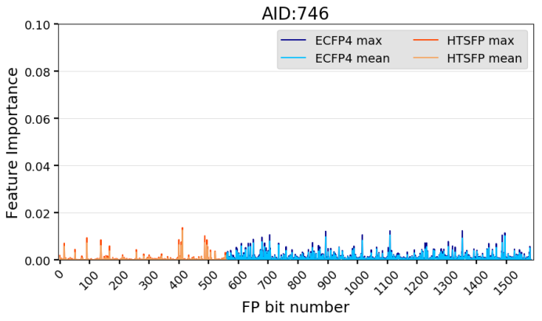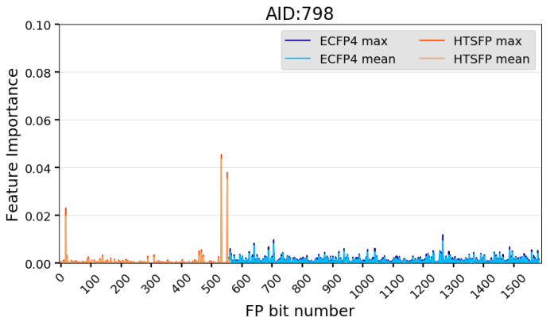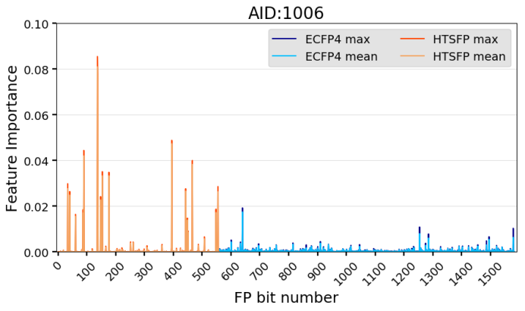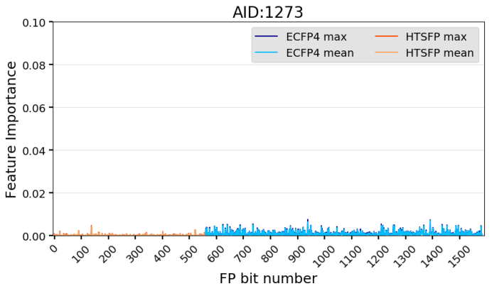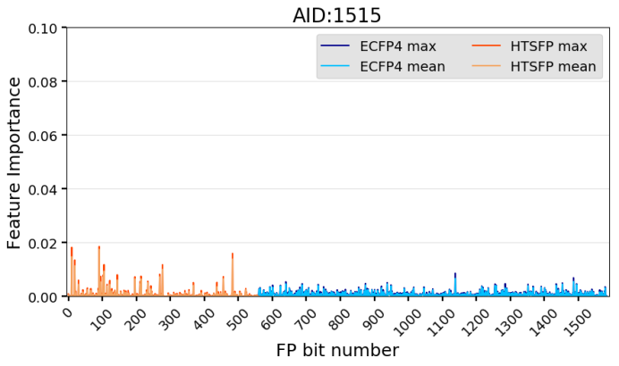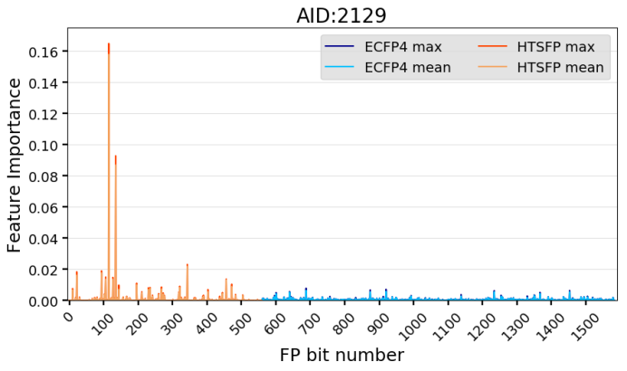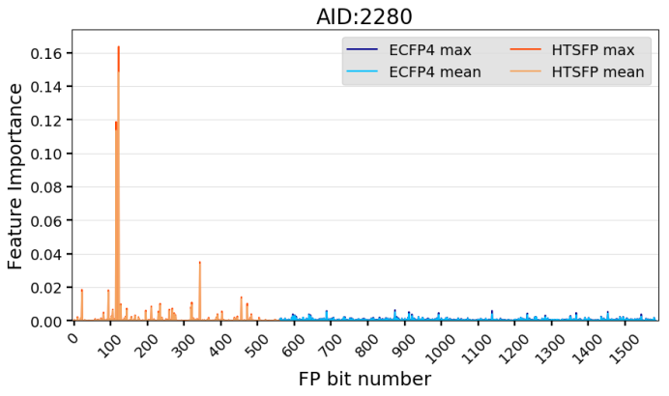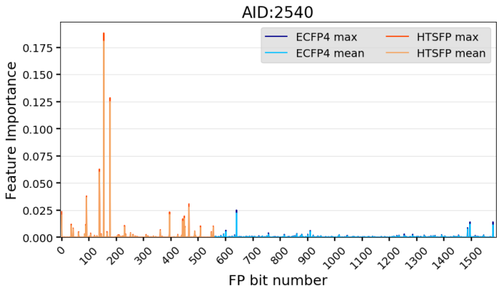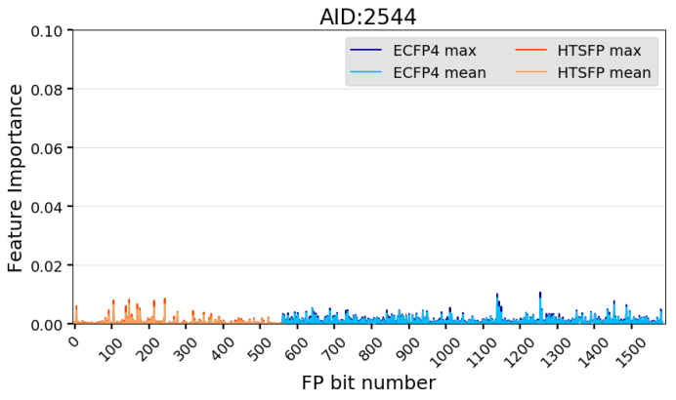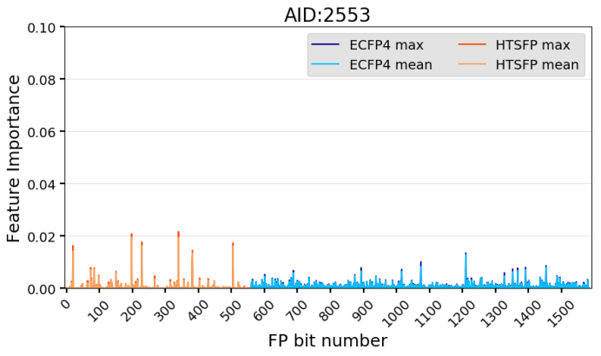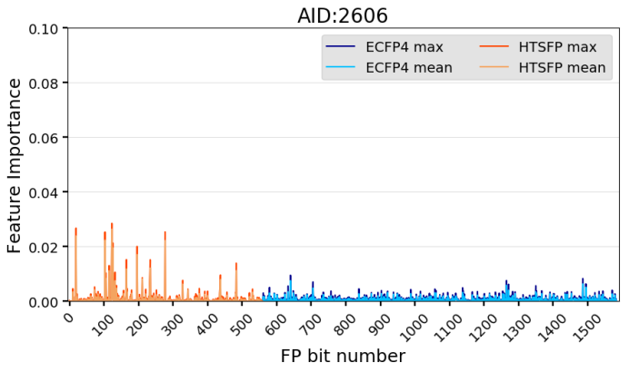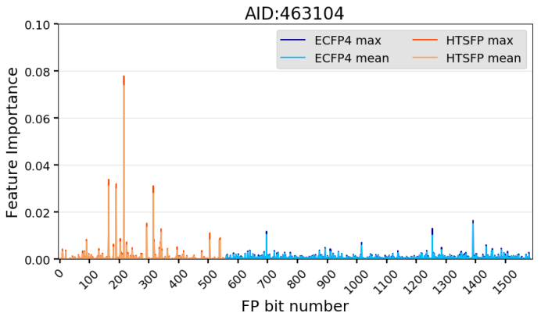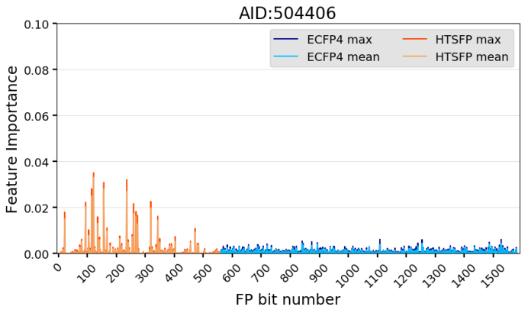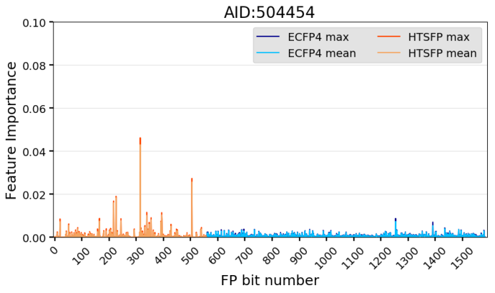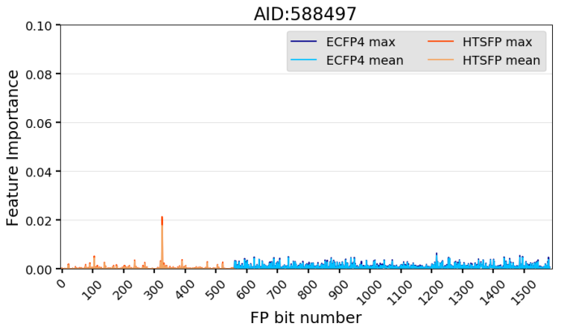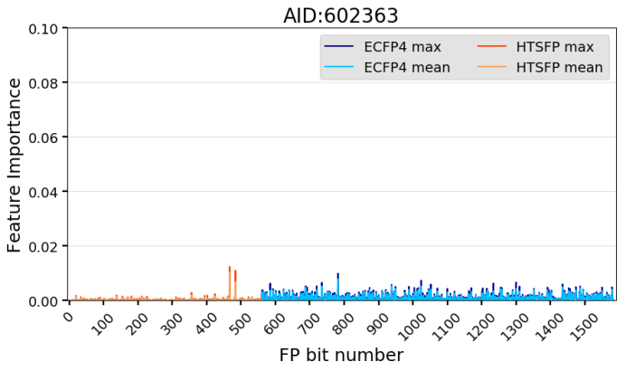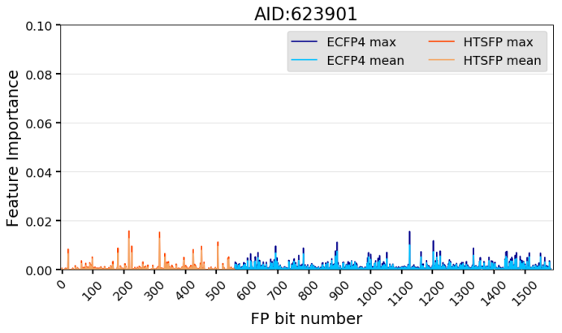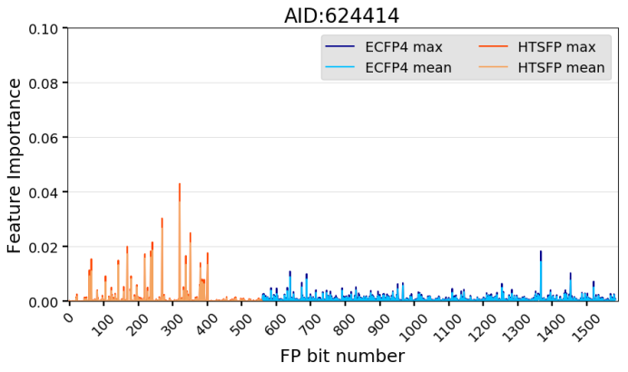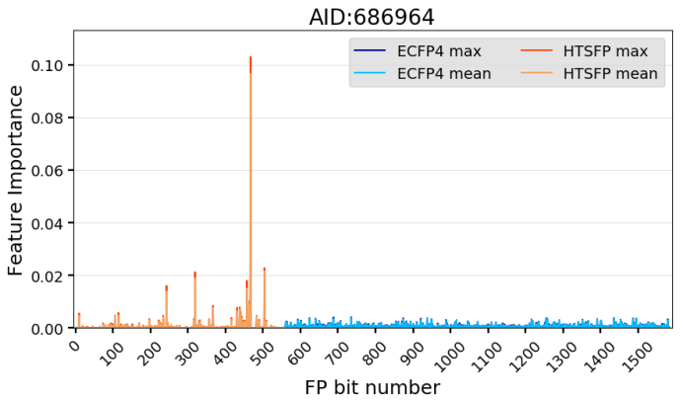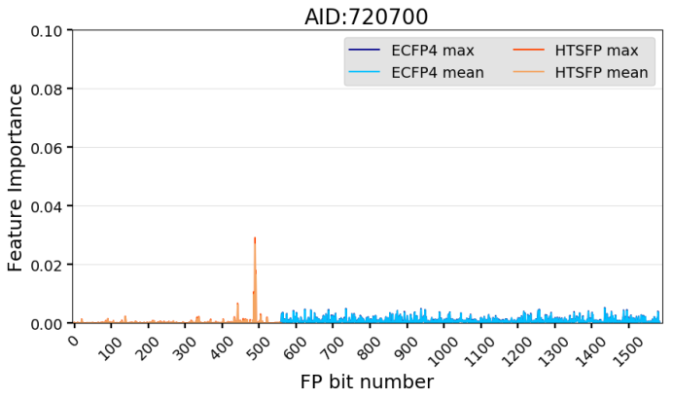
Figure S7. Feature importance analysis of the combined fingerprint (BaSH). Features 0-560 correspond to the HTSFP portion (orange) and features 560-1584 correspond to the ECFP4 portion (blue) of the combined fingerprint. The light and dark shades of each feature refer to the mean and max values from the six-fold cross validation, respectively.
Assay ID | Index position | Feature Importance | Target
798 | Test Assay |  | Coagulation factor XI
800 | 532 | 0.044 | Coagulation factor XIIa light chain
873 | 551 | 0.035 | Human kallikrein 5 (hK5) serine protease
1046 | 17 | 0.02 | Prothrombin
687 | 466 | 0.004 | Coagulation factor XI
680 | 458 | 0.003 | Coagulation factor XI
1515 | Test Assay |  | Retinoblastoma Binding Protein 9 (RBBP9)
1822 | 91 | 0.018 | M18 aspartyl aminopeptidase
1022 | 10 | 0.015 | MCL-1 anti-apoptotic proteins
720543 | 483 | 0.014 | Abhydrolase domain-containing protein 4 isoform 1
1053197 | 19 | 0.011 | Sialic acid acetylesterase (SIAE)
504803 | 277 | 0.01 | HTRA serine peptidase 1 (HTRA1)
2553 | Test Assay |  | Transient Receptor Potential Cation Channel C6 (TRPC6)
463111 | 198 | 0.02 | Regulator of G-protein signaling 4 isoform 2
588852 | 340 | 0.019 | Muscarinic acetylcholine receptor M1
488977 | 229 | 0.016 | High affinity choline transporter 1
743279 | 505 | 0.016 | Inhibitors of Inflammasome Signaling: IL-1-beta
1063 | 20 | 0.014 | Inhibitors of Leishmania Parasite Growth
463104 | Test Assay |  | Activators of the adaptive arm of the Unfolded Protein response
485346 | 216 | 0.074 | E3 ubiquitin-protein ligase Mdm2 isoform MDM2, protein Mdm4
2732 | 165 | 0.031 | Inhibitors Of CHOP To Regulate The unfolded protein response to ER stress
449763 | 190 | 0.03 | Activators of the apoptotic arm of the unfolded Protein response
588405 | 315 | 0.028 | Protein phosphatase 1 regulatory subunit 15A
540308 | 293 | 0.014 | Melanocortin receptor 4 (MC4R)

Assay ID | Index position | Feature Importance | Target
504454 | Test Assay |  | Beta-2 adrenergic receptor
588405 | 315 | 0.043 | Protein phosphatase 1 regulatory subunit 15A
743279 | 505 | 0.026 | Inhibitors of Inflammasome Signaling: IL-1-beta
488899 | 226 | 0.018 | MITF microphthalmia-associated transcription factor
485346 | 217 | 0.016 | E3 ubiquitin-protein ligase Mdm2/MdmX
624352 | 394 | 0.01 | Endothelial PAS domain-containing protein 1
588497 | Test Assay |  | Botulinum neurotoxin light chain F protease
588499 | 325 | 0.018 | Botulinum neurotoxin type A
588501 | 326 | 0.016 | Lethal factor [Bacillus anthracis str. A2012]
1962 | 105 | 0.005 | Likely tRNA 2'-phosphotransferase
493008 | 236 | 0.003 | Troponin C, I, & T, and alpha tropomyosin
624256 | 390 | 0.003 | Promoters of Myeloid Differentiation
624414 | Test Assay |  | Human Mucolipin Transient Receptor Potential 1 (TRPML1)
588473 | 320 | 0.036 | Corticotropin-releasing hormone receptor 2
504660 | 269 | 0.027 | D(1A) dopamine receptor
602248 | 351 | 0.021 | M1 muscarinic receptor(CHRM1)
493084 | 241 | 0.019 | Thyrotropin-releasing hormone receptor
2797 | 168 | 0.017 | Vasopressin V1a receptor
686964 | Test Assay |  | Methyl-CpG binding domain protein 2
687016 | 467 | 0.097 | E3 ubiquitin-protein ligase UHRF1 isoform 1
743269 | 504 | 0.022 | Integrase [Human immunodeficiency virus 1]
588458 | 319 | 0.019 | DNA (cytosine-5)-methyltransferase 1 isoform b
652257 | 457 | 0.015 | Protein arginine methyltransferase 1 (PRMT1)
493091 | 243 | 0.014 | Carboxy-terminal domain RNA polymerase II polypeptide A small Phosphatase 1 isoform 1

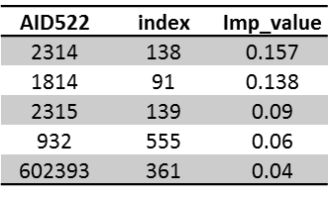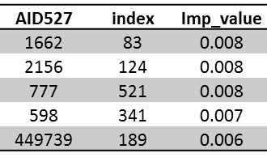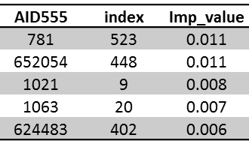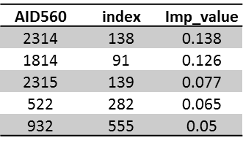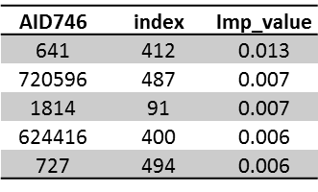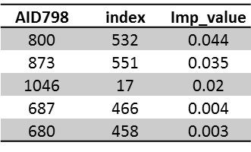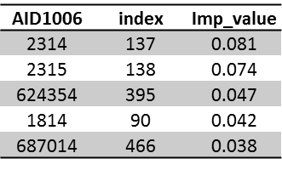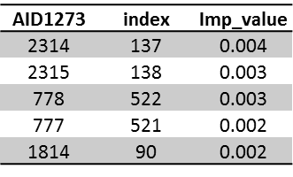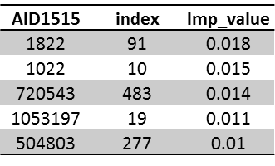
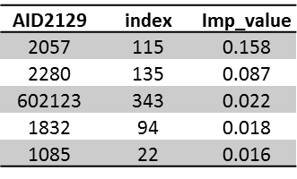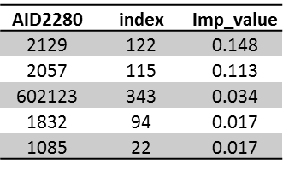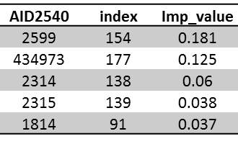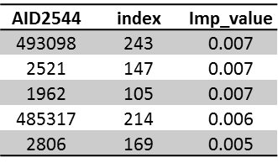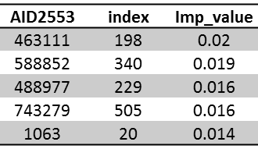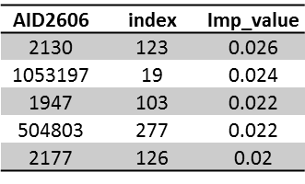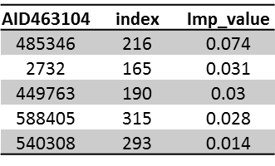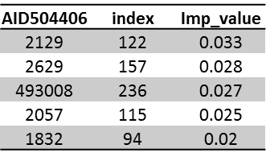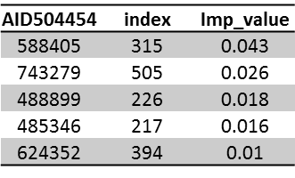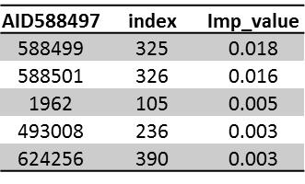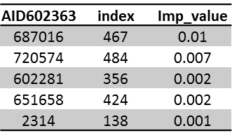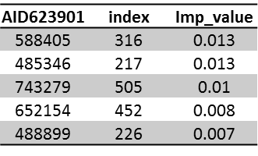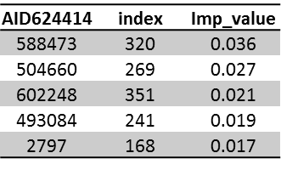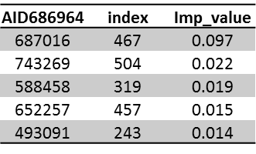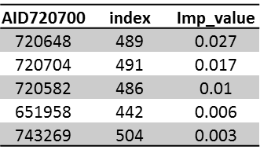
Table S1. The top five most important features for each validation assay. Column 1 refers to PubChem assay ID number, column 2 refers to the position of the assay in the HTSFP portion of the fingerprint, and the ‘Imp_value’ refers to the relative importance value of the feature in the BaSH fingerprint.

FP type | Assay | ROC-AUC | MCC | Kappa | Precision | Recall | F1 | A_count | N_count | TP | FN | FP | TN
HTSFP | 522 | 0.970 | 0.442 | 0.344 | 0.226 | 0.931 | 0.364 | 1225 | 63682 | 1141 | 84 | 3899 | 59783
ECFP | 522 | 0.849 | 0.207 | 0.196 | 0.165 | 0.312 | 0.216 | 1225 | 63682 | 382 | 843 | 1930 | 61752
BaSH | 522 | 0.972 | 0.490 | 0.427 | 0.300 | 0.847 | 0.443 | 1225 | 63682 | 1037 | 188 | 2415 | 61267
HTSFP | 527 | 0.689 | 0.029 | 0.024 | 0.018 | 0.063 | 0.028 | 64 | 24010 | 4 | 60 | 214 | 23796
ECFP | 527 | 0.709 | 0.034 | 0.025 | 0.077 | 0.016 | 0.026 | 64 | 24010 | 1 | 63 | 12 | 23998
BaSH | 527 | 0.775 | 0.082 | 0.054 | 0.222 | 0.031 | 0.055 | 64 | 24010 | 2 | 62 | 7 | 24003
HTSFP | 555 | 0.796 | 0.127 | 0.065 | 0.039 | 0.497 | 0.073 | 316 | 64923 | 157 | 159 | 3819 | 61104
ECFP | 555 | 0.786 | 0.310 | 0.309 | 0.336 | 0.291 | 0.312 | 316 | 64923 | 92 | 224 | 182 | 64741
BaSH | 555 | 0.844 | 0.309 | 0.308 | 0.346 | 0.282 | 0.311 | 316 | 64923 | 89 | 227 | 168 | 64755
HTSFP | 560 | 0.960 | 0.383 | 0.280 | 0.179 | 0.890 | 0.298 | 979 | 63928 | 871 | 108 | 3993 | 59935
ECFP | 560 | 0.838 | 0.181 | 0.172 | 0.144 | 0.270 | 0.188 | 979 | 63928 | 264 | 715 | 1565 | 62363
BaSH | 560 | 0.960 | 0.425 | 0.365 | 0.252 | 0.762 | 0.379 | 979 | 63928 | 746 | 233 | 2209 | 61719
HTSFP | 746 | 0.664 | 0.071 | 0.048 | 0.034 | 0.216 | 0.058 | 366 | 59421 | 79 | 287 | 2277 | 57144
ECFP | 746 | 0.865 | 0.238 | 0.230 | 0.313 | 0.186 | 0.233 | 366 | 59421 | 68 | 298 | 149 | 59272
BaSH | 746 | 0.889 | 0.230 | 0.215 | 0.337 | 0.161 | 0.218 | 366 | 59421 | 59 | 307 | 116 | 59305
HTSFP | 798 | 0.774 | 0.172 | 0.108 | 0.062 | 0.497 | 0.110 | 302 | 218414 | 150 | 152 | 2281 | 216133
ECFP | 798 | 0.660 | 0.165 | 0.135 | 0.317 | 0.086 | 0.135 | 302 | 218414 | 26 | 276 | 56 | 218358
BaSH | 798 | 0.795 | 0.289 | 0.241 | 0.540 | 0.156 | 0.242 | 302 | 218414 | 47 | 255 | 40 | 218374
HTSFP | 1006 | 0.954 | 0.364 | 0.262 | 0.167 | 0.872 | 0.281 | 2976 | 192588 | 2595 | 381 | 12930 | 179658
ECFP | 1006 | 0.914 | 0.291 | 0.247 | 0.174 | 0.547 | 0.264 | 2976 | 192588 | 1627 | 1349 | 7712 | 184876
BaSH | 1006 | 0.970 | 0.519 | 0.484 | 0.366 | 0.765 | 0.495 | 2976 | 192588 | 2277 | 699 | 3952 | 188636
HTSFP | 1273 | 0.496 | 0.007 | 0.004 | 0.011 | 0.084 | 0.020 | 1153 | 126144 | 97 | 1056 | 8376 | 117768
ECFP | 1273 | 0.595 | 0.064 | 0.059 | 0.108 | 0.045 | 0.064 | 1153 | 126144 | 52 | 1101 | 430 | 125714
BaSH | 1273 | 0.582 | 0.067 | 0.039 | 0.213 | 0.023 | 0.041 | 1153 | 126144 | 26 | 1127 | 96 | 126048
HTSFP | 1515 | 0.679 | 0.092 | 0.073 | 0.047 | 0.196 | 0.076 | 445 | 217519 | 87 | 358 | 1770 | 215749
ECFP | 1515 | 0.655 | 0.054 | 0.043 | 0.111 | 0.027 | 0.043 | 445 | 217519 | 12 | 433 | 96 | 217423
BaSH | 1515 | 0.732 | 0.117 | 0.075 | 0.322 | 0.043 | 0.075 | 445 | 217519 | 19 | 426 | 40 | 217479
HTSFP | 2129 | 0.936 | 0.534 | 0.495 | 0.364 | 0.796 | 0.500 | 2199 | 312803 | 1751 | 448 | 3053 | 309750
ECFP | 2129 | 0.840 | 0.232 | 0.231 | 0.231 | 0.243 | 0.237 | 2199 | 312803 | 535 | 1664 | 1782 | 311021
BaSH | 2129 | 0.947 | 0.688 | 0.685 | 0.634 | 0.751 | 0.688 | 2199 | 312803 | 1651 | 548 | 952 | 311851
HTSFP | 2280 | 0.912 | 0.473 | 0.424 | 0.296 | 0.764 | 0.427 | 1419 | 323331 | 1084 | 335 | 2572 | 320759
ECFP | 2280 | 0.813 | 0.224 | 0.219 | 0.284 | 0.181 | 0.221 | 1419 | 323331 | 257 | 1162 | 648 | 322683
BaSH | 2280 | 0.933 | 0.622 | 0.616 | 0.544 | 0.715 | 0.618 | 1419 | 323331 | 1014 | 405 | 849 | 322482
HTSFP | 2540 | 0.993 | 0.699 | 0.661 | 0.505 | 0.980 | 0.666 | 4119 | 326278 | 4036 | 83 | 3960 | 322318
ECFP | 2540 | 0.920 | 0.255 | 0.187 | 0.122 | 0.611 | 0.204 | 4119 | 326278 | 2517 | 1602 | 18061 | 308217
BaSH | 2540 | 0.994 | 0.754 | 0.736 | 0.608 | 0.944 | 0.740 | 4119 | 326278 | 3887 | 232 | 2506 | 323772
HTSFP | 2544 | 0.592 | 0.060 | 0.049 | 0.032 | 0.122 | 0.050 | 393 | 330004 | 48 | 345 | 1467 | 328537
ECFP | 2544 | 0.685 | 0.102 | 0.091 | 0.166 | 0.064 | 0.092 | 393 | 330004 | 25 | 368 | 126 | 329878
BaSH | 2544 | 0.707 | 0.090 | 0.064 | 0.214 | 0.038 | 0.065 | 393 | 330004 | 15 | 378 | 55 | 329949
HTSFP | 2553 | 0.805 | 0.205 | 0.143 | 0.093 | 0.538 | 0.158 | 3253 | 302361 | 1751 | 1502 | 17132 | 285229
ECFP | 2553 | 0.803 | 0.240 | 0.240 | 0.232 | 0.267 | 0.248 | 3253 | 302361 | 869 | 2384 | 2873 | 299488
BaSH | 2553 | 0.861 | 0.313 | 0.313 | 0.339 | 0.302 | 0.320 | 3253 | 302361 | 984 | 2269 | 1920 | 300441
HTSFP | 2606 | 0.791 | 0.118 | 0.077 | 0.044 | 0.318 | 0.078 | 157 | 324594 | 50 | 107 | 1080 | 323514
ECFP | 2606 | 0.747 | 0.156 | 0.129 | 0.295 | 0.083 | 0.129 | 157 | 324594 | 13 | 144 | 31 | 324563
BaSH | 2606 | 0.862 | 0.288 | 0.244 | 0.521 | 0.159 | 0.244 | 157 | 324594 | 25 | 132 | 23 | 324571
HTSFP | 463104 | 0.914 | 0.193 | 0.115 | 0.067 | 0.599 | 0.120 | 1100 | 330576 | 659 | 441 | 9192 | 321384
ECFP | 463104 | 0.822 | 0.079 | 0.058 | 0.182 | 0.035 | 0.059 | 1100 | 330576 | 39 | 1061 | 175 | 330401
BaSH | 463104 | 0.945 | 0.209 | 0.157 | 0.463 | 0.095 | 0.158 | 1100 | 330576 | 105 | 995 | 122 | 330454
HTSFP | 504406 | 0.868 | 0.179 | 0.107 | 0.060 | 0.541 | 0.108 | 194 | 323720 | 105 | 89 | 1643 | 322077
ECFP | 504406 | 0.792 | 0.209 | 0.175 | 0.386 | 0.113 | 0.175 | 194 | 323720 | 22 | 172 | 35 | 323685
BaSH | 504406 | 0.884 | 0.373 | 0.346 | 0.551 | 0.253 | 0.346 | 194 | 323720 | 49 | 145 | 40 | 323680
HTSFP | 504454 | 0.776 | 0.217 | 0.186 | 0.126 | 0.395 | 0.191 | 1446 | 337839 | 571 | 875 | 3967 | 333872
ECFP | 504454 | 0.699 | 0.102 | 0.086 | 0.188 | 0.057 | 0.088 | 1446 | 337839 | 83 | 1363 | 358 | 337481
BaSH | 504454 | 0.838 | 0.284 | 0.282 | 0.316 | 0.259 | 0.285 | 1446 | 337839 | 375 | 1071 | 810 | 337029
HTSFP | 588497 | 0.605 | 0.081 | 0.058 | 0.036 | 0.206 | 0.061 | 780 | 339542 | 161 | 619 | 4300 | 335242
ECFP | 588497 | 0.605 | 0.026 | 0.022 | 0.047 | 0.015 | 0.023 | 780 | 339542 | 12 | 768 | 245 | 339297
BaSH | 588497 | 0.658 | 0.145 | 0.115 | 0.295 | 0.072 | 0.115 | 780 | 339542 | 56 | 724 | 134 | 339408
HTSFP | 602363 | 0.597 | 0.035 | 0.014 | 0.008 | 0.200 | 0.016 | 446 | 346711 | 89 | 357 | 10501 | 336210
ECFP | 602363 | 0.515 | -0.006 | -0.002 | 0.000 | 0.009 | 0.001 | 446 | 346711 | 4 | 442 | 14101 | 332610
BaSH | 602363 | 0.575 | -0.006 | -0.002 | 0.000 | 0.009 | 0.001 | 446 | 346711 | 4 | 442 | 14430 | 332281
HTSFP | 623901 | 0.510 | 0.017 | 0.007 | 0.005 | 0.094 | 0.010 | 470 | 332289 | 44 | 426 | 8289 | 324000
ECFP | 623901 | 0.641 | 0.025 | 0.009 | 0.006 | 0.162 | 0.012 | 470 | 332289 | 76 | 394 | 12058 | 320231
BaSH | 623901 | 0.745 | 0.021 | 0.007 | 0.005 | 0.147 | 0.010 | 470 | 332289 | 69 | 401 | 13087 | 319202
HTSFP | 624414 | 0.791 | 0.281 | 0.229 | 0.146 | 0.546 | 0.231 | 482 | 399857 | 263 | 219 | 1534 | 398323
ECFP | 624414 | 0.828 | 0.173 | 0.171 | 0.203 | 0.149 | 0.172 | 482 | 399857 | 72 | 410 | 283 | 399574
BaSH | 624414 | 0.907 | 0.441 | 0.441 | 0.429 | 0.454 | 0.442 | 482 | 399857 | 219 | 263 | 291 | 399566
HTSFP | 686964 | 0.786 | 0.282 | 0.237 | 0.156 | 0.522 | 0.240 | 1149 | 368790 | 600 | 549 | 3245 | 365545
ECFP | 686964 | 0.637 | 0.105 | 0.101 | 0.145 | 0.079 | 0.103 | 1149 | 368790 | 91 | 1058 | 535 | 368255
BaSH | 686964 | 0.789 | 0.380 | 0.369 | 0.487 | 0.299 | 0.371 | 1149 | 368790 | 344 | 805 | 362 | 368428
HTSFP | 720700 | 0.633 | 0.117 | 0.098 | 0.071 | 0.237 | 0.110 | 3123 | 366816 | 740 | 2383 | 9647 | 357169
ECFP | 720700 | 0.577 | 0.017 | 0.016 | 0.033 | 0.015 | 0.021 | 3123 | 366816 | 48 | 3075 | 1385 | 365431
BaSH | 720700 | 0.658 | 0.143 | 0.123 | 0.259 | 0.084 | 0.127 | 3123 | 366816 | 262 | 2861 | 750 | 366066
Table 2. Overview of all metrics and confusion matrix for all descriptor types and assays.
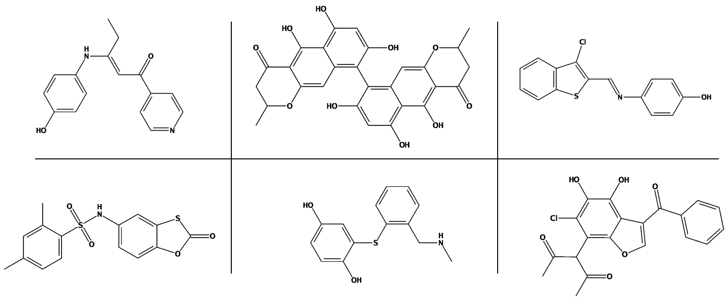Figure S8. Example chemical structures from assay 1515 that were only correctly predicted by the BaSH fingerprint. The figure shows six compounds which indicate the structural diversity of compounds correctly predicted using the BaSH fingerprint.

