Additional data 2: Primary data for virulence factor analysis

Supplementary Figures
Figure S1. Agarose gel electrophoresis of the PCR-based vacA subtype genotyping. M, 100 bp DNA ladder (Elpisbio); Numbers 1–10 indicate individual patients; A, stomach antrum; B, stomach body. A. vacA s1 gene (259 bp). All strains were positive. B. vacA s1a gene (212 bp). 1B, 2B, 3A, 3B, 5B and 8B are vacA s1a positive while remaining strains are negative for this gene. C. vacA s1c gene (213 bp). 1A, 2A, 4A, 4B, 5A, 6A, 6B, 7A, 7B, 8A, 9A, 9B, 10A and 10B 8B are vacA s1c positive while remaining strains are negative for this gene. D. vacA m1 (570 bp) and m2 (645 bp) gene. 5A, 8B, 9A and 9B are vacA m2 positive while remaining strains are vacA m1 positive. E. vacA i1 gene (432 bp). 5A and 8B are vacA i1 gene negative while remaining strains are positive for this gene. F. vacA i2 gene (426 bp). 5A and 8B are vacA i2 gene positive while remaining strains are negative for this gene.
Figure S2. Amino acid sequences analysis of the cagA gene. Numbers 1–10 indicate individual patients; A, stomach antrum; B, stomach body. 5A, 8A, 8B, 10B strains, respectively, show cagA with EPIYA-ABC pattern while remaining strains are EPIYA-ABD. The different EPIYA patterns in the same patient were present in 5 (5A, 5B strains) and 10 (10A, 10B strains).
Figure S3. Agarose gel electrophoresis of the PCR-based iceA and dupA genotyping. M, 100 bp DNA ladder (Elpisbio); Numbers 1–10 indicate individual patients; A, stomach antrum; B, stomach body. A. iceA1 gene (247 bp). All strains were positive. B. dupA gene (dupA-A primer, 401 bp). C. dupA gene (dupA-B primer, 1115 bp). 5B, 8A, 8B and 10A were dupA positive while remaining strains were negative for this gene.

Supplementary Tables
Table S2. Nucleotide and deduced amino acid sequences of the signal peptide-coding region of the oipA gene.

Figure S1.
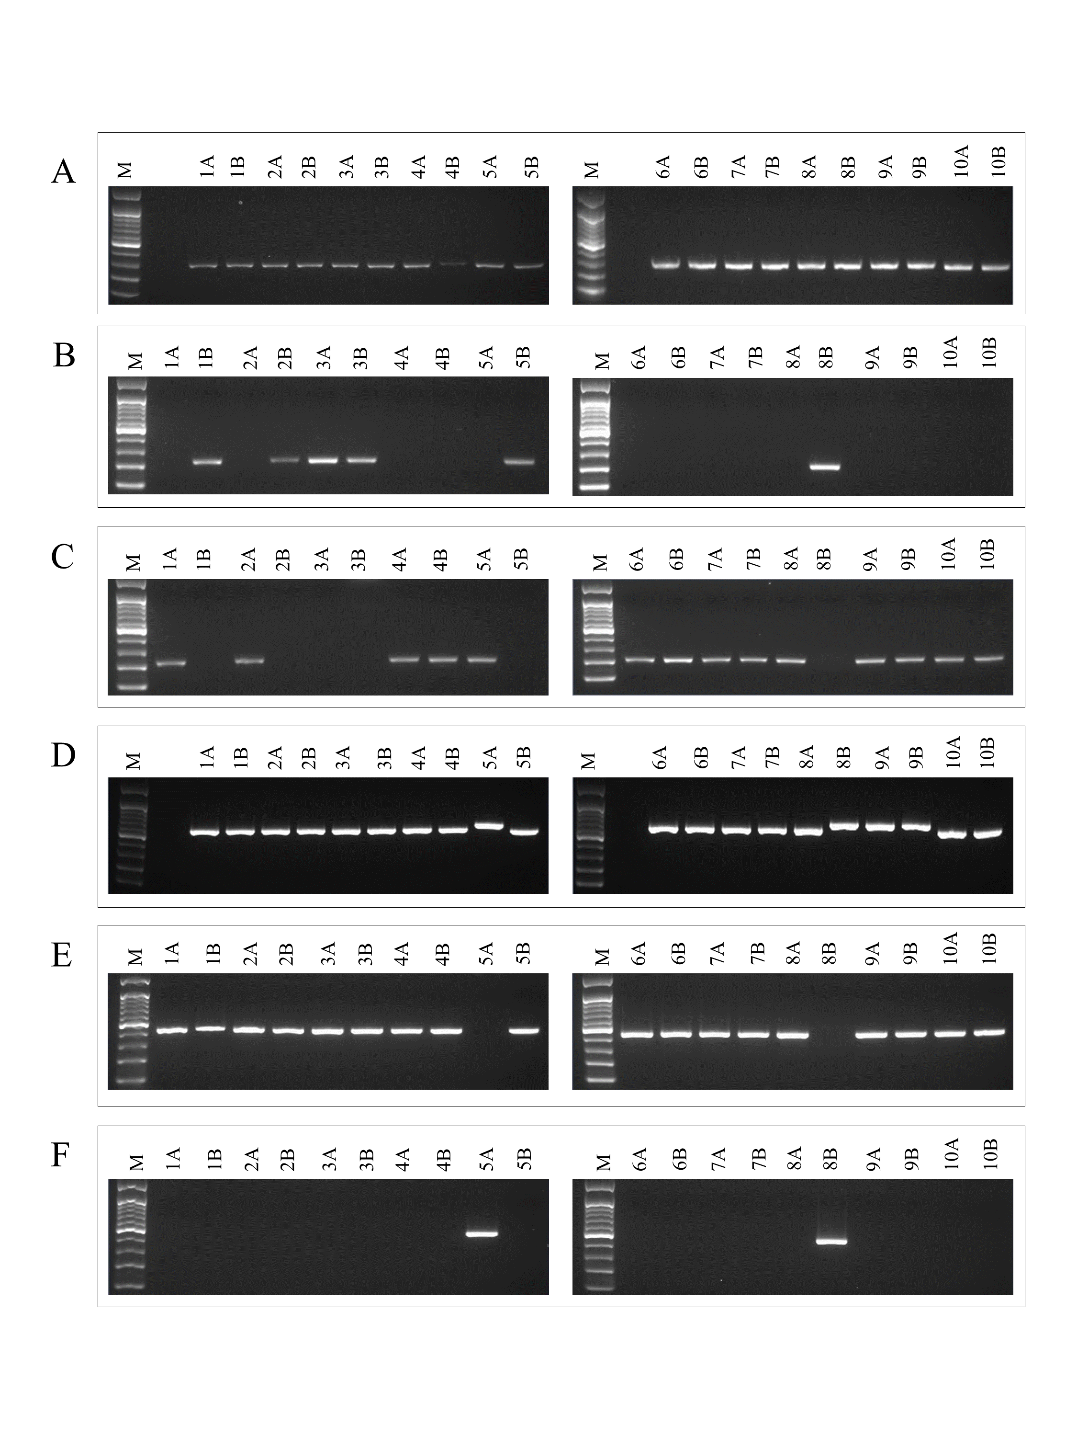

Figure S2.
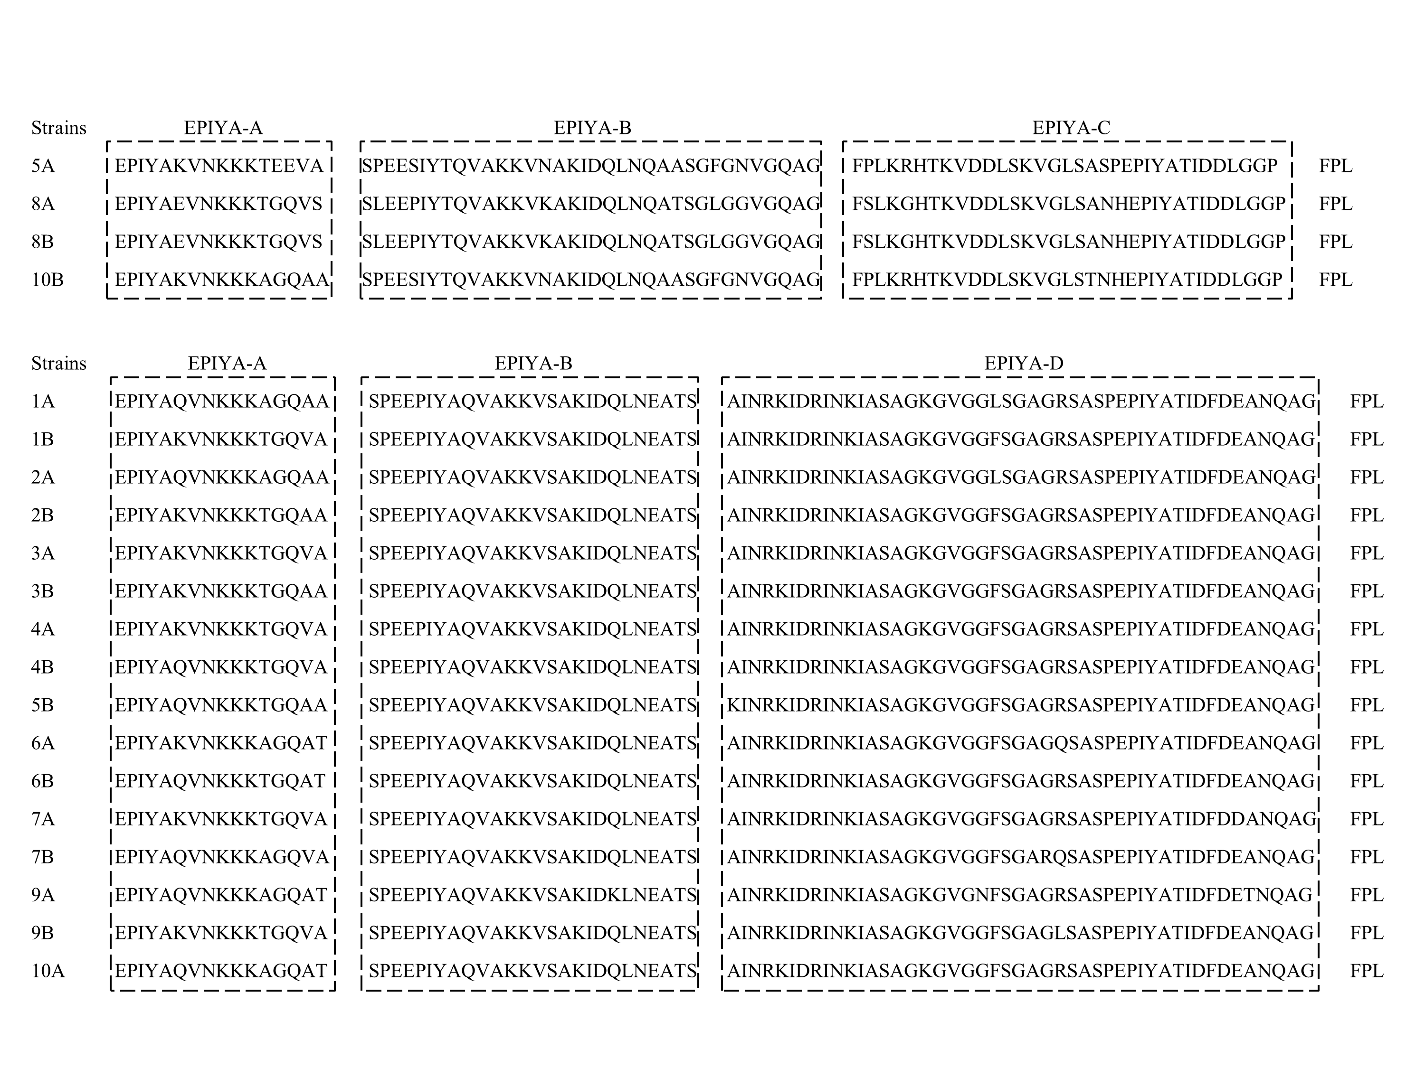
Figure S3.
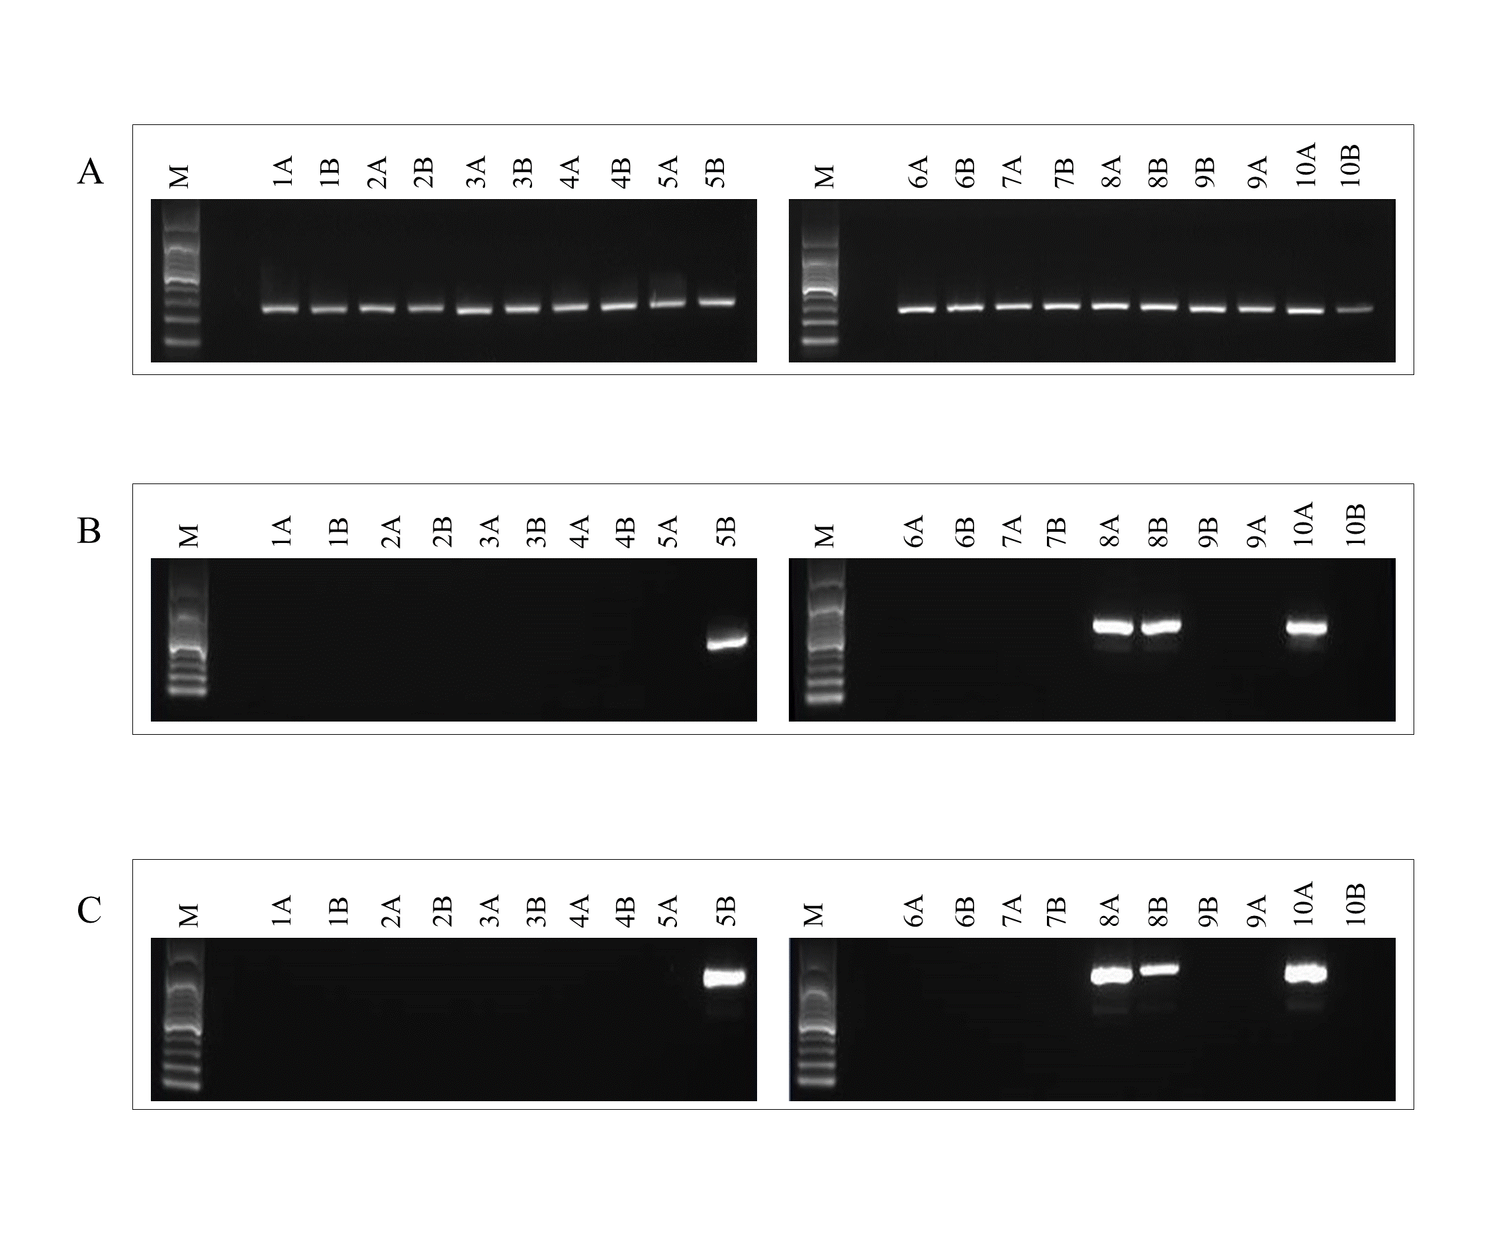
Table S2. Nucleotide and deduced amino acid sequences of the signal peptide-coding region of the oipA gene.
Strains | Sequence of signal peptide encoding region of oipA | Number of CT repeats | Gene status
1A | ATGAAAAAAACCCTTTTACTAACTCTCTTTTTCTCGTTTTGGCTC | 3+1 | on
 | M K K T L L L T L F F S F W L
1B | ATGAAAAAAGCCCTTTTACTAACTCTCTTTTTCTCGTTTTGGCTC | 3+1 | on
 | M K K A L L L T L F F S F W L
2A | ATGAAAAAAACCCTTTTACTAACTCTCTTTTTCTCGTTTTGGCTC | 3+1 | on
 | M K K T L L L T L F F S F W L
2B | ATGAAAAAAGCTCTCTTACTAACTCTCTTTTTCTCGTTTTGGCTC | 3+1 | on
 | M K K A L L L T L F F S F W L
3A | ATGAAAAAAGCCCTTTTACTAACTCTCTTTTTCTCGTTTTGGCTC | 3+1 | on
 | M K K A L L L T L F F S F W L
3B | ATGAAAAAAGCTCTCTTACTAACTCTCTTTTTCTCGTTTTGGCTC | 3+1 | on
 | M K K A L L L T L F F S F W L
4A | ATGAAAAAAACCCTTTTACTCTTTCTGTCTTTCTCGTTTTGGCTC | 2+1+1+1 | on
 | M K K T L L L F L S F S F W L
4B | ATGAAAAAAACCCTTTTACTAACTCTCTTTTTCTCGTTTTGGCTC | 3+1 | on
 | M K K T L L L T L F F S F W L
5A | ATGAAAAAAACCCTTTTACTAACTCTCTTTTTCTCGTTTTGGCTC | 3+1 | on
 | M K K T L L L T L F F S F W L
5B | ATGAAAAAAACCCTTTTACTAACTCTCTTTTTCTCGTTTTGGCTC | 3+1 | on
 | M K K T L L L T L F F S F W L
6A | ATGAAAAAAACCCTTTTACTCTTTCTGTCTCTCTCGTTTTGGCTC | 2+1+3 | on
 | M K K T L L L F L S L S F W L
6B | ATGAAAAAAACCCTTTTACTAACCCTCTTTTTCTCGTTTTGGCTC | 2+1 | on
 | M K K T L L L T L F F S F W L
7A | ATGAAAAAAACCCTTTTACTAACTCTCTTTTTCTCGTTTTGGCTC | 3+1 | on
 | M K K T L L L T L F F S F W L
7B | ATGAAAAAAACCCTTTTACTAACTCTCTTTTTCTTGTTTTGGCTC | 3+1 | on
 | M K K T L L L T L F F L F W L
8A | ATGAAAAAAGCTCTCTTACTAACTCTCTCTCTCCCTCTCTCGTTTTGGCTC | 5+3 | on
 | M K K A L L L T L S L P L S F W L
8B | ATGAAAAAAGCTCTCTTACTAACTCTCTCTCTCCCTCTCTCGTTTTGGCTC | 5+3 | on
 | M K K A L L L T L S L P L S F W L
9A | ATGAAAAAAACCCTTTTACTCTTTCTGTCTTTCTCGTTTTGGCTC | 2+1+1+1 | on
 | M K K T L L L F L S F S F W L
9B | ATGAAAAAAACCCTTTTACTCTTTCTCTCTTTCTTGTTTTGGCTC | 2+3+1 | on
 | M K K T L L L F L S F L F W L
10A | ATGAAAAAAACCCTTTTACTCTTTCTCTTTTTCTCGTTTTGGCTC | 2+2+1 | on
 | M K K T L L L F L F F S F W L
10B | ATGAAAAAAGCTCTCTTACTAACTCTCTTTTTCTCGTTTTGGCTC | 3+1 | on
 | M K K A L L L T L F F S F W L
Numbers 1–10 indicate individual patients; A, stomach antrum; B, stomach body; Number of CT repeats, cytosine-thymine repeated in the nucleotide sequence; on, functional status

