Additional File

Table 1 Primers used for real-time qPCR
Primer name | Primer sequence
ICAM‐1 (forward) | 5′‐TCACCTATGGCAACGACTCC‐3′
ICAM‐1 (reverse) | 5′-GTGTCTCCTGGCTCTGGTTC‐3′
VCAM‐1 (forward) | 5′‐GAAGGTGGCTCTGTGACCAT‐3′
VCAM‐1 (reverse) | 5′‐AAAGGTGCTGTAGATTCCCATT‐3′
GAPDH (forward) | 5′‐GCACCGTCAAGGCTGAGAAC‐3′
GAPDH (reverse) | 5′‐TGGTGAAGACGCCAGTGGA‐3′

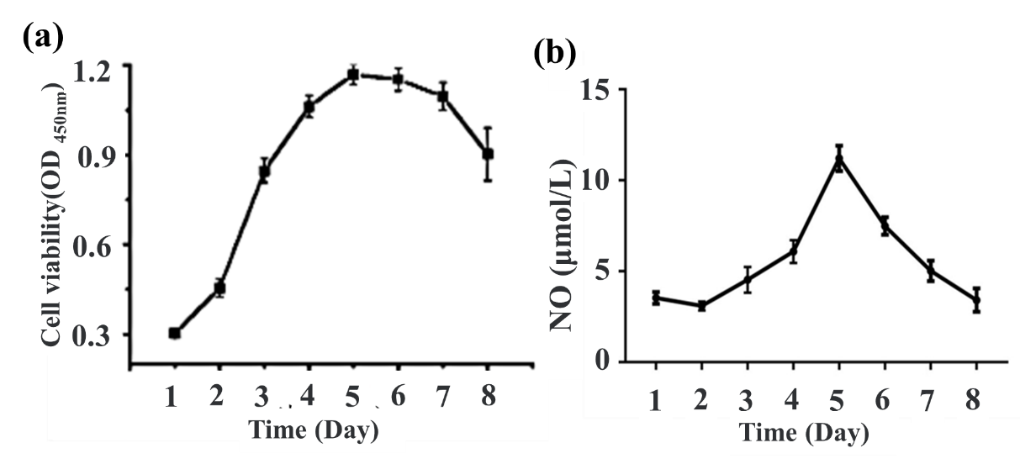
Fig.1. (a) The viability of ECs in the carotid artery model. (b) The functionality of ECs in the carotid artery model.
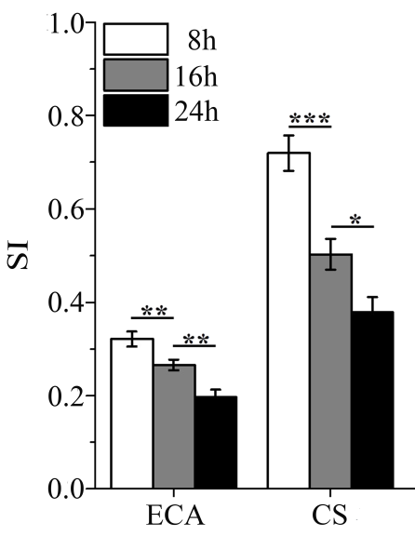
Fig.2. The SI of ECs in the carotid artery model in different study regions and time

