Additional file 4: Results of the meta-analysis for the outcomes of interest
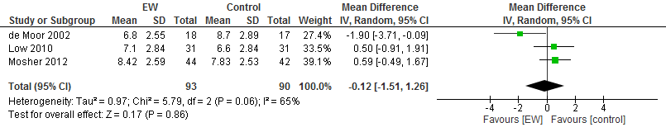
Figure S1. Pooled data comparing the effectiveness of EW on sleep (sleep quality/sleep duration) compared with the control task
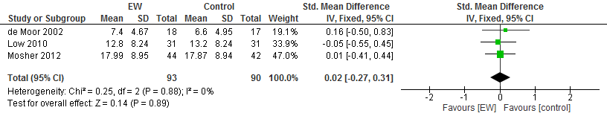
Figure S2. Pooled data comparing the effectiveness of EW on depression compared with the control task
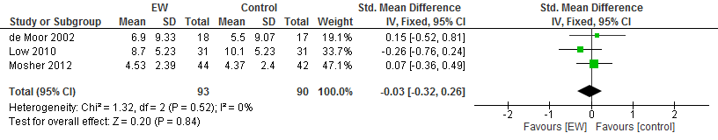
Figure S3. Pooled data comparing the effectiveness of EW on distress compared with the control task

