Supplementary Information:
Epsilon-Fe₂O₃ is a novel intermediate for magnetite biosynthesis in magnetotactic bacteria
Tong Wen^{1, 3, †}, Yunpeng Zhang^{1, 4†}, Yuanyuan Geng¹, Junquan Liu¹, Abdul Basit¹, Jiesheng Tian¹, Ying Li¹, Jilun Li¹, Jing Ju^{2*}, Wei Jiang^{1*}

Supplementary Information Figure S1. HRTEM images with high resolution and the corresponding FFT analyses of intracellular iron oxide nanoparticles in MSR-1 wild type after the induction of ferric citrate for different time interval.
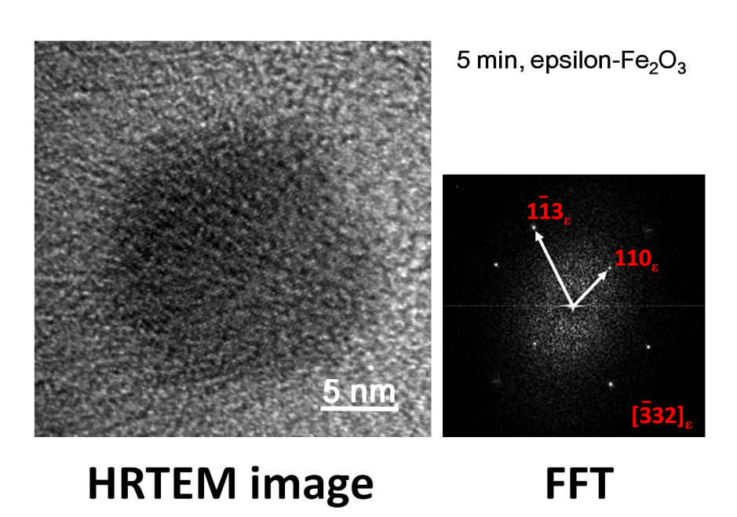
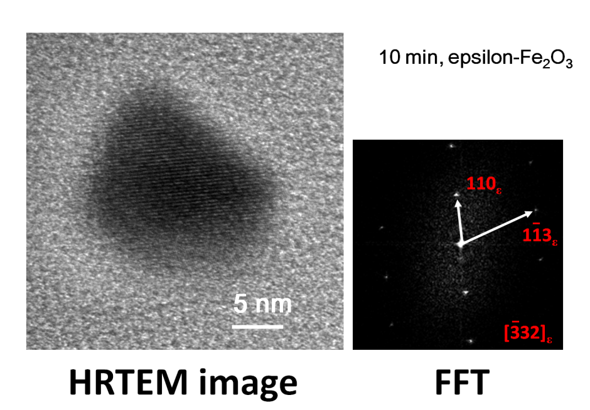
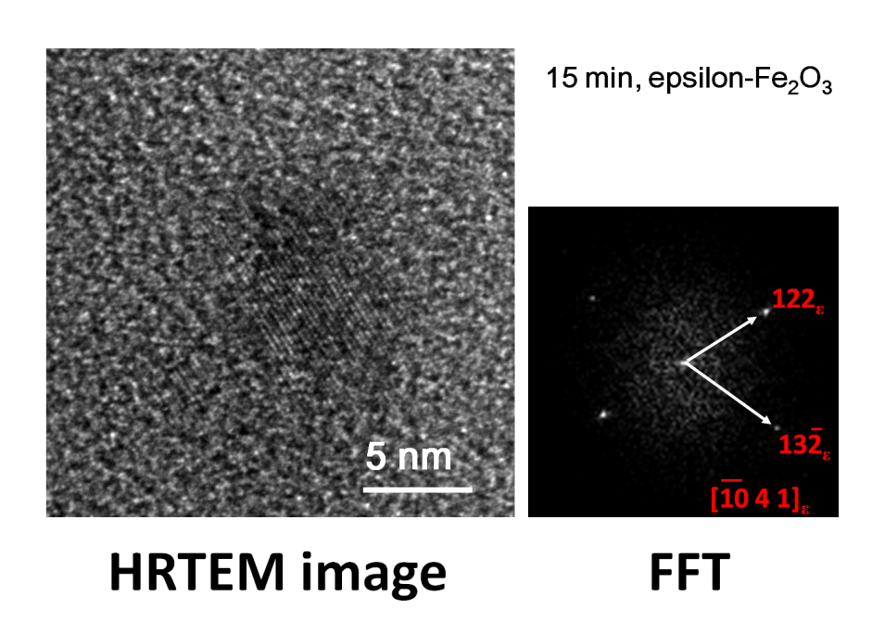
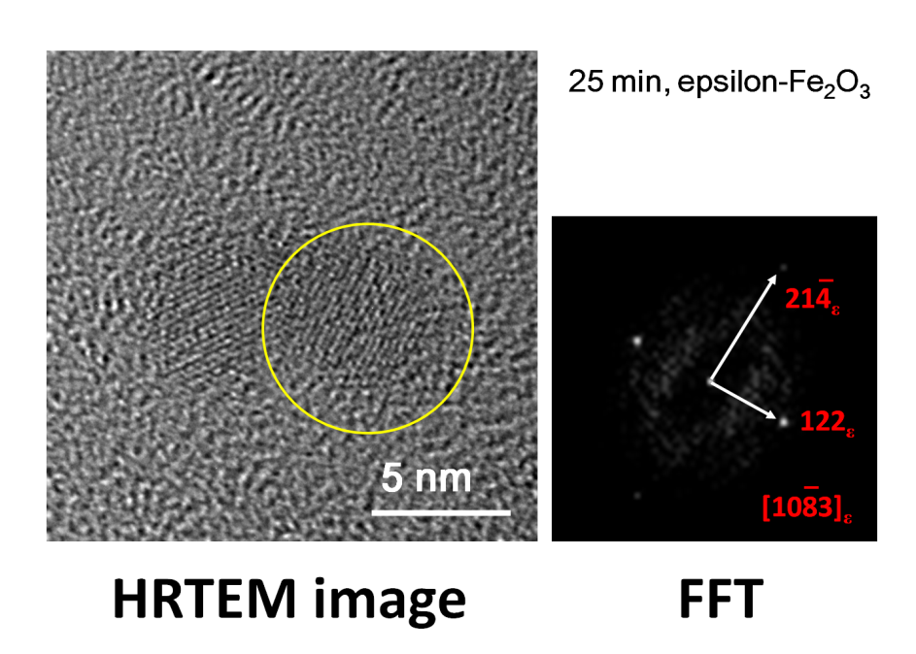
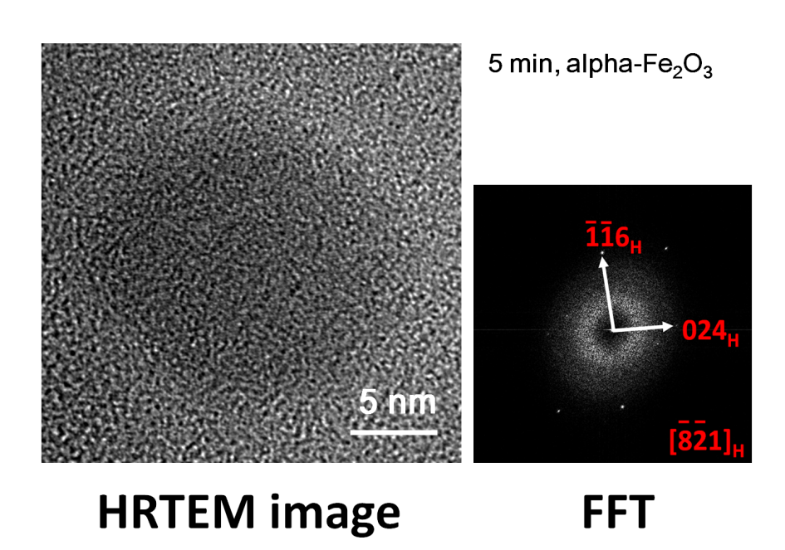
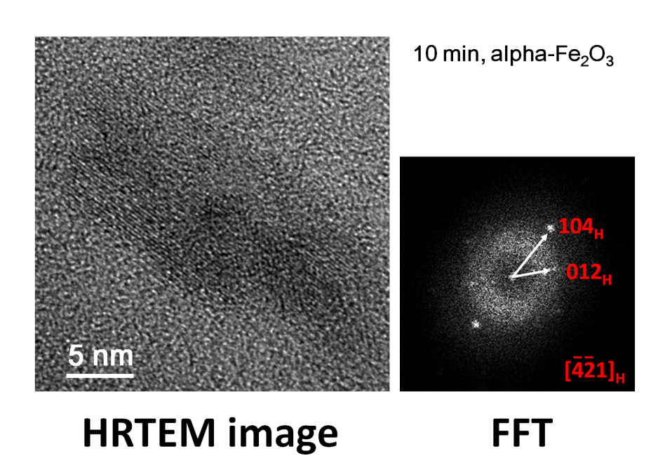
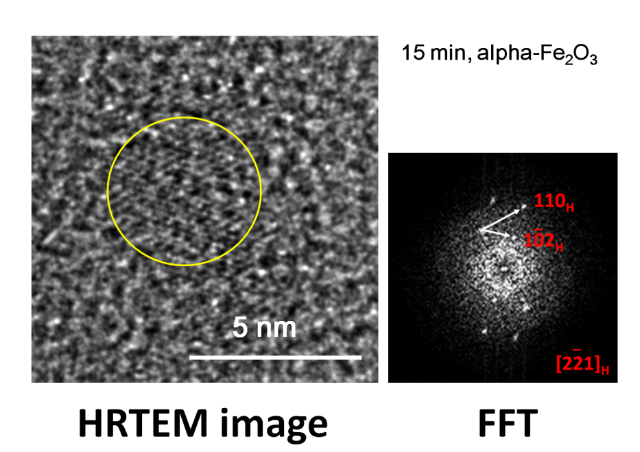
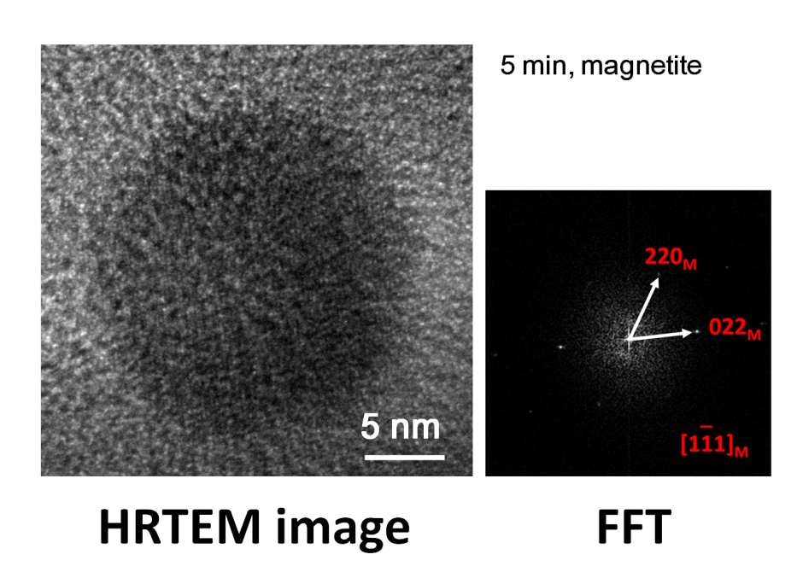
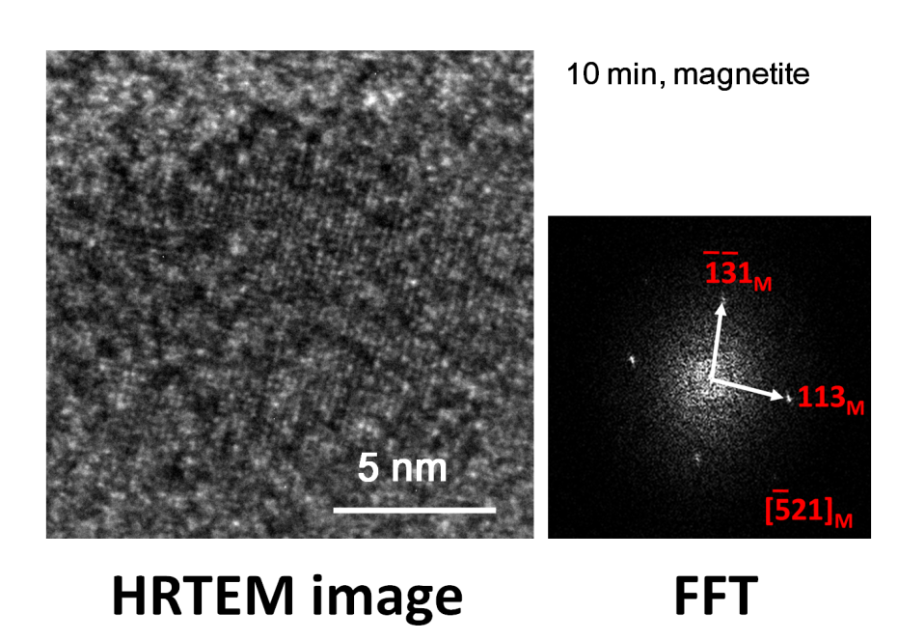
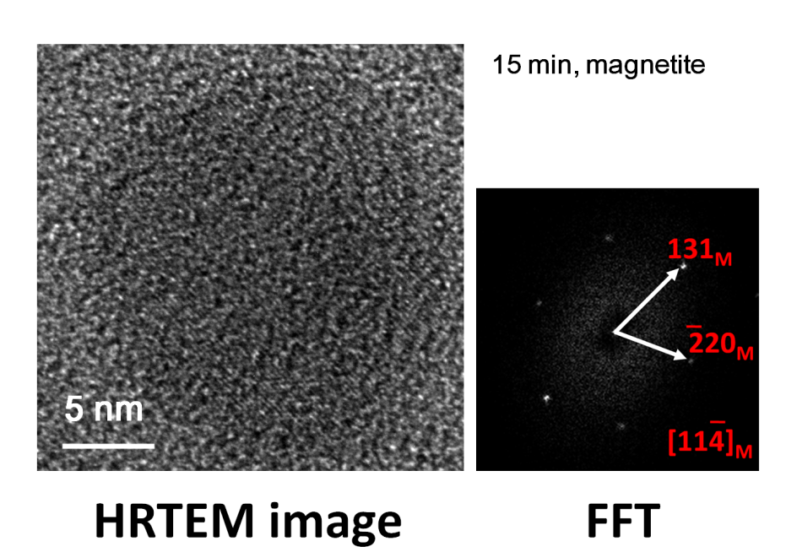
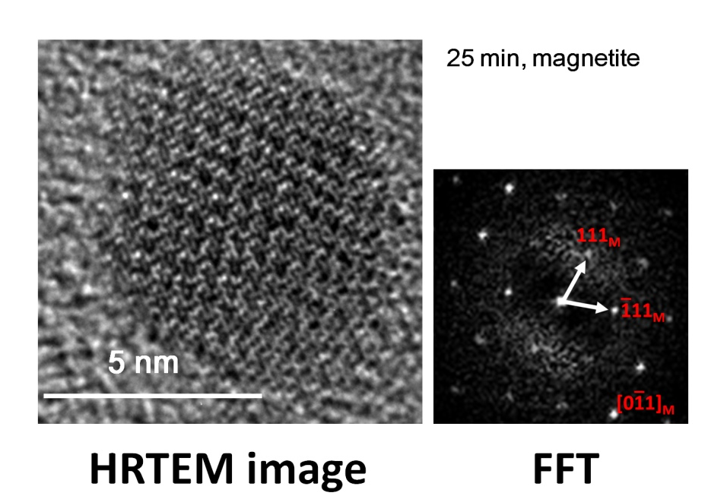
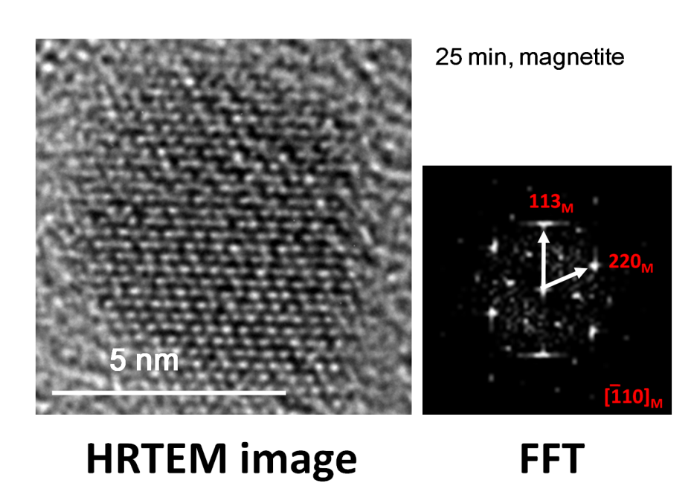

Supplementary Information Figure S2. Some representative HRTEM images of epsilon-Fe₂O₃ and alpha-Fe₂O₃ used for the phase ratio determination in Fig. 5 of the main text.
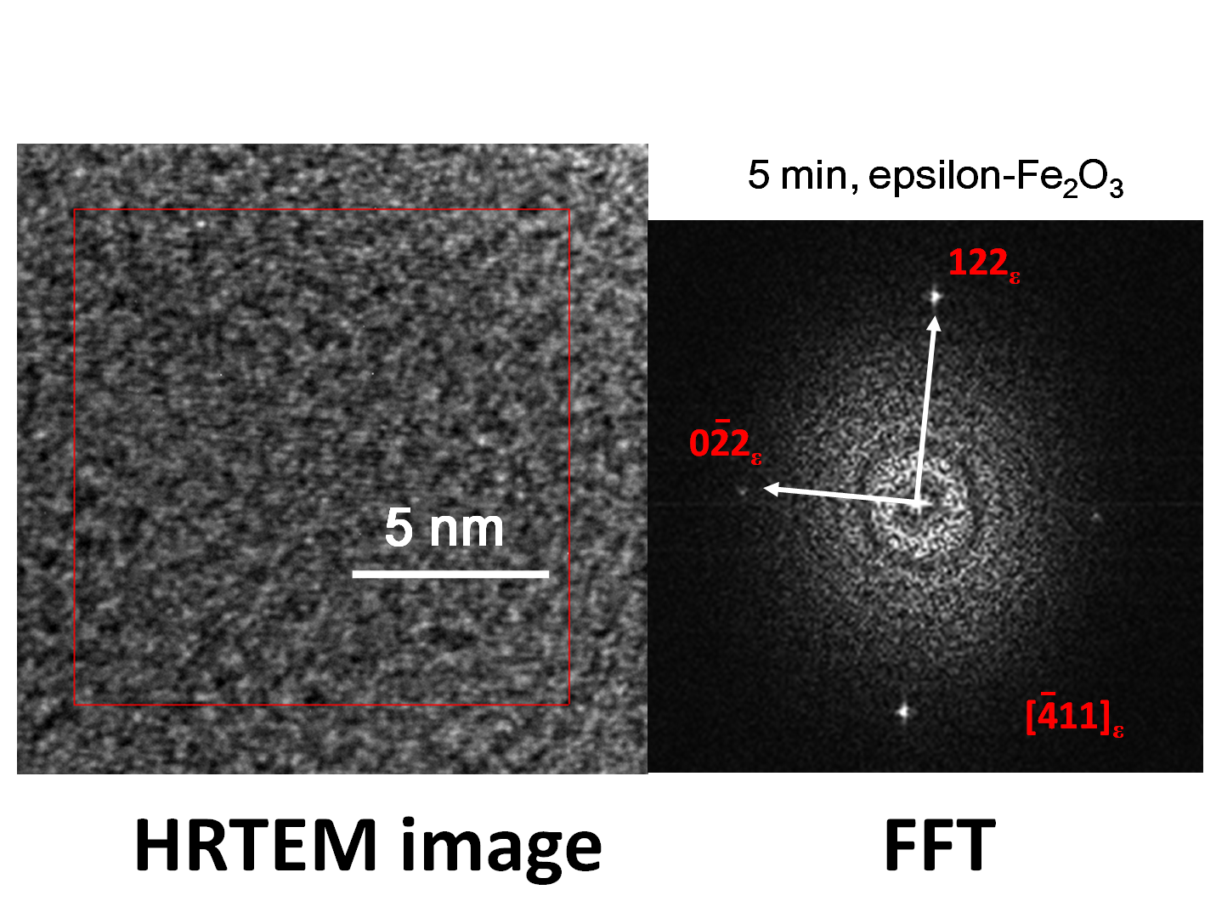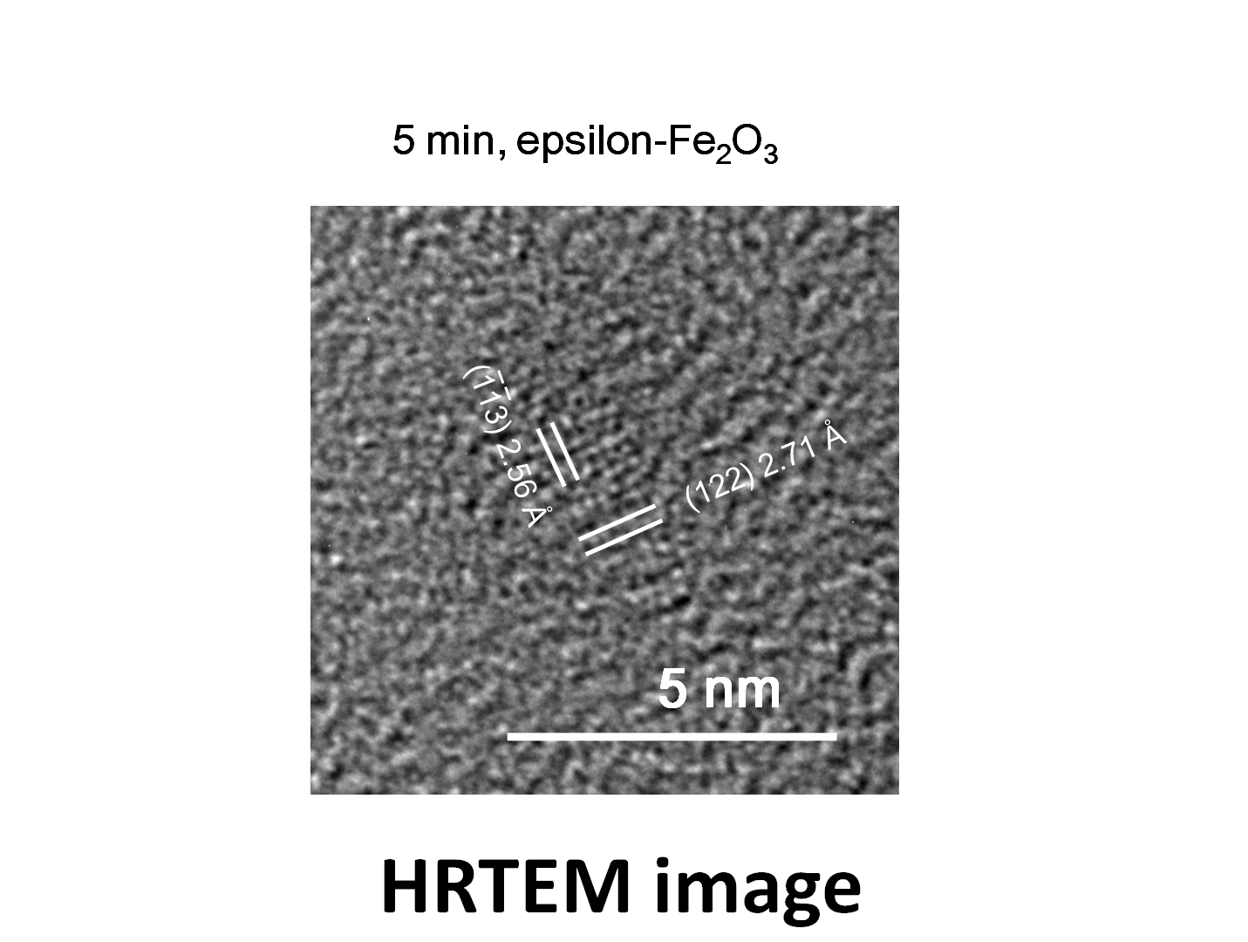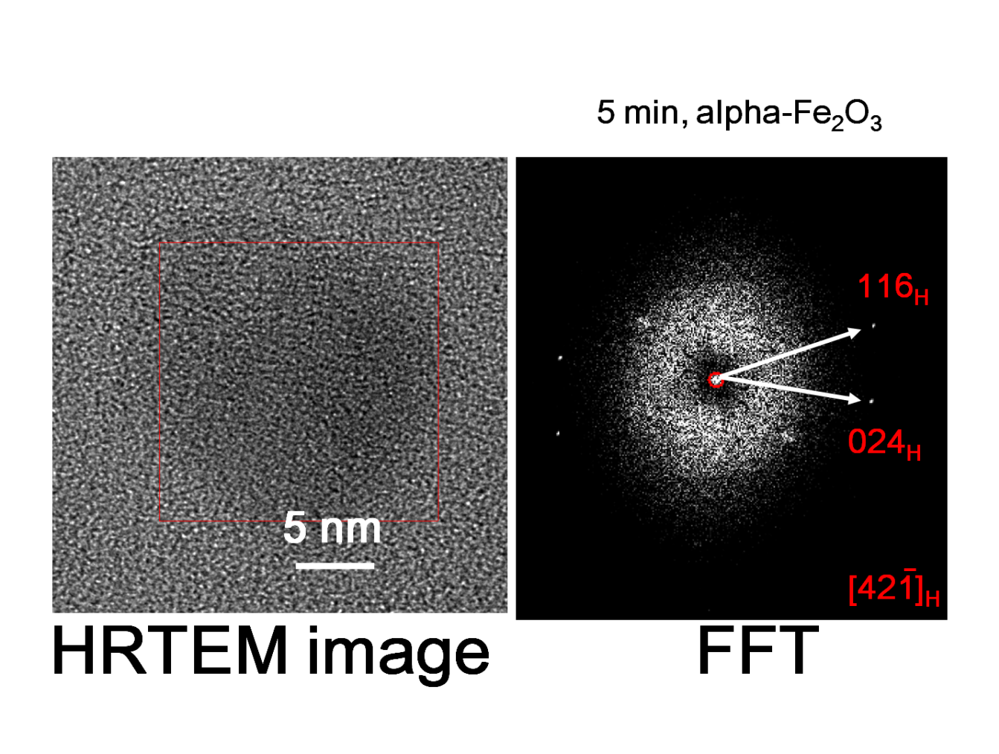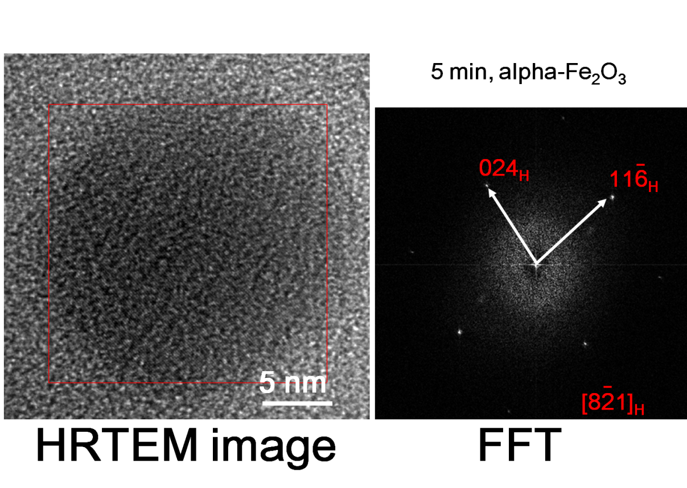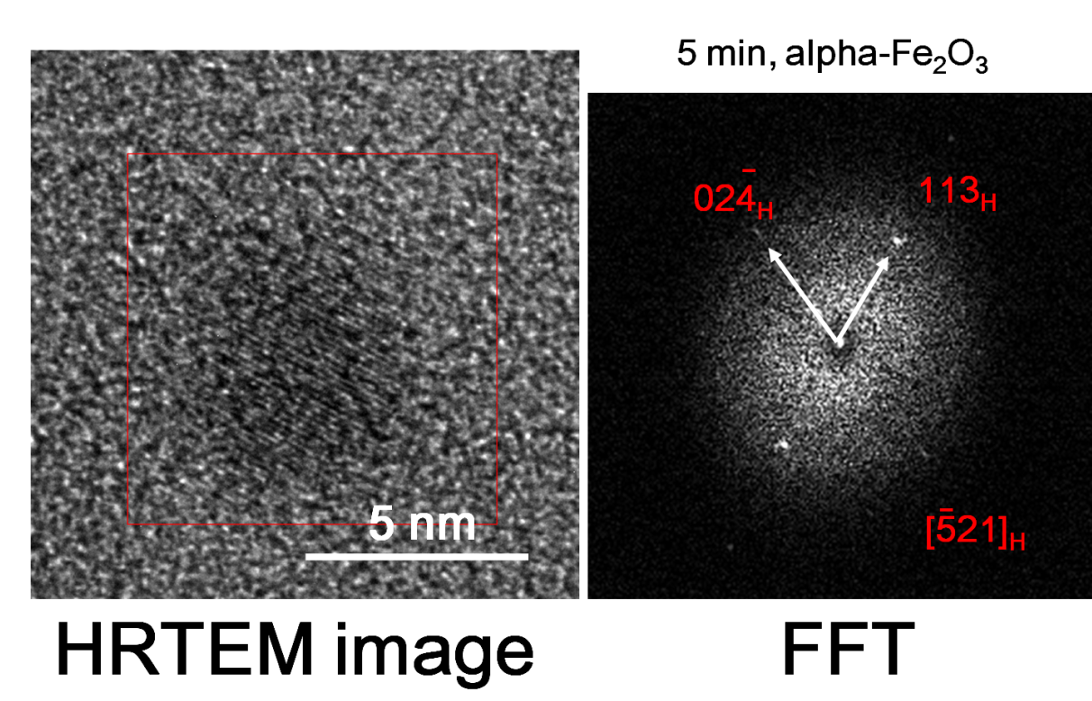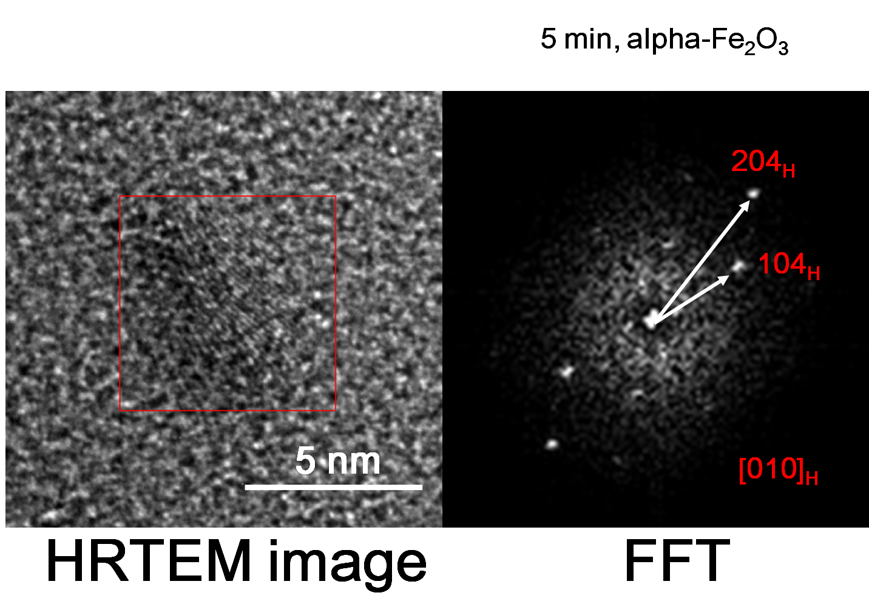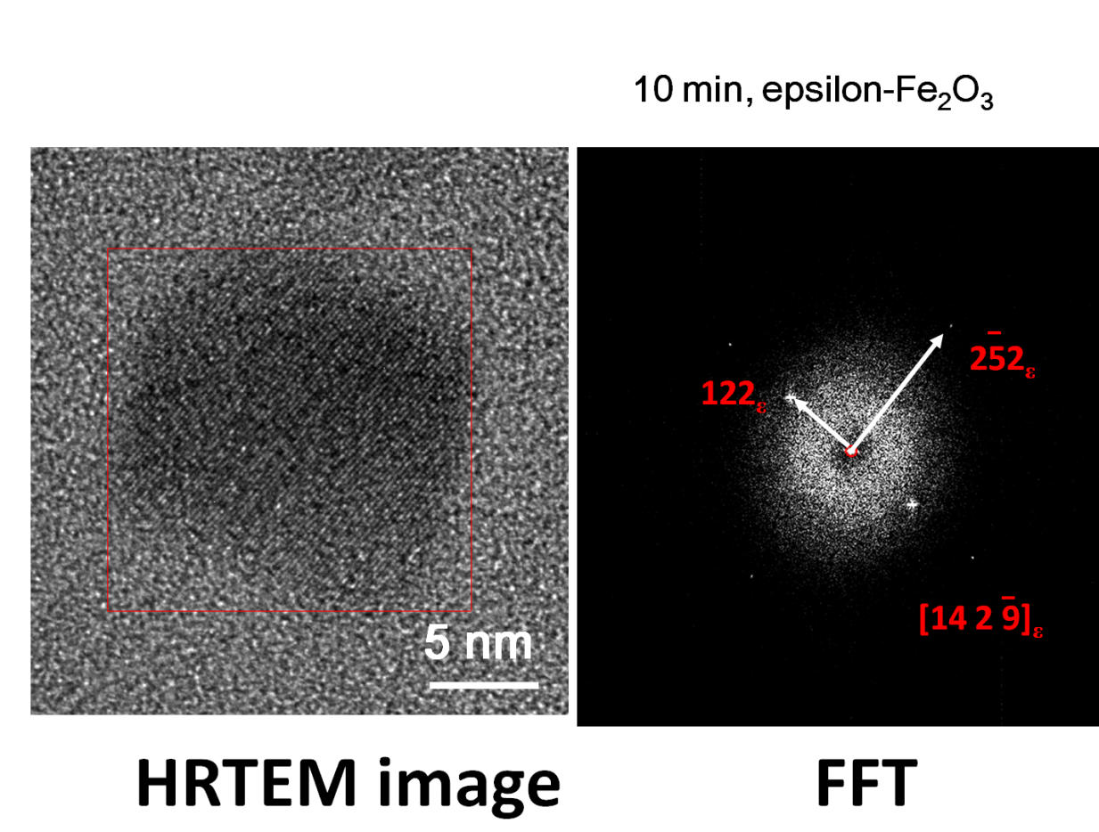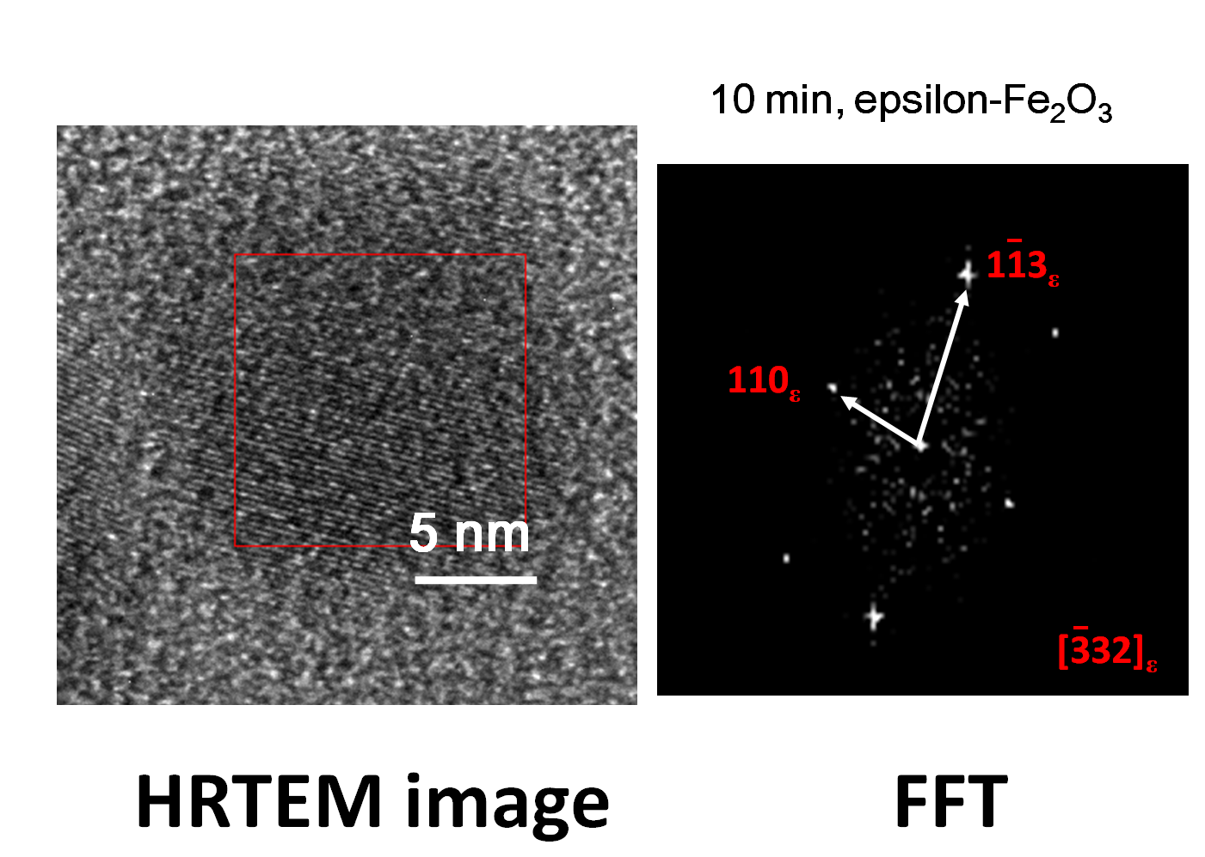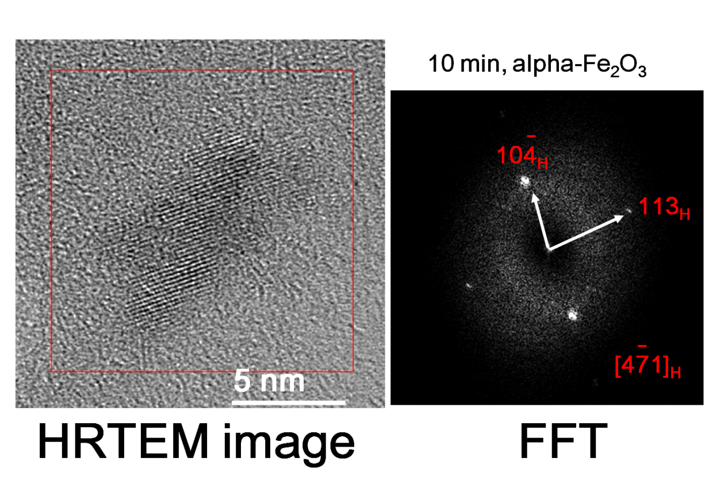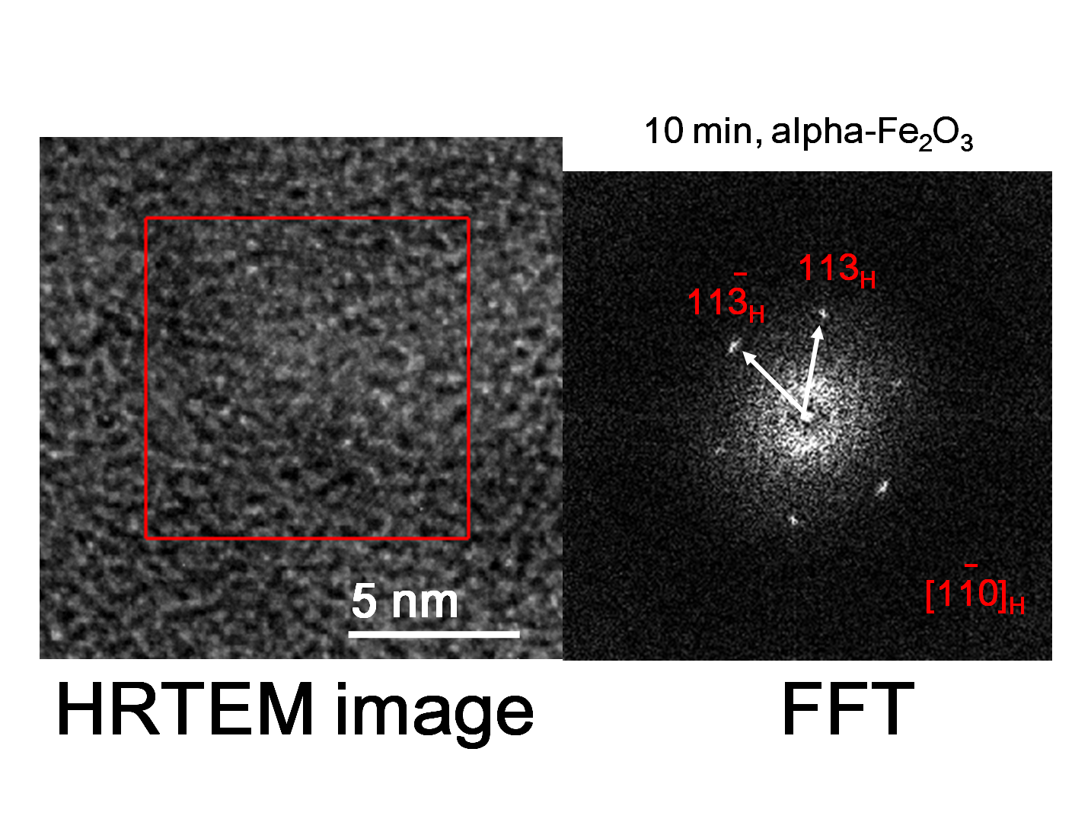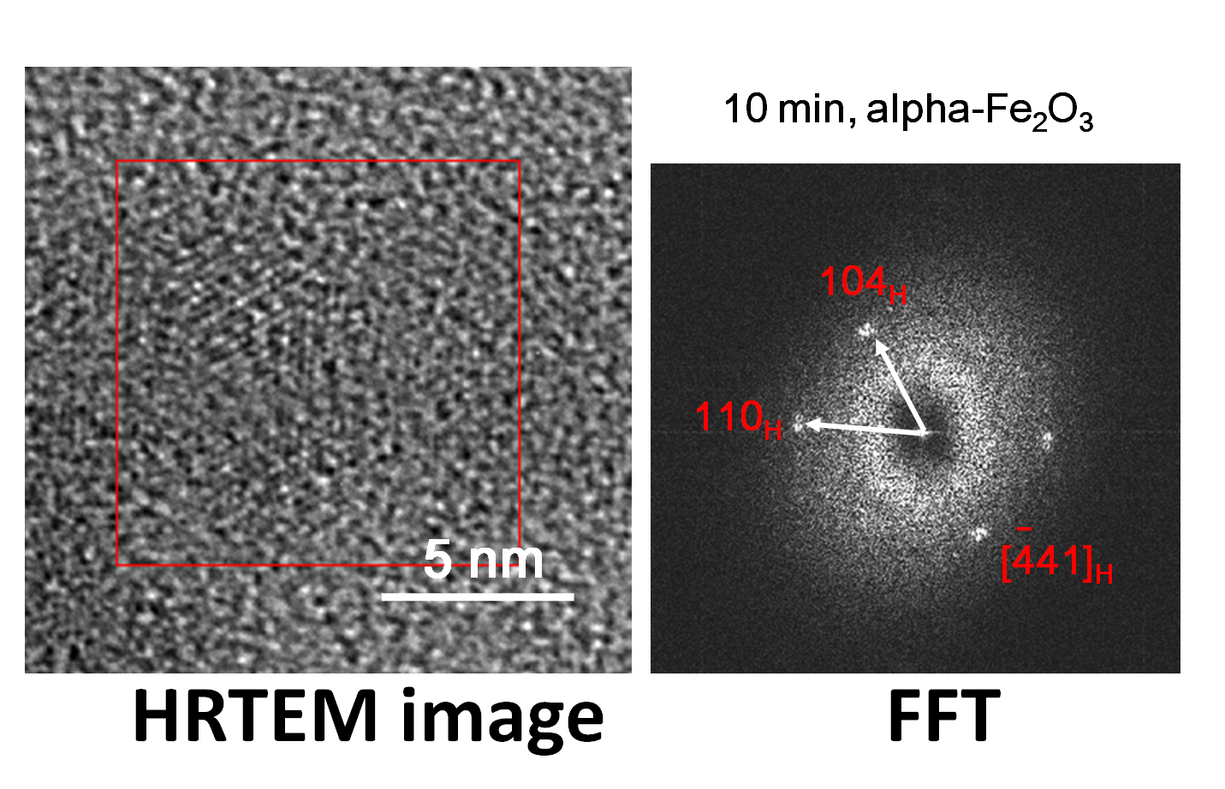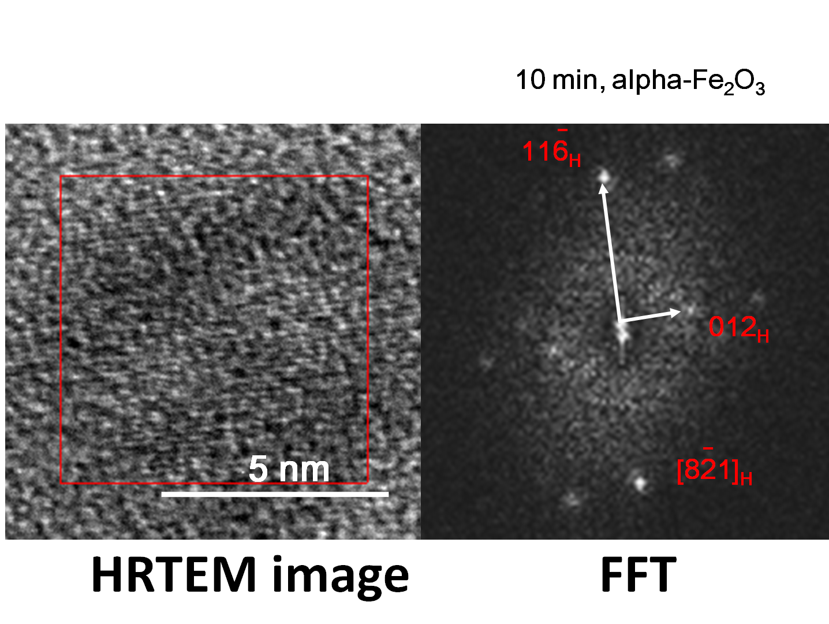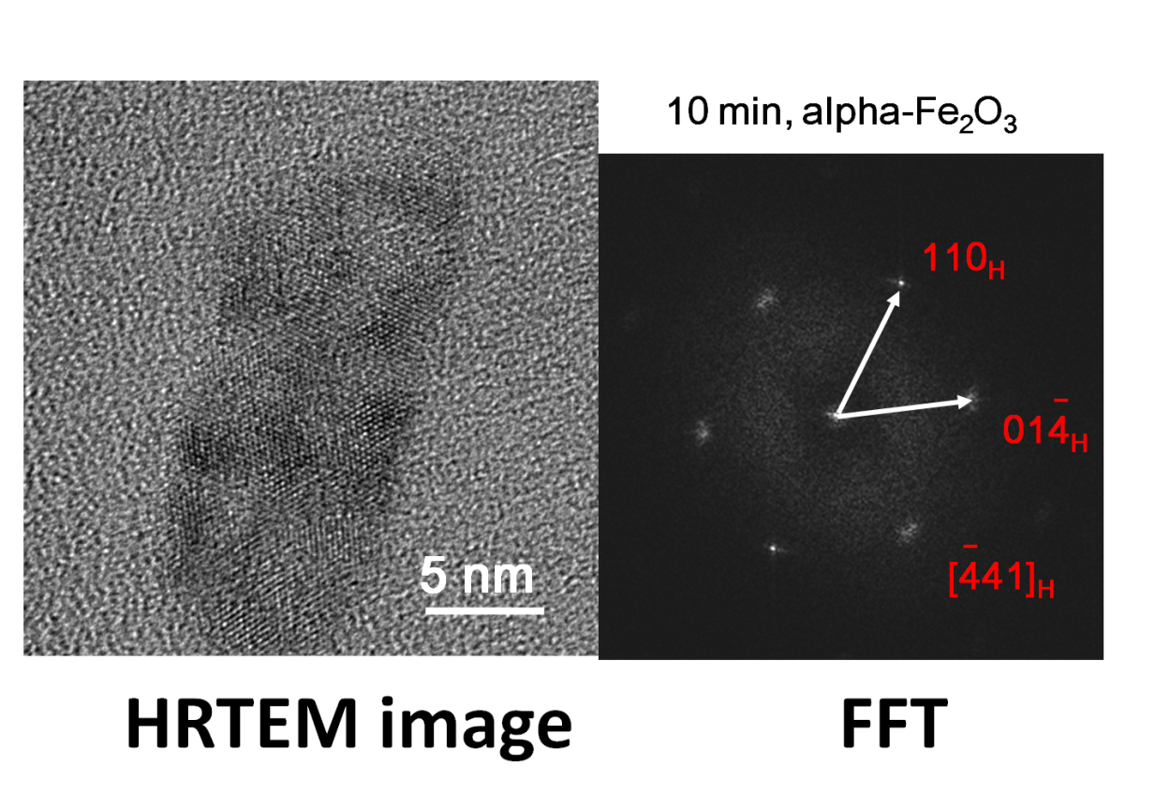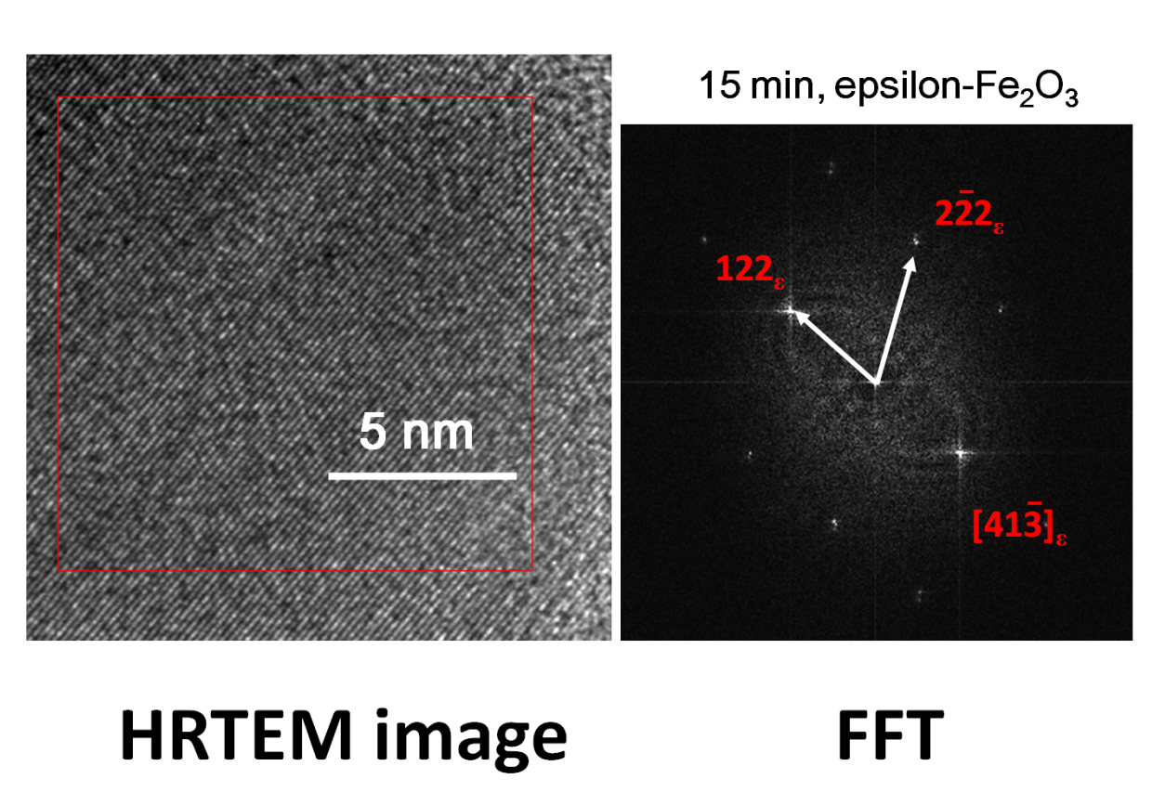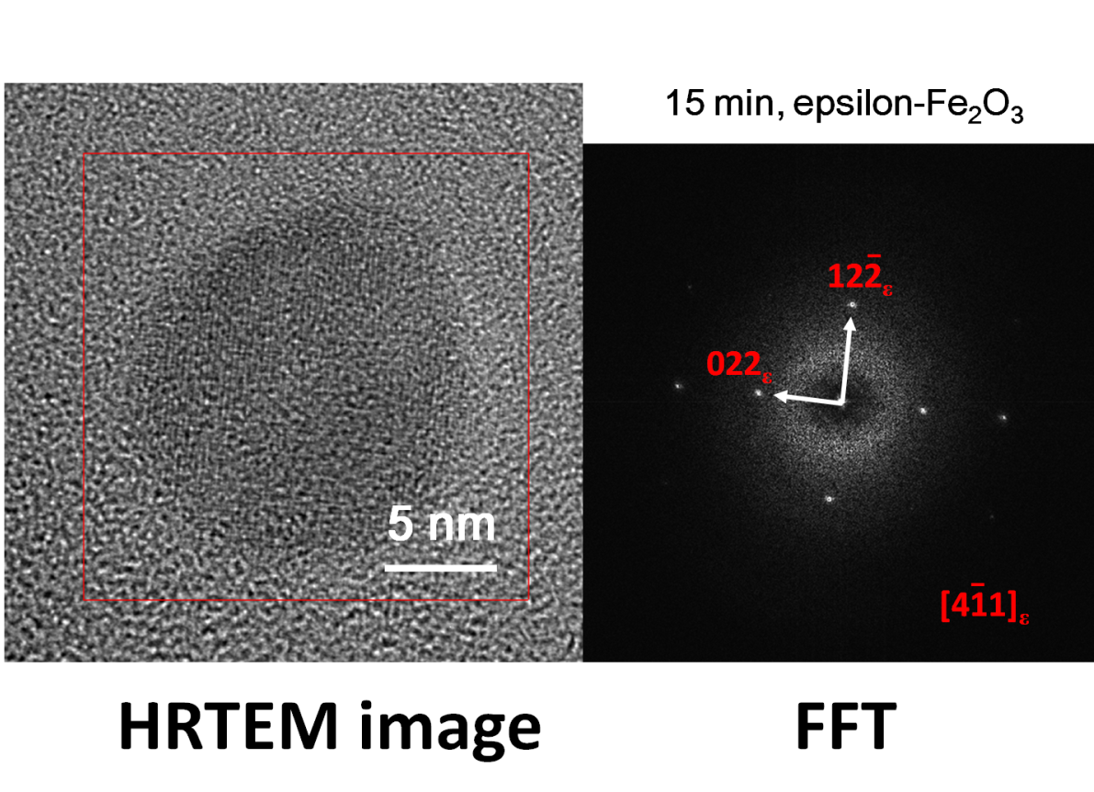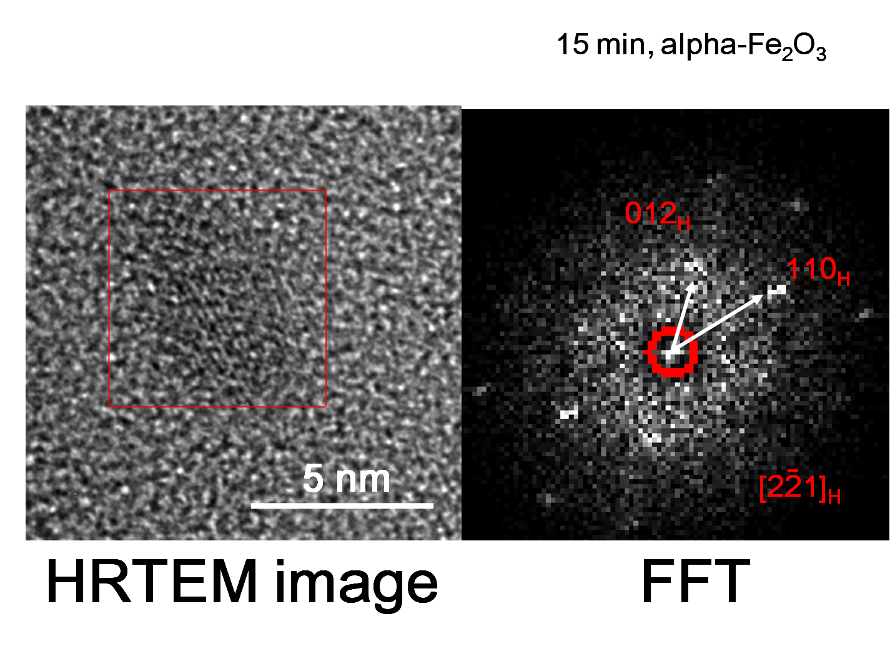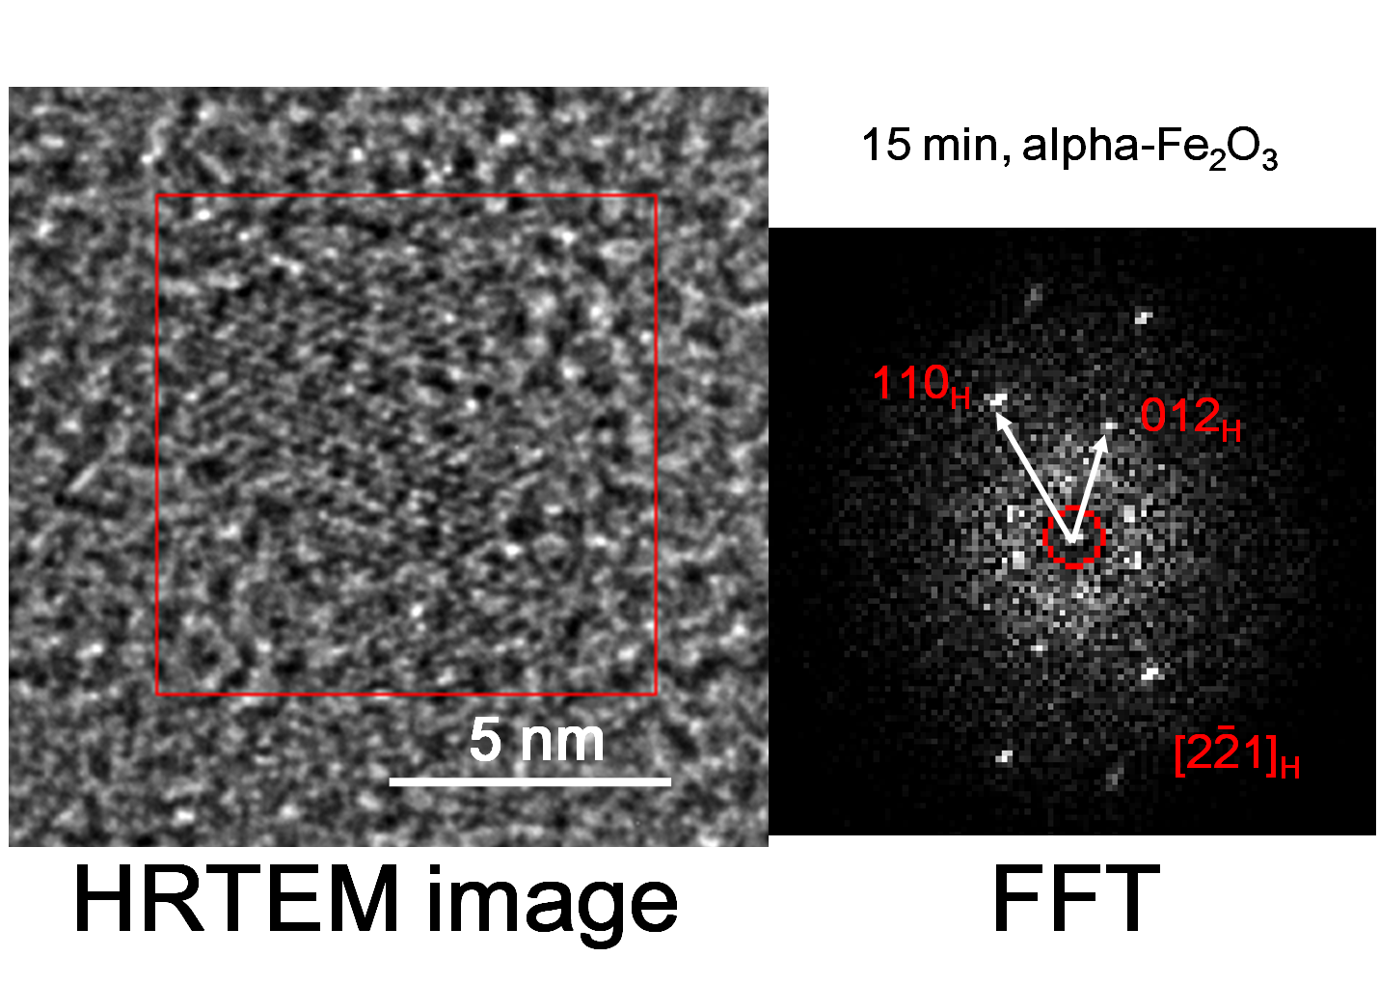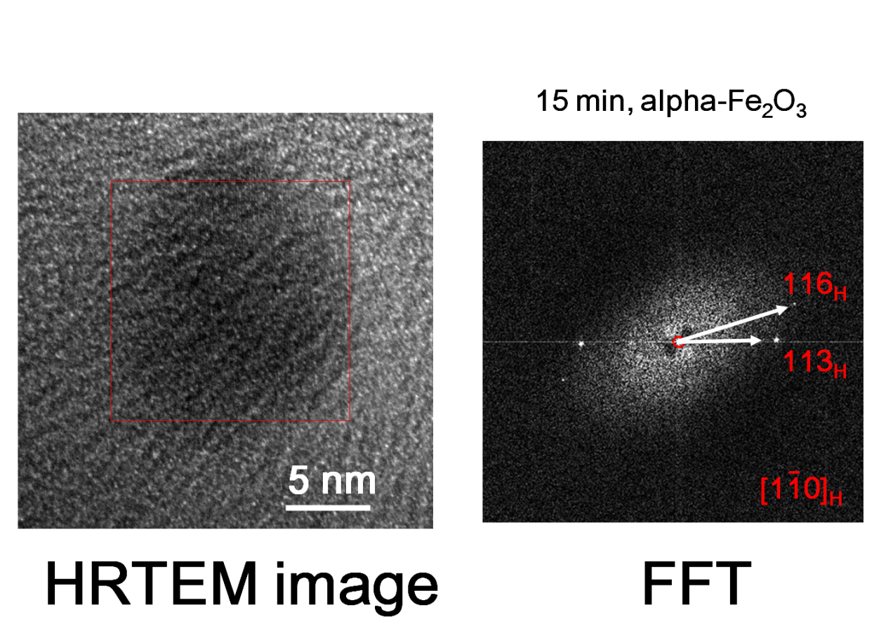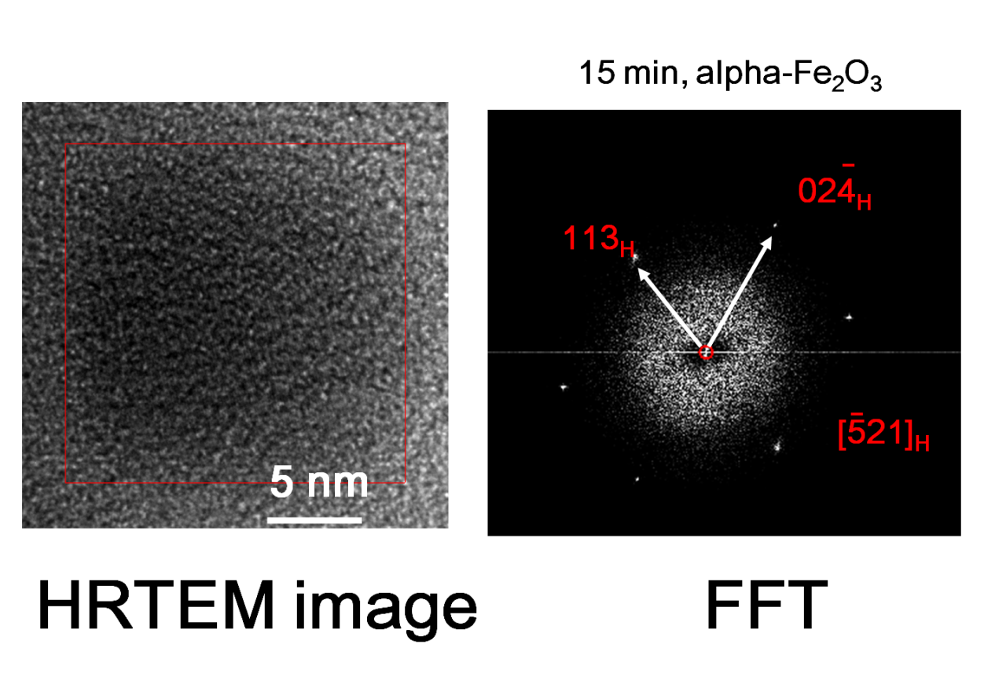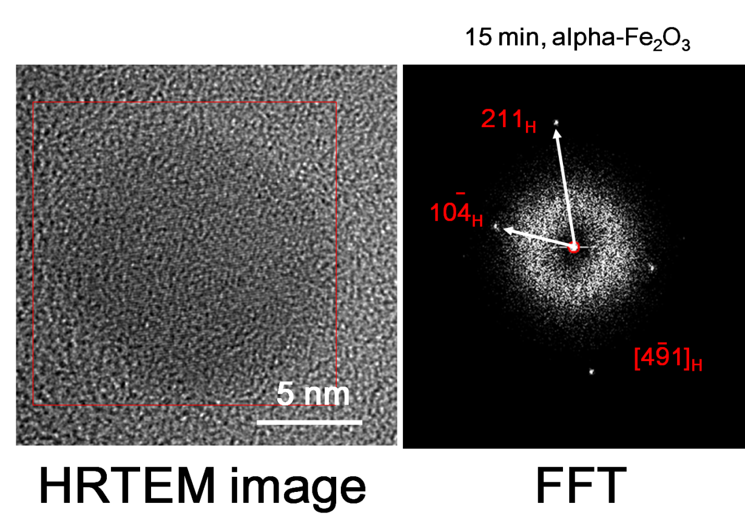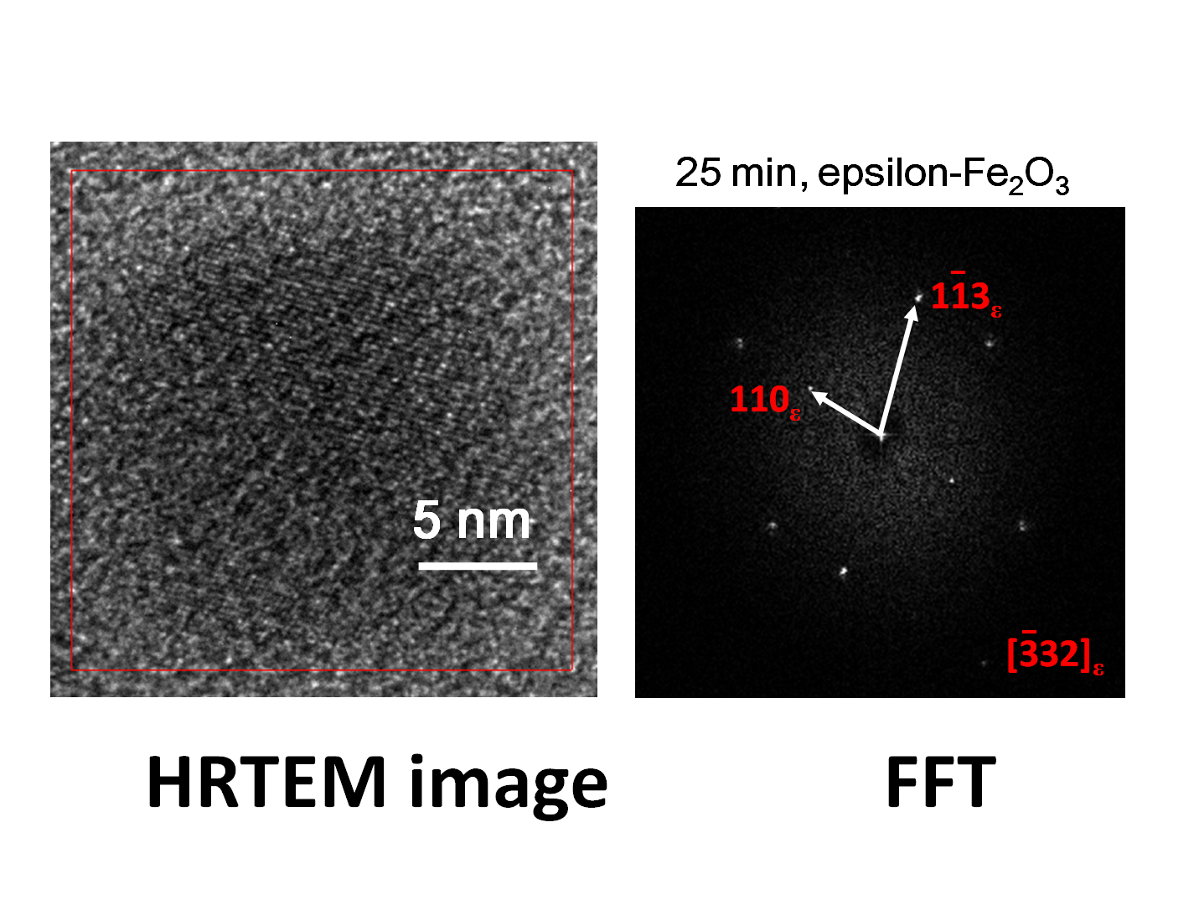

Supplementary Information Table S1. Crystallographic information of the ε-Fe₂O₃ exhibited in Figure 3a, Figure 4 and the theoretical data of ε-Fe₂O₃ and Fe₃O₄ (magnetite). For further crystallographic information, people can refer to pdf card as 33-0664 for α-Fe₂O₃, 65-3107 for magnetite and 52-1449 for ε-Fe₂O₃, respectively.

Image identifier | 5 min | 10 min | 15 min | 25 min
Axis of projection, as indicated in Fig. 2 for epsilon-Fe₂O₃ | [-332] | [-332] | [-10 4 1] | [10 -8 3]
Reflections identified for epsilon-Fe₂O₃ | 110 and 1-13 | 110 and 1-13 | 122 and 13-2 | 21-4 and 122
Possible axis of projection for magnetite | [03-1] | [03-1] | [4 1 -1] | [4 1 -1]
Possible reflections identified for magnetite | 200* and 113 | 200* and 113 | 022 and 1-13 | 1-31 and 115
Ratio measured between two sets of reciprocal spacings (referred to as r1 and r2) | 1.68  r1 = 4.36 Å and r2 = 2.59 Å | 1.65  r1 = 4.31 Å and r2 = 2.61 Å | 1.2  r1 = 2.73 Å and r2 = 2.28 Å | 1.61  r1 = 2.68 Å and r2 = 1.66 Å
Ratio between spacings as indicated in Fig. 2 for epsilon-Fe₂O₃ (referred to as r1 and r2) | 1.72  r1 = 4.39 Å and r2 = 2.55 Å | 1.72  r1 = 4.39 Å and r2 = 2.55 Å | 1.22  r1 = 2.71 Å and r2 = 2.23 Å | 1.6  r1 = 2.71 Å and r2 = 1.69 Å
Ratio between spacings in magnetite (referred to as r1 and r2) | 1.66  r1 = 4.2 Å and r2 = 2.53 Å | 1.66  r1 = 4.2 Å and r2 = 2.53 Å | 1.17  r1 = 2.97 Å and r2 = 2.53 Å | 1.57  r1 = 2.53 Å and r2 = 1.61 Å
Angle measured between two sets of reciprocal spacings (degrees) | 71 | 70.5 | 64.7 | 85
Angle between reciprocal lattice directions as indicated in Fig. 2  for epsilon-Fe₂O₃ | 73 | 73 | 64.1 | 86.4
Angle between reciprocal lattice directions in magnetite | 72.5 | 72.5 | 64.8 | 80

