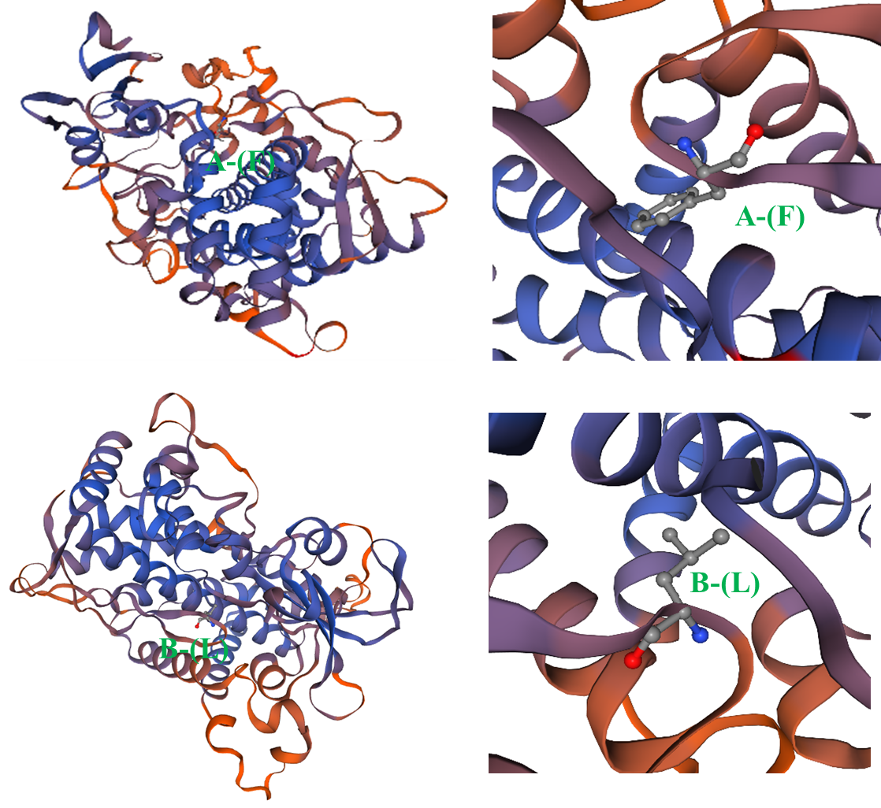
Fig. S9 Predicted 3D structure of CYP17A1 proteins of different genotypes with SWISS-MODEL Workspace (https://swissmodel.expasy.org/).

