Additional Material
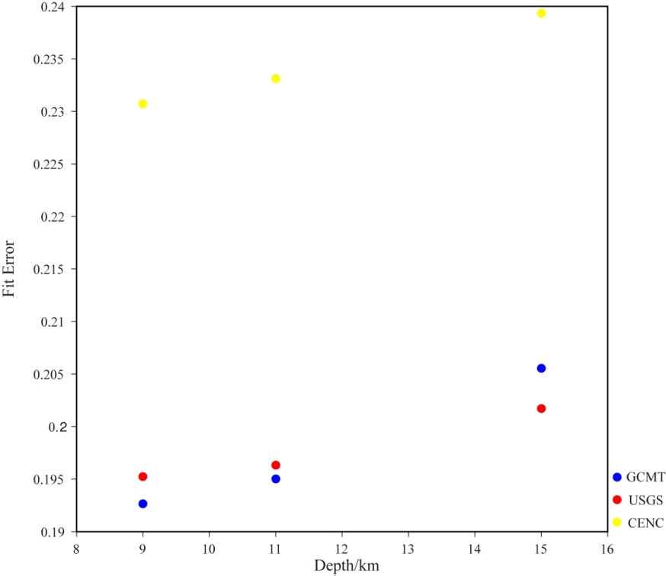
Fig.S1 Fit error of different focal mechanisms for the 2017 Jiuzhaigou earthquake.
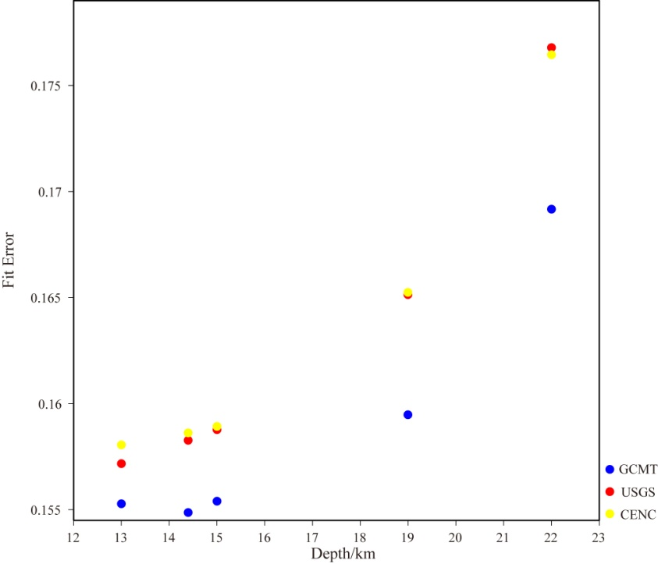
Fig.S2 Fit error of different focal mechanisms for the 2013 Lushan earthquake.
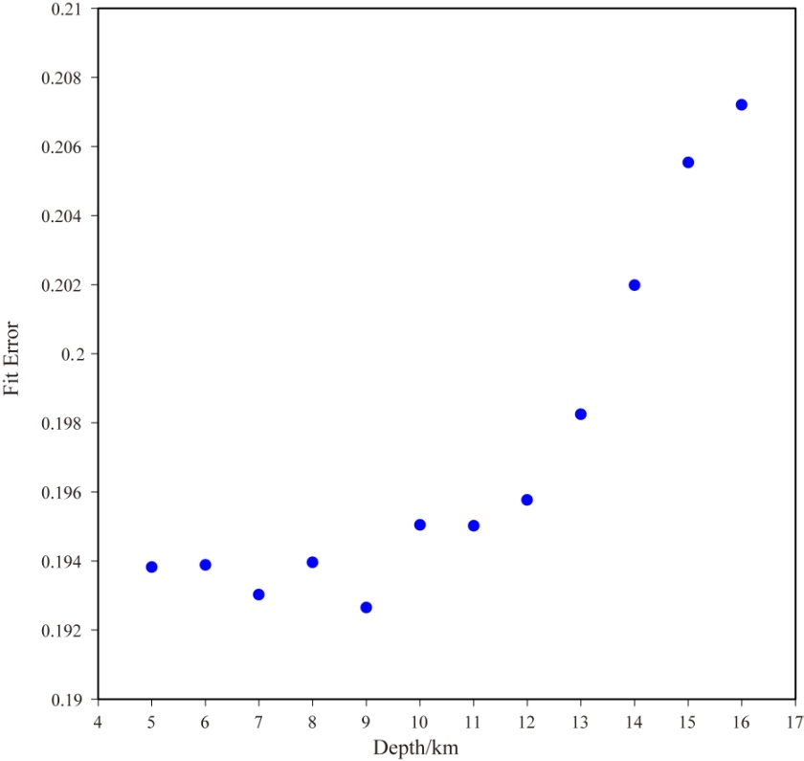
Fig.S3 Fit error of different depths for the 2017 Jiuzhaigou earthquake (strike150°, dip78°, rake-13°).
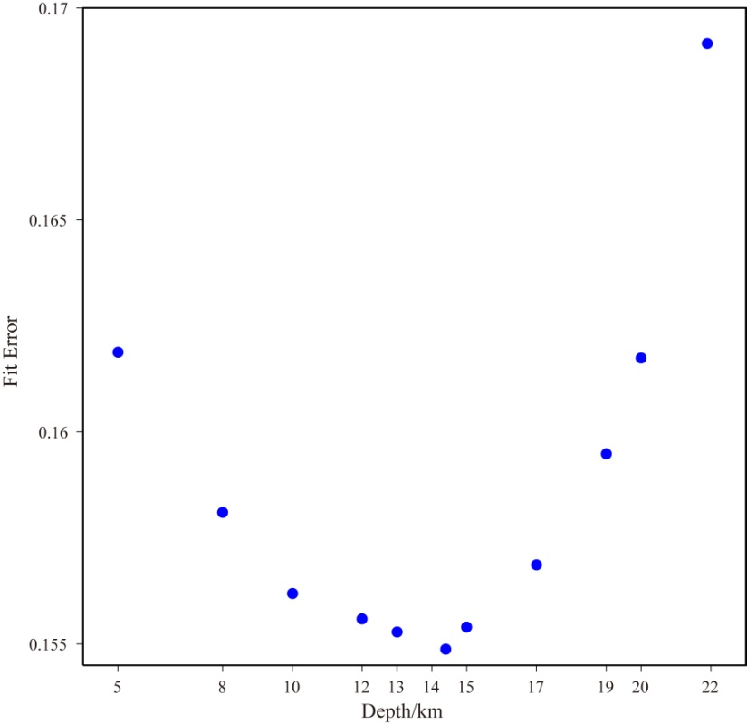
Fig.S4 Fit error of different depths for the 2013 Lushan earthquake (strike212°, dip42°, rake100°).
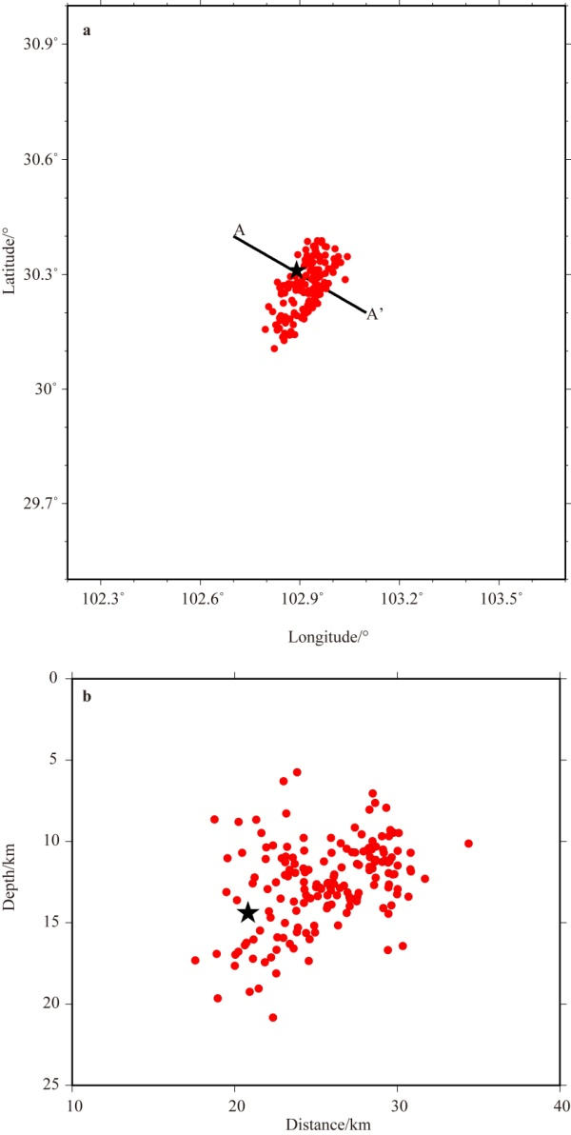
Fig.S5 a. Map of relocated sequence of the 2013 Lushan earthquake, b. depth cross section along AA'. The red dots denote aftershocks, whereas the main shock is represented with the black star.
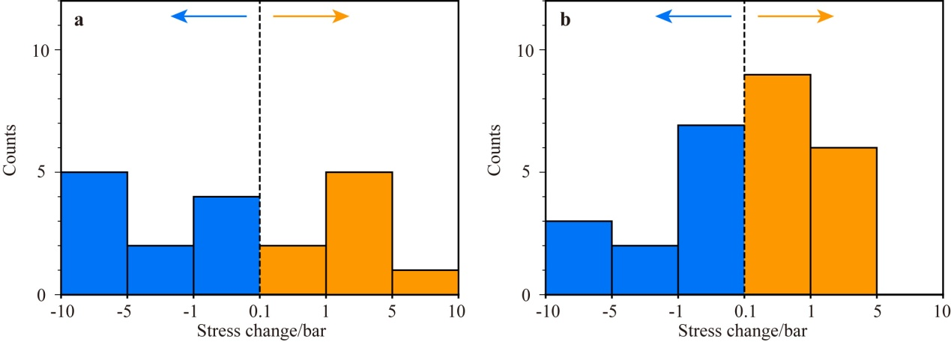
Fig.S6 Histograms of aftershocks as the function of the value of stress change. a. the 2017 Jiuzhaigou earthquake, b. the 2013 Lushan earthquake.
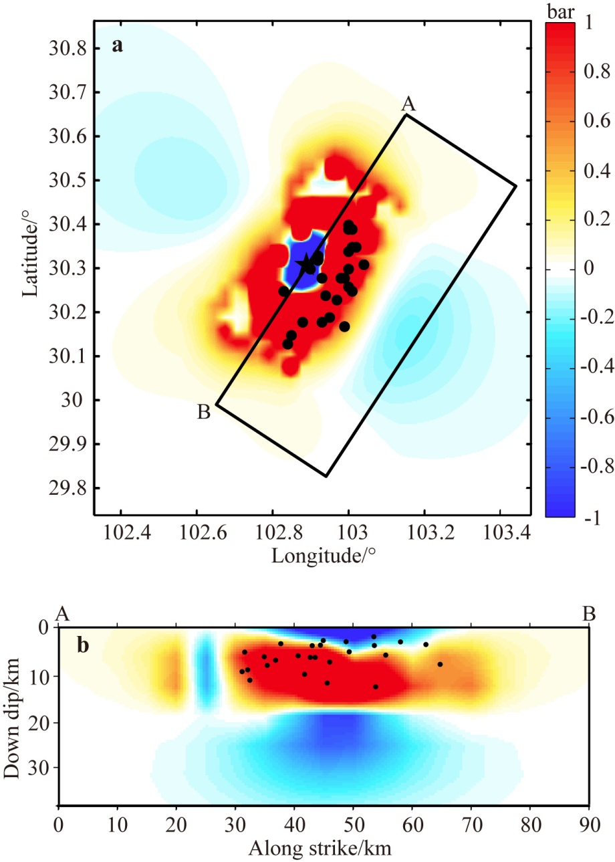
Fig.S7 Stress changes imparted caused by the 2013 Lushan earthquake. a maximum Coulomb stress change, b stress change of the cross-section AB in a (Dip=42°). The box on the a denotes the projected area of the fault plane shown in b.
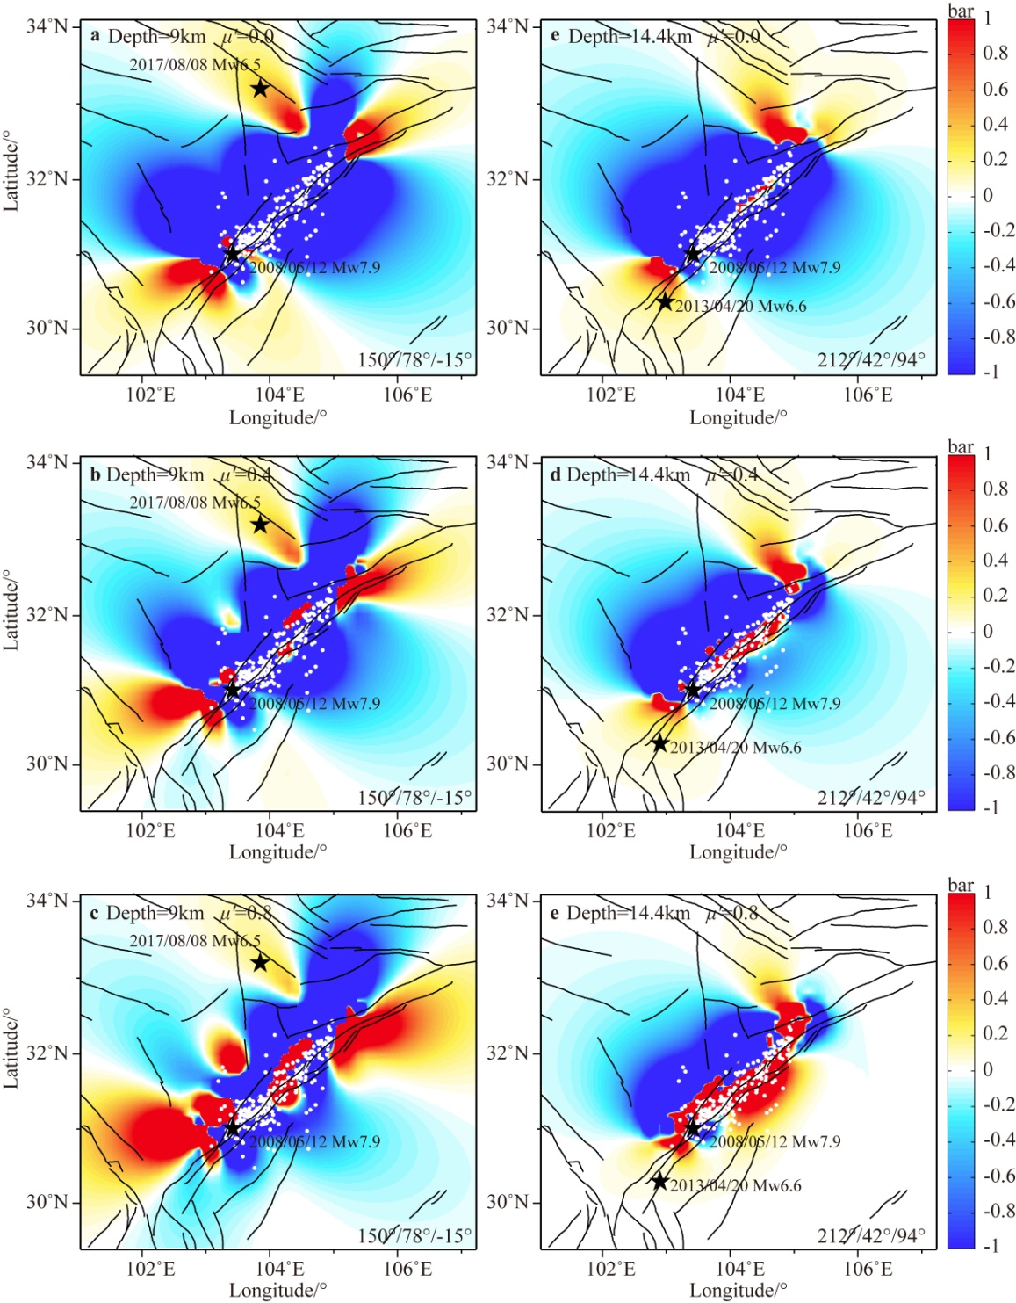
Fig.S8 Stress changes imparted by the 2008 Wenchuan earthquake calculated with various depths and effective friction coefficients. a, b and c are the calculations with effective friction coefficient of 0.0, 0.4 and 0.8 at 14 km depth, respectively. d, e and f are the calculations with effective friction coefficient of 0.0, 0.4 and 0.8 at 9 km depth, respectively. The yellow star and black stars are the epicenters of the Wenchuan, Jiuzhaigou and Lushan earthquakes, and black circles denote the Wenchuan earthquake 1 day M_{L}>4 aftershocks.
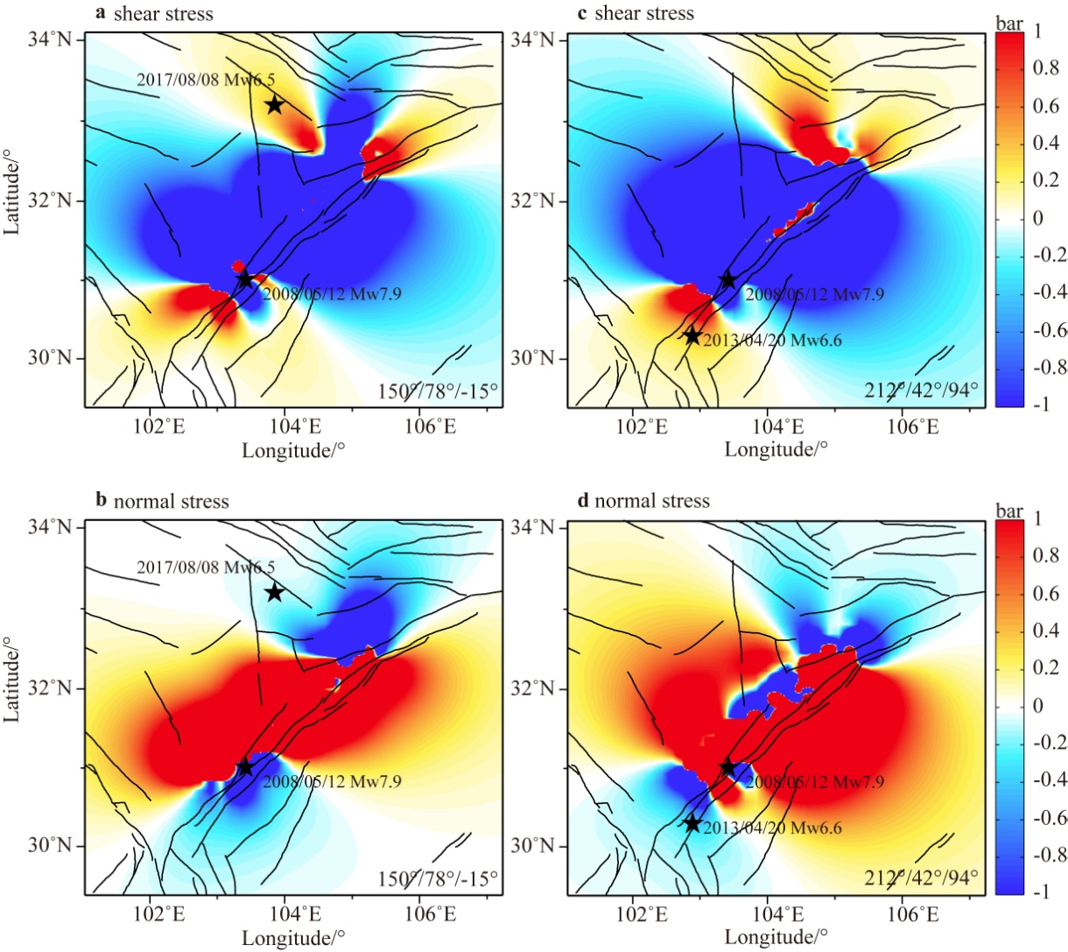
Fig.S9 Shear and normal stress changes imparted by the 2008 Wenchuan earthquake. a, b are the calculations at 9 km depth. c, d are the calculations at 14.4 km depth.

