Table S1: Summary of sequencing reads after filtering.
Sample | Total Raw Reads (Mb) | Total Clean Reads (Mb) | Total Clean Bases (Gb) | Clean Reads Q30 (%) | Clean Reads Ratio (%)
APm-CTL | 80.16 | 78.2 | 7.82 | 91.46 | 97.56
APm-T3 | 80.29 | 78.13 | 7.81 | 91.31 | 97.31
APm-T6 | 80.02 | 78.29 | 7.83 | 92.18 | 97.84
APm-T24 | 80.1 | 78.15 | 7.81 | 91.35 | 97.57
Total | 320.57 | 312.77 | 31.27 | - | -

Table S2: Transcriptome de novo assembly Unigenes quality metrics.
Sample | Total Number | Total Length | Mean Length | N50 | N70 | N90 | GC (%)
APm-CTL | 33222 | 30504667 | 918 | 1714 | 880 | 337 | 44.16
APm-T3 | 41527 | 41092534 | 989 | 1902 | 1015 | 357 | 44.03
APm-T6 | 36865 | 34636710 | 939 | 1794 | 928 | 338 | 44.10
APm-T24 | 42649 | 42772885 | 1002 | 1939 | 1033 | 359 | 43.89
All-Unigene | 48662 | 56085297 | 1152 | 2289 | 1294 | 412 | 44.10

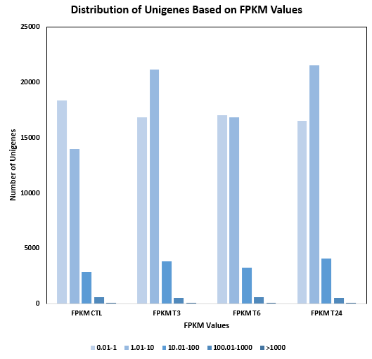
Figure S1: Distribution of Unigenes based on FPKM values.

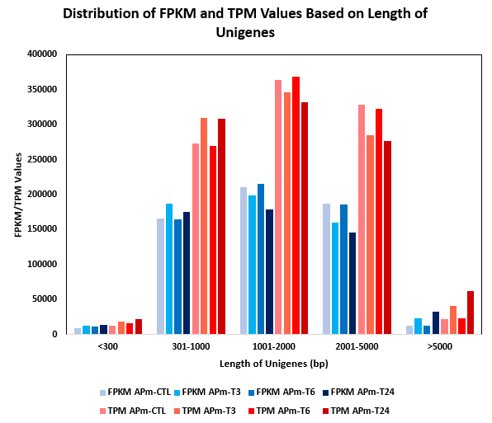
Figure S2: Distribution of FPKM and TPM values based on Length of Unigenes.

Table S3: Overview of functional annotation results.
Values | Number | Percentage
Unigenes Annotated to Nr | 24,709 | 50.78%
Unigenes Annotated to Nt | 18,622 | 38.27%
Unigenes Annotated to SwissProt | 21,388 | 43.95%
Unigenes Annotated to COG | 11,636 | 23.91%
Unigenes Annotated to KEGG | 20,696 | 42.53%
Unigenes Annotated to GO | 4,510 | 9.27%
Unigenes Annotated to InterPro | 16,438 | 33.78%
Overall | 29,106 | 59.81%
Total | 48,662 | 100%

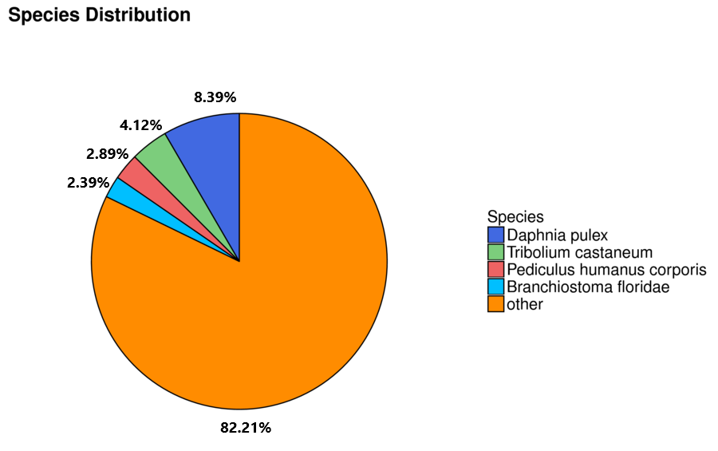
Figure S3: Species distribution of transcriptome Unigenes annotated to NR annotation.

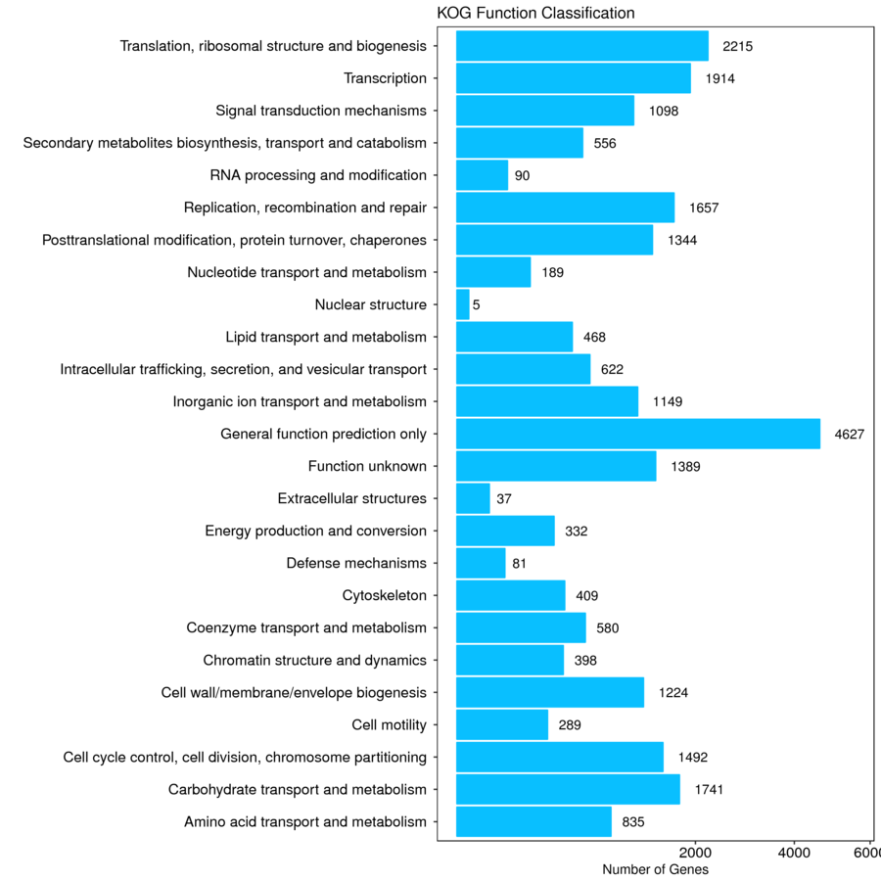
Figure S4: Functional distribution of Unigenes based on COG analysis.
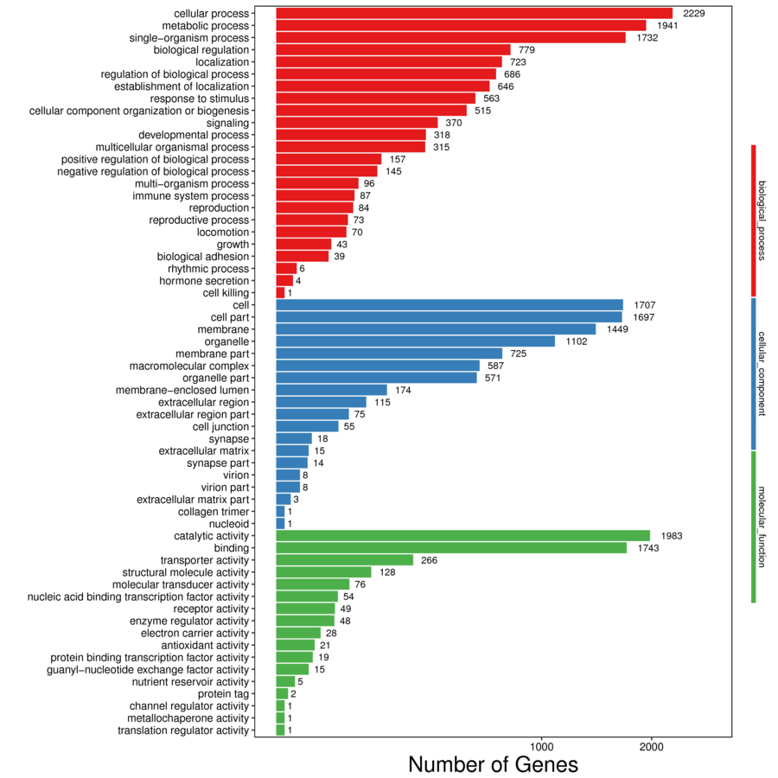
Figure S5: Functional distribution of Unigenes based on GO annotation.
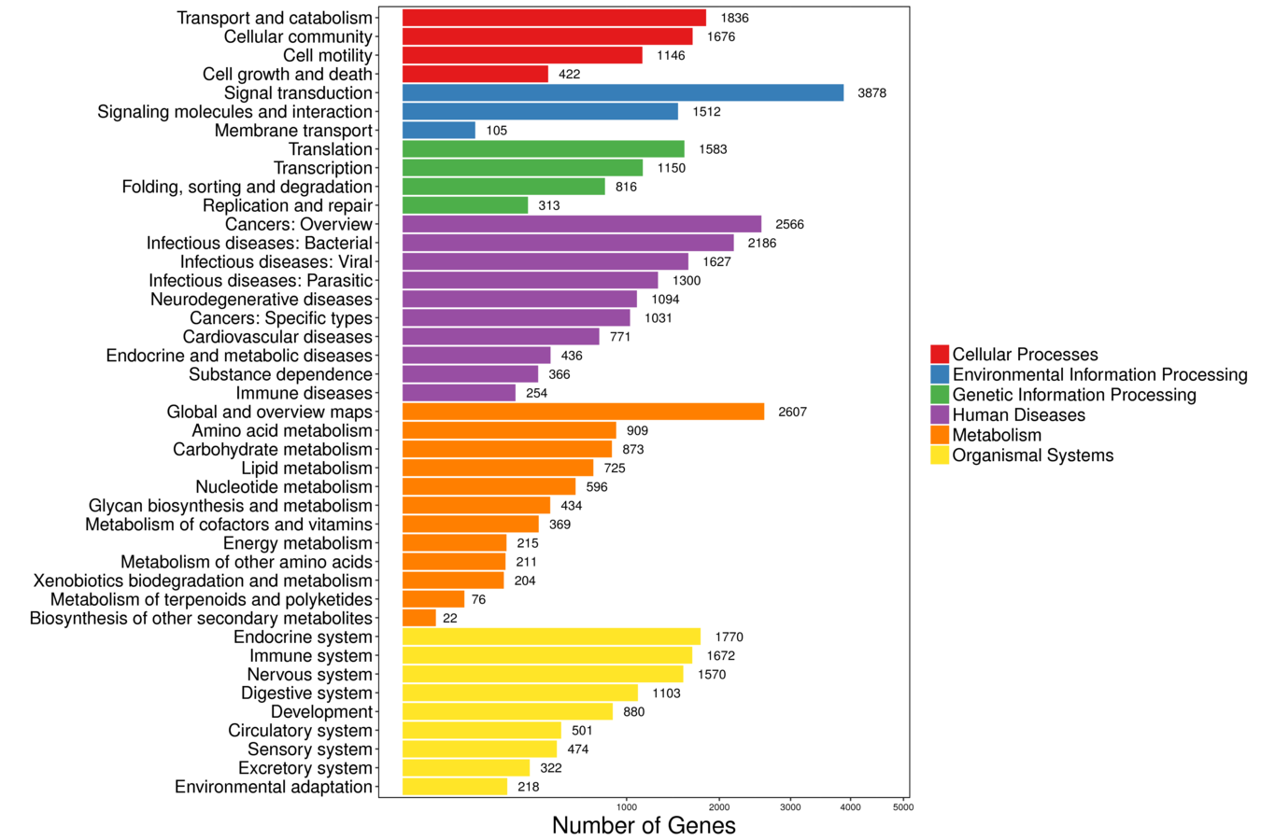
Figure S6: Functional distribution of Unigenes based on KEGG annotation.

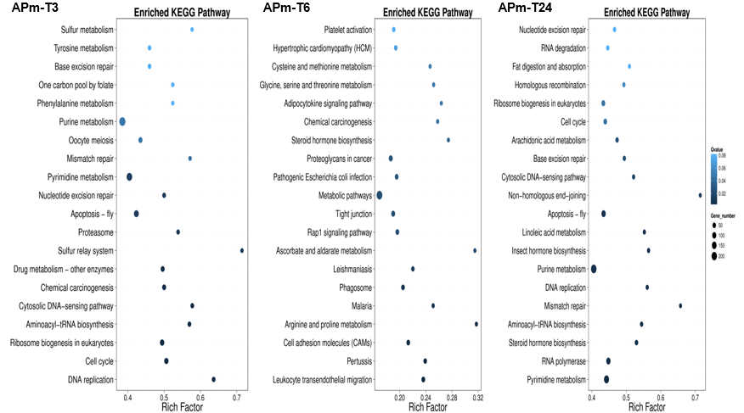
Figure S7: Functionally enriched KEGG pathways based on DEGs.
Table S4: Primer sequences designed for qRT-PCR analysis.
No. | Primer Sequence | Target Gene
1 | qPmCTL-F: 5’- GAA CGT GGA ACT GGC TGG AC -3’ | C-type lectin
2 | qPmCTL-R: 5’- CTG GTA ATC GTT GAA GGT GGG ATG -3’ | C-type lectin
3 | qPmIMD-F: 5’- CGA GAC AAG GTC GAG GTC AG -3’ | IMD
4 | qPmIMD-R: 5’- CTC GTA CAC TCG GTC GAC ATT A -3’ | IMD
5 | qPmALF-F: 5’- GCC ACC ACA AGA ACC TTA GA -3’ | ALF
6 | qPmALF-R: 5’- ACT GCT CCG GTT TAG AGA AAG -3’ | ALF
7 | qPmHG-F: 5’- TTC ATC CCG ACG AGA ATG TG -3’ | HMGB1
8 | qPmHG-R: 5’- CCA TGT CGT GGA ACT TCT TCT -3’ | HMGB1
9 | qELF F: 5’- TATGGTTGTCAACTTTGCCCC -3’ | EF1a
10 | qELF R: 5’- AACCTCGCTTCAGATCCTTTAC -3’ | EF1a

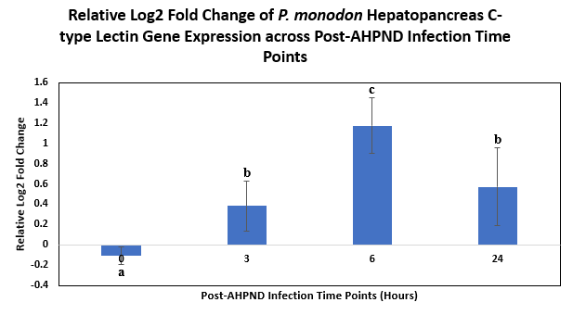
Figure S8: Relative log2 fold change of P. monodon hepatopancreas C-type lectin gene expression across post-AHPND infection time points.

Table S5: One-Way Analysis of Variance (One-Way ANOVA) and post hoc Duncan test showing statistical significance of P. monodon post-AHPND infection C-type Lectin relative gene expressions obtained.
ANOVA
Relative Gene Expression
 | Sum of Squares | df | Mean Square | F | Sig.
Between Groups | 2.520 | 3 | .840 | 11.528 | .003
Within Groups | .583 | 8 | .073
Total | 3.102 | 11

Relative Gene Expression
Duncanª
Time Hours Post-AHPND Infection | N | Subset for alpha = 0.05
 |  | a | b | c
0 | 3 | -.10667
3 | 3 | .38333 | .38333
24 | 3 |  | .57000
6 | 3 |  |  | 1.17333
Sig. |  | .057 | .422 | 1.000
Means for groups in homogeneous subsets are displayed.
a. Uses Harmonic Mean Sample Size = 3.000.

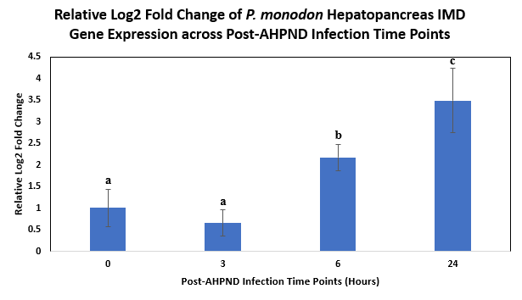
Figure S9: Relative log2 fold change of P. monodon hepatopancreas IMD gene expression across post-AHPND infection time points.

Table S6: One-Way Analysis of Variance (One-Way ANOVA) and post hoc Duncan test showing statistical significance of P. monodon post-AHPND infection IMD relative gene expressions obtained.
ANOVA
Relative Gene Expression
 | Sum of Squares | df | Mean Square | F | Sig.
Between Groups | 14.794 | 3 | 4.931 | 21.158 | <0.001
Within Groups | 1.865 | 8 | .233
Total | 16.658 | 11

Relative Gene Expression
Duncanª
Time Hours Post-AHPND Infection | N | Subset for alpha = 0.05
 |  | a | b | c
3 | 3 | .66000
0 | 3 | 1.00667
6 | 3 |  | 2.17333
24 | 3 |  |  | 3.49333
Sig. |  | .405 | 1.000 | 1.000
Means for groups in homogeneous subsets are displayed.
a. Uses Harmonic Mean Sample Size = 3.000.

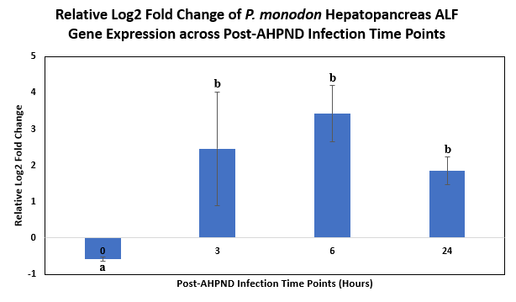
Figure S10: Relative log2 fold change of P. monodon hepatopancreas ALF lectin gene expression across post-AHPND infection time points.

Table S7: One-Way Analysis of Variance (One-Way ANOVA) and post hoc Duncan test showing statistical significance of P. monodon post-AHPND infection ALF relative gene expressions obtained.
ANOVA
Relative Gene Expression
 | Sum of Squares | df | Mean Square | F | Sig.
Between Groups | 26.198 | 3 | 8.733 | 10.883 | .003
Within Groups | 6.419 | 8 | .802
Total | 32.617 | 11

Relative Gene Expression
Duncanª
Time Hours Post-AHPND Infection | N | Subset for alpha = 0.05
 |  | a | b
0 | 3 | -.58000
24 | 3 |  | 1.85000
3 | 3 |  | 2.45667
6 | 3 |  | 3.42333
Sig. |  | 1.000 | .073
Means for groups in homogeneous subsets are displayed.
a. Uses Harmonic Mean Sample Size = 3.000.

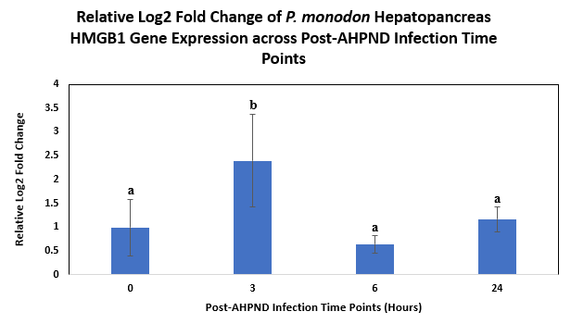
Figure S11: Relative log2 fold change of P. monodon hepatopancreas HMGB1 lectin gene expression across post-AHPND infection time points.

Table S8: One-Way Analysis of Variance (One-Way ANOVA) and post hoc Duncan test showing statistical significance of P. monodon post-AHPND infection HMGB1 relative gene expressions obtained.
ANOVA
Relative Gene Expression
 | Sum of Squares | df | Mean Square | F | Sig.
Between Groups | 5.254 | 3 | 1.751 | 5.024 | .030
Within Groups | 2.789 | 8 | .349
Total | 8.042 | 11

Relative Gene Expression
Duncanª
Time Hours Post-AHPND Infection | N | Subset for alpha = 0.05
 |  | a | b
6 | 3 | .64000
0 | 3 | .99000
24 | 3 | 1.17000
3 | 3 |  | 2.39667
Sig. |  | .322 | 1.000
Means for groups in homogeneous subsets are displayed.
a. Uses Harmonic Mean Sample Size = 3.000.

