Table S 1. Characteristics of patients in the study cohort and the validation cohort.
Characteristics |  | Study cohort (n=568) | Validation cohort (n=308) | P value for heterogeneity
Age, n (%) |  |  |  | 0.1316
<=65 y |  | 198 (35) | 124 (40)
66-74 y |  | 194 (34) | 86 (28)
75+ y |  | 176 (31) | 98 (32)
Sex, n (%) |  |  |  | 0.1579
Female |  | 268 (47) | 130 (42)
Male |  | 300 (53) | 178 (58)
Education, n (%) |  |  |  | 0.0218
Low |  | 380 (67) | 190 (62)
Medium |  | 117 (21) | 58 (19)
High |  | 71 (13) | 60 (19)
Family history of CRC, n (%)ª |  | 81 (14) | 47 (15) | 0.6839
Lifetime regular active smoking, n (%)^{b} |  |  |  | 0.5390
None |  | 258 (46) | 125 (41)
<20 pack-years |  | 190 (34) | 108 (35)
20+ pack-years |  | 119 (21) | 73 (24)
Alcohol consumption, mean (g/day) ^{c} |  | 16.1 | 20.3 | 0.0009
Body mass index, mean (kg/m²)^{d} |  | 26.5 | 26.4 | 0.6692
Physical activity, mean (life time METs, hr/week)^{e} |  | 240.7 | 237.2 | 0.6983
Regular use of NSAIDs, n (%)^{f} |  | 147 (26) | 90 (29) | 0.2887
Regular use of statins, n (%)^{g} |  | 61 (11) | 47 (15) | 0.0544
Regular use of hormone replacement therapy, n (%)^{h} |  | 82 (14) | 38 (12) | 0.3927
Tumor location, n (%) |  |  |  | 0.4279
Proximal colon |  | 210 (37) | 108 (35)
Distal colon |  | 176 (31) | 88 (29)
Rectum |  | 182 (32) | 112 (36)
Cancer stage, n (%) |  |  |  | 0.3926
I |  | 105 (18) | 54 (18)
II |  | 184 (32) | 113 (37)
III |  | 192 (34) | 89 (29)
IV |  | 87 (15) | 52 (17)
Lymph node count, n (%) |  |  |  | 0.0013
<=12 |  | 178 (31) | 82 (27)
12-20 |  | 274 (48) | 129 (42)
20+ |  | 116 (20) | 97 (31)
Surgery, n (%) |  | 567 (100) | 308 (100) | 0.4612
Chemotherapy, n (%) |  | 270 (48) | 121 (39) | 0.0190
KRAS mutation, n (%)^{i} |  |  |  | 0.0008
Negative |  | 324 (66) | 224 (77)
Positive |  | 168 (34) | 66 (23)
BRAF mutation, n (%) |  |  |  | 0.2981
Negative |  | 522 (92) | 289 (94)
Positive |  | 46 (8) | 19 (6)
Microsatellite instability, n (%)
MSS |  | 503 (89) | 282 (92) | 0.1644
MSI-H |  | 65 (11) | 26 (8)
Missing data for (a) 3 patients of the study set and for 2 patients of the validation set, (b) 1 patient of the study set and for 2 patients of the validation set, (c) 3 patients of the study set and for 4 patients of the validation set, (d) 1 patient of the study set and for 4 patients of the validation set, (e) 15 patients of the study set and for 9 patients of the validation set, (f) 2 patients of the study set and for 1 patient of the validation set, (g) 2 patients of the study set, (h) 1 patient of the study set and for 1 patient of the validation set, (i) 76 patients of the study set and for 18 patients of the validation set.
Table S 2. Genes used to define CIMP status in previous studies that were available on the 450k methylation array.
Gene nameª | Covered by 450k |  | Gene nameª | Covered by 450k |  | Gene nameª | Covered by 450k |  | Gene nameª | Covered by 450k
ADAMTS1 | √ |  | APC | √ |  | BRAF | √ |  | CACNA1G | √
CDH13 | √ |  | CHFR | √ |  | CRABP1 | √ |  | DUSP26 | √
EDIL3 | √ |  | ELMO1 | √ |  | FBN2 | √ |  | GATA5 | √
HAND1 | √ |  | HCAD | √ |  | HIC1 | √ |  | HLTF | √
HRK | √ |  | ID4 | √ |  | IGF2 | √ |  | IGFBP3 | √
KIRREL2 | √ |  | LOX | √ |  | MDR1 | √ |  | MGMT | √
MINT1 | √ |  | MINT2 | √ |  | MINT12 | × |  | MINT17 | ×
MINT25 | × |  | MINT27 | × |  | MINT31 | × |  | MLH1 | √
Neurog1 | √ |  | P14 | √ |  | P16 | √ |  | RASSF2 | √
RIZ1 | √ |  | RSASF1A | √ |  | RUNX3 | √ |  | SLC13A5 | √
SOCS1 | √ |  | STOX2 | √ |  | THBD | √ |  | TIMP3 | √
TSLC1 | √ |  | TSP1 | √ |  | UCHL1 | √ |  | WRN | √
a: UCSC RefGene name.

Table S 3. CpG sites identified in the study cohort that were included or excluded in the final analyses.
CpG site | Association with disease-specific survivalª (HR, 95%CI) |  | Not confirmed  in validation cohort | 10%--90% range of  β value (distance) | Distance < 0.1 | Finally included
 | Study cohort | Validation cohort
cg16935707 | 1.43 (1.22-1.67) | 1.33 (1.09-1.61) |  | 0.612--0.890 (0.278) |  | √
cg05481217 | 1.43 (1.22-1.67) | 1.30 (1.06-1.60) |  | 0.543--0.705 (0.162) |  | √
cg08044454 | 1.44 (1.22-1.69) | 1.39 (1.14-1.70) |  | 0.426--0.790 (0.364) |  | √
cg01552551 | 1.43 (1.22-1.68) | 1.28 (1.04-1.58) |  | 0.451--0.816 (0.365) |  | √
cg20537325 | 1.34 (1.18-1.55) | 1.31 (1.05-1.63) |  | 0.889--0.932 (0.043) | ×
cg24311416 | 1.43 (1.21-1.71) | 1.32 (1.04-1.66) |  | 0.412--0.759 (0.347) |  | √
cg02425108 | 1.40 (1.19-1.65) | 1.32 (1.04-1.66) |  | 0.440--0.709 (0.269) |  | √
cg05075097 | 1.51 (1.23-1.86) | 1.05 (0.83-1.33) | × | 0.053--0.106 (0.053) | ×
cg15659052 | 1.38 (1.17-1.63) | 1.37 (1.09-1.71) |  | 0.293--0.689 (0.396) |  | √
cg24771017 | 1.32 (1.14-1.54) | 1.04 (0.83-1.31) | × | 0.858--0.953 (0.095) | ×
a: Cox regression analyses using the z-score of the β value (per unit, high to low) with adjustment for age, sex, tumor stage, tumor location, chemotherapy, MSI status and BRAF mutation status.

Table S 4. Association of the coefficient score with characteristics of colorectal cancer patients in the study cohort and the validation cohort.
Characteristics | Study cohort (n=568) |  |  |  |  | Validation cohort (n=308)
 | Tertile1 | Tertile2 | Tertile3 | P value |  | Tertile1 | Tertile2 | Tertile3 | P value
Age, n (%)
<=65 y | 56 (30) | 68 (36) | 74 (38) |  |  | 43 (45) | 39 (44) | 42 (34)
66-74 y | 68 (37) | 63 (34) | 63 (32) |  |  | 21 (22) | 25 (28) | 40 (32)
75+ y | 61 (33) | 57 (30) | 58 (30) | 0.6112 |  | 31 (33) | 25 (28) | 42 (34) | 0.3208
Sex, n (%)
Female | 83 (45) | 100 (53) | 85 (44) |  |  | 39 (41) | 35 (39) | 56 (45)
Male | 102 (55) | 88 (47) | 110 (56) | 0.1266 |  | 56 (59) | 54 (61) | 68 (55) | 0.6708
Education, n (%)
Low | 121 (65) | 134 (71) | 125 (64) |  |  | 54 (57) | 51 (57) | 85 (69)
Medium | 43 (23) | 35 (19) | 39 (20) |  |  | 19 (20) | 23 (26) | 16 (13)
High | 21 (11) | 19 (10) | 31 (16) | 0.3188 |  | 22 (23) | 15 (17) | 23 (19) | 0.1198
Family history of CRC, n (%)
No | 157 (85) | 158 (84) | 169 (88) |  |  | 79 (83) | 78 (88) | 102 (84)
Yes | 28 (15) | 29 (16) | 24 (12) | 0.6462 |  | 16 (17) | 11 (12) | 20 (16) | 0.6465
Lifetime regular active smoking, n (%)
None | 82 (44) | 87 (47) | 89 (46) |  |  | 32 (34) | 36 (41) | 57 (48)
<20 pack-years | 58 (31) | 63 (34) | 66 (34) |  |  | 40 (42) | 27 (31) | 38 (32)
20+ pack-years | 45 (24) | 36 (19) | 38 (20) | 0.7787 |  | 23 (24) | 25 (28) | 25 (21) | 0.2068
Tumor location, n (%)
Proximal colon | 71 (38) | 80 (43) | 59 (30) |  |  | 41 (43) | 27 (30) | 40 (32)
Distal colon | 56 (30) | 49 (26) | 71 (36) |  |  | 21 (22) | 26 (29) | 41 (33)
Rectum | 58 (31) | 59 (31) | 65 (33) | 0.1087 |  | 33 (35) | 36 (40) | 43 (35) | 0.2420
Cancer stage, n (%)
I | 32 (17) | 42 (22) | 31 (16) |  |  | 15 (16) | 13 (15) | 26 (21)
II | 58 (31) | 67 (36) | 59 (30) |  |  | 31 (33) | 35 (39) | 47 (38)
III | 60 (32) | 63 (34) | 69 (35) |  |  | 31 (33) | 28 (31) | 30 (24)
IV | 35 (19) | 16 (9) | 36 (18) | 0.0604 |  | 18 (19) | 13 (15) | 21 (17) | 0.6494
Lymph node count, n (%)
<=12 | 50 (27) | 59 (31) | 69 (35) |  |  | 19 (20) | 24 (27) | 39 (31)
12-20 | 90 (49) | 93 (49) | 91 (47) |  |  | 39 (41) | 41 (46) | 49 (40)
20+ | 45 (24) | 36 (19) | 35 (18) | 0.3553 |  | 37 (39) | 24 (27) | 36 (29) | 0.2225
Chemotherapy, n (%)
No | 95 (51) | 112 (60) | 91 (47) |  |  | 54 (57) | 52 (58) | 81 (65)
Yes | 90 (49) | 76 (40) | 104 (53) | 0.0382 |  | 41 (43) | 37 (42) | 43 (35) | 0.3874
KRAS mutation, n (%)
Negative | 102 (61) | 115 (71) | 107 (66) |  |  | 67 (73) | 72 (86) | 85 (75)
Positive | 65 (39) | 47 (29) | 56 (34) | 0.1656 |  | 25 (27) | 12 (14) | 29 (25) | 0.0856
BRAF mutation, n (%)
Negative | 166 (90) | 171 (91) | 185 (95) |  |  | 93 (98) | 81 (91) | 115 (93)
Positive | 19 (10) | 17 (9) | 10 (5) | 0.1565 |  | 2 (2) | 8 (9) | 9 (7) | 0.1233
Microsatellite instability, n (%)
MSS | 167 (90) | 161 (86) | 175 (90) |  |  | 89 (94) | 79 (89) | 114 (92)
MSI-H | 18 (10) | 27 (14) | 20 (10) | 0.3031 |  | 6 (6) | 10 (11) | 10 (8) | 0.4777

(A) Study cohort
(B) Validation cohort
Figure S 1. Heatmaps showing the methylation level of the seven CpG sites across all the patients in the study cohort (A) and the validation cohort (B), respectively.

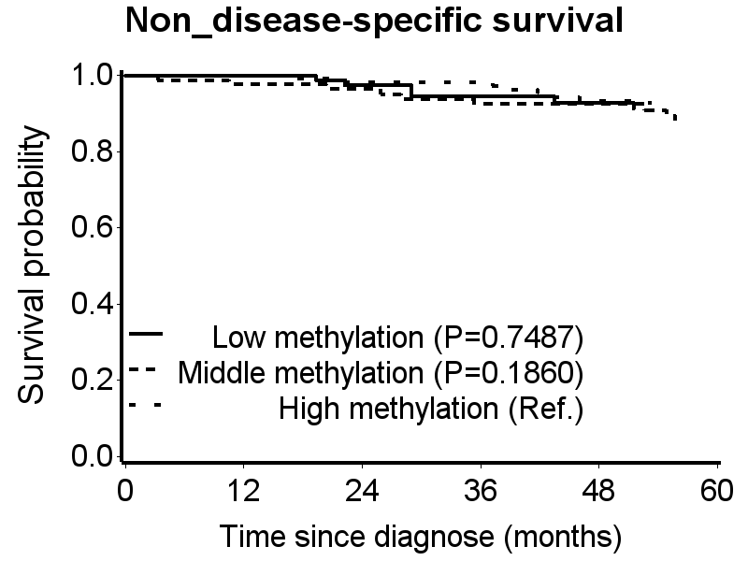
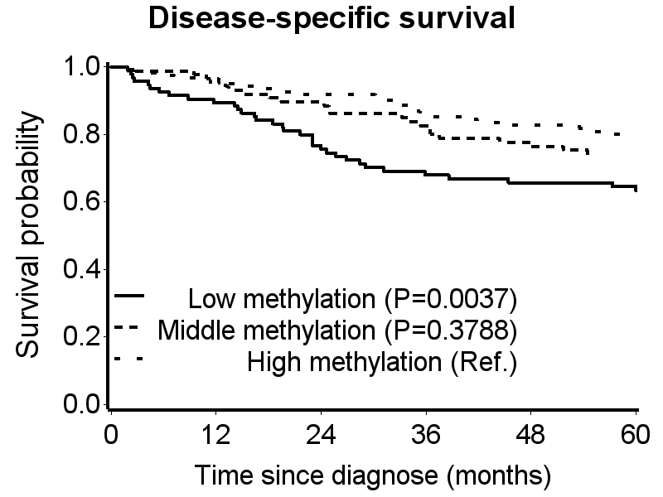
Figure S 2. Unadjusted Kaplan-Meier curves of the association of the coefficient score with disease-specific survival and non-disease-specific survival in the validation cohort.

