Additional file 1
Table S1. Mental Health-Related Quality of Life: Estimated Regression Coefficients
Parameter | Estimate | Standard  Error | t Value | p_{trend}
Intercept | 34.0654835 | 14.9583051 | 2.28 | 0.0231
MVPA | 0.0841021 | 0.2471580 | 0.34 | 0.7338
Age | 0.0208270 | 0.0154412 | 1.35 | 0.1779
Female | -4.4857684 | 0.3509665 | -12.78 | <.0001
Education
High School | 0.8434270 | 0.4661886 | 1.81 | 0.0709
>High School | 1.5218253 | 0.4340994 | 3.51 | 0.0005
Annual Household Income
$30,000-$50,000 | 2.7816719 | 0.4208288 | 6.61 | <.0001
>$50,000 | 4.0614392 | 0.5983186 | 6.79 | <.0001
Missing | 2.4923742 | 0.6132266 | 4.06 | <.0001
Study Site
Chicago, IL | 0.3532105 | 0.6834423 | 0.52 | 0.6055
Miami, FL | 1.4626777 | 0.6859181 | 2.13 | 0.0334
San Diego, CA | -0.0685568 | 0.7626196 | -0.09 | 0.9284
Hispanic/Latino Background
Cuban | -1.0118703 | 0.8356625 | -1.21 | 0.2264
Puerto Rican | -1.9966470 | 0.8042982 | -2.48 | 0.0133
Dominican | 0.4517670 | 0.9455393 | 0.48 | 0.6330
Central American | 0.1822015 | 0.6966461 | 0.26 | 0.7938
South American | -0.7657274 | 0.7782149 | -0.98 | 0.3255
More than one | -1.6922847 | 1.1655660 | -1.45 | 0.1470
Marital Status
Married | 0.2843234 | 0.5048305 | 0.56 | 0.5735
Separated | 0.1346609 | 0.5297905 | 0.25 | 0.7994
Alcohol Intake
Former | -0.8375503 | 0.4531570 | -1.85 | 0.0650
Current | -1.4652628 | 0.4473472 | -3.28 | 0.0011
No Health Insurance | -0.0147414 | 0.3369367 | -0.04 | 0.9651
Spanish Preferred Language | -0.1462836 | 0.5552745 | -0.26 | 0.7923
2nd Generation | -0.8533607 | 0.6102645 | -1.40 | 0.1625
Chronic Conditions
Swelling of Joints | -3.0198422 | 0.6915665 | -4.37 | <.0001
Liver Disease | -1.4706351 | 0.6557711 | -2.24 | 0.0253
Cancer | 0.6545595 | 1.1514557 | 0.57 | 0.5699
Stroke/TIA | -1.1364249 | 1.4848442 | -0.77 | 0.4443
Angina | -2.6486178 | 0.9462714 | -2.80 | 0.0053
Number of Accelerometer Wear Days | 2.6443341 | 2.4676352 | 1.07 | 0.2843

Table S2. Physical Health-Related Quality of Life: Estimated Regression Coefficients
Parameter | Estimate | Standard  Error | t Value | p_{trend}
Intercept | 41.0166056 | 4.81374154 | 8.52 | <.0001
MVPA | 1.1214265 | 0.13941068 | 8.04 | <.0001
Age | -0.1239800 | 0.01032994 | -12.00 | <.0001
Female | 0.1022652 | 0.23838187 | 0.43 | 0.6681
Education
High School | 0.8717527 | 0.31173523 | 2.80 | 0.0053
>High School | 1.6497590 | 0.29769463 | 5.54 | <.0001
Annual Household Income
$30,000-$50,000 | 1.2754248 | 0.28165208 | 4.53 | <.0001
>$50,000 | 2.5388078 | 0.38870972 | 6.53 | <.0001
Missing | 0.9723622 | 0.37426641 | 2.60 | 0.0096
Study Site
Chicago, IL | 2.3102701 | 0.38429659 | 6.01 | <.0001
Miami, FL | 3.8265307 | 0.47357434 | 8.08 | <.0001
San Diego, CA | 2.5788248 | 0.43279813 | 5.96 | <.0001
Hispanic/Latino Background
Cuban | -0.0005610 | 0.58392973 | -0.00 | 0.9992
Puerto Rican | -0.2887029 | 0.44726322 | -0.65 | 0.5188
Dominican | 0.9342643 | 0.57797847 | 1.62 | 0.1065
Central American | -0.5630098 | 0.50291298 | -1.12 | 0.2633
South American | 0.0851834 | 0.52683210 | 0.16 | 0.8716
More than one | 0.1023599 | 0.61581984 | 0.17 | 0.8680
Marital Status
Married | 0.4268355 | 0.26628474 | 1.60 | 0.1094
Separated | -0.1435363 | 0.52014978 | -0.28 | 0.7827
Alcohol Intake
Former | 0.0355016 | 0.33234170 | 0.11 | 0.9150
Current | 0.9580112 | 0.31524774 | 3.04 | 0.0025
No Health Insurance | -0.9924950 | 0.25574226 | -3.88 | 0.0001
Spanish Preferred Language | 0.1667202 | 0.40345176 | 0.41 | 0.6796
2nd Generation | -0.9661960 | 0.51187760 | -1.89 | 0.0595
Chronic Conditions
Swelling of Joints | -6.7617984 | 0.40425970 | -16.73 | <.0001
Liver Disease | -1.8577548 | 0.41596910 | -4.47 | <.0001
Cancer | -2.6995868 | 0.59936655 | -4.50 | <.0001
Stroke/TIA | -2.7598712 | 0.80052926 | -3.45 | 0.0006
Angina | -2.8521446 | 0.42859204 | -6.65 | <.0001
Number of Accelerometer Wear Days | 1.4059874 | 0.79370276 | 1.77 | 0.0770

Figure S1. MVPA Categories
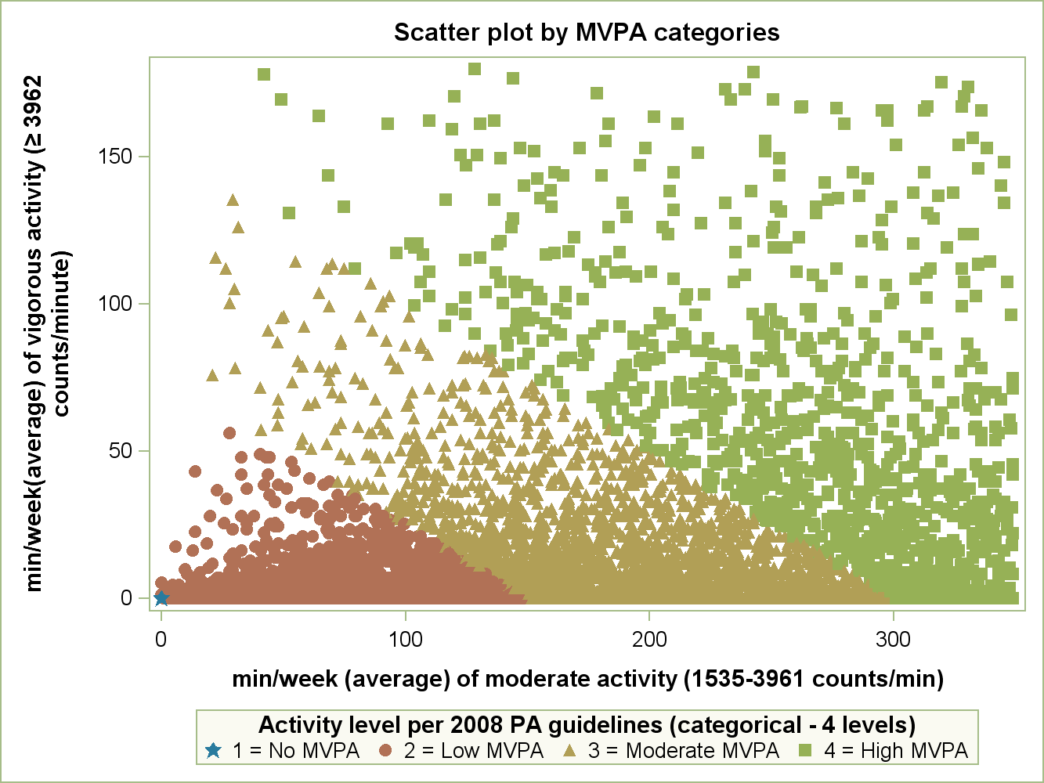

Please note that the scatterplot does not account for the sampling weights for our dataset.

