Additional Information

**Improved electrical performance of a sol–gel IGZO transistor with high-k Al2O3 gate dielectric achieved by post annealing**

Esther Lee1,†, Tae Hyeon Kim1,†, Seung Won Lee2, Jee Hoon Kim1, Jaeun Kim1, Tae Gun Jeong1, Ji-Hoon Ahn2, and Byungjin Cho1,*

1Department of Advanced Material Engineering, Chungbuk National University,

Chungbuk 28644, Republic of Korea

2Department of Electronic Material Engineering, Korea Maritime and Ocean University, Busan 49112, Republic of Korea

*Correspondence: [bjcho@chungbuk.ac.kr](mailto:bjcho@chungbuk.ac.kr)

†Authors contributed equally to this work.



**Figure S1.** FIB SEM image of the IGZO-based FET device.

**Figure S2.** AFM images of Al2O3 surface (a) before and (b) after post annealing. AFM images of IGZO surface (c) before and (d) after post annealing.

**Figure S3.** (a) Transfer characteristics of IGZO transistor devices with different post annealing temperature (50 ~ 300 °C). Comparison of electrical parameters such as (b) Ion/Ioff, ratio, (c) ΔVth, and (d) mobility for devices treated with different post annealing temperature.



**Figure S4.** Comparison of the transfer curves of the IGZO-based FET devices with different Al2O3 dielectric layer thickness (a) before and (b) after post annealing.

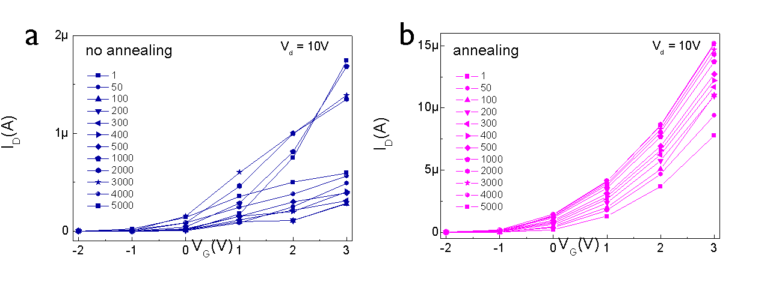

**Figure S5.** Comparison of transfer curves during 5000 cycling test for (a) no annealing and (b) annealing device.

**Table S1.** Comparison of electrical parameters between the IGZO transistor devices without post-annealing and the devices with post-annealing

|  |  |  |  |  |  |  |  |  |
| --- | --- | --- | --- | --- | --- | --- | --- | --- |
| Type | VD (V) | | Ion (A) | Ioff (A) | Ion/Ioff | Vth (V) | S.S.  (mV/dec) | μ  (cm2V-1s-1) |
| No annealing | | 0.1 | 3.8710-8 | 1.0910-11 | 3.52103 | 0.70 | 206 | 0.16 |
| 2 | 4.8910-7 | 7.65E-10-11 | 6.39103 | 0.44 | 214 | 0.13 |
| Post  annealing | | 0.1 | 1.910-7 | 1.4210-11 | 1.33104 | 0.25 | 165 | 0.90 |
| 2 | 2.8510-6 | 1.1710-10 | 2.42104 | 0.21 | 174 | 0.81 |

**Table S2.** Comparison of processing techniques studied for performance improvement of IGZO/Al2O3 transistor devices

|  |  |  |  |  |  |
| --- | --- | --- | --- | --- | --- |
| processing technique | Electrical Parameter | before | after | Ratio (%) $$\frac{after-before}{before}×100$$ | Ref. |
| Post annealing | on/off | 3.52E+03 | 1.33E+04 | 278 | This work |
| SS | 206 | 165 | -20 |
| mobility | 0.16 | 0.9 | 462 |
| Al2O3 passivated  by thermal ALD | on/off | 9.59E+06 | 3.67E+04 | -100 | [S1] |
| SS | 250 | 330 | 32 |
| mobility | 8.6 | 10.1 | 17 |
| Al2O3 passivated  by remote plasma ALD | on/off | 9.59E+06 | 4.77E+06 | -0.5 | [S1] |
| SS | 250 | 210 | -16 |
| mobility | 8.6 | 7.8 | 9 |
| HfO2 buffer layer | on/off | 4.77E+06 | 1.32E+07 | 177 | [S1] |
| SS | 210 | 230 | 10 |
| mobility | 7.8 | 8 | 3 |

References

[S1] Y. B. Ko, S. W. Bang, S. J. Lee, S.Y. Park, The effects of a HfO2 bufferlayer on Al2O3-passivatedindium-gallium-zinc-oxide thin film transistors. Phys. Status solidi. 10-11. 403405 (2011)