Additional file 3
Figure 1 displays the average reductions (in percentages) in PCBD, MDD, and PTSD for completers in both conditions. These rates were computed by 100-((Average post-treatment score/average pre-treatment score)*100). In black, the reductions from pre-treatment to post-treatment for the immediate intervention group are displayed. In white, the reductions from pre-waiting to post-waiting for the waiting list controls are displayed. On average, the participants in the immediate intervention group report 25.6% to 41.5% reduction in PCBD, MDD, and PTSD levels, whereas the waiting list controls report 5.7% to 11.6% reduction in PCBD and MDD levels, respectively, and 132.9% increase in PTSD levels.

Figure 1. Percentages of reductions in mean PCBD, MDD, and PTSD levels for the immediate intervention (n = 5) and waiting list control condition (n = 4).
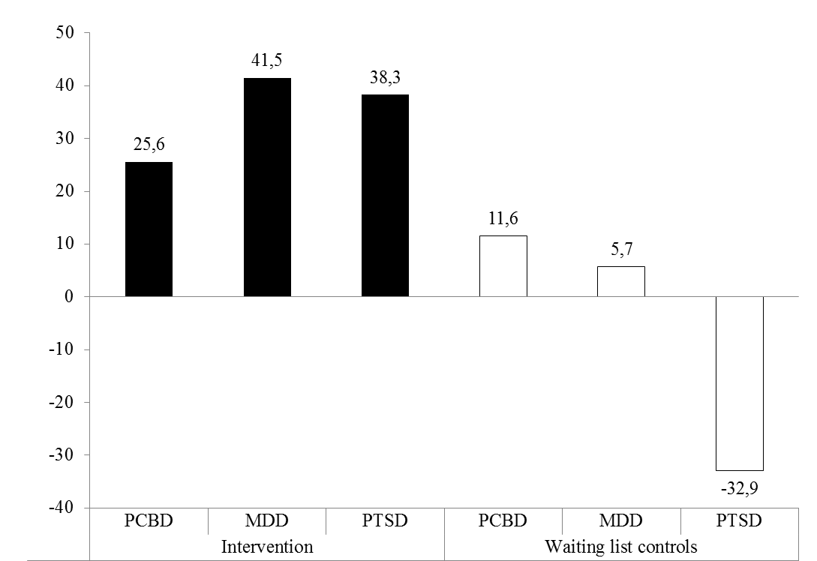
Note. PCBD = persistent complex bereavement disorder; MDD = major depressive disorder; PTSD = posttraumatic stress disorder.

