Time-resolved study of site-specific corrosion in a single crystalline silver nanoparticle

Steffen Trautmann^{a*}, André Dathe^{a*}, Andrea Csákiª, Matthias Thieleª, Robert Müllerª, Wolfgang Fritzscheª, Ondrej Stranikª†
ª Leibniz Institute of Photonic Technology (IPHT) Jena, Member of the Leibniz Research Alliance - Leibniz Health Technologies, Albert-Einstein-Straße 9, 07745 Jena, Germany.
* contributed equally
† corresponding author: ondrej.stranik@leibniz-ipht.de

Fitting procedure of the curve CPn(t) curves
- CPn(t) curve was scaled to from -1 to 1.
- Non-linear fit with sigmoidal curve y(t) = 2/pi*atan(a*(t-b))
  - b .. Inflection point, a ..slope at the inflection point
  - due to the limited AFM sampling frequency the lower limit of the parameter a was set to 1
  - the 75% corrosion time was defined as 2/a*tan(pi/2*0.75)

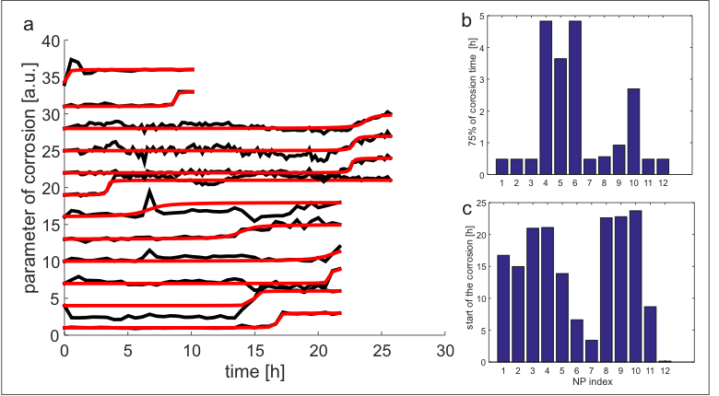
Figure S1 a- Time evolution of the corrosion parameter (normalized) for each single particle (black line) and their corresponding sigmoidal fit (red line). b – fitted corrosion time (75% of corrosion) for each NP. c – fitted starting point of the corrosion for each NP.

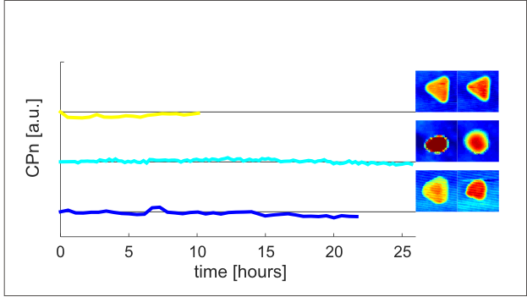
Figure S2 Graph of the time evolution of the corrosion parameter CPn for an exemplary not altered TrNPs from each measurement set (for better visibility each curve is offset by 1).. Inset – AFM images of the TrNPs at the beginning and at the end of the measurement.

