Integrated genetic and methylomic analyses identify shared biology between autism and autistic traits

Supplementary Note

iPSYCH-Minerva Epigenetics Group author list
Eilis Hannon1
Diana Schendel2, 6, 15
Christine Ladd-Acosta3,4
Jakob Grove5,6,7,8,
Christine Søholm Hansen6,9,10
David Michael Hougaard6,9
Michaeline Bresnahan11
Ole Mors6,13
Mads Vilhelm Hollegaard6,9ˆ
Marie Bækvad-Hansen6,9
Mady Hornig11,12
Preben Bo Mortensen6,14,15,16,
Anders D. Børglum5,6,7
Thomas Werge6,10,17,
Marianne Giørtz Pedersen6,13,16,
Merete Nordentoft6,18
Joseph Buxbaum19
M. Daniele Fallin4, 21
Jonas Bybjerg-Grauholm6,9,
Abraham Reichenberg19
Jonathan Mill1
Anna Starnawska 5,6,7,13
Nicklas Heine Staunstrup 5,6,7,13
Magdalena Janecka affiliations 19
Henriette Thisted Horsdal 6, 15
Shantel Weinsheimer6, 10

1 University of Exeter Medical School, University of Exeter, RILD Building, Level 4, Barrack Rd, Exeter EX2 5DW, UK.
2 Department of Public Health, Aarhus University, Aarhus, Denmark.
3 Department of Epidemiology, Johns Hopkins Bloomberg School of Public Health, Baltimore, MD, USA.
4 Wendy Klag Center for Autism and Developmental Disabilities, Johns Hopkins Bloomberg School of Public Health, Baltimore, MD, USA.
5 Department of Biomedicine and Centre for Integrative Sequencing, iSEQ, Aarhus University, Aarhus, Denmark.
6 iPSYCH, The Lundbeck Foundation Initiative for Integrative Psychiatric Research, Aarhus, Denmark.
7 Centre for Genomics and Personalized Medicine, Aarhus, Denmark.
8 Bioinformatics Research Centre, Aarhus University, Aarhus, Denmark.
9 Center for Neonatal Screening, Department for Congenital Disorders, Statens Serum Institut, Copenhagen, Denmark.
10Institute of Biological Psychiatry, MHC Sct. Hans, Mental Health Services Copenhagen, Roskilde, Denmark.
11Center for Infection and Immunity, Columbia University Mailman School of Public Health, New York, USA.
12Department of Epidemiology, Columbia University Mailman School of Public Health, New York, USA.
13Psychosis Research Unit, Aarhus University Hospital, Risskov, Denmark.
14Department of Clinical Medicine, Aarhus University; Aarhus University Hospital, Risskov, Denmark.
15National Centre for Register-Based Research, Aarhus University, Aarhus, Denmark.
16Centre for Integrated Register-based Research, Aarhus University, Aarhus, Denmark.
17Department of Clinical Medicine, University of Copenhagen, Copenhagen, Denmark.
18Mental Health Services in the Capital Region of Denmark, Mental Health Center Copenhagen, University of Copenhagen, Copenhagen, Denmark.
19 Icahn School of Medicine at Mount Sinai, New York, NY, USA
20Department of Psychiatry, Columbia University, New York, USA.
21Department of Mental Health, Johns Hopkins Bloomberg School of Public Health, Baltimore, MD, USA.
Supplementary Figure 1: Histograms of SCDC and CCC scores in the samples used in the MWAS
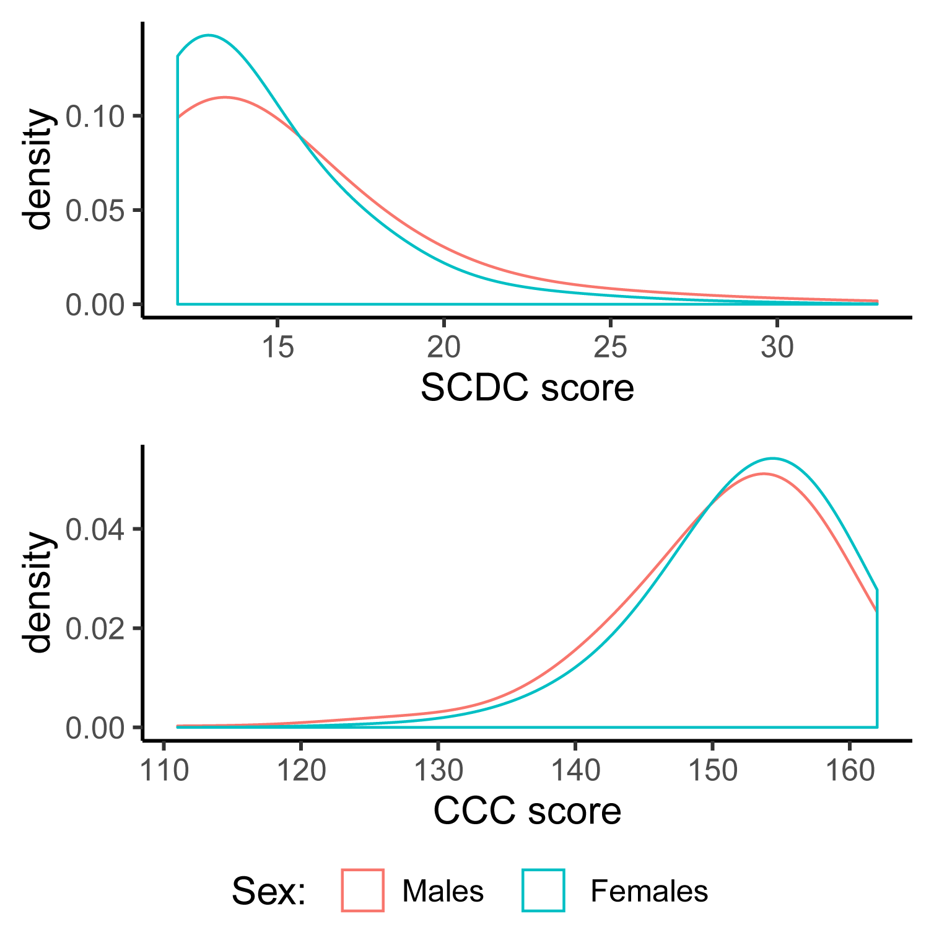
Kernel density plots of SCDC scores (n = 701) and CCC scores (n = 666) in the sample used for the MWAS analyses.
Supplementary Figure 2: Manhattan plot and qq-plot of the MWAS for the CCC scores
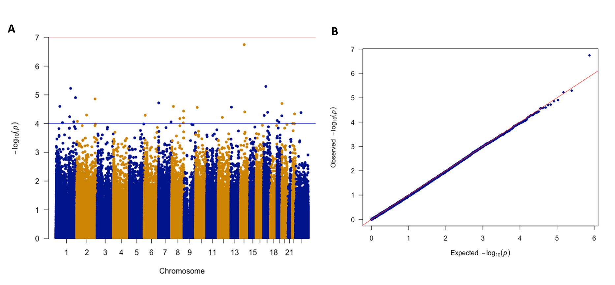
A: Manhattan plot of the CCC MWAS. B: Quantile-Quantile plot of the CCC MWAS
Supplementary Table 1: Sample information and participant demographics
 | SCDC | CCC
Mean | 14.65 (3.44) | 151.83 (6.77)
Sample size | 701 | 666
Males | 341 | 323
Whitecells | 575 | 543
Bcell | 0.16 (0.03) | 0.16 (0.03)
CD3T | 0.019 (0.05) | 0.019 (0.05)
CD4T | 0.16 (0.04) | 0.16 (0.05)
CD8T | 0.06 (0.03) | 0.06 (0.04)
Gran | 0.46 (0.08) | 0.46 (0.09)
Mono | 0.10 (0.03) | 0.10 (0.03)
NK | 0.14 (0.03) | 0.14 (0.03)
This table provides sample information and participant demographics. We provide the mean values and , in paranthesis, standard deviation for the mean scores, and cell proportions for participants included in the SCDC and the CCC MWAS.
Supplementary Table 2: List of CpGs with P < 0.0001 in the SCDC MWAS

Name | Chromosome | Position | Gene symbol | Gene Region | BETA | SE | P
cg00156802 | chrX | 19358457 | chrX:19361726-19362479 |  | -0.81768 | 0.2024 | 5.35E-05
cg03098447 | chr17 | 7210075 | EIF5A;EIF5A;EIF5A | TSS1500;TSS1500;TSS1500 | 2.499287 | 0.641473 | 9.77E-05
cg03202738 | chr4 | 1.56E+08 | NPY2R | TSS200 | 3.25216 | 0.791181 | 3.95E-05
cg05125693 | chr10 | 94051830 | CPEB3;MARCH5 | TSS1500;Body | 2.865308 | 0.724334 | 7.63E-05
cg05877109 | chr14 | 23775794 | BCL2L2 | TSS1500 | 2.574715 | 0.583753 | 1.03E-05
cg07640800 | chr2 | 80529315 | LRRTM1;CTNNA2;CTNNA2 | 3'UTR;Body;Body | 1.673823 | 0.381845 | 1.17E-05
cg10894566 | chr15 | 89905901 | chr15:89904822-89906050 |  | 5.931252 | 1.379222 | 1.70E-05
cg11228785 | chr5 | 1.79E+08 | ADAMTS2;ADAMTS2 | Body;Body | 1.080653 | 0.275089 | 8.55E-05
cg11416605 | chrX | 63267928 | chrX:63263904-63264129 |  | 1.233394 | 0.296407 | 3.17E-05
cg11490681 | chr17 | 77460916 | HRNBP3 | 5'UTR | 0.591558 | 0.151996 | 9.94E-05
cg13448605 | chr1 | 38100467 | RSPO1;RSPO1 | 1stExon;5'UTR | 11.17919 | 2.843069 | 8.42E-05
cg14379490 | chr9 | 96221055 | FAM120A | Body | -1.78917 | 0.35686 | 5.34E-07
cg15925695 | chr11 | 1.12E+08 | DIXDC1;DIXDC1 | TSS200;Body | 2.998837 | 0.745251 | 5.72E-05
cg17185953 | chr1 | 53387522 | ECHDC2 | TSS200 | 3.780007 | 0.964301 | 8.86E-05
cg19478343 | chr20 | 49620679 | KCNG1 | Body | -1.6772 | 0.402575 | 3.10E-05
cg19984781 | chr6 | 30710898 | FLOT1 | TSS1500 | 0.932476 | 0.237908 | 8.87E-05
cg25165908 | chr12 | 1.11E+08 | CUX2 | Body | -1.17914 | 0.299162 | 8.10E-05
cg25377985 | chr4 | 1.48E+08 | TTC29 | TSS1500 | 1.876305 | 0.464107 | 5.28E-05
cg27314761 | chr2 | 1.97E+08 | SLC39A10;SLC39A10 | 5'UTR;5'UTR | -1.07153 | 0.248946 | 1.68E-05

Supplementary Table 3: Results of the gene-set analyses for the SCDC MWAS (top 50 gene sets)

ID | Description | Size | pvalue | padj
GO:0022626 | cytosolic ribosome | 261 | 9.12E-05 | 0.17
GO:0002181 | cytoplasmic translation | 119 | 0.000442 | 0.40
GO:0000184 | nuclear-transcribed mRNA catabolic process, nonsense-mediated decay | 155 | 0.000639 | 0.40
GO:0071826 | ribonucleoprotein complex subunit organization | 308 | 0.001124 | 0.51
GO:0003735 | structural constituent of ribosome | 256 | 0.001618 | 0.51
GO:0022625 | cytosolic large ribosomal subunit | 140 | 0.002153 | 0.51
GO:0030183 | B cell differentiation | 128 | 0.002483 | 0.51
GO:0042100 | B cell proliferation | 105 | 0.002731 | 0.51
GO:0022618 | ribonucleoprotein complex assembly | 293 | 0.002934 | 0.51
GO:0010927 | cellular component assembly involved in morphogenesis | 125 | 0.003083 | 0.51
GO:0032279 | asymmetric synapse | 268 | 0.004005 | 0.51
GO:0006805 | xenobiotic metabolic process | 146 | 0.004308 | 0.51
GO:0098984 | neuron to neuron synapse | 271 | 0.004424 | 0.51
GO:0019210 | kinase inhibitor activity | 115 | 0.004464 | 0.51
GO:0099572 | postsynaptic specialization | 263 | 0.004754 | 0.51
GO:0004860 | protein kinase inhibitor activity | 110 | 0.004758 | 0.51
GO:0005840 | ribosome | 484 | 0.005194 | 0.51
GO:0034728 | nucleosome organization | 278 | 0.005454 | 0.51
GO:0042113 | B cell activation | 318 | 0.005769 | 0.51
GO:0006898 | receptor-mediated endocytosis | 381 | 0.006104 | 0.51
GO:0022627 | cytosolic small ribosomal subunit | 112 | 0.006365 | 0.51
GO:0050670 | regulation of lymphocyte proliferation | 238 | 0.006579 | 0.51
GO:0045047 | protein targeting to ER | 113 | 0.006649 | 0.51
GO:0072599 | establishment of protein localization to endoplasmic reticulum | 117 | 0.006713 | 0.51
GO:0014069 | postsynaptic density | 261 | 0.006767 | 0.51
GO:0048675 | axon extension | 128 | 0.008435 | 0.61
GO:0032944 | regulation of mononuclear cell proliferation | 241 | 0.009089 | 0.64
GO:0046651 | lymphocyte proliferation | 303 | 0.010073 | 0.64
GO:0031503 | protein-containing complex localization | 348 | 0.010266 | 0.64
GO:0070972 | protein localization to endoplasmic reticulum | 144 | 0.010555 | 0.64
GO:0070663 | regulation of leukocyte proliferation | 253 | 0.0109 | 0.64
GO:0031901 | early endosome membrane | 146 | 0.011318 | 0.64
GO:0050671 | positive regulation of lymphocyte proliferation | 153 | 0.011383 | 0.64
GO:0009897 | external side of plasma membrane | 303 | 0.012647 | 0.64
GO:0015935 | small ribosomal subunit | 170 | 0.012804 | 0.64
GO:0070665 | positive regulation of leukocyte proliferation | 163 | 0.013243 | 0.64
GO:1902936 | phosphatidylinositol bisphosphate binding | 111 | 0.01341 | 0.64
GO:0051291 | protein heterooligomerization | 124 | 0.01344 | 0.64
GO:0000786 | nucleosome | 154 | 0.013598 | 0.64
GO:0044445 | cytosolic part | 441 | 0.014362 | 0.64
GO:0032943 | mononuclear cell proliferation | 307 | 0.014697 | 0.64
GO:0044391 | ribosomal subunit | 393 | 0.014809 | 0.64
GO:1905897 | regulation of response to endoplasmic reticulum stress | 102 | 0.014985 | 0.64
GO:0044815 | DNA packaging complex | 166 | 0.015002 | 0.64
GO:2001237 | negative regulation of extrinsic apoptotic signaling pathway | 114 | 0.015159 | 0.64
GO:0031623 | receptor internalization | 108 | 0.016557 | 0.66
GO:0032946 | positive regulation of mononuclear cell proliferation | 156 | 0.016599 | 0.66
GO:0050864 | regulation of B cell activation | 176 | 0.01669 | 0.66
GO:0034614 | cellular response to reactive oxygen species | 177 | 0.01728 | 0.66
GO:0035690 | cellular response to drug | 363 | 0.017447 | 0.66

