Additional file 1

Table S1 Excluded candidate predictor variables
Variable |  | Reason for exclusion
PatientID |  | Unique ID. Not patient/clinically related
UHNS_ID |  | Unique ID. Not patient/clinically related
Dispatch Complaint1 |  | Not patient/clinically related
Dispatch Complaint2 |  | Not patient/clinically related
Dispatch Category |  | Not patient/clinically related
Forename |  | PID removed following linkage
Surname |  | PID removed following linkage
Address 1 |  | PID removed following linkage
Address 2 |  | PID removed following linkage
City |  | PID removed following linkage
County |  | PID removed following linkage
Post Code |  | PID removed following linkage
DOB |  | Age variable calculated in preference
Incident Address |  | PID removed following linkage
Incident City |  | PID removed following linkage
Incident Postcode |  | PID removed following linkage
Incident Time |  | Not patient/clinically related
Response Priority |  | Not patient/clinically related
Mobile |  | Not patient/clinically related
Arrive Scene |  | Not patient/clinically related
Leaving Scene |  | Not patient/clinically related
Destination Arrival |  | Not patient/clinically related
Peak Flow (l/min) |  | Very high missingness
End Tidal CO2 (kPa) |  | Very high missingness
Airway Signs |  | Very high missingness
Airway Status |  | Very high missingness
Arrest Occurance |  | Excluded case type
Crew Level 1 |  | Not patient/clinically related
Crew Level 2 |  | Not patient/clinically related
Institution Name |  | Not patient/clinically related
PID – personal identifiable data

Table S2 R-Hat statistics
Variable | % Missing | Mean | Variance
Imp | 0.9762475 | 1.0016182 | 1.0047219
Resps | 0.2571366 | 0.9991814 | 1.0523770
SpO2 | 0.7103944 | 1.0026238 | 1.0008604
Pulse | 0.5665722 | 1.0037685 | 0.9977388
SBP | 1.7127915 | 1.0248377 | 1.0073032
DBP | 1.8609719 | 1.0253729 | 1.0076894
Temp | 15.4281979 | 1.0011967 | 0.9988709
BM | 22.8285029 | 1.0017126 | 1.0002574
GCS_eye | 1.3161909 | 1.0092198 | 1.0081991
GCS_verbal | 1.3161909 | 1.0126162 | 1.0070718
GCS_motor | 1.3161909 | 1.0095771 | 1.0100301
Skin | 11.4970582 | 0.9984954 | 0.9984608
CBRT | 13.3013728 | 0.9993559 | 0.9993735
AVPU | 0.2135542 | 1.0334403 | 1.0201990
RPupilReact | 9.4879059 | 1.0446562 | 1.0445606
RPupilSize | 6.8642406 | 1.2355947 | 1.2227659
LPupilReact | 9.1697538 | 1.0489290 | 1.0491825
LPupilSize | 6.4937895 | 1.2547893 | 1.2512539

Table S3 Logistic Regression of continuous candidate predictor variables
Variable | intercept |  | ß | 95% CI | p-value
Age | -5.2 |  | 0.028 | 0.023 to 0.033 |  | <0.001
Resps | -5.9 |  | 0.11 | 0.10 to 0.12 |  | <0.001
SpO2 | 6.6 |  | -0.11 | -0.11 to -0.96 |  | <0.001
Pulse | -5.8 |  | 0.026 | 0.023 to 0.028 |  | <0.001
SBP | -1.4 |  | -0.015 | -0.018 to -0.011 |  | <0.001
DBP | -1.9 |  | -0.018 | -0.023 to -0.013 |  | <0.001
Temp | -33.1 |  | 0.8 | 0.72 to 0.88 |  | <0.001
BM | -3.6 |  | 0.053 | 0.032 to 0.074 |  | <0.001
GCS_sum | -1.2 |  | -0.15 | -0.18 to -0.12 |  | <0.001
RPupilSize | -2.9 |  | -0.12 | -0.23 to -0.0089 |  | 0.034
ß – regression coefficient, CI – confidence interval

Table S4 Logistic regression of categorical candidate predictor variables
Variable | Category | intercept | ß_{i} | 95% CI | p-value
Imp | General medical | Reference category
 | Other | -3.5 | -0.45 | -0.26 to 1.20 | 0.21
 | Cardiovascular | -3.5 | -0.36 | -0.68 to -0.044 | 0.026
 | Neurological | -3.5 | -1.80 | -2.50 to -1.20 | <0.001
 | Obstetric/Gynae | -3.5 | -13.00 | -340 to 310 | 0.94
 | Respiratory | -3.5 | 1.50 | 1.30 to 1.70 | <0.001
Location | Home | Reference category
 | Nursing home | -3.3 | 1.20 | 0.95 to 1.40 | <0.001
 | Other | -3.3 | -0.94 | -1.20 to -0.65 | <0.001
Gender | Male | Reference category
 | Female | -3.2 | -0.026 | -0.19 to 0.14 | 0.75
GCS_eye | Spontaneous | Reference category
 | Verbal | -3.4 | 1.00 | 0.74 to 1.30 | <0.001
 | Pain | -3.4 | 1.10 | 0.58 to 1.50 | <0.001
 | No response | -3.4 | 1.10 | 0.60 to 1.60 | <0.001
GCS_verbal | Oriented | Reference category
 | Confused | -3.4 | 0.44 | 0.18 to 0.69 | <0.001
 | Inappropriate words | -3.4 | 1.40 | 0.86 to 1.90 | <0.001
 | Incomprehensible sounds | -3.4 | 1.30 | 0.87 to 1.70 | <0.001
 | No response | -3.4 | 1.30 | 0.91 to 1.60 | <0.001
GCS_motor | Obeys | Reference category
 | Localises | -3.4 | 1.20 | 0.87 to 1.50 | <0.001
 | Withdraws | -3.4 | 1.20 | 0.80 to 1.60 | <0.001
 | Flexion | -3.4 | 0.83 | -0.61 to 2.30 | 0.26
 | Extension | -3.4 | 2.30 | 0.98 to 3.60 | <0.001
 | No response | -3.4 | 1.20 | 0.72 to 1.70 | <0.001
Skin | Normal | Reference category
 | Cyanosed | -3.7 | 1.80 | 1.40 to 2.30 | <0.001
 | Flushed | -3.7 | 1.10 | 0.82 to 1.40 | <0.001
 | Jaundice | -3.7 | 1.50 | 0.82 to 2.20 | <0.001
 | Mottling | -3.7 | 2.20 | 1.40 to 2.90 | <0.001
 | Pallor | -3.7 | 1.10 | 0.95 to 1.30 | <0.001
 | Rash | -3.7 | -11.0 | -390 to 370 | 0.96
CBRT | Normal | Reference category
 | Delayed | -3.4 | 1.30 | 1.00 to 1.50 | <0.001
AVPU | Alert | Reference category
 | Verbal | -3.4 | 0.96 | 0.70 to 1.20 | 0.63
 | Pain | -3.4 | 1.10 | 0.75 to 1.50 | 0.90
 | No response | -3.4 | 0.99 | 0.49 to 1.50 | 0.001
RPupilReact | Brisk | Reference category
 | Sluggish | -3.3 | 0.55 | 0.26 to 0.84 | <0.001
 | Fixed | -3.3 | -0.40 | -1.60 to 0.74 | 0.49
ß – regression coefficient, CI – confidence interval

Table S5 Multivariable logistic regression model utilising GCS sum
Variable |  | ß_{i} | lo 95 | hi 95 | p-value | Score assigned
 | intercept | -5.46 | -5.98 | -4.93 | 0.00
Location | home | reference |  |  |  | 0
 | nursing home | 0.21 | -0.14 | 0.56 | 0.23* | 0
 | other | -0.28 | -0.64 | 0.08 | 0.13* | 0
Age | below 40 | reference |  |  |  | 0
 | 40 to 49 | 0.12 | -0.58 | 0.81 | 0.74* | 0
 | 50 to 59 | 0.40 | -0.20 | 1.00 | 0.19* | 0
 | 60 to 69 | 0.82 | 0.30 | 1.33 | <0.001 | 1
 | 70 to 79 | 0.94 | 0.45 | 1.43 | <0.001 | 1
 | 80 to 89 | 0.87 | 0.37 | 1.36 | <0.001 | 1
 | 90 to 99 | 1.35 | 0.79 | 1.92 | <0.001 | 1
 | 100 plus | 1.59 | -0.17 | 3.35 | 0.08* | 0
Respirations | below 10 | -13.20 | -948.66 | 922.25 | 0.98* | 0
 | 10 to 20 | reference |  |  |  | 0
 | 21 to 25 | 0.52 | 0.19 | 0.86 | <0.001 | 1
 | 26 to 30 | 0.89 | 0.56 | 1.22 | <0.001 | 1
 | 31 to 35 | 1.00 | 0.57 | 1.44 | <0.001 | 1
 | 36 to 40 | 1.28 | 0.91 | 1.65 | <0.001 | 1
 | 41 to 45 | 2.14 | 1.46 | 2.81 | <0.001 | 2
 | 46 to 50 | 0.87 | -0.03 | 1.76 | 0.06* | 0
 | 51 to 55 | 1.27 | -0.17 | 2.70 | 0.08* | 0
 | 56 to 60 | 1.96 | 1.02 | 2.91 | <0.001 | 2
 | 60 plus | -12.60 | -3227.5 | 3202.2 | 0.99* | 0
SpO2 | above 93 | reference |  |  |  | 0
 | 89 to 93 | 0.92 | 0.64 | 1.20 | <0.001 | 1
 | 85 to 88 | 0.79 | 0.39 | 1.19 | <0.001 | 1
 | below 85 | 1.19 | 0.84 | 1.55 | <0.001 | 1
Pulse | below 60 | -0.58 | -1.43 | 0.27 | 0.18* | 0
 | 60 to 100 | reference |  |  |  | 0
 | 101 to 110 | 0.62 | 0.29 | 0.94 | <0.001 | 1
 | 111 to 120 | 0.63 | 0.29 | 0.97 | <0.001 | 1
 | 121 to 130 | 0.96 | 0.58 | 1.34 | <0.001 | 1
 | 131 to 140 | 0.88 | 0.42 | 1.33 | <0.001 | 1
 | 141 to 150 | 1.84 | 1.34 | 2.35 | <0.001 | 2
 | 151 to 160 | 1.11 | 0.39 | 1.83 | <0.001 | 1
 | 161 to 170 | 0.38 | -0.86 | 1.63 | 0.55* | 0
 | 171 to 180 | 0.04 | -2.11 | 2.18 | 0.97* | 0
 | 180 plus | 1.07 | -0.13 | 2.28 | 0.08* | 0
SBP | below 60 | 0.74 | -1.35 | 2.82 | 0.49* | 0
 | 60 to 69 | 1.39 | 0.43 | 2.36 | <0.001 | 1
 | 70 to 79 | 1.04 | 0.26 | 1.82 | 0.01 | 1
 | 80 to 89 | 0.72 | 0.19 | 1.25 | 0.01 | 1
 | 90 to 99 | 0.65 | 0.24 | 1.05 | <0.001 | 1
 | 100 to 120 | reference |  |  |  | 0
 | 121 to 129 | -0.06 | -0.44 | 0.32 | 0.74* | 0
 | 130 to 139 | -0.09 | -0.46 | 0.28 | 0.64* | 0
 | 140 to 149 | -0.21 | -0.60 | 0.18 | 0.30* | 0
 | 150 to 159 | -0.05 | -0.46 | 0.36 | 0.80* | 0
 | 160 plus | -0.72 | -1.13 | -0.32 | <0.001 | -1
GCS (sum) | 15 | reference |  |  |  | 0
 | 13 to 14 | -0.25 | -0.62 | 0.12 | 0.19* | 0
 | 9 to 12 | 0.67 | 0.27 | 1.08 | <0.001 | 1
 | 3 to 8 | 0.48 | -0.08 | 1.05 | 0.09* | 0
Temperature | below 35.0 | -0.49 | -1.49 | 0.50 | 0.33* | 0
 | 35.0 to 35.5 | 0.18 | -0.41 | 0.76 | 0.55* | 0
 | 35.6 to 36.0 | -0.24 | -0.70 | 0.22 | 0.31* | 0
 | 36.1 to 36.5 | -0.21 | -0.56 | 0.15 | 0.25* | 0
 | 36.6 to 37.4 | reference |  |  |  | 0
 | 37.5 to 38.0 | 0.55 | 0.20 | 0.91 | <0.001 | 1
 | 38.1 to 38.5 | 1.16 | 0.78 | 1.54 | <0.001 | 1
 | 38.6 to 39.0 | 1.23 | 0.79 | 1.66 | <0.001 | 1
 | 39.1 to 39.5 | 1.09 | 0.53 | 1.64 | <0.001 | 1
 | 39.6 to 40.0 | 1.65 | 1.07 | 2.23 | <0.001 | 2
 | above 40.0 | 1.91 | 1.09 | 2.74 | <0.001 | 2
Skin | normal | reference |  |  |  | 0
 | cyanosed | -0.05 | -0.68 | 0.58 | 0.88* | 0
 | flushed | 0.13 | -0.25 | 0.50 | 0.50* | 0
 | jaundice | 0.90 | 0.01 | 1.79 | 0.05 | 1
 | mottling | 0.82 | -0.33 | 1.96 | 0.16* | 0
 | pallor | 0.40 | 0.14 | 0.66 | <0.001 | 0
 | rash | -12.76 | -1121.5 | 1095.9 | 0.98* | 0
CBRT | normal | reference |  |  |  | 0
 | delayed | -0.06 | -0.42 | 0.31 | 0.75* | 0
* Did not reach statistical significance

Table S6 Multivariable logistic regression model utilising GCS components
Variable |  | ß_{i} |  | lo 95 | hi 95 |  | p-value | Score assigned
 | Intercept | -5.46 |  | -5.98 | -4.93 |  | 0.00
Location | home | reference |  |  |  |  |  | 0
 | nursing home | 0.20 |  | -0.14 | 0.55 |  | 0.25* | 0
 | other | -0.28 |  | -0.64 | 0.07 |  | 0.12* | 0
Age | under 40 | reference |  |  |  |  |  | 0
 | 40 to 49 | 0.10 |  | -0.60 | 0.79 |  | 0.79* | 0
 | 50 to 59 | 0.39 |  | -0.21 | 0.99 |  | 0.20* | 0
 | 60 to 69 | 0.79 |  | 0.28 | 1.31 |  | <0.001 | 1
 | 70 to 79 | 0.93 |  | 0.44 | 1.42 |  | <0.001 | 1
 | 80 to 89 | 0.84 |  | 0.34 | 1.33 |  | <0.001 | 1
 | 90 to 99 | 1.33 |  | 0.77 | 1.90 |  | <0.001 | 1
 | 100 plus | 1.63 |  | -0.07 | 3.34 |  | 0.06* | 0
Respirations | below 10 | -13.47 |  | -940.42 | 913.48 |  | 0.98* | 0
 | 10 to 20 | reference |  |  |  |  |  | 0
 | 21 to 25 | 0.53 |  | 0.20 |  | 0.87 | <0.001 | 1
 | 26 to 30 | 0.89 |  | 0.56 |  | 1.22 | <0.001 | 1
 | 31 to 35 | 1.01 |  | 0.57 |  | 1.45 | <0.001 | 1
 | 36 to 40 | 1.30 |  | 0.92 |  | 1.67 | <0.001 | 1
 | 41 to 45 | 2.12 |  | 1.45 |  | 2.80 | <0.001 | 2
 | 46 to 50 | 0.85 |  | -0.06 |  | 1.75 | 0.07* | 0
 | 51 to 55 | 1.21 |  | -0.22 |  | 2.64 | 0.10* | 0
 | 56 to 60 | 1.94 |  | 1.00 |  | 2.88 | <0.001 | 2
 | 60 plus | -12.59 |  | -3230.28 |  | 3205.09 | 0.99* | 0
SpO2 | above 93 | reference |  |  |  |  |  | 0
 | 89 to 93 | 0.91 |  | 0.63 |  | 1.19 | <0.001 | 1
 | 85 to 88 | 0.79 |  | 0.38 |  | 1.19 | <0.001 | 1
 | below 85 | 1.18 |  | 0.83 |  | 1.53 | <0.001 | 1
Pulse | below 60 | -0.58 |  | -1.43 | 0.27 |  | 0.18* | 0
 | 60 to 100 | reference |  |  |  |  |  | 0
 | 101 to 110 | 0.64 |  | 0.31 | 0.96 |  | <0.001 | 1
 | 111 to 120 | 0.63 |  | 0.29 | 0.97 |  | <0.001 | 1
 | 21 to 130 | 0.96 |  | 0.59 | 1.34 |  | <0.001 | 1
 | 131 to 140 | 0.87 |  | 0.42 | 1.32 |  | <0.001 | 1
 | 141 to 150 | 1.84 |  | 1.33 | 2.34 |  | <0.001 | 2
 | 151 to 160 | 1.09 |  | 0.37 | 1.81 |  | <0.001 | 1
 | 161 to 170 | 0.45 |  | -0.78 | 1.67 |  | 0.47* | 0
 | 171 to 180 | 0.01 |  | -2.13 | 2.16 |  | 0.99* | 0
 | 180 plus | 1.05 |  | -0.16 | 2.27 |  | 0.09* | 0
SBP | below 60 | 0.87 |  | -1.11 | 2.85 |  | 0.39* | 0
 | 60 to 69 | 1.44 |  | 0.48 | 2.40 |  | <0.001 | 1
 | 70 to 79 | 1.06 |  | 0.29 | 1.83 |  | 0.01 | 1
 | 80 to 89 | 0.71 |  | 0.18 | 1.25 |  | 0.01 | 1
 | 90 to 99 | 0.64 |  | 0.24 | 1.05 |  | <0.001 | 1
 | 100 to 120 | reference |  |  |  |  |  | 0
 | 121 to 129 | -0.07 |  | -0.45 | 0.31 |  | 0.71* | 0
 | 130 to 139 | -0.08 |  | -0.46 | 0.29 |  | 0.66* | 0
 | 140 to 149 | -0.19 |  | -0.59 | 0.20 |  | 0.33* | 0
 | 150 to 159 | -0.07 |  | -0.48 | 0.34 |  | 0.75* | 0
 | 160 plus | -0.72 |  | -1.13 | -0.32 |  | <0.001 | -1
GCS (verbal) | oriented | reference |  |  |  |  |  | 0
 | confused |  | 0.02 | -0.33 | 0.36 |  | 0.92* | 0
 | Inapp. words |  | 0.50 | -0.25 | 1.25 |  | 0.19* | 0
 | Incomp. sounds |  | 0.46 | -0.21 | 1.13 |  | 0.18* | 0
 | no response | 0.83 |  | 0.31 | 1.34 |  | <0.001 | 1
Temperature | below 35 | -0.50 |  | -1.49 | 0.48 |  | 0.32* | 0
 | 35.0 to 35.5 | 0.17 |  | -0.42 | 0.75 |  | 0.58* | 0
 | 35.6 to 36.0 | -0.25 |  | -0.71 | 0.21 |  | 0.28* | 0
 | 36.1 to 36.5 | -0.21 |  | -0.56 | 0.15 |  | 0.25* | 0
 | 36.6 to 37.4 | reference |  |  |  |  |  | 0
 | 37.5 to 38.0 | 0.55 |  | 0.19 |  | 0.90 | <0.001 | 1
 | 38.1 to 38.5 | 1.15 |  | 0.78 |  | 1.53 | <0.001 | 1
 | 38.6 to 39.0 | 1.22 |  | 0.78 |  | 1.66 | <0.001 | 1
 | 39.1 to 39.5 | 1.09 |  | 0.53 |  | 1.64 | <0.001 | 1
 | 39.6 to 40.0 | 1.62 |  | 1.04 |  | 2.20 | <0.001 | 2
 | above 40 | 1.89 |  | 1.06 |  | 2.72 | <0.001 | 2
Skin | normal | reference |  |  |  |  |  | 0
 | cyanosed | 0.00 |  | -0.63 |  | 0.62 | 1.00* | 0
 | flushed | 0.13 |  | -0.24 |  | 0.51 | 0.48* | 0
 | jaundice | 0.89 |  | 0.00 |  | 1.78 | 0.05 | 1
 | mottling | 0.79 |  | -0.36 |  | 1.93 | 0.18* | 0
 | pallor | 0.40 |  | 0.14 |  | 0.66 | <0.001 | 0
 | rash | -12.76 |  | -1121.39 |  | 1095.86 | 0.98* | 0
CBRT | normal | Reference |  |  |  |  |  | 0
 | delayed | -0.06 |  | -0.42 | 0.31 |  | 0.76* | 0
* Did not reach statistical significance

Table S7 Multivariable logistic regression model utilising AVPU
Variable |  | ß_{i} | lo 95 | hi 95 | p-value | Score assigned
 | intercept | -5.50 | -6.02 | -4.97 | 0.00
Location | home | reference |  |  |  | 0
 | nursing home | 0.24 | -0.09 | 0.58 | 0.15* | 0
 | other | -0.28 | -0.64 | 0.07 | 0.12* | 0
Age | below 40 | reference |  |  |  | 0
 | 40 to 49 | 0.14 | -0.55 | 0.84 | 0.69* | 0
 | 50 to 59 | 0.45 | -0.16 | 1.05 | 0.15* | 0
 | 60 to 69 | 0.83 | 0.32 | 1.34 | <0.001 | 1
 | 70 to 79 | 0.98 | 0.49 | 1.47 | <0.001 | 1
 | 80 to 89 | 0.88 | 0.38 | 1.37 | <0.001 | 1
 | 90 to 99 | 1.37 | 0.81 | 1.93 | <0.001 | 1
 | 100 plus | 1.34 | -0.40 | 3.08 | 0.13* | 0
Respirations | below 10 | -13.25 | -945.34 | 918.84 | 0.98* | 0
 | 10 to 20 | reference |  |  |  | 0
 | 21 to 25 | 0.54 | 0.21 | 0.87 | <0.001 | 1
 | 26 to 30 | 0.91 | 0.58 | 1.24 | <0.001 | 1
 | 31 to 35 | 1.01 | 0.57 | 1.45 | <0.001 | 1
 | 36 to 40 | 1.32 | 0.95 | 1.69 | <0.001 | 1
 | 41 to 45 | 2.15 | 1.49 | 2.80 | <0.001 | 2
 | 46 to 50 | 0.80 | -0.10 | 1.69 | 0.08* | 0
 | 51 to 55 | 1.23 | -0.18 | 2.64 | 0.09* | 0
 | 56 to 60 | 1.99 | 1.05 | 2.93 | <0.001 | 2
 | 60 plus | -12.55 | -3229.45 | 3204.36 | 0.99* | 0
SpO2 | above 93 | reference |  |  |  | 0
 | 89 to 93 | 0.90 | 0.62 | 1.18 | <0.001 | 1
 | 85 to 88 | 0.76 | 0.35 | 1.16 | <0.001 | 1
 | below 85 | 1.16 | 0.81 | 1.50 | <0.001 | 1
Pulse | below 60 | -0.58 | -1.42 | 0.27 | 0.18* | 0
 | 60 to 100 | reference |  |  |  | 0
 | 101 to 110 | 0.62 | 0.30 | 0.95 | <0.001 | 1
 | 111 to 120 | 0.64 | 0.30 | 0.98 | <0.001 | 1
 | 121 to 130 | 0.99 | 0.61 | 1.36 | <0.001 | 1
 | 131 to 140 | 0.89 | 0.45 | 1.33 | <0.001 | 1
 | 141 to 150 | 1.88 | 1.38 | 2.37 | <0.001 | 2
 | 151 to 160 | 1.14 | 0.43 | 1.85 | <0.001 | 1
 | 161 to 170 | 0.74 | -0.39 | 1.87 | 0.20* | 0
 | 171 to 180 | 0.07 | -2.07 | 2.21 | 0.95* | 0
 | 180 plus | 1.12 | -0.08 | 2.33 | 0.07* | 0
SBP | below 60 | 0.72 | -1.33 | 2.78 | 0.49* | 0
 | 60 to 69 | 1.40 | 0.45 | 2.36 | <0.001 | 1
 | 70 to 79 | 1.01 | 0.23 | 1.79 | 0.01 | 1
 | 80 to 89 | 0.73 | 0.20 | 1.26 | 0.01 | 1
 | 90 to 99 | 0.64 | 0.24 | 1.04 | <0.001 | 1
 | 100 to 120 | reference |  |  |  | 0
 | 121 to 129 | -0.10 | -0.47 | 0.28 | 0.62* | 0
 | 130 to 139 | -0.11 | -0.48 | 0.27 | 0.58* | 0
 | 140 to 149 | -0.20 | -0.59 | 0.19 | 0.30* | 0
 | 150 to 159 | -0.08 | -0.49 | 0.32 | 0.69* | 0
 | 160 plus | -0.71 | -1.11 | -0.31 | <0.001 | -1
AVPU | alert | reference |  |  |  | 0
 | verbal | 0.44 | 0.08 | 0.80 | 0.02 | 0
 | pain | 0.48 | -0.12 | 1.07 | 0.12* | 0
 | no response | 0.61 | -0.13 | 1.36 | 0.11* | 0
Temperature | below 35.0 | -0.50 | -1.49 | 0.49 | 0.32* | 0
 | 35.0 to 35.5 | 0.13 | -0.45 | 0.71 | 0.66* | 0
 | 35.6 to 36.0 | -0.28 | -0.74 | 0.18 | 0.23* | 0
 | 36.1 to 36.5 | -0.19 | -0.54 | 0.16 | 0.28* | 0
 | 36.6 to 37.4 | reference |  |  |  | 0
 | 37.5 to 38.0 | 0.53 | 0.17 | 0.88 | <0.001 | 1
 | 38.1 to 38.5 | 1.17 | 0.79 | 1.54 | <0.001 | 1
 | 38.6 to 39.0 | 1.17 | 0.74 | 1.60 | <0.001 | 1
 | 39.1 to 39.5 | 1.13 | 0.59 | 1.67 | <0.001 | 1
 | 39.6 to 40.0 | 1.60 | 1.02 | 2.18 | <0.001 | 2
 | above 40.0 | 1.90 | 1.07 | 2.73 | <0.001 | 2
Skin | normal | reference |  |  |  | 0
 | cyanosed | -0.10 | -0.73 | 0.53 | 0.76* | 0
 | flushed | 0.12 | -0.26 | 0.49 | 0.54* | 0
 | jaundice | 0.82 | -0.08 | 1.71 | 0.07* | 0
 | mottling | 0.99 | -0.06 | 2.05 | 0.07* | 0
 | pallor | 0.39 | 0.13 | 0.65 | <0.001 | 0
 | rash | -12.73 | -1122.95 | 1097.49 | 0.98* | 0
CBRT | normal | Reference |  |  |  | 0
 | delayed | -0.04 | -0.40 | 0.32 | 0.82* | 0
* Did not reach statistical significance

Table S8 Final weighted scores for candidate model using GCS sum
Variable | Interval | Score
Age | Under 60 | 0
 | 60 or older | 1
Respirations | 20 or lower | 0
 | 21 to 40 | 1
 | 41 to 60 | 2
 | 61 or over | 0
SpO2 | 94 or higher | 0
 | 93 or lower | 1
Pulse | 100 or lower | 0
 | 101 to 140 | 1
 | 141 to 160 | 2
 | 161 or over | 0
SBP | Under 60 | 0
 | 60 to 99 | 1
 | 100 to 159 | 0
 | 160 or higher | -1
Temperature | 37.4 or lower | 0
 | 37.5 to 39.5 | 1
 | 39.6 or higher | 2
Skin | Jaundice, pallor, mottling | 1
 | Any other | 0
GCS (sum) | 13 to 15 | 0
 | 3 to 12 | 1

Table S9 Final weighted scores for candidate model using GCS components
Variable | Interval | Score
Age | Under 60 | 0
 | 60 or older | 1
Respirations | 20 or lower | 0
 | 21 to 40 | 1
 | 41 to 60 | 2
 | 61 or over | 0
SpO2 | 94 or higher | 0
 | 93 or lower | 1
Pulse | 100 or lower | 0
 | 101 to 140 | 1
 | 141 to 160 | 2
 | 161 or over | 0
SBP | Under 60 | 0
 | 60 to 99 | 1
 | 100 to 159 | 0
 | 160 or higher | -1
Temperature | 37.4 or lower | 0
 | 37.5 to 39.5 | 1
 | 39.6 or higher | 2
Skin | Jaundice, pallor, mottling | 1
 | Any other | 0
GCS (verbal) | Any response | 0
 | No response | 1

Table S10 Final weighted scores for candidate model using AVPU
Variable | Interval | Score
Age | Under 60 | 0
 | 60 or older | 1
Respirations | 20 or lower | 0
 | 21 to 40 | 1
 | 41 to 60 | 2
 | 61 or over | 0
SpO2 | 94 or higher | 0
 | 93 or lower | 1
Pulse | 100 or lower | 0
 | 101 to 140 | 1
 | 141 to 160 | 2
 | 161 or over | 0
SBP | Under 60 | 0
 | 60 to 99 | 1
 | 100 to 159 | 0
 | 160 or higher | -1
Temperature | 37.4 or lower | 0
 | 37.5 to 39.5 | 1
 | 39.6 or higher | 2

Table S11 Operating characteristics for the SEPSIS score
Score | ≥1 | ≥2 | ≥3 | ≥4 | ≥5 | ≥6 | ≥7 | ≥8 | ≥9
Patients with undifferentiated medical complaints
Sens | 0.99 (0.98-1.00) | 0.94 (0.92-0.96) | 0.82 (0.79-0.85) | 0.63 (0.59-0.67) | 0.39 (0.35-0.43) | 0.22 (0.18-0.25) | 0.09 (0.11-0.17) | 0.03(0.02-0.04) | 0.01 (0.0-0.02)
Spec | 0.24 (0.23-0.25) | 0.55 (0.55-0.56) | 0.77 (0.76-0.78) | 0.89 (0.89-0.90) | 0.96 (0.96-0.96) | 0.99 (0.99-0.99) | 1.0 (1.0-1.0) | 1.0 (1.0-1.0) | 1.0 (1.0-1.0)
PPV | 0.05 (0.04-0.05) | 0.07 (0.07-0.08) | 0.12 (0.11-0.13) | 0.19 (0.17-0.20) | 0.27 (0.24-0.30) | 0.40 (0.34-0.45) | 0.51 (0.41-0.61) | 0.57 (0.37-0.76) | 0.80 (0.28-0.99)
NPV | 1.00(1.00-1.00) | 1.00(0.99-1.00) | 0.99 (0.99-1.00) | 0.98 (0.98-0.99) | 0.98 (0.97-0.98) | 0.97 (0.97-0.97) | 0.97 (0.96-0.97) | 0.96 (0.96-0.97) | 0.96 (0.96-0.97)
PLR | 1.30 (1.29-1.32) | 2.11 (2.06-2.17) | 3.57 (3.41-3.75) | 5.96 (5.52-6.43) | 9.48 (8.35-10.76) | 17.0 (13.9-21.0) | 27.62 (19.01-40.1) | 34.8 (16.5-73.2) | 104.4 (11.7-932.2)
NLR | 0.04 (0.01-0.08) | 0.10 (0.07-0.14) | 0.23 (0.19-0.27) | 0.41 (0.37-0.46) | 0.64 (0.60-0.68) | 0.79 (0.76-0.83) | 0.91 (0.89-0.94) | 0.97 (0.96-0.99) | 0.99 (0.98-1.0)
Patients with infection
Sens | 0.99 (0.98-1.00) | 0.94 (0.92-0.96) | 0.82 (0.79-0.85) | 0.63 (0.59-0.67) | 0.39 (0.35-0.43) | 0.22 (0.18-0.25) | 0.09 (0.11-0.17) | 0.03 (0.02-0.04) | 0.01 (0.0-0.02)
Spec | 0.86 (0.86-0.87) | 0.90 (0.92-0.96) | 0.94 (0.93-0.94) | 0.97 (0.96-0.97) | 0.99 (0.98-0.99) | 0.99 (0.99-1.0) | 1.0 (1.0-1.0) | 1.0 (1.0-1.0) | 1.0 (1.0-1.0)
PPV | 0.21 (0.20-0.23) | 0.26 (0.24-0.28) | 0.33 (0.31-0.36) | 0.41 (0.38-0.44) | 0.5 (0.45-0.55) | 0.62 (0.55-0.68) | 0.71 (0.60-0.81) | 0.76 (0.53-0.92) | 0.80 (0.28-0.99)
NPV | 1.0 (1.0-1.0) | 1.0 (1.0-1.0) | 0.99 (0.99-0.99) | 0.99 (0.98-0.99) | 0.98 (0.97-0.98) | 0.97 (0.97-0.97) | 0.97 (0.96-0.97) | 0.96 (0.96-0.97) | 0.96 (0.96-0.97)
PLR | 7.14 (6.86-7.43) | 9.33 (8.87-9.82) | 13.0 (12.1-13.9) | 18.1 (16.4-20.1) | 26.1 (22.2-30.1) | 41.7 (32.0-54.5) | 64.0 (39.3-104.4) | 83.5 (30.7-227.1) | 104.3 (11.7-932.2)
NLR | 0.01 (0.00-0.02) | 0.06 (0.05-0.09) | 0.19 (0.16-0.22) | 0.38 (0.34-0.42) | 0.62 (0.58-0.66) | 0.79 (0.76-0.82) | 0.91 (0.89-0.93) | 0.97 (0.96-0.99) | 0.99 (0.98-1.0)
Sens-sensitivity, Spec-specificity, PPV-positive predictive value, NPV-negative predictive value, PLR-positive likelihood ratio, NLR-negative likelihood ratio, brackets () 95% confidence interval

Figure S1 Convergence plots
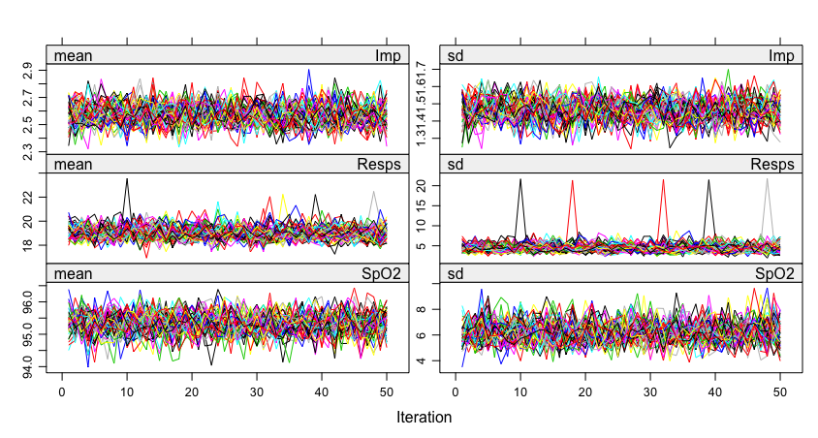
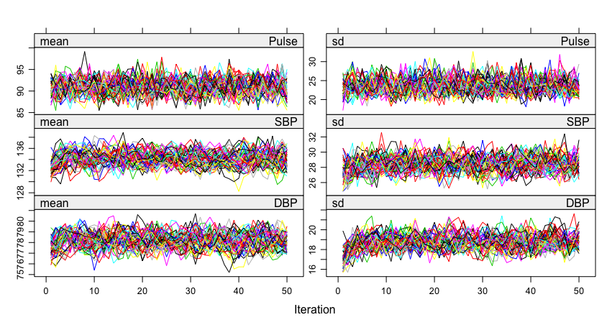
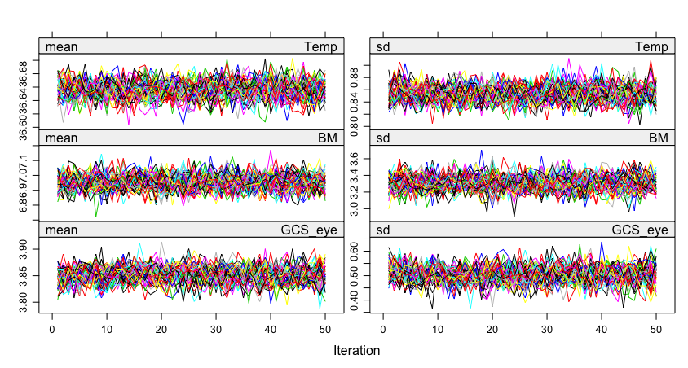
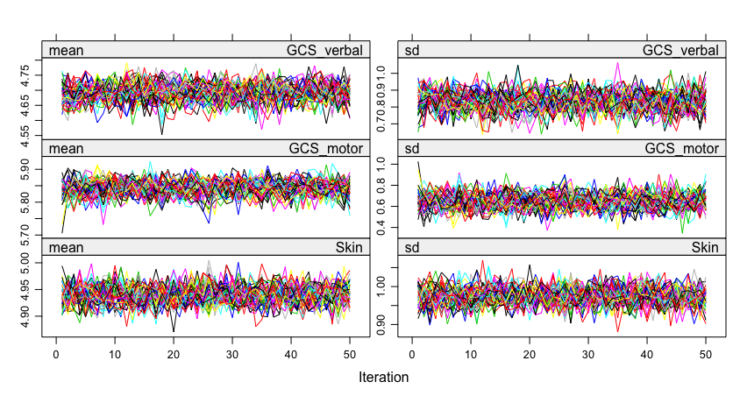
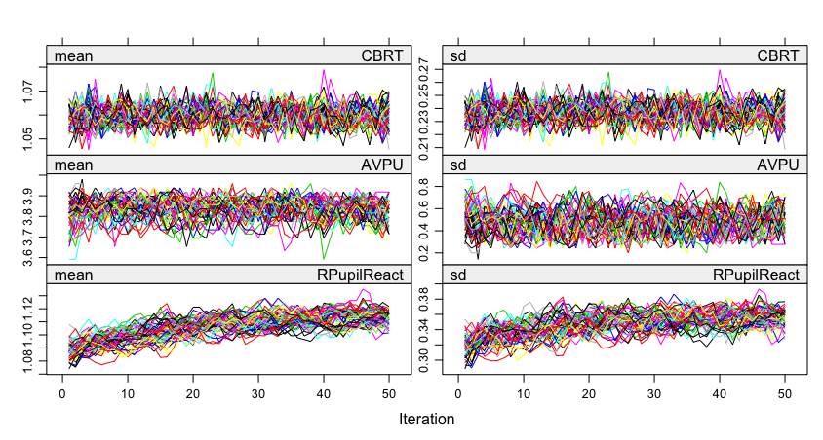
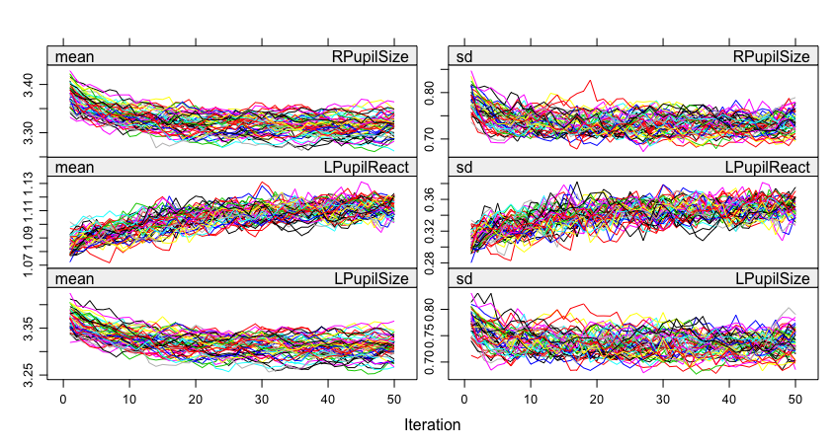

Figure S2 Density plots

Density plot Resps
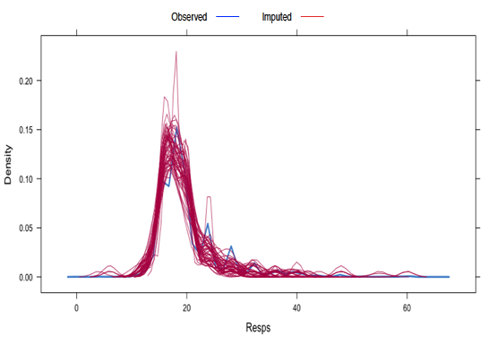
Density plot SpO₂
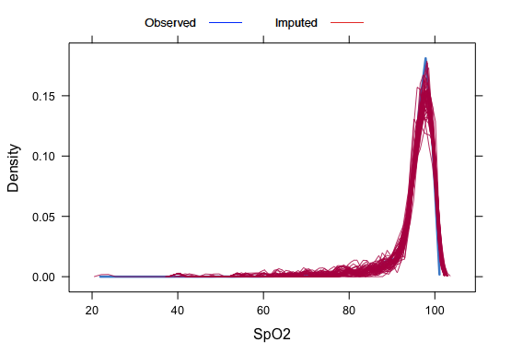
Density plot Pulse
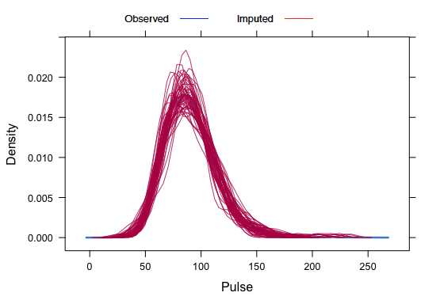

Density plot SBP
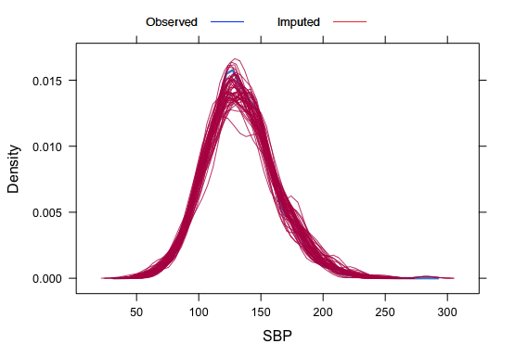
Density plot DBP
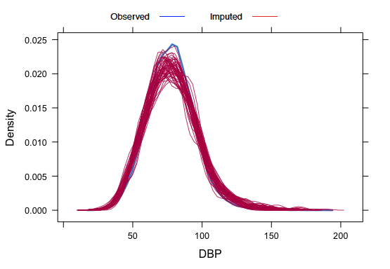

Density plot BM
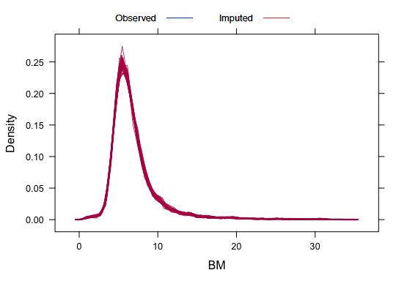
Density plot Temp
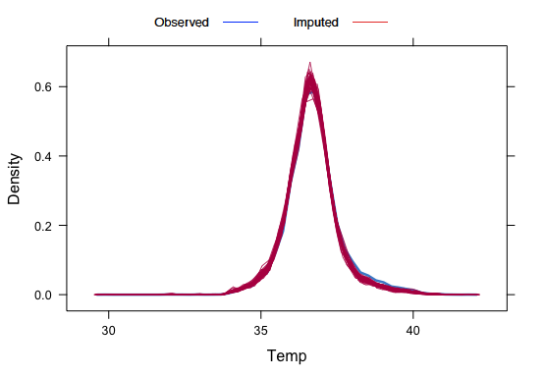

Density plot RPupilSize
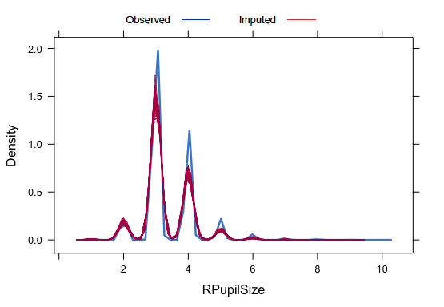

Figure S3 Box and whisker plots

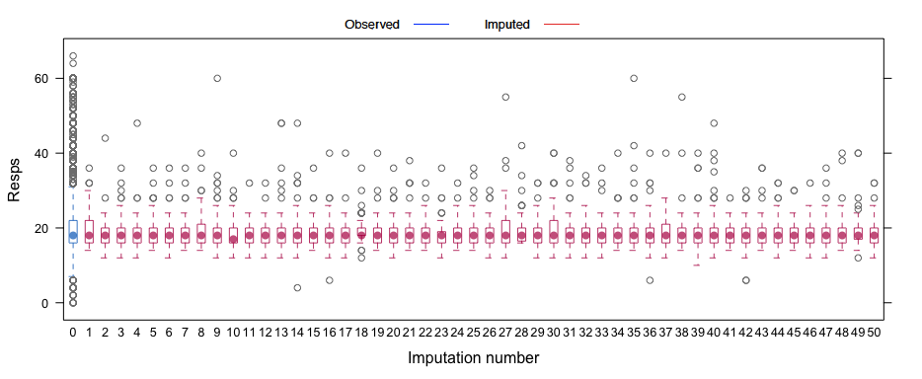
Box and Whisker plot Resps

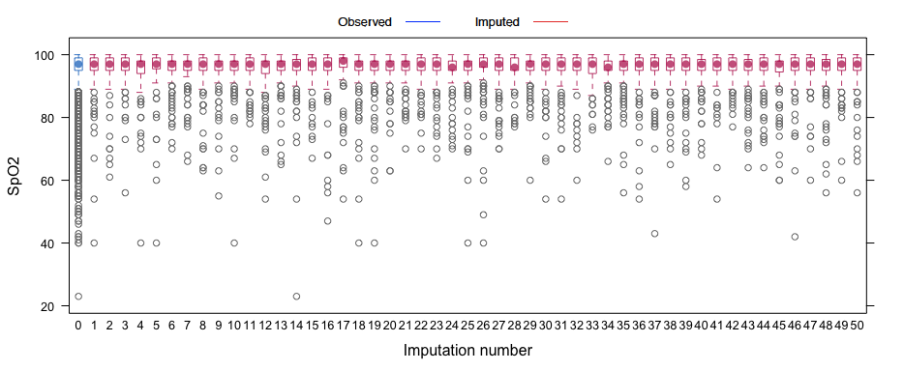
Box and Whisker plot SpO2

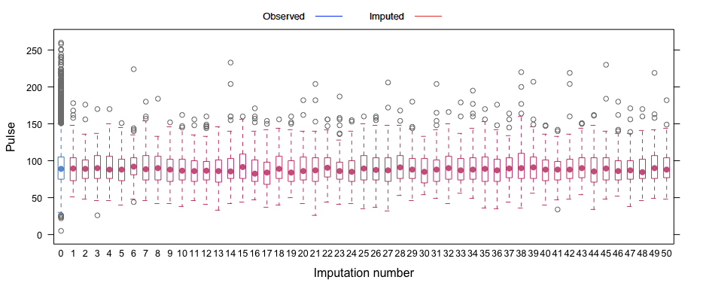
Box and Whisker plot Pulse

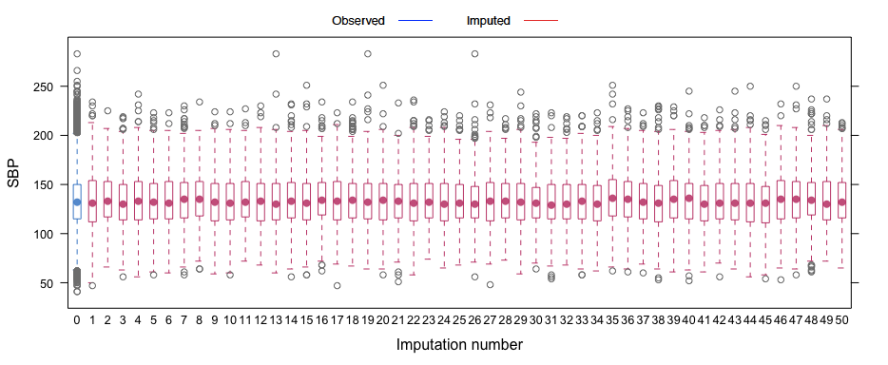
Box and Whisker plot SBP

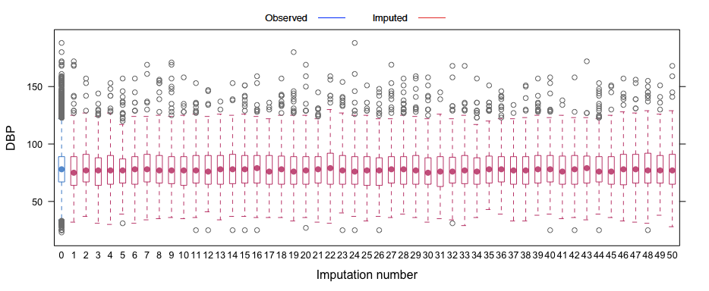
Box and Whisker plot DBP

Box and Whisker plot BM
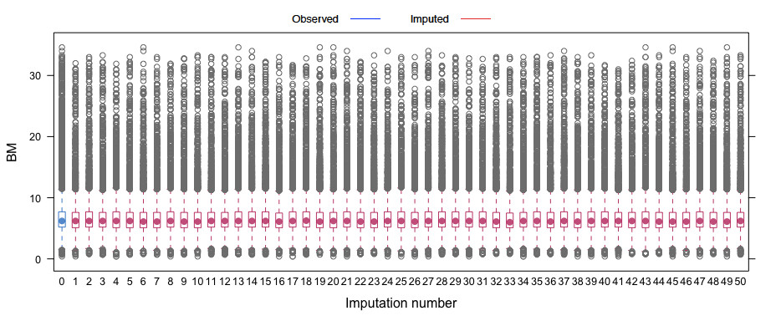

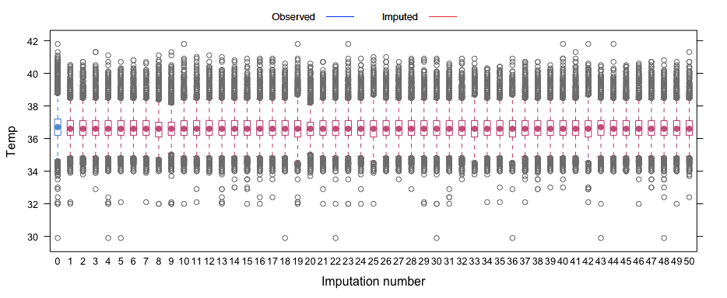
Box and Whisker plot Temp

Box and Whisker plot RPupilSize
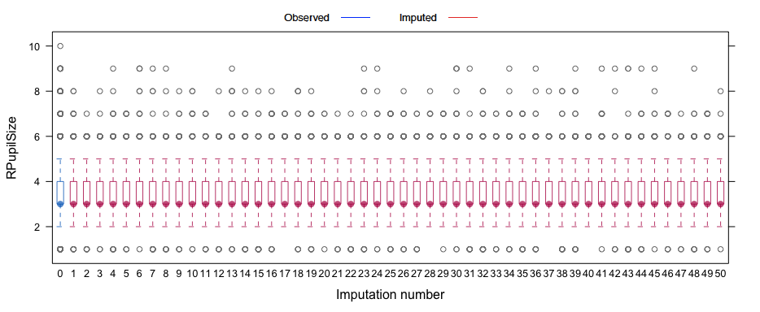
Figure S4 Colinearity between candidate predictor variables
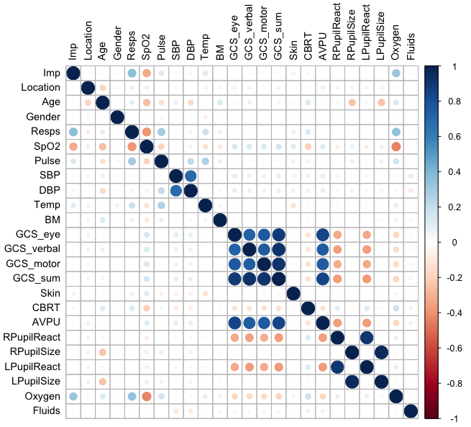

Blue circles indicate a positive relationship, while red circles indicate an inverse relationship. Darker colour shades and increasing circle size indicate increasing strength of the relationship. The dark blue diagonal represents the perfect relationship of each variable with itself.

