"Next-generation sequencing identifies monogenic diabetes in 16% of patients with late adolescence or adult-onset diabetes selected on a clinical basis: a cross-sectional analysis ", by Xavier Donath et al.
Additional file 2.
- Tables S1, S2, S3, S4, S5, S6, S7
- Figures S1, S2, S3

Table S1. Cases with class 3/4/5 variants identified in two genes
case # | Gene | Location | Nucleotide change | Protein effect | Variant type | Class of pathogenicity | References | sex | Euro-Caucasian | n of generations with diabetes | age (years) | BMI (kg/m²) | symptoms | HbA1c (%) | insulin therapy
1 | HNF4A | Exon 8 | c.1063G>C | p.Gly355Arg | Splice defect | 5 | This report | F | yes | 3 | 17 | 32.6 | yes | na | yes
 | ABCC8 | Exon 10 | c.1561C>T | p.Arg521Trp | Misense | 3 | This report
2 | GCK | Exon 10 | c.1333A>T | p.Ser445Cys | Missense | 4 | [1] | M | yes | 4 | 20 | 23.8 | no | 7.5 | no
 | KCNJ11 | Exon 1 | c.1040G>A | p.Arg347His | Missense | 3 | [2]
3 | GCK | Exon 2 | c.128G>A | p.Arg43His | Missense | 5 | [3] | F | na | 1 | 38 | 20.8 | no | 6.1 | na
 | HNF1A | Exon 4 | c.862G>A | p.Gly288Arg | Missense | 3 | This report
4 | HNF1A | Exon 4 | c.872dupC | p.Gly292fs | Frameshift | 5 | [4] | M | no | 4 | 37 | 21.1 | no | 6.2 | no
 | HNF1B | Exon 3 | c.793G>A | p.Val265Met | Missense | 3 | This report
5 | GCK | Exon 5 | c.571C>T | p.Arg191Trp | Missense | 5 | [1] | F | na | 2 | 20 | na | no | na | no
 | ABCC8 | Exon 33 | c.4058G>C | p.Arg1353Pro | Missense | 4 | [5]

Sequence variants are numbered with respect to GenBank cDNA sequences. ABCC8, NM_000352.3; GCK, NM_000162.3; HNF1A, NM_000545.6; HNF1B, NM_000458.3; HNF4A, NM_175914.4; KCNJ11, NM_000525.3 and described according to Human Genome Variation Society (HGVS) guidelines (http://www.hgvs.org/varnomen). Variants were classified according to ACMG recommendations [see Table S3 for details]. LOF, loss-of-function variants

1. Osbak KK, Colclough K, Saint-Martin C, Beer NL, Bellanné-Chantelot C, Ellard S, Gloyn AL.: Update on mutations in glucokinase (GCK), which cause maturity-onset diabetes of the young, permanent neonatal diabetes, and hyperinsulinemic hypoglycemia. Hum Mut 2012, 30(11): 1512-26.
2. Kapoor RR, Flanagan SE, Arya VB, Shield JP, Ellard S, Hussain K.: Clinical and molecular characterisation of 300 patients with congenital hyperinsulinism. Eur J Endocrinol 2013, 168(4): 557-64.
3. Beer NL, Osbak KK, van de Bunt M, Tribble ND, Steele AM, Wensley KJ, Edghill EL, Colcough K, Barrett A, Valentínová L, et al: Insights into the pathogenicity of rare missense GCK variants from the identification and functional characterization of compound heterozygous and double mutations inherited in cis. Diabetes Care 2012, 35(7): 1482-4.
4. Colclough K, Bellanne-Chantelot C, Saint-Martin C, Flanagan SE, Ellard S.: Mutations in the genes encoding the transcription factors hepatocyte nuclear factor 1 alpha and 4 alpha in maturity-onset diabetes of the young and hyperinsulinemic hypoglycemia. Hum Mut 2013, 34(5): 669-85.
5. Magge SN, Shyng SL, MacMullen C, Steinkrauss L, Ganguly A, Katz LE, Stanley CA.: Familial leucine-sensitive hypoglycemia of infancy due to a dominant mutation of the beta-cell sulfonylurea receptor. J Clin Endocrinol Metab 2004, 89(9): 4450-6.

Table S2. Loss-of-function variants identified in ABCC8 and KCNJ11
Gene | Location | Nucleotide Change | Protein effect | Variant type | Class of pathogenicity | References
ABCC8 | Exon 2 | c.220C>T | p.Arg74Trp | Missense | 4 | (1)
ABCC8  ABCC8 | Exon 6  Exon 10 | c.892C>T  c.1484G>A | p. Arg298Cys  p.Arg495Gln | Misense  Missense | 3  4 | (2)  (3)
ABCC8  ABCC8 | Exon 12  Exon 18 | c.1741T>A  c.2294+1G>A | p.Ser581Thr  p.? | Missense  Splice defect | 3  5 | (4)  This report
ABCC8 | Exon 35 | c.4262G>A | p.Arg1421His | Missense | 4 | (5)
KCNJ11  KCNJ11 | 5’UTR  Exon 1 | c.-54C>T  c.148C>T | p.0?  p.Arg50Trp | Promoter variant  Missense | 3  4 | (6)  This report *
KCNJ11 | Exon 1 | c.617G>A | p.Arg206His | Missense | 4 | This report *
KCNJ11 | Exon 1 | c.934G>T | p.Gly312Cys | Missense | 4 | (7)
*variant previously identified in cases diagnosed with recessive form of HHI in the diagnostic’s database of Pitié-Salpêtrière hospital
Sequence variants are numbered with respect to GenBank cDNA sequences. ABCC8, NM_000352.3; KCNJ11, NM_000525.3 and described according to Human Genome Variation Society (HGVS) guidelines (http://www.hgvs.org/varnomen). Variants were classified according to ACMG recommendations [see Table S3 for details].

1. Suchi M, MacMullen C, Thornton P, Adzick N, Ganguly A, Ruchelli E, Stanley C.: Molecular and immunohistochemical analyses of the focal form of congenital hyperinsulinism. Mod Pathol 2006, 19(1): 122-9.
2. Snider KE, Becker S, Boyajian L, Shyng SL, MacMullen C, Hughes N, Ganapathy K, Bhatti T, Stanley CA, Ganguly A.: Genotype and phenotype correlations in 417 children with congenital hyperinsulinism. J Clin Endocrinol Metab 2013, 98(2): E355-363.
3. Yan F, Lin Y, MacMullen C, Ganguly A, Stanley C, Shyng S: Congenital hyperinsulinism associated ABCC8 mutations that cause defective trafficking of ATP-sensitive K+ channels: identification and rescue. Diabetes 2007, 56(9): 2239-48.
4. Salisbury RJ, Han B, Jennings RE, Berry AA, Stevens A, Mohamed Z, Sugden SA, De Krijger R, Cross SE, Johnson PP, et al.: Altered Phenotype of beta-Cells and Other Pancreatic Cell Lineages in Patients With Diffuse Congenital Hyperinsulinism in Infancy Caused by Mutations in the ATP-Sensitive K-Channel. Diabetes 2015, 64(9): 3182-3188.
5. Saito-Hakoda A, Yorifuji T, Kanno J, Kure S, Fujiwara I.: Nateglinide is Effective for Diabetes Mellitus with Reactive Hypoglycemia in a Child with a Compound Heterozygous ABCC8 Mutation. Clin Pediatr Endocrinol 2012, 21(3): 45-52.
6. Huopio H, Jaaskelainen J, Komulainen J, Miettinen R, Karkkainen P, Laakso M, Tapanainen P, Voutilainen R, Otonkoski T: Acute insulin response tests for the differential diagnosis of congenital hyperinsulinism. J Clin Endocrinol Metab 2002, 87(10): 4502-4507.
7. Arya VB, Guemes M, Nessa A, Alam S, Shah P, Gilbert C, Senniappan S, Flanagan SE, Ellard S, Hussain K.: Clinical and histological heterogeneity of congenital hyperinsulinism due to paternally inherited heterozygous ABCC8/KCNJ11 mutations . Eur J Endocrinol 2014, 171(6): 685-95.
Table S3. List of novel pathogenic (Class 5) or likely pathogenic (Class 4) variants

 |  |  |  | Criteria for classifying variants according to ACMG guidelines (1)
Gene | Location | Nucleotide Change | Protein effect | Variant type | Variant consequence | Functional data | Population data | Segregation data | Computational and predictive evidence | Class of pathogenicity
ABCC8 | Exon 22 | c.2588A>G | p.His863Arg | Missense |  |  | PM2 | PP1 | PM5 PP3 | 4
ABCC8 | Exon 37 | c.4514T>C | p.Met1505Thr | Missense |  | PS3 | PM2 |  | PP3 | 4
GCK | Intron 1 | c.46-1G>T | p.? | Splice defect | PVS1 |  | PM2 |  |  | 5
GCK | Exon 2 | c.208G>C | p.Glu70Gln | Splice defect |  | PS3 | PM2 | PP1 | PM5 PP3 PP2 | 5
GCK | Exon 2-3 | c.46-?_363+?del | p.? | In-frame exonic deletion | PM4 |  | PM2 |  |  | 4
GCK | Exon 3 | c.236T>C | p.Leu79Pro | Missense |  |  | PM2 | PS2 | PP3 PP2 | 4
GCK | Exon 3 | c.247A>G | p.Asn83Asp | Missense |  |  | PM2 |  | PP3 PP2 | 4
GCK | Exon 3 | c.268A>T | p.Lys90Ter | Nonsense | PVS1 |  | PM2 |  |  | 5
GCK | Exon 4 | c.388A>G | p.Ile130Val | Missense |  |  | PM2 |  | PM5 PP3 PP2 | 4
GCK | Exon 5 | c.485G>C | p.Gly162Ala | Missense |  |  | PM2 |  | PM5 PP3 PP2 | 4
GCK | Exon 5 | c.505A>G | p.Lys169Glu | Missense |  |  | PM2 |  | PM5 PP3 PP2 | 4
GCK | Exon 5 | c.508G>T | p.Gly170Cys | Missense |  |  | PM2 |  | PM5 PP3 PP2 | 4
GCK | Exon 5 | c.513C>G | p.Phe171Leu | Missense | PS1 |  | PM2 |  | PM5 PP3 PP2 | 5
GCK | Exon 6 | c.677T>G | p.Val226Gly | Missense |  |  | PM2 |  | PM1 PP3 PP2 | 4
GCK | Exon 7 | c.686del | p.Gly229fs | Frameshift | PVS1 |  | PM2 |  |  | 5
GCK | Exon 7 | c.770G>A | p.Trp257Ter | Nonsense | PVS1 |  | PM2 |  |  | 5
GCK | Exon 7 | c.781G>C | p.Gly261Arg | Missense | PS1 |  | PM2 | PP1 | PM1 PM5 PP3 PP2 | 5
GCK | Exon 7 | c.821A>C | p.Asp274Ala | Missense |  |  | PM2 |  | PM5 PP3 PP2 | 4
GCK | Exon 7 | c.824_850del | p.Arg275_Asn283del | In-frame deletion | PM4 |  | PM2 |  | PP3 | 4
GCK | Exon 7 | c.859C>T | p.Gln287Ter | Nonsense | PVS1 |  | PM2 |  |  | 5
GCK | Exon 8 | c.868G>A | p.Glu290Lys | Missense |  |  | PM2 |  | PM5 PP3 PP2 | 4
GCK | Exon 8 | c.904G>T | p.Val302Leu | Missense | PS1 |  | PM2 |  | PM5 PP3 PP2 | 5
GCK | Exon 8 | c.908G>C | p.Arg303Pro | Missense |  |  | PM2 |  | PM1 PP3 PP2 | 4
GCK | Exon 8 | c.1019G>A | p.Ser340Asn | Splice defect | PVS1 |  | PM2 |  | PM5 PP3 PP2 | 5
GCK | Exon 9 | c.1134_1151del | p.Ala379_Ala384del | In-frame deletion | PM4 |  | PM2 |  | PP3 | 4
GCK | Exon 9 | c.1135G>A | p.Ala379Thr | Missense |  |  | PM2 |  | PM5 PP3 PP2 | 4
GCK | Exon 9 | c.1181_1182delinsCG | p.Arg394Pro | Missense |  | PS3 | PM2 |  | PP3 PP2 | 4
GCK | Exon 9 | c.1238_1253+14delinsGCCCCCA | p.Tyr413_Ser418delinsCysProHis | Splice defect | PVS1 |  | PM2 | PP1 | PP3 | 5
GCK | Exon 9 | c.1246C>T | p.His416Tyr | Missense |  |  | PM2 |  | PM5 PP3 PP2 | 4
GCK | Exon 10 | c.1313T>C | p.Phe438Ser | Missense |  |  | PM2 |  | PM5 PP3 PP2 | 4
GCK | Exon 10 | c.1348del | p.Ala450fs | Frameshift | PVS1 |  | PM2 |  |  | 5
HNF1A | Exon 1 | c.26A>G | p.Gln9Arg | Missense |  |  | PM2 |  | PM1 PM5 PP3 | 4
HNF1A | Exon 1 | c.35T>G | p.Leu12Arg | Missense |  |  | PM2 |  | PM5 PP3 | 4
HNF1A | Exon 1 | c.102del | p.Tyr36fs | Frameshift | PVS1 |  | PM2 |  |  | 5
HNF1A | Exon 1 | c.142dup | p.Glu48fs | Frameshift | PVS1 |  | PM2 |  |  | 5
HNF1A | Exon 1 | c.242del | p.Phe81fs | Frameshift | PVS1 |  | PM2 |  |  | 5
HNF1A | Intron 1 | c.326+3_326+9del | p.? | Splice defect | PVS1 |  | PM2 |  | PP3 | 4
HNF1A | Intron 1 | c.326+4A>G | p.? | Splice defect | PVS1 |  | PM2 |  | PP3 | 4
HNF1A | Exon 2 | c.364T>C | p.Tyr122His | Missense |  |  | PM2 |  | PM1 PP3 | 4
HNF1A | Exon 2 | c.375G>C | p.Gln125His | Missense |  |  | PM2 |  | PM1 PP3 | 4
HNF1A | Exon 2 | c.467C>T | p.Thr156Met | Missense |  |  | PM2 |  | PM1 PP3 | 4
HNF1A | Exon 2 | c.496T>G | p.Tyr166Asp | Missense |  |  | PM2 |  | PM1 PP3 | 4
HNF1A | Exon 2 | c.514G>T | p.Glu172Ter | Nonsense | PVS1 |  | PM2 |  |  | 5
HNF1A | Exon 2 | c.327-?_526+?del | p.? | Exonic deletion | PVS1 |  | PM2 |  |  | 5
HNF1A | Intron 2 | c.526+1delG | p.? | Splice defect | PVS1 |  | PM2 |  | PP3 | 5
HNF1A | Exon 3 | c.570del | p.Gly191fs | Frameshift | PVS1 |  | PM2 |  |  | 5
HNF1A | Exon 4 | c.775G>A | p.Val259Ile | Missense |  |  | PM2 |  | PM1 PM5 PP3 | 4
HNF1A | Exon 4 | c.825_827del | p.Glu275_Ala276delinsAsp | In-frame deletion | PM4 |  | PM2 |  | PM1 PP3 | 4
HNF1A | Exon 8 | c.1623G>A | p. ? | Splice defect | PVS1 |  | PM2 |  | PP3 | 4
HNF1A | Exon 9 | c.1742_1768+2delinsACAGGG | p.? | Splice defect | PVS1 |  | PM2 |  | PP3 | 4
HNF1A | Exon 9 | c.1697dup | p.His566fs | Frameshift | PVS1 |  | PM2 |  |  | 5
HNF1A | Exon 10 | c.1772_1773del | p.Ser591fs | Frameshift | PSª |  | PM2 |  |  | 4
HNF1B | Exon 1 | c.34C>T | p.Leu12Phe | Missense |  |  | PM2 |  | PM1 PP3 | 4
HNF1B | Exon 2 | c.377A>G | p.Lys126Arg | Missense |  |  | PM2 |  | PM1 PP3 | 4
HNF1B | Exon 2 | c.473C>A | p.Thr158Asn | Missense |  |  | PM2 |  | PM1 PP3 | 4
HNF4A | Exon 4 | c.325C>T | p.Gln109Ter | Nonsense | PVS1 |  |  |  | PM1 | 5
HNF4A | Exon 4 | c.335G>C | p.Arg112Pro | Missense |  |  | PM2 |  | PM5 PP3 | 4
HNF4A | Exon 5 | c.433_436del | p.Ser145fs | Frameshift | PVS1 |  | PM2 |  |  | 5
HNF4A | Exon 5 | c.535T>C | p.Trp179Arg | Missense |  |  | PM2 |  | PM1 PP3 | 4
HNF4A | Exon 6 | c.589del | p.Leu197fs | Frameshift | PVS1 |  | PM2 |  |  | 5
HNF4A | Exon 6 | c.625G>A | p.Gly209Arg | Missense |  |  | PM2 | PP1 | PM1 PP3 | 4
HNF4A | Exon 8 | c.851_852del | p.Gly284fs | Frameshift | PVS1 |  | PM2 | PS2 |  | 5
INS | Exon 2 | c.85C>T | p.His29Tyr | Missense |  |  | PM2 |  | PM5 PP3 | 4
INS | Exon 2 | c.100C>T | p.His34Tyr | Missense |  |  | PM2 |  | PM5 PP3 | 4
KCNJ11 | Exon 1 | c.125G>A | p.Cys42Tyr | Missense |  | PS3^{b} | PM2 |  | PM5 PP3 | 4
KCNJ11 | Exon 1 | c.952A>G | p.Ile318Val | Missense |  | PS3^{b} |  | PP1 | PP3 | 4

Sequence variants are numbered with respect to GenBank cDNA sequences. ABCC8, NM_000352.3; GCK, NM_000162.3; HNF1A, NM_000545.6; HNF1B, NM_000458.3; HNF4A, NM_175914.4; INS, NM_000207.2; KCNJ11, NM_000525.3 and described according to Human Genome Variation Society (HGVS) guidelines (http://www.hgvs.org/varnomen). Variants were classified according to ACMG recommendations [1].

Variant consequence: PVS1, Nonsense, frameshift, canonical ±1 or ±2 splice sites, single or multi-exon deletions; PS1, same amino-acid change as a previously established pathogenic variant regardless of nucleotide change; PM4, in-frame deletions in a nonrepeat region. ªPS instead of PVS1 as this frameshift is located in the last exon of the HNF1A gene
Functional data: PS3, well-established in vitro functional studies supportive of a damaging effect on the gene product; or ^{b}improved glycaemic response treated with sulfonylureas.
Population data: PM2, if variant allele frequency (VAF) < 0.01% in geographically-matched population databases (ExAC [http://exac.broadinstitute.org/] and dbSNP [www.ncbi.nlm.nih.gov/snp])
Segregation data: PS2, de novo variant; PP1, segregation with diabetes in at least 2 affected relatives in proband’s family;
Computational evidence: PM1, located in a mutational hot spot and/or critical and well-established functional domain; PM5, novel missense change at an amino acid residue where a different missense change determined to be pathogenic has been seen before;
Predictive evidence: PP3, in silico evidence. For missense mutations, use of 4 predictive algorithms of pathogenicity (SIFT, PolyPhen-2, Align-GVGD and CADD); for CADD, we used a cut-off threshold of 20 (>20: considered pathogenic). For intronic variants, PP3 was attributed if both MaxEntScan and Splice site Finder algorithms predicted a splicing defect according to Houdayer et Coll. [2], guidelines (a variant score at least 15% lower than the reference allele for MaxEntScan and at least 5% lower for Splice site Finder); PP2, Missense variant in a gene that has a low rate of benign missense variation and in which missense variants are a common mechanism of disease.
Patient’s phenotype: PP4, proband’s and family’s history was suggestive of monogenic diabetes. Criteria for performing MODY genetic testing were systematically checked before NGS analysis, PP4 was attributed to all patients included in this study.
Class of pathogenicity determined taking into account all criteria according to rules established by the ACMG [1].

1. Richards S, Aziz N, Bale S, Bick D, Das S, Gastier-Foster J, Grody WW, Hegde M, Lyon E, Spector E et al: Standards and guidelines for the interpretation of sequence variants: a joint consensus recommendation of the American College of Medical Genetics and Genomics and the Association for Molecular Pathology. Genet Med 2015, 17(5):405-424.
2. Houdayer C, Caux-Moncoutier V, Krieger S, Barrois M, Bonnet F, Bourdon V, Bronner M, Buisson M, Coulet F, Gaildrat P et al: Guidelines for splicing analysis in molecular diagnosis derived from a set of 327 combined in silico/in vitro studies on BRCA1 and BRCA2 variants. Hum Mutat 2012, 33(8):1228-1238.

Table S4. List of known class 4-5 variants identified in ABCC8, HNF1B, KCNJ11 and INS genes

Gene | Location | Nucleotide Change | Protein effect | Variant type | References | Associated phenotype in literature
ABCC8 | Exon | c.806C>A | p.Ala269Asp | Missense | [1] | NDM
ABCC8 | Exon 28 | c.3547C>T | p.Arg1183Trp | Missense | [2] | TNDM
ABCC8 | Exon 28 | c.3548G>A | p.Arg1183Gln | Missense | [3] | TNDM
ABCC8 | Exon 34 | c.4139G>A | p.Arg1380His (3)ª | Missense | [2 ; 4] | TNDM
HNF1B | Exon 2 | c.529C>T | p.Arg177Ter | Missense | [5] | HNF1B renal disease
HNF1B | Exon 3 | c.704G>A | p.Arg235Gln | Missense | [7] | HNF1B renal disease
HNF1B | Exons 1-4 | c.1-?_1045+?del | p.0? (10)ª | Exonic deletion | [6] | HNF1B renal disease
HNF1B | Exons 1-9 | c.1-?_1674+?del | p.0? | Gene deletion | [7] | HNF1B renal disease
KCNJ11 | Exon 1 | c.679G>A | p.Glu227Lys | Missense | [8] | TNDM
INS | Exon 2 | c.16C>T | p.Arg6Cys (2)ª | Missense | [9] | MODY
INS | Exon 2 | c.130G>A | p.Gly44Arg | Missense | [10]; Bellanné-Chantelot, Saint-Martin unpublished^{b} | MODY
INS | Exon 3 | c.163C>T | p.Arg55Cys | Missense | [11] | MODY

Sequence variants are numbered with respect to GenBank cDNA sequences. ABCC8, NM_000352.3; GCK, NM_000162.3; HNF1A, NM_000545.6; HNF1B, NM_000458.3; HNF4A, NM_175914.4; INS, NM_000207.2; KCNJ11, NM_000525.3 and described according to Human Genome Variation Society (HGVS) guidelines (http://www.hgvs.org/varnomen).
ªNumber of probands into parentheses; ^{b}1 additional family diagnosed with TNDM in the diagnostics database of Pitié-Salpêtrière hospital; NDM, neonatal diabetes mellitus; TNDM, transient neonatal diabetes mellitus.

1. Vaxillaire M, Dechaume A, Busiah K, Cave H, Pereira S, Scharfmann R, de Nanclares GP, Castano L, Froguel P, Polak M et al: New ABCC8 mutations in relapsing neonatal diabetes and clinical features. Diabetes 2007, 56(6):1737-1741.
2. Flanagan SE, Patch AM, Mackay DJ, Edghill EL, Gloyn AL, Robinson D, Shield JP, Temple K, Ellard S, Hattersley AT: Mutations in ATP-sensitive K+ channel genes cause transient neonatal diabetes and permanent diabetes in childhood or adulthood. Diabetes 2007, 56(7):1930-1937.
3. Babenko AP, Polak M, Cave H, Busiah K, Czernichow P, Scharfmann R, Bryan J, Aguilar-Bryan L, Vaxillaire M, Froguel P: Activating mutations in the ABCC8 gene in neonatal diabetes mellitus. N Engl J Med 2006, 355(5):456-466.
4. Hartemann-Heurtier A, Simon A, Bellanné-Chantelot C, Reynaud R, Cavé H, Polak M, Vaxillaire M, Grimaldi A: Mutations in the ABCC8 gene can cause autoantibody-negative insulin-dependent diabetes. Diabetes Metab 2009, 35(3):233-235.
5. Horikawa Y, Iwasaki N, Hara M, Furuta H, Hinokio Y, Cockburn BN, Lindner T, Yamagata K, Ogata M, Tomonaga O et al: Mutation in hepatocyte nuclear factor-1 beta gene (TCF2) associated with MODY. Nat Genet 1997, 17(4):384-385.
6. Yorifuji T, Fujimaru R, Hosokawa Y, Tamagawa N, Shiozaki M, Aizu K, Jinno K, Maruo Y, Nagasaka H, Tajima T et al: Comprehensive molecular analysis of Japanese patients with pediatric-onset MODY-type diabetes mellitus. Pediatr Diabetes 2012, 13(1):26-32.
7. Bellanne-Chantelot C, Clauin S, Chauveau D, Collin P, Daumont M, Douillard C, Dubois-Laforgue D, Dusselier L, Gautier JF, Jadoul M et al: Large genomic rearrangements in the hepatocyte nuclear factor-1beta (TCF2) gene are the most frequent cause of maturity-onset diabetes of the young type 5. Diabetes 2005, 54(11):3126-3132.
8. Edghill EL, Gloyn AL, Goriely A, Harries LW, Flanagan SE, Rankin J, Hattersley AT, Ellard S: Origin of de novo KCNJ11 mutations and risk of neonatal diabetes for subsequent siblings. J Clin Endocrinol Metab 2007, 92(5):1773-1777.
9. Edghill EL, Flanagan SE, Patch AM, Boustred C, Parrish A, Shields B, Shepherd MH, Hussain K, Kapoor RR, Malecki M et al: Insulin mutation screening in 1,044 patients with diabetes: mutations in the INS gene are a common cause of neonatal diabetes but a rare cause of diabetes diagnosed in childhood or adulthood. Diabetes 2008, 57(4):1034-1042.
10. Flannick J, Johansson S, Njolstad PR: Common and rare forms of diabetes mellitus: towards a continuum of diabetes subtypes. Nat Rev Endocrinol 2016, 12(7):394-406.
11. Molven A, Ringdal M, Nordbo AM, Raeder H, Stoy J, Lipkind GM, Steiner DF, Philipson LH, Bergmann I, Aarskog D et al: Mutations in the insulin gene can cause MODY and autoantibody-negative type 1 diabetes. Diabetes 2008, 57(4):1131-1135.

Table S5. Main characteristics of the 15 patients with HNF1B-MODY.

Patient # | HNF1B  Nucléotide change / protein effect | Sex F/M | Eurocaucasian origin yes/no | n of generations with diabetes | Age at diagnosis of diabetes (years) | BMI at diagnosis of diabetes (kg/m²) | Symptoms at diagnosis of diabetesª yes/no | HbA1c at diagnosis (%) | Insulin therapy at diagnosis yes/no | Age at study  (years) | Diabetes duration  (years) | Plasma creatinine (µmol/L) | Renal morphology^{b}
1 | c.34C>T / p.Leu12Phe | M | no | 2 | 32 | 24,4 | yes | 10,3 | yes | 33 | 1 | 56 | na
2 | Whole deletion | F | yes | 2 | 15 | 23,4 | yes | na | yes | 18 | 3 | 53 | cysts
3 | Exons 1-4 deletion | M | na | 2 | 18 | na | no | na | no | 66 | 48 | 212 | one cyst
4 | Whole deletion | M | yes | 3 | 27 | 20,2 | yes | 9,9 | yes | 27 | 0 | 88 | normal
5 | Whole deletion | M | no | 3 | 15 | na | yes | na | yes | 25 | 10 | na | normal
6 | Whole deletion | M | no | 3 | 29 | 19,7 | yes | 14 | yes | 29 | 0 | na | na
7 | Whole deletion | M | yes | 1 | 33 | 21,4 | no | 7,1 | no | 35 | 2 | 79 | normal
8 | Whole deletion | M | no | 3 | 34 | 21,8 | yes | 14,2 | yes | 55 | 21 | 98 | normal
9 | Whole deletion | F | yes | 1 | 22 | 19,1 | no | 5,3 | no | 25 | 3 | 61 | cysts
10 | Whole deletion | M | yes | 2 | 18 | na | yes | na | yes | 25 | 7 | 76 | na
11 | c.377A>G / p.Lys126Arg | M | yes | 2 | 39 | 26,1 | yes | na | yes | 45 | 6 | 78 | normal
12 | Whole deletion | M | no | 3 | 22 | 28,5 | yes | 12,1 | yes | 27 | 5 | 89 | normal
13 | c.473C>A / p.Thr158Asn | M | yes | 3 | 15 | 19 | no | 6,6 | no | 16 | 1 | 65 | normal
14 | Whole deletion | F | no | 1 | 40 | 18,4 | yes | 12 | yes | 49 | 9 | 31 | normal
15 | c.704G>A / p.Arg235Gln | F | yes | 3 | 37 | 16,5 | yes | na | yes | 37 | 0 | 54 | na

ªSymptoms of diabetes: polyuria and/or unexplained body weight loss and/or diabetic ketoacidosis.
^{b}Assessed by ultrasonography and/or computed tomography scan

Table S6. Main characteristics at the onset of diabetes in patients with monogenic vs. non-monogenic diabetes

 | Monogenic | Monogenic  excluding GCK-cases | Non-monogenicª | P ; OR [95% CI]  Monogenic vs. non-monogenic | P ; OR [95% CI]  Monogenic excluding GCK  vs. non-monogenic
N patients | 254& | 142 | 1241 | 254 vs. 1241 | 142 vs. 1241
Sex: F/M | 168/86 (66%) | 89/53 (63%) | 619/622 (50%) | < 10⁻⁴; 1.96 [1.48-2.60] | 0.0045; 1.69 [1.18-2.41]
Eurocaucasian/others | 192/37 (84%) | 101/32 (76%) | 600/499 (55%) | < 10⁻⁴; 4.32 [2.98-6.26] | < 10⁻⁴; 2.63 [1.73-3.98]
Age (years) | 24 [18-30] (254) | 24 [18.3-29.8] (142) | 31 [25-39] (1239) | < 10⁻⁴ | < 10⁻⁴
≥3 generations with diabetes: yes/no | 144/105 (58%) | 84/55 (60%) | 581/631 (48%) | 0.0053; 1.49 [1.13-1.96] | 0.0055; 1.66 [1.16-2.37]
BMI (kg/m²) (n) | 21.8 [20.1-24.2] (221) | 22.8 [20.8-25] (124) | 24.2 [21.6-27.7] (1107) | < 10⁻⁴ | < 10⁻⁴
BMI: normal/increased (%) | 180/43 (81%) | 92/33 (74%) | 642/475 (57%) | < 10⁻⁴; 3.10 [2.18-4.41] | 0.0005; 2.06 [1.36-3.12]
Symptoms of diabetes^{b}: yes/no | 37/204 (15%) | 33/102 (24%) | 461/702 (40%) | < 10⁻⁴; 0.28 [0.19-0.40] | 0.0005; 0.49 [0.33-0.74]
HbA_{1C} (%) | 6.7 [6.3-8.7] (157) | 8.05 [6.6-9.7] (86) | 9.6 [7-12] (588) | < 10⁻⁴ | 0.0011
HbA_{1C} (mmol/mol) | 50 [45-72] (157) | 64 [49-83] (86) | 81 [53-108] (588) | < 10⁻⁴ | 0.0011
Insulin therapy: yes/no | 38/189 (17%) | 36/94 (28%) | 339/768 (31%) | < 10⁻⁴; 0.46 [0.31-0.66] | 0.5455; 0.87 [0.58-1.30]
Hypertension: yes/no | 23/133 (15%) | 16/71 (18%) | 214/538 (28%) | 0.0003; 0.43 [0.27-0.70] | 0.0562; 0.57 [0.32-1.00]
Dyslipidemia: yes/no | 23/116 (17%) | 16/63 (20%) | 235/461 (34%) | < 10⁻⁴; 0.39 [0.24-0.63] | 0.0157; 0.50 [0.28-0.88]

Values are actual numbers with percentages into parentheses, or median with interquartile range into brackets and numbers of values into parentheses.
ªNon-monogenic, no genetic etiology detected by targeted NGS on 7 genes;
^{b}Symptoms of diabetes: polyuria and/or unexplained body weight loss and/or diabetic ketoacidosis;
BMI, body mass index.

Table S7. List of variants of uncertain significance (class 3)

 |  |  |  | Criteria for classifying variants according to ACMG guidelines [1]
Gene | Location | Nucleotide Change | Protein effect | Variant type | Variant consequence | Functional data | Population data | Segregation data | Computational and predictive evidence | Class of pathogenicity
ABCC8 | Exon 1 | c.40G>T | p.Ala14Ser | Missense |  |  | PM2 |  | BP4 | 3
ABCC8 | Exon 3 | c.291G>T | p.? | Splice defect |  |  | PM2 |  |  | 3
ABCC8 | Exon 3 | c.361G>A | p.Val121Met | Missense |  |  | PM2 |  | PP3 | 3
ABCC8 | Exon 3 | c.380T>C | p.Ile127Thr | Missense |  |  | PM2 |  | PP3 | 3
ABCC8 | Intron 4 | c.580-16_580-14del | p.? | Splice defect |  |  |  |  |  | 3
ABCC8 | Exon 5 | c.770T>C | p.Met257Thr | Missense |  |  | PM2 |  |  | 3
ABCC8 | Exon 5 | c.809T>G | p.Phe270Cys | Missense |  |  | PM2 |  | PP3 | 3
ABCC8 | Exon 6 | c.946G>Aª | p.Gly316Arg | Missense |  |  | PM2 |  | PP3 | 3^{b}
ABCC8 | Exon 9 | c.1337T>C | p.Ile446Thr | Missense |  |  |  |  | PP3 | 3
ABCC8 | Exon 10 | c.1510C>T | p.Arg504Cys | Missense |  |  |  | BP5 | PP3 | 3
ABCC8 | Exon 10 | c.1537G>A | p.Ala513Thr | Missense |  |  | PM2 |  | PP3 | 3^{b}
ABCC8 | Exon 15 | c.2104C>T | p.Arg702Cys | Missense |  |  | PM2 |  | PP3 | 3
ABCC8 | Exon 15 | c.2116+61A>G | p.? | Splice defect |  |  | PM2 |  | PP3 | 3
ABCC8 | Exon 21 | c.2491T>A | p.Ser831Thr | Missense |  |  | PM2 |  | PP3 | 3
ABCC8 | Exon 21 | c.2512A>G | p.Ile838Val | Missense |  |  | PM2 |  |  | 3
ABCC8 | Exon 21 | c.2546A>C | p.Asn849Thr | Missense |  |  | PM2 |  | PP3 | 3
ABCC8 | Exon 25 | c.3113C>A | p.Thr1038Asn | Missense |  |  | PM2 |  | PP3 | 3
ABCC8 | Exon 28 | c.3496G>A | p.Val1166Met | Missense |  |  | PM2 |  | PP3 | 3
ABCC8 | Exon 31 | c.3778G>A | p.Val1260Met | Missense |  |  | BS1 |  | PP3 | 3
ABCC8 | Exon 31 | c.3827T>C | p.Leu1276Pro | Missense |  |  | PM2 |  | PP3 | 3
ABCC8 | Exon 31 | c.3868A>G | p.Met1290Val | Missense |  |  | PM2 |  | BP4 | 3
ABCC8 | Exon 35 | c.4279C>A | p.Gln1427Lys | Missense |  |  | PM2 |  | PP3 | 3
ABCC8 | Exon 37 | c.4511T>A | p.Ile1504Asn | Missense |  |  | PM2 |  | PP3 | 3
ABCC8 | Exon 39 | c.4736G>A | p.Arg1579His | Missense |  |  | PM2 |  | PP3 | 3
GCK | Exon 2 | c.142G>A | p.Glu48Lys | Missense |  |  | PM2 |  | PP3 PP2 | 3
GCK | Exon 3 | c.325T>C | p.Ser109Pro | Missense |  |  | PM2 |  | PP3 PP2 | 3
GCK | Intron 5 | c.580-9T>G† | p.? | Splice defect |  |  | PM2 |  | PP3 | 3
GCK | Exon 8 | c.923G>C | p.Arg308Thr | Missense |  |  | PM2 |  | PP3 PP2 | 3
GCK | Exon 9 | c.1207C>T | p.Arg403Cys | Missense |  |  | PM2 |  | PP3 PP2 | 3
GCK | Exon 10 | c.1373_1376del† | p.Lys458fs | Frameshift | PM4 |  | PM2 |  |  | 3
HNF1A | Promoter | c.-191T>C | p.= | Promoter variant |  |  | PM2 |  |  | 3
HNF1A | Exon 1 | c.98C>T | p.Pro33Leu | Missense |  |  | PM2 | PP5 | BP4 | 3
HNF1A | Exon 2 | c.490A>G | p.Thr164Ala | Missense |  |  | PM2 | PP5 | PM1 BP4 | 3
HNF1A | Exon 2 | c.511C>G | p.Arg171Gly | Missense |  |  | PM2 | PP5 | PM1 BP4 | 3^{b}
HNF1A | Exon 4 | c.866C>T | p.Pro289Leu | Missense |  |  | PM2 |  | PP3 | 3
HNF1A | Exon 7 | c.1380_1406del | p.Gln460_Leu468del | In-frame deletion | PM4 |  |  |  |  | 3
HNF1A | Exon 8 | c.1522G>A | p.Glu508Lys | Missense |  | PS3 |  |  | PP3 | 3^{b}
HNF1A | Exon 10 | c.1865T>C | p.Ile622Thr | Missense |  |  | PM2 |  | PP3 | 3
HNF1B | Exon 1 | c.118G>A | p.Gly40Arg | Missense |  |  | PM2 |  | PP3 | 3
HNF1B | Exon 7 | c.1460T>C | p.Met487Thr | Missense |  |  | PM2 |  | PP3 | 3
HNF1B | Exon 7 | c.1484T>A | p.Met495Lys | Missense |  |  | PM2 |  | PP3 | 3
HNF4A | Exon 2 | c.203A>G | p.Lys68Arg | Missense |  |  | PM2 |  | PP3 | 3
HNF4A | Exon 4 | c.353G>A | p.Arg118Gln | Missense |  |  | PM2 |  | PP3 | 3
HNF4A | Exon 5 | c.461T>G | p.Ile154Ser | Missense |  |  | PM2 |  | PP3 | 3
HNF4A | Exon 5 | c.478G>A | p.Ala160Thr | Missense |  |  | PM2 |  | PP3 | 3
HNF4A | Exon 6 | c.658G>A | p.Val220Met | Missense |  |  | PM2 |  | PP3 | 3^{b}
INS | Exon 2 | c.11G>A | p.Trp4Ter | Nonsense |  |  | PM2 |  | PP3 | 3^{c}
INS | Exon 2 | c.155C>T | p.Pro52Leu | Missense |  |  | PM2 |  | PP3 | 3
INS | Intron 2 | c.188-15G>A | p.? | Splice defect |  |  | PM2 |  | PP3 | 3^{b}
KCNJ11 | Exon 1 | c.86G>A | p.Arg29His | Missense |  |  | PM2 |  | PP3 | 3
KCNJ11 | Exon 1 | c.160C>T | p.Arg54Cys | Missense |  |  | PM2 |  | PP3 | 3
KCNJ11 | Exon 1 | c.341T>C | p.Ile114Thr | Missense |  |  | PM2 |  | PP3 | 3
KCNJ11 | Exon 1 | c.353C>T | p.Ser118Leu | Missense |  |  | PM2 |  | BP4 | 3^{b}
KCNJ11 | Exon 1 | c.463G>A | p.Val155Met | Missense |  |  | PM2 |  | PP3 | 3
KCNJ11 | Exon 1 | c.623G>A | p.Ser208Asn | Missense |  |  | PM2 |  | PP3 | 3
KCNJ11 | Exon 1 | c.662G>A | c.Arg221His | Missense |  |  | PM2 |  | PP3 | 3
ªVariant identified in two probands; ^{b}Variant previously reported in literature; ^{c}Variant identified at an heterozygous state and previously reported in literature at homozygous state in type 1-like diabetes [2].
Sequence variants are numbered with respect to GenBank cDNA sequences. ABCC8, NM_000352.3; GCK, NM_000162.3; HNF1A, NM_000545.6; HNF1B, NM_000458.3; HNF4A, NM_175914.4; INS, NM_000207.2; KCNJ11, NM_000525.3 and described according to Human Genome Variation Society (HGVS) guidelines [3].

Variant evaluation was conducted as described in Supplemental Table S2. One additional criterion was considered for these variants as piece of predictive evidence : BP4, when results of prediction algorithm are contradictory and do not suggest any impact on the gene product.

1. Richards S, Aziz N, Bale S, Bick D, Das S, Gastier-Foster J, Grody WW, Hegde M, Lyon E, Spector E et al: Standards and guidelines for the interpretation of sequence variants: a joint consensus recommendation of the American College of Medical Genetics and Genomics and the Association for Molecular Pathology. Genet Med 2015, 17(5):405-424.
2. Di Benedetto M, Richard O, Pélissier P, Darteyre S, Cavé H, Stéphan JL: [Permanent neonatal diabetes and recessive mutation in the INS gene: a familial history]. Arch Pediatr 2013, 20(2):199-202.
3. den Dunnen JT, Dalgleish R, Maglott DR, Hart RK, Greenblatt MS, McGowan-Jordan J, Roux AF, Smith T, Antonarakis SE, Taschner PE: HGVS Recommendations for the Description of Sequence Variants: 2016 Update. Hum Mutat 2016, 37(6):564-569.
Figure S1. Main characteristics at diagnosis of diabetes in patients with monogenic diabetes according to the involved gene
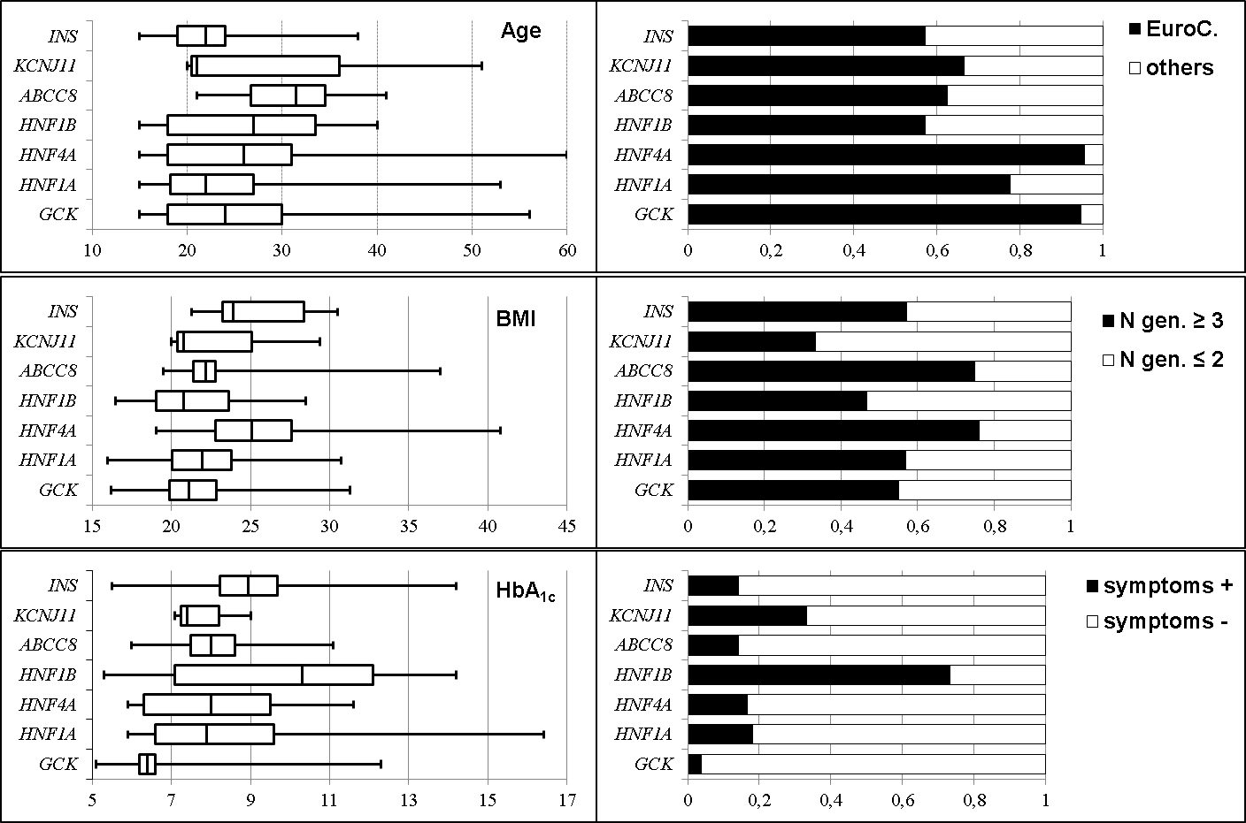
Legend. Box-plot representation of age (years), BMI, body mass index (kg/m²), HbA_{1c} (%), and percentages of geographical origin family history of diabetes in ≥ 3 generations, and presence of diabetes symptoms.
Figure S2. Main characteristics at diagnosis of diabetes in patients with (M+) and without (M-) monogenic diabetes
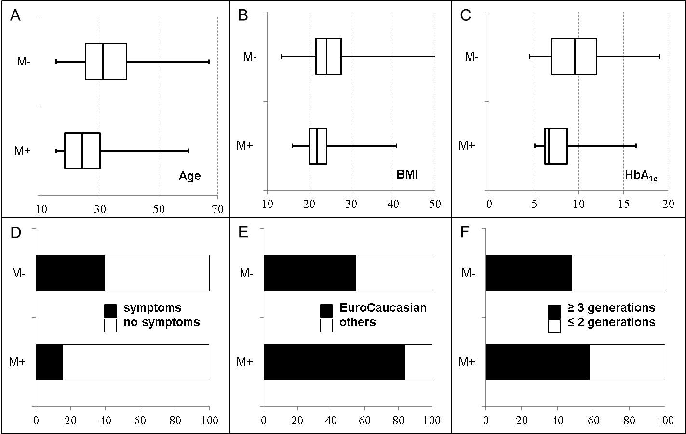
Legend. Box-plot representation of A, age (years), B, BMI, body mass index (kg/m²), C, HbA_{1c} (%), and percentages of D, presence of
diabetes symptoms, E, geographical origin, and F, family history of diabetes in ≥3 generations.
Figure S3. Hierarchical clustering of 1495 patients with a clinical suspicion of monogenic diabetes

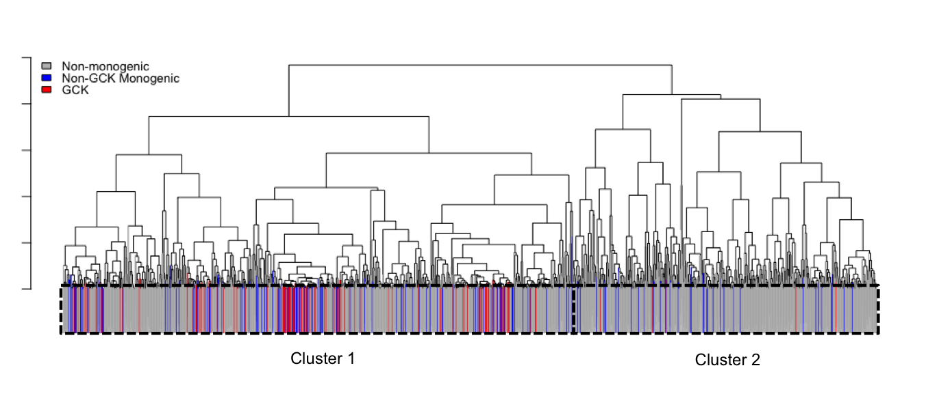

Legend. Dendrogram of the non-supervised hierarchical clustering performed in 1495 patients with a clinical suspicion of monogenic diabetes. Patients with loss-of-function variants (n=10) and those with a class 3 variant (n=59) were not included in this analysis.

