Additional file 1: figure S1. Funnel plots

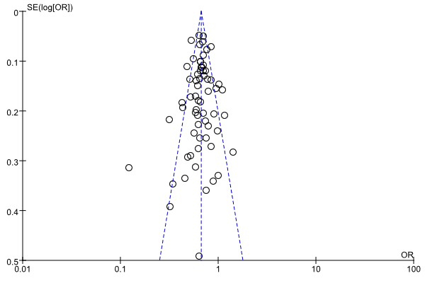
Funnel plot of the rs7903146 polymorphism and T2DM under dominant comparison.

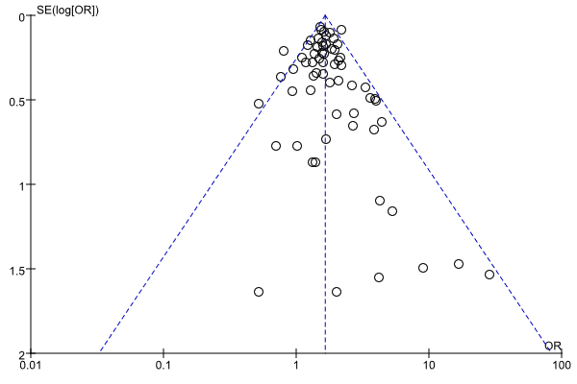
Funnel plot of the rs7903146 polymorphism and T2DM under recessive comparison.

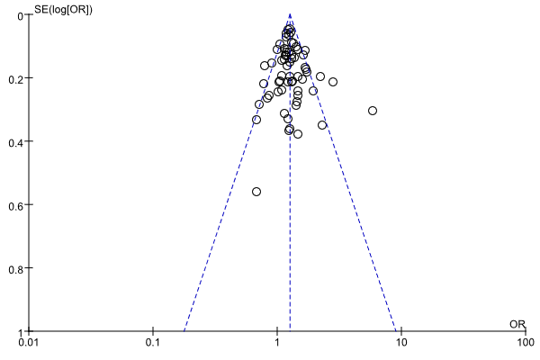
Funnel plot of the rs7903146 polymorphism and T2DM under over-dominant comparison.

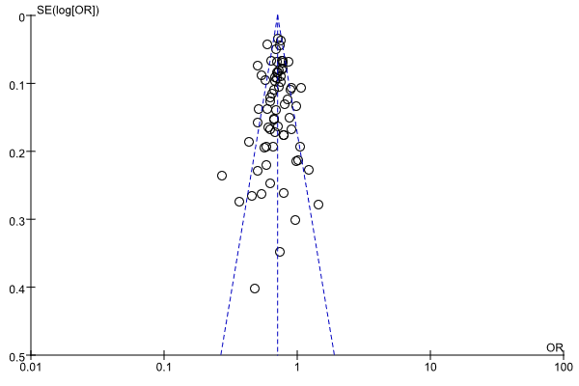
Funnel plot of the rs7903146 polymorphism and T2DM under allele comparison.

